CNN Model on MNIST Data:

Optimizer:Adam

Filtersize:64,128

Final layer: 1024

Accuracy: 0.9457

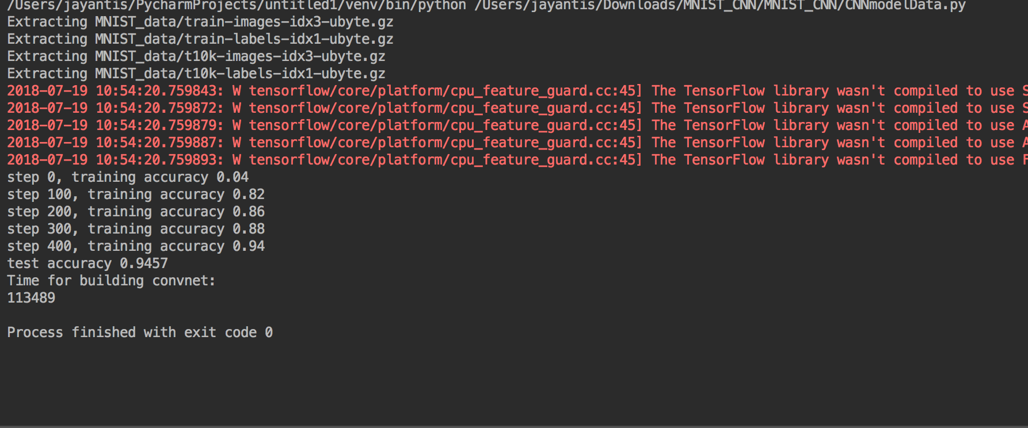

CNN Model on MNIST Data

Optimizer:Adagrad

Filter size:16,36

Final layer: 128

Accuracy: 0.2541

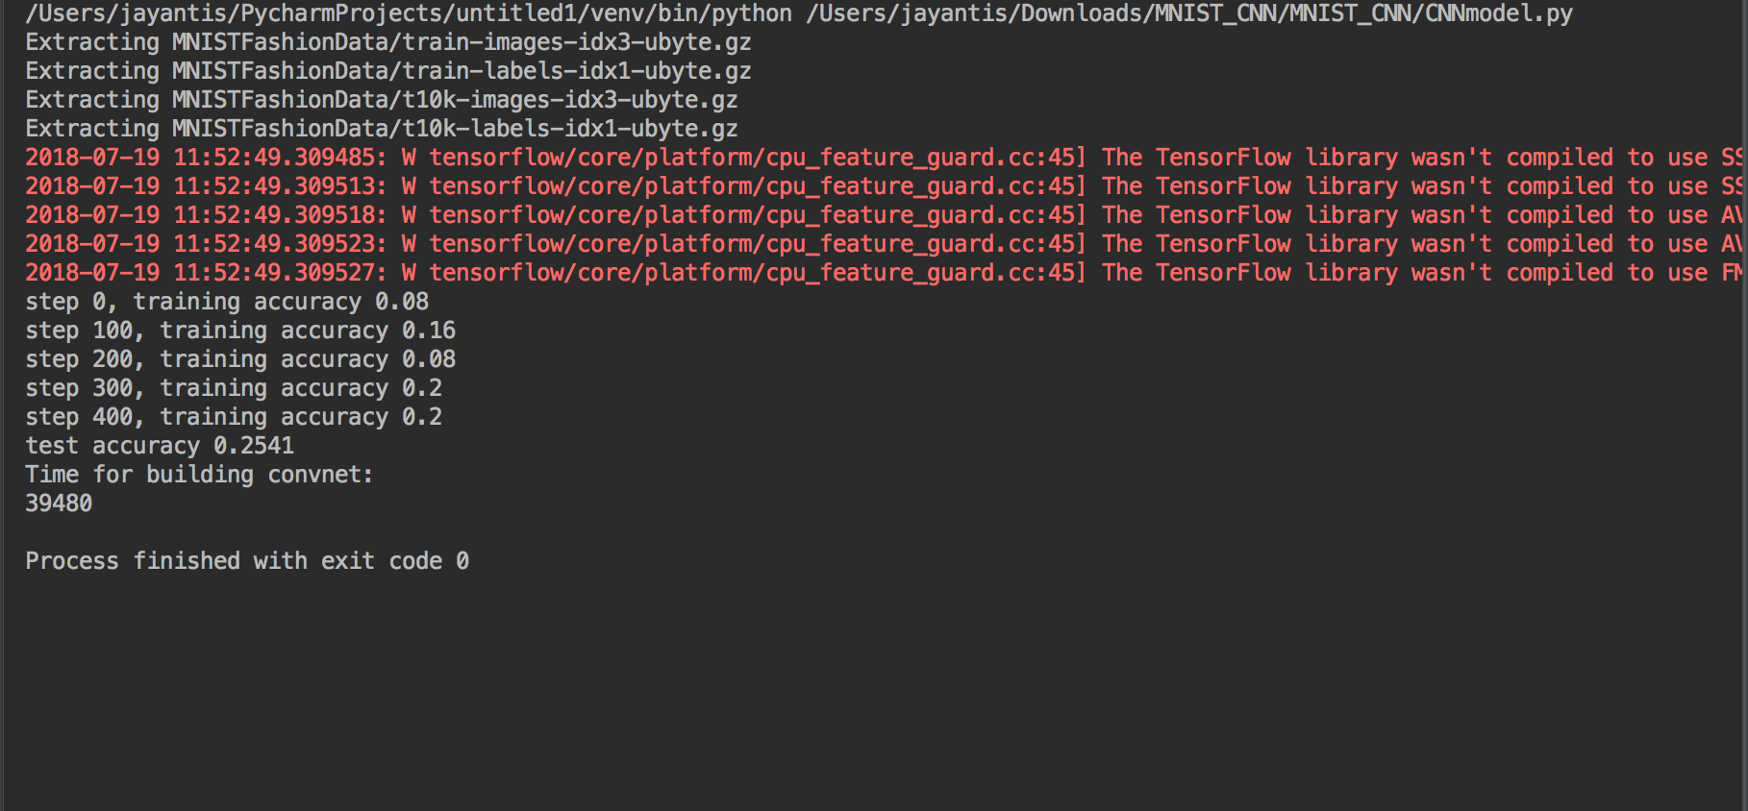

CNN Model on MNIST Data

Optimizer: GradientDescent

Filter size:16,36

Final layer: 128

Accuracy: 0.1465

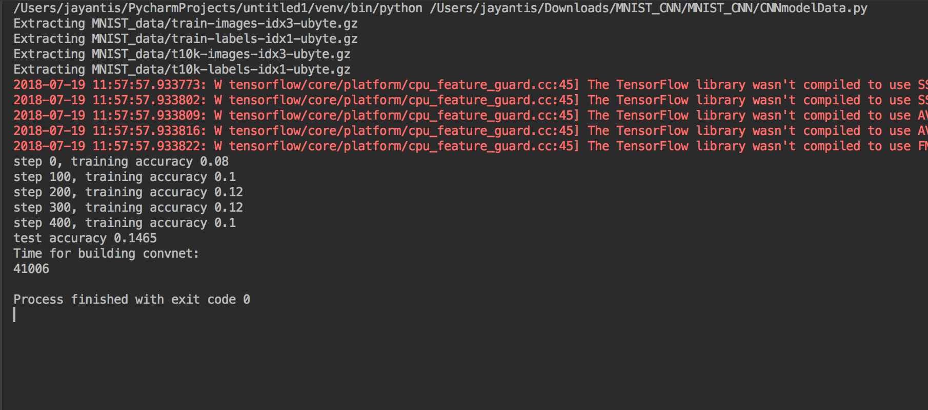

CNN Model on MNIST Fashion Data:

Optimizer: Adam

Filter size:32,64

Final layer:1024

Accuracy: 0.9505

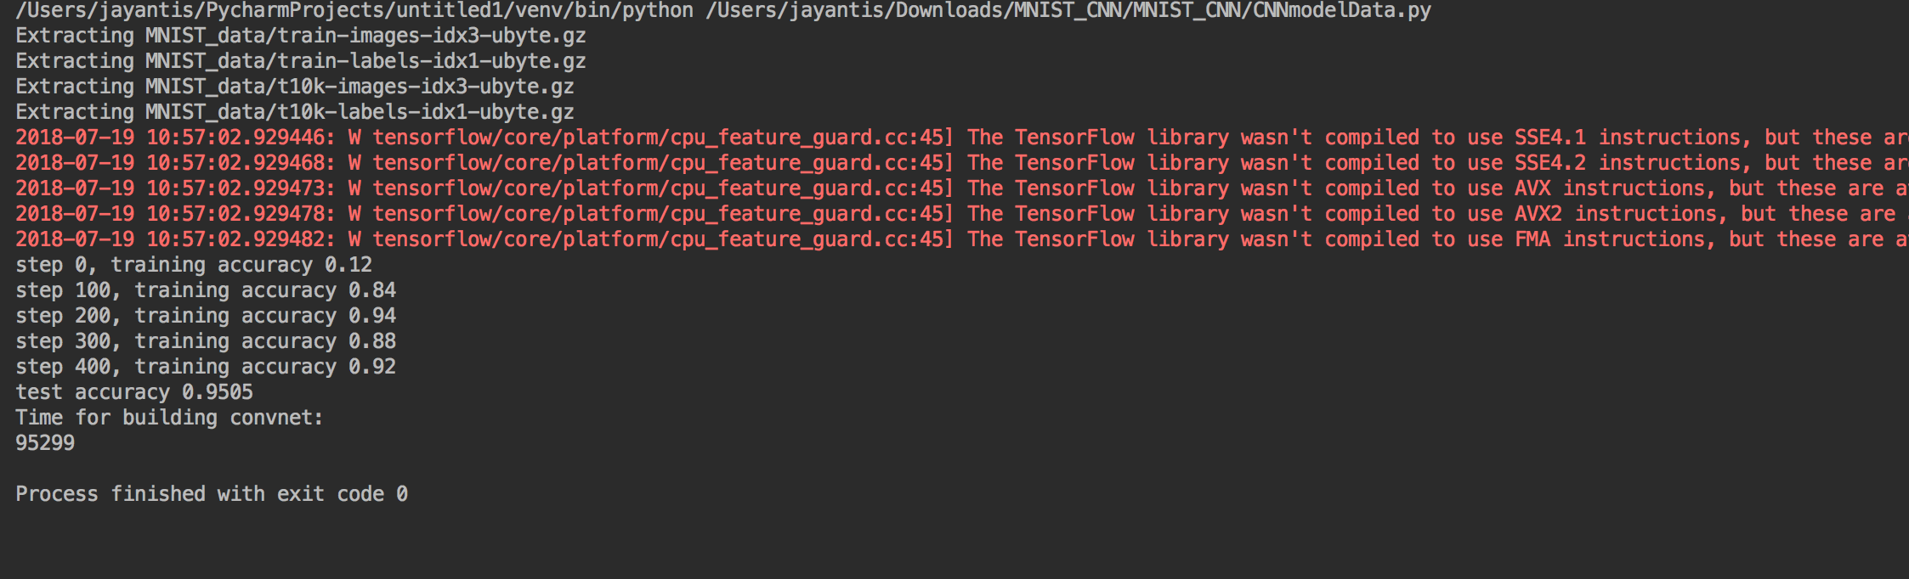

CNN Model on MNIST Fashion Data

Optimizer: Adagrad

filter size: 16,36

final layer:128

Accuracy: 0.2349

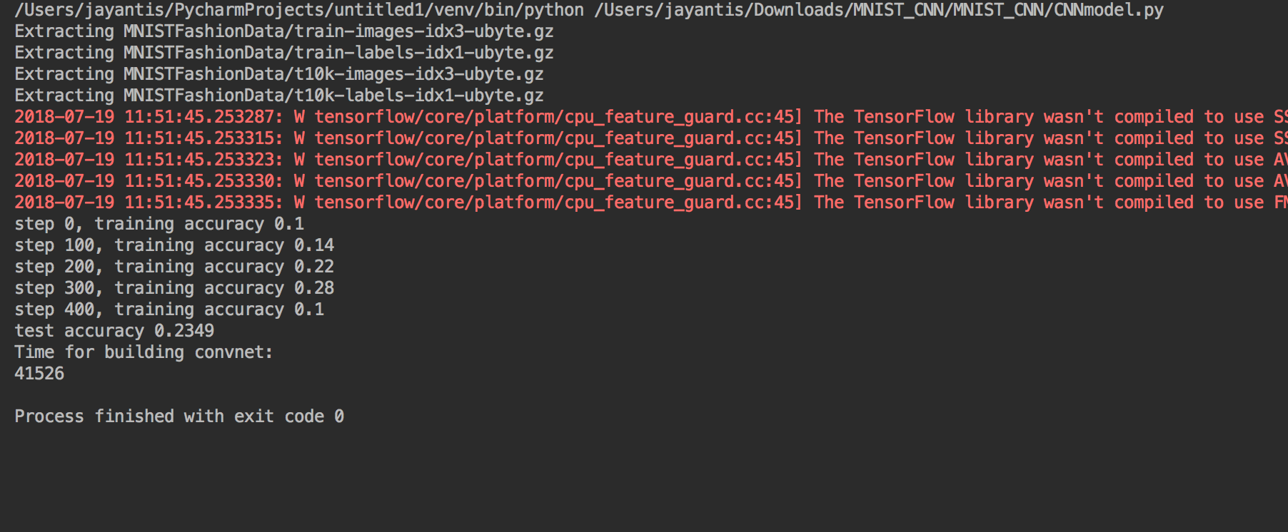

CNN Model on MNIST Fashion Data

Optimizer: GradientDescentOptimizer

filter size: 16,36

final layer:128

Accuracy: 0.1855

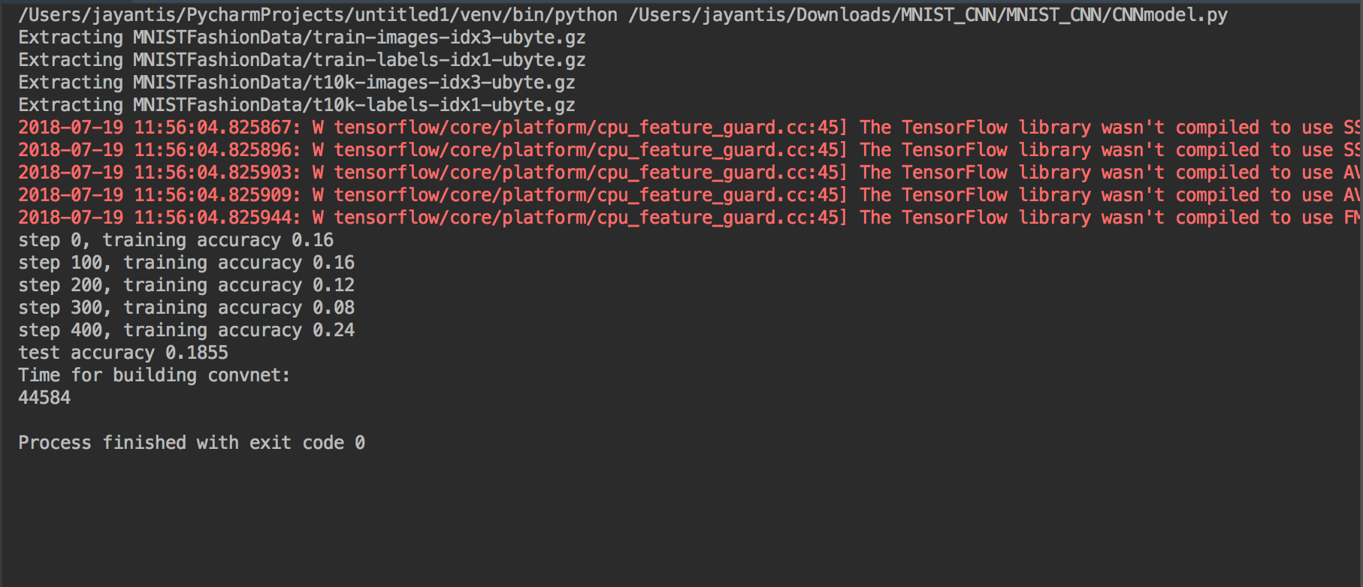

TensorBoard:

