.1
élQm
UNWINDI YOUR WAY
Welcome to Élam; A serene escape from the daily hustle and bustle, into a scented sanctuary perched 1640 meters above sea level. Located on the Letchmi Estate of Munnar, it offers an unparalleled view of the majestic Western Ghats. Nestled amidst 16 acres of cardamom and coffee plantations, Élam is a luxurious haven designed to immerse you in nature's tranquility
At Élam, you'll discover the keys to our three exquisitely designed premium cottages, each meticulously crafted to envelop you in supreme comfort and luxury
Experience minimalist elegance in our Glass Haven. This contemporary haven features clean lines, expansive glass windows, abundant natural light, and breathtaking views of the surrounding landscape.
Discover our Pyramid Retreat, a modern architectural marvel seamlessly blending with nature and offering panoramic views of the stunning landscape.
Here at Élam, we believe that true luxury is rooted in experiencing nature in its purest form. During construction, we meticulously planned each step to minimize impact, preserving the natural habitats around us. This dedication inspires us as we look to the future, committed to protecting this pristine environment. With a strong focus on sustainability, we aim to minimize our carbon footprint by reducing the use of plastic and paper, while opting for biodegradable products.
Delve into the untouched beauty of Munnar, with our soulful treks, and winding drives through the lush tea estates.
Come - Unwind Your Way at Élam!

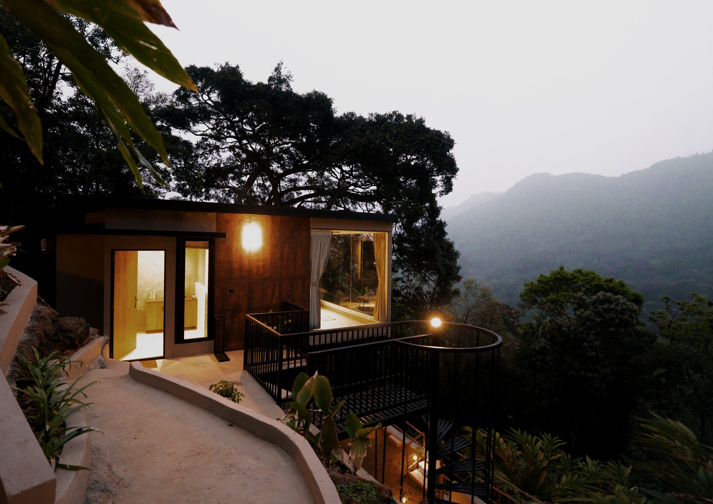
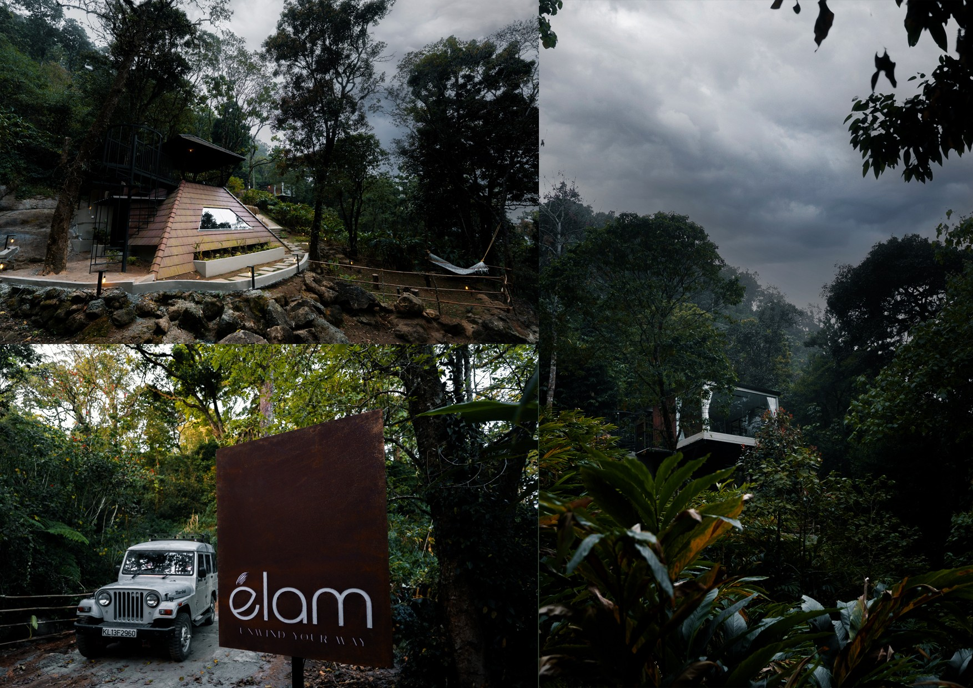
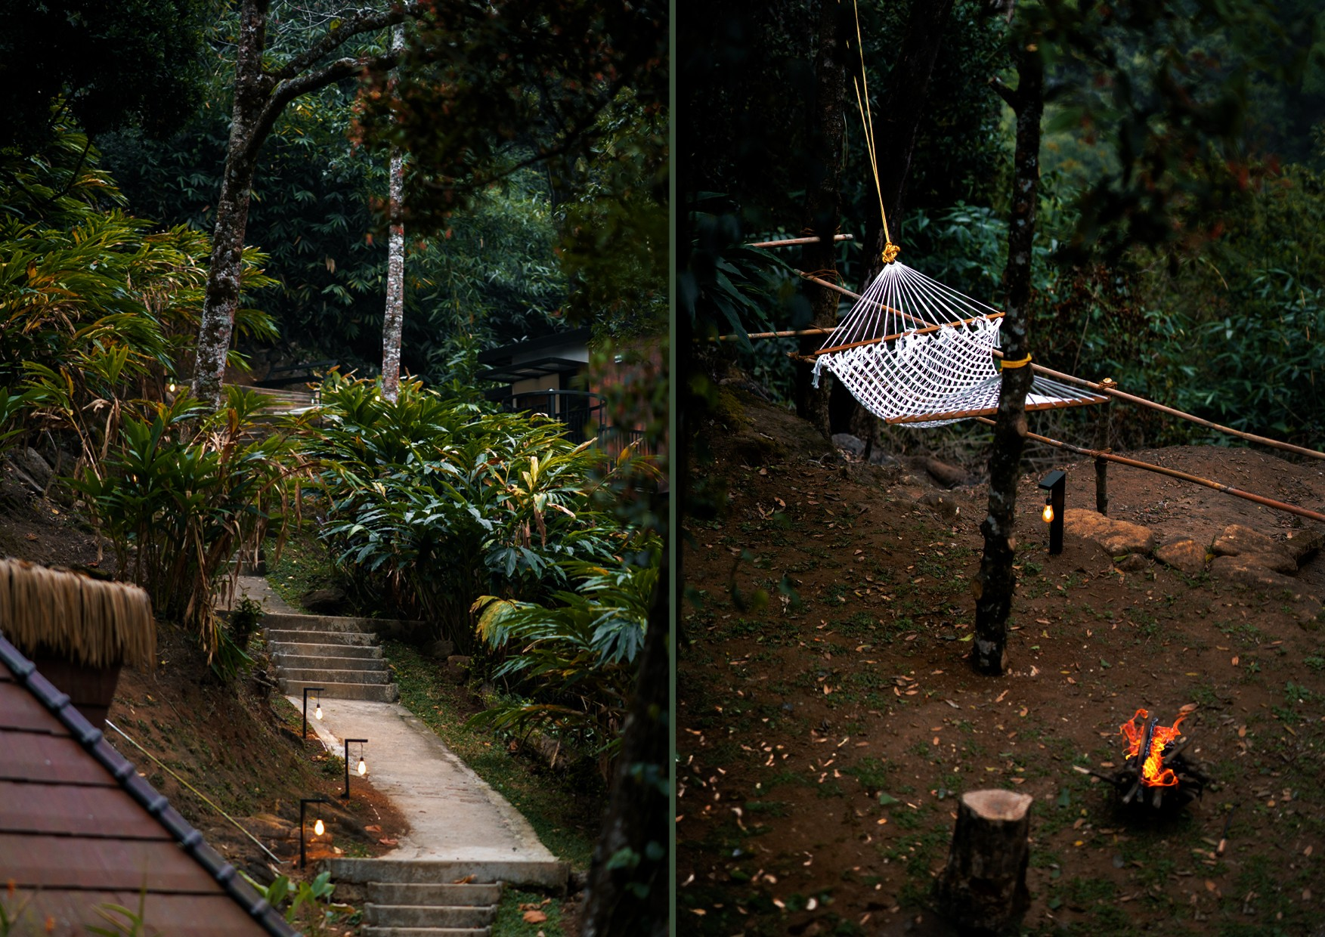
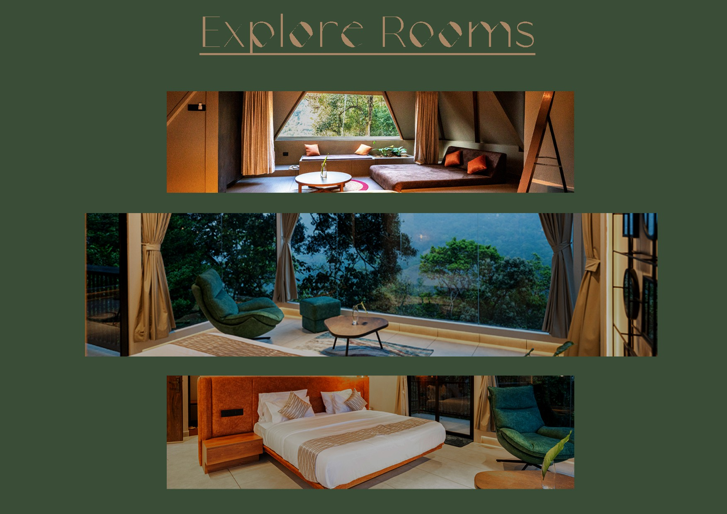

At Élam, experience refined simplicity in our stunning Glass Cabin, where modern design meets nature's grandeur. This contemporary sanctuary showcases clean architectural lines and floor to ceiling glass walls that dissolve the boundary between indoors and out. Sunlight floods every corner throughout the day, creating an ever changing play of light and shadow.

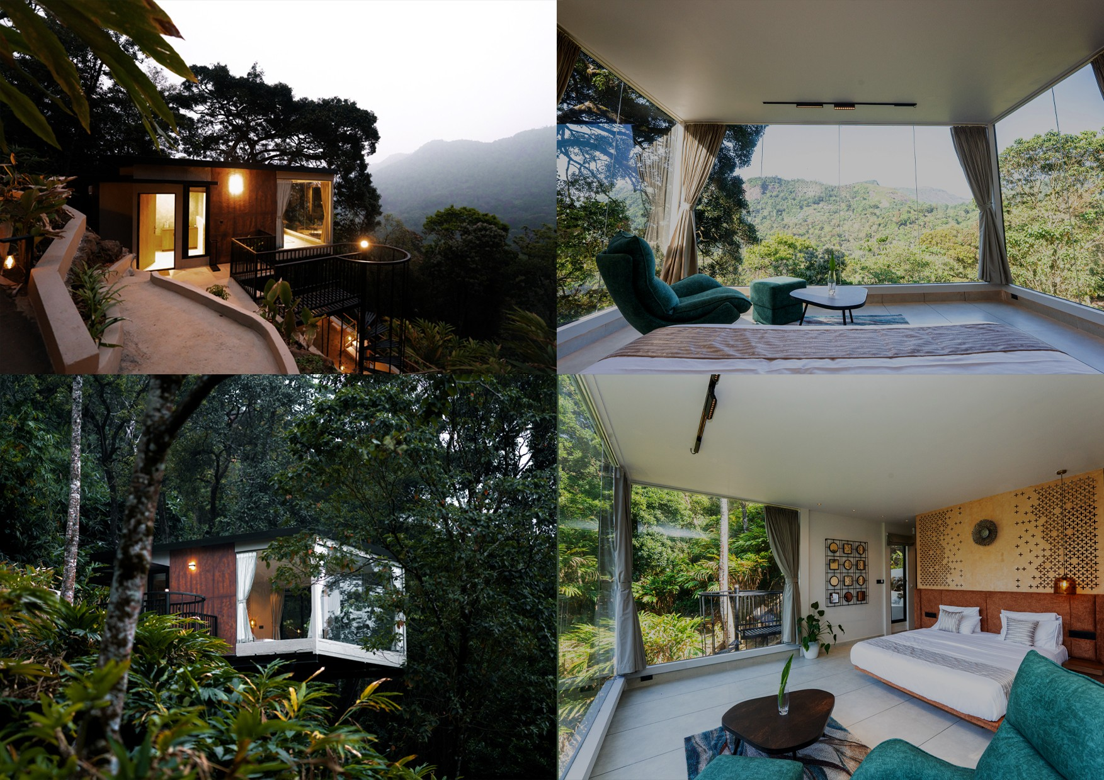
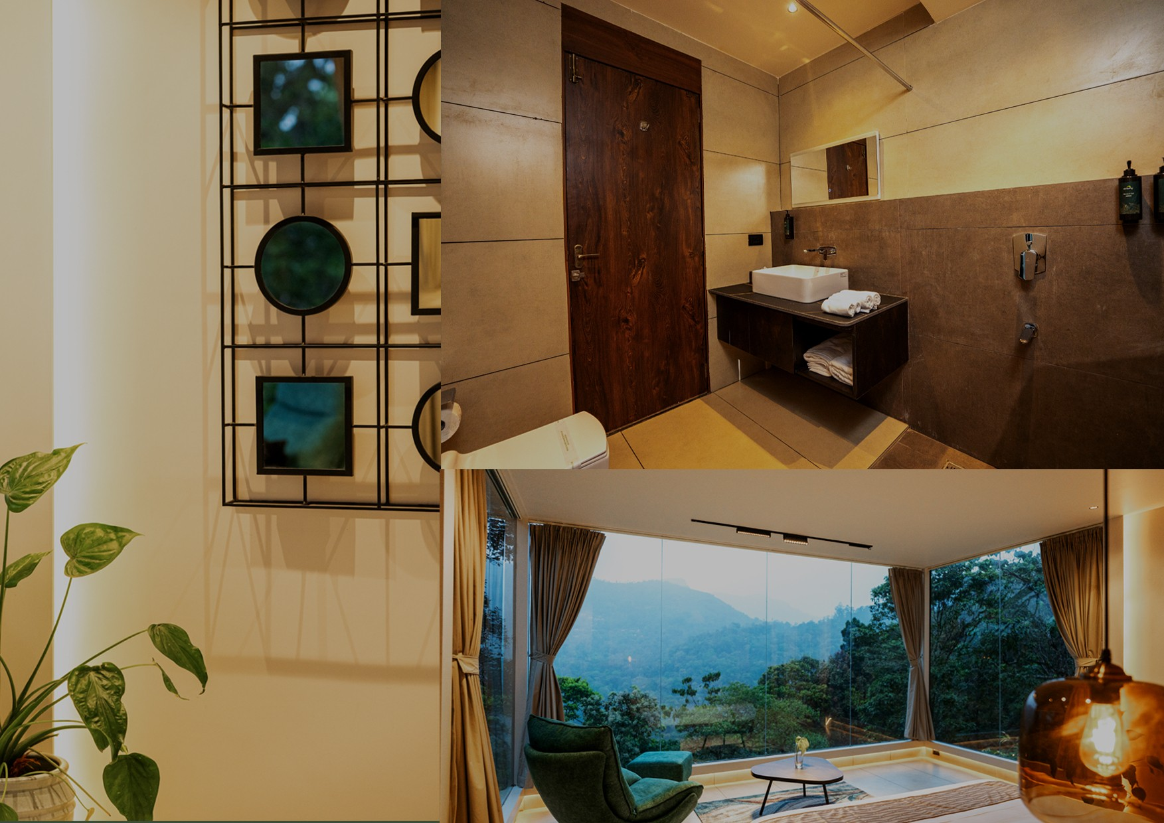

Discover our Pyramid Retreat, a modern architectural marvel seamlessly blending with nature and offering panoramic views of the stunning landscape. More than accommodation, the Pyramid Retreat provides a transformative environment for rest, reflection, and rejuvenation. The unique architecture creates spaces that feel both expansive and intimately sheltered, while the constant presence of the natural world through every window serves as a gentle reminder to slow down, breathe deeply, and rediscover what matters most.

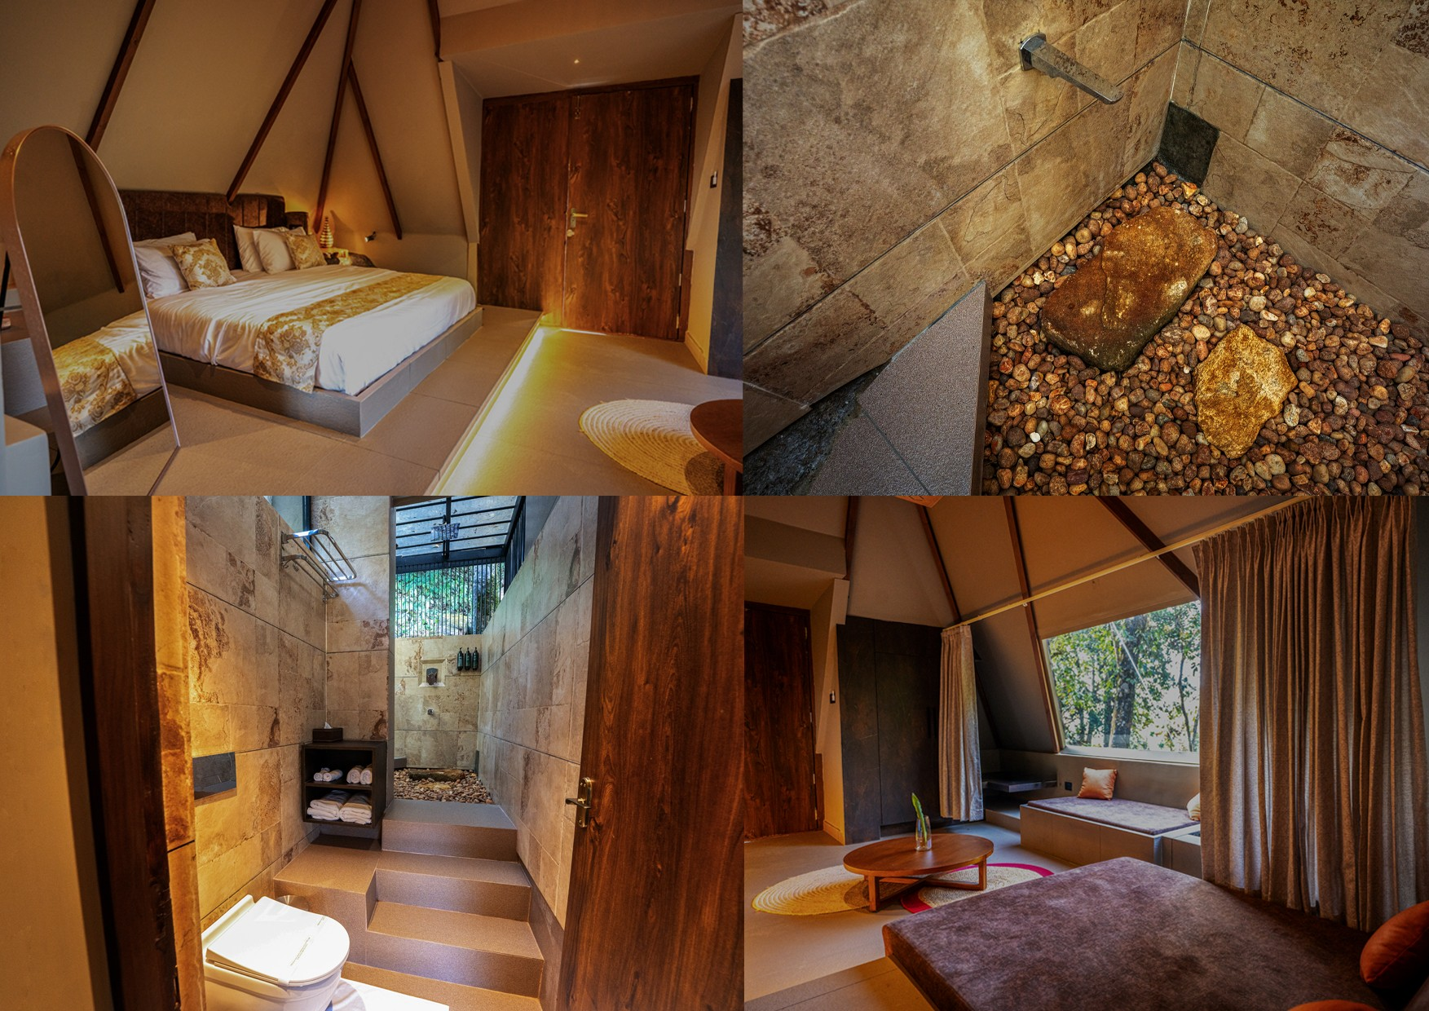

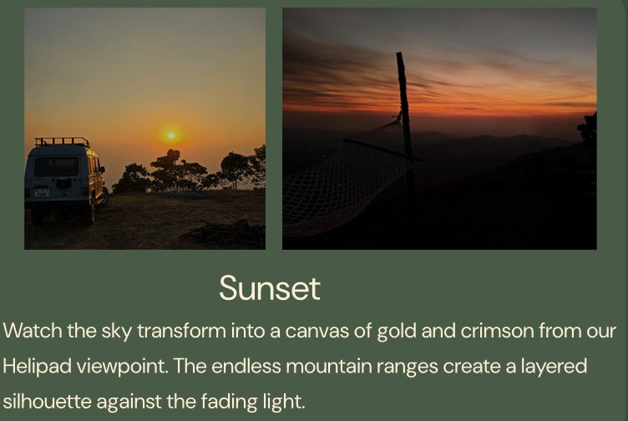
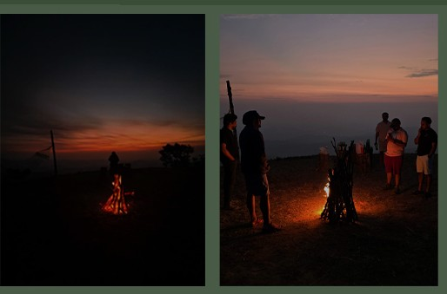
Campfire
Gather around crackling flames as stories and laughter fill the crisp mountain air. The warmth of the fire complements the coolness of the forest night

Stargazing
Far from city lights, our skies reveal constellations in breathtaking
clarity. The Milky Way stretches overhead like a celestial river.
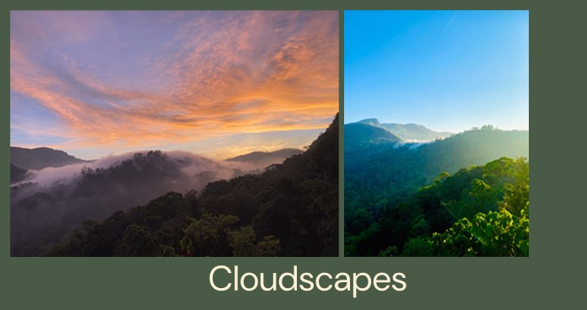
Watch valleys disappear beneath a mystical sea of white clouds. The morning mist transforms familiar landscapes into dreamlike panoramas.

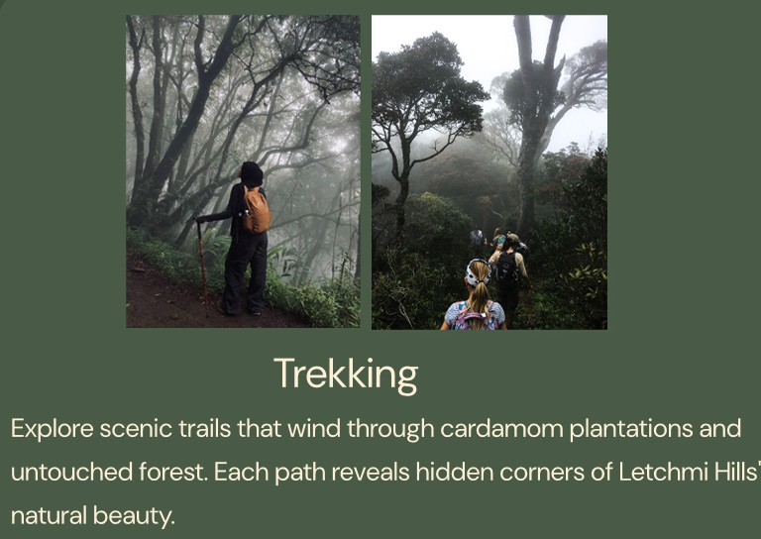
Offroading
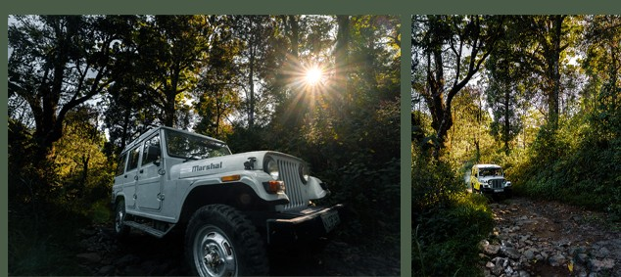
Your journey to Élam is an adventure through rugged plantation roads. The bumpy ride through coffee estates sets the tone for exploration.

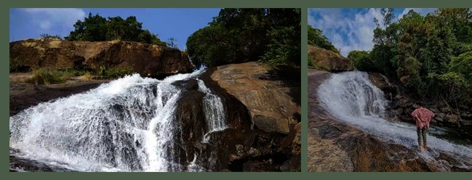
Waterfalls
natural
Viriparai waterfalls cascade down rocky cliffs just a short drive away. The thundering water and cool mist offer refreshing escape. habitat


www.elammunnar.com
8

