
ARCHITECTURE DESIGN ANALYSIS REPORT
AI-Driven Construction Site Safety Monitoring Platform

CSA1012 — SOFTWARE ENGINEERING

towards the award of the degree of

BACHELOR OF TECHNOLOGY
IN
COMPUTER SCIENCE (AI)

Submitted by

K.P. SREENATH REDDY (192373049)

Under the Supervision of

DR ANITADAVAMANI K
SIMATS ENGINEERING
Saveetha Institute of Medical and Technical Sciences
Chennai — 602105
Aug 2026

0. Problem Statement Overview
Construction sites are among the most hazardous industrial environments, with accidents commonly caused by unsafe practices, inadequate supervision, equipment failures, and non-compliance with safety regulations. Traditional manual inspections are slow, periodic, and unable to detect hazards as they occur. This report presents an Architecture Design Analysis for an AI-Driven Construction Site Safety Monitoring Platform that uses IoT devices, computer vision, wearable sensors, and artificial intelligence to continuously monitor workers, equipment, hazardous zones, and environmental conditions, in order to detect unsafe activity, predict accident risk, alert supervisors in real time, and maintain auditable compliance records across multiple construction projects.

Core Objectives
- Continuously monitor worker safety across active construction sites.
- Automatically detect Personal Protective Equipment (PPE) violations.
- Track and enforce hazardous zone boundaries in real time.
- Predict accident risk using historical and real-time data.
- Monitor heavy equipment movement to prevent collisions.
- Notify supervisors immediately upon detecting unsafe conditions.
- Generate automated safety compliance reports for audits and regulators.
- Support multiple, geographically distributed construction projects on one secure, scalable platform.

1. System Requirements Analysis

1.1 System Objectives
The primary objective of the platform is to shift construction safety management from reactive, manual inspection to continuous, proactive, AI-assisted monitoring. The system must ingest heterogeneous real-time data streams (video, sensor telemetry, location, and environmental readings), apply computer vision and machine learning models to detect unsafe conditions, and close the loop by alerting the right people fast enough to prevent an incident — while also building a durable, auditable record for compliance reporting and continuous improvement.

1.2 Functional Requirements
ID | Functional Requirement
FR-1 | Ingest live video streams from fixed CCTV cameras and drones across multiple sites.
FR-2 | Detect PPE compliance (helmets, vests, harnesses, gloves, boots) using computer vision.
FR-3 | Track worker and equipment location via wearables, RFID/BLE tags, and GPS.
FR-4 | Define and monitor geofenced hazardous zones; detect unauthorized entry.
FR-5 | Collect environmental sensor data (gas leaks, noise, temperature, vibration) and flag threshold breaches.
FR-6 | Run predictive analytics to estimate accident risk from combined historical and live data.
FR-7 | Monitor heavy equipment movement and proximity to workers to prevent collisions.
FR-8 | Send real-time alerts to supervisors via dashboard, mobile push, SMS, and on-site alarms.
FR-9 | Generate scheduled and on-demand safety compliance reports per project and per regulation.
FR-10 | Maintain a historical, queryable archive of safety events, video evidence, and incidents.
FR-11 | Support role-based access for supervisors, safety officers, workers, admins, and auditors.
FR-12 | Provide integration APIs for ERP, HRMS, insurance, and regulatory reporting systems.
FR-13 | Support onboarding and configuration of multiple, independent construction projects/sites.

1.3 Non-Functional Requirements
ID | Non-Functional Requirement
NFR-1 | Detect and alert on critical hazards (e.g., zone intrusion, missing PPE near danger) within seconds of occurrence.
NFR-2 | Scale horizontally to support many concurrent projects, thousands of devices, and dozens of simultaneous video feeds.
NFR-3 | Maintain high availability (target 99.9%) during active work shifts, including partial-network-outage tolerance at the edge.
NFR-4 | Encrypt data in transit and at rest; enforce strict access control over worker and video data (privacy-by-design).
NFR-5 | Be maintainable — allow AI models and business rules to be updated/replaced without full system downtime.
NFR-6 | Provide auditability — tamper-evident logs of alerts, overrides, and report generation for regulatory review.
NFR-7 | Be interoperable with third-party enterprise and regulatory systems via well-defined APIs.
NFR-8 | Be usable by non-technical field staff on mobile devices, including low-connectivity environments.

1.4 Key Quality Attributes
The following quality attributes are the primary drivers of the architectural decisions made in this report, since the platform is a life-safety system operating across distributed, resource-constrained construction sites.
Quality Attribute | Relevance to the Platform
Scalability | Must support multiple concurrent construction projects, thousands of IoT devices, and continuous video streams without degradation.
Reliability | Safety alerts must be generated correctly and consistently; missed detections can directly endanger human life.
Availability | The platform must operate 24/7 across active work shifts, including night shifts and remote sites with intermittent connectivity.
Performance | Real-time video and sensor analysis requires low-latency inference (near real-time hazard detection, sub-second alerting).
Security | Worker biometric/location data, video footage, and compliance records are sensitive and must be protected from breach or tampering.
Maintainability | AI models, regulations, and site configurations change frequently; components must be independently updatable.
Interoperability | Must integrate with ERP, HRMS, insurance, and regulatory reporting systems across different construction companies.
Usability | Supervisors and workers with varying technical literacy must be able to use dashboards and mobile alerts effectively.

2. Selection of Software Architecture

2.1 Selected Architectural Style
A Hybrid Architecture is selected, combining three complementary styles applied at different tiers of the system:
- Edge Computing at the Field Layer — lightweight AI inference and data pre-processing run on-site, close to cameras and sensors, before data ever leaves the construction site.
- Event-Driven Microservices at the Processing/Application Layer — independent services (PPE detection, hazard-zone monitoring, risk prediction, equipment monitoring, notifications, reporting) communicate asynchronously through an event bus/message broker.
- Layered (N-tier) Architecture for overall system organization — Field, Ingestion, Processing, Data, and Presentation layers are cleanly separated, each with well-defined interfaces.

2.2 Justification
A pure monolithic or classic three-tier client-server architecture is insufficient for this problem because the platform must process multiple concurrent, high-volume real-time data streams (video, telemetry, sensor data) from geographically distributed sites, run several independent AI models, and remain responsive even when network connectivity to a central data center is degraded. The hybrid approach was chosen for the following reasons:
- Real-time responsiveness: Edge inference allows PPE and hazard detection to happen within milliseconds on-site, rather than waiting on a round trip to the cloud — critical when seconds matter for worker safety.
- Independent scalability: Each AI capability (PPE detection, risk prediction, equipment monitoring) has different computational demands and can be scaled independently as a microservice, rather than scaling an entire monolith.
- Fault isolation: If one detection service fails or is being updated, other safety-critical services (e.g., hazard-zone monitoring) continue operating uninterrupted.
- Loose coupling via events: An event-driven backbone (Kafka/MQTT) decouples data producers (sensors, cameras) from consumers (AI services, dashboards), allowing new analytics services to be added later without redesigning existing components.
- Multi-project/multi-tenancy support: The layered separation of concerns allows the Data and Presentation layers to cleanly support many independent construction projects on shared, centrally managed infrastructure.
- Resilience to connectivity loss: Since construction sites often have unreliable networks, edge buffering and local inference ensure the system keeps detecting critical hazards even during temporary disconnection from the cloud.
Alternative styles were considered and rejected as the primary style (though elements of each are still used): a pure Client-Server model does not scale well to many simultaneous video/sensor streams and creates a single point of congestion; a pure Serverless model is attractive for reporting and analytics workloads but is not well suited to continuous, stateful video-stream processing; and a pure monolithic layered system would not allow independent scaling or fault isolation of AI components, which is unacceptable in a life-safety system.

3. Software Architecture Diagram
The diagram below illustrates the complete system structure: the Field/Edge Layer capturing raw data on-site, the Ingestion & Messaging Layer streaming data to the backend, the AI & Processing microservices analyzing that data, cross-cutting Identity/Security services, the polyglot Data Layer persisting information, and the Presentation Layer delivering insights and alerts to end users.
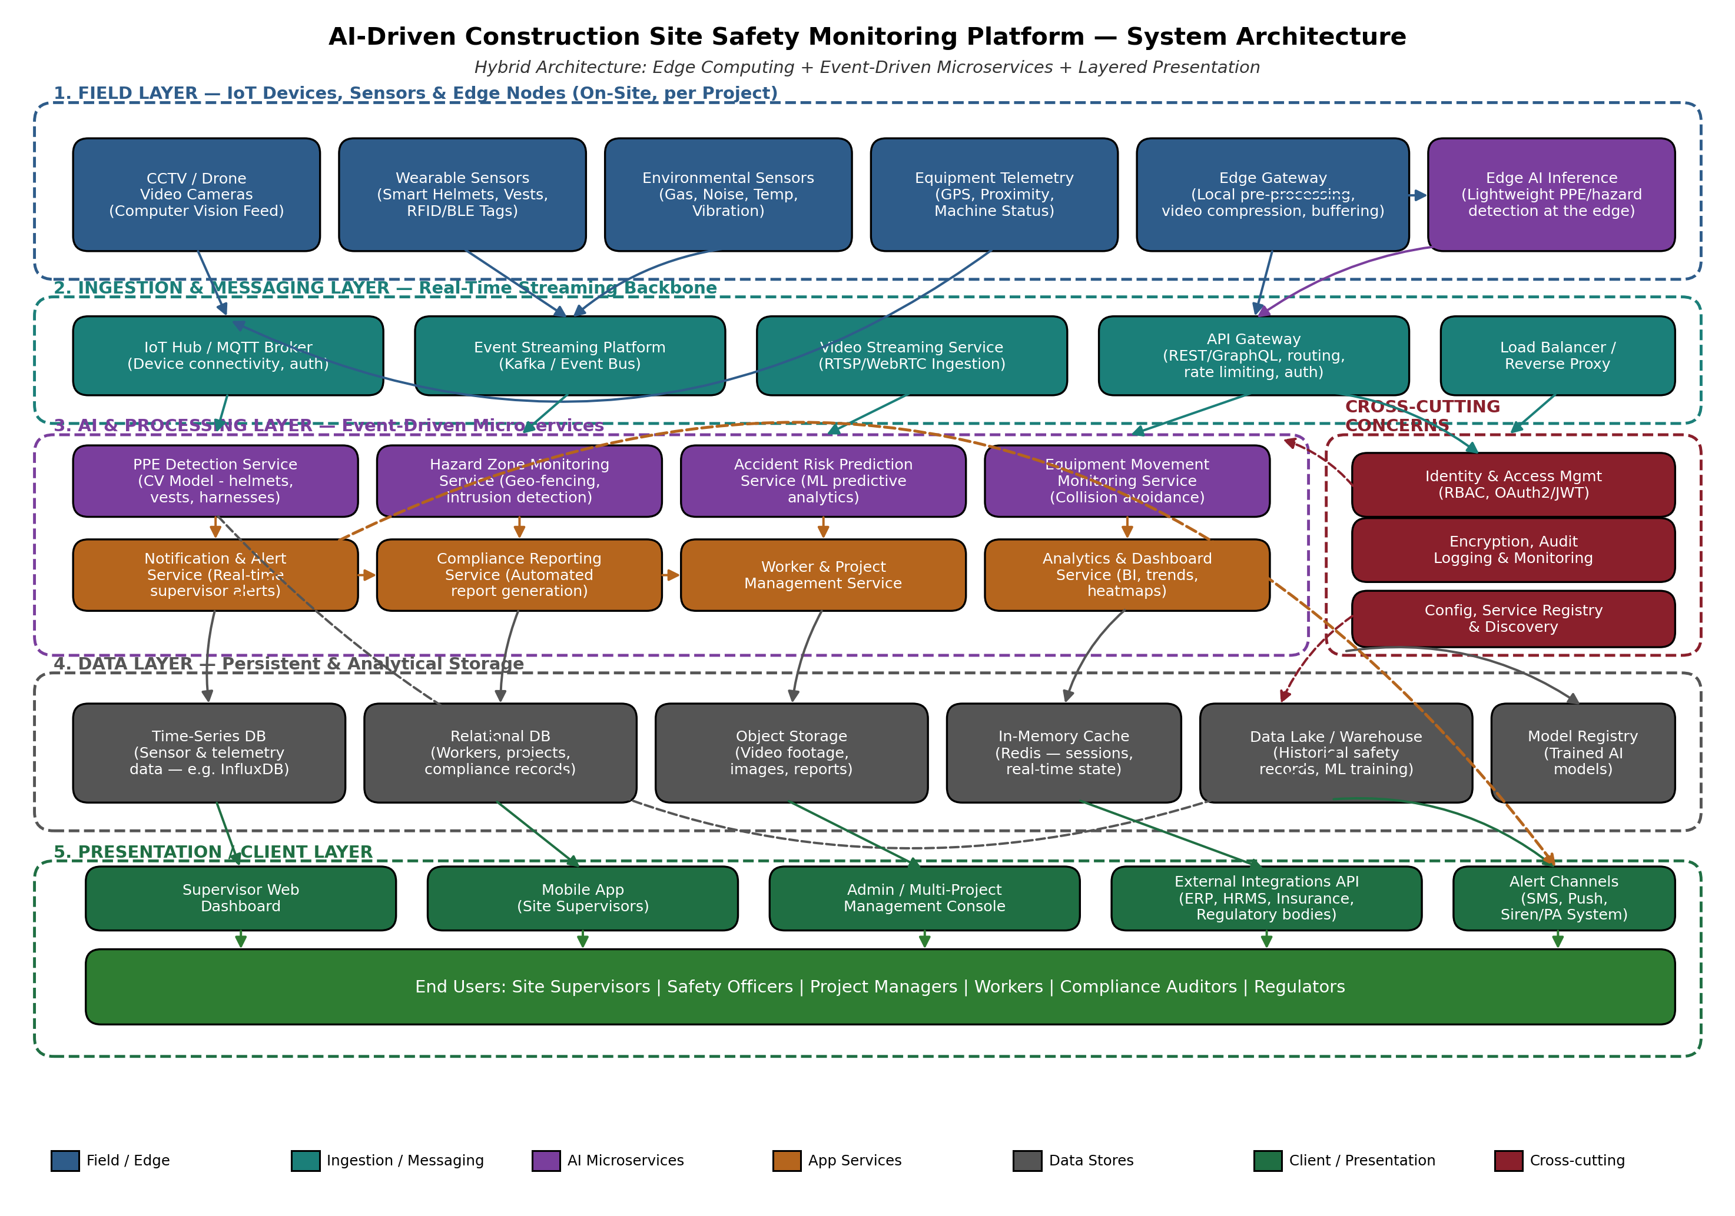
Notation: solid arrows represent primary, high-frequency data/control flow; dashed arrows represent supporting or lower-frequency flows (e.g., security enforcement calls, archival writes, and direct alert delivery). Colour groups correspond to architectural layers/concerns as shown in the legend beneath the diagram.

4. Components and Their Interactions

4.1 Component Responsibilities
Component | Responsibility | Key Technology Examples
Field / Edge Layer | Captures raw video, sensor, wearable, and equipment telemetry data on-site; performs lightweight pre-processing and local inference to cut bandwidth and latency. | IP/CCTV cameras, drones, BLE/RFID tags, smart PPE, environmental sensors, edge AI accelerators (e.g., Jetson-class devices)
Ingestion & Messaging Layer | Provides reliable, decoupled transport of high-volume events and video from the field to backend services; handles authentication of devices. | MQTT broker, Kafka/event bus, RTSP/WebRTC media servers, API Gateway, load balancer
AI & Processing Microservices | Independently deployable services that analyze data: PPE detection, hazard-zone intrusion, accident-risk prediction, and equipment-collision monitoring. | Computer vision models (CNN/YOLO-class), ML risk-prediction models, geofencing engine, container orchestration (Kubernetes)
Application Services | Business-logic services that consume AI outputs to notify supervisors, manage compliance reports, manage worker/project data, and power analytics dashboards. | Notification service (push/SMS/siren), reporting engine, project/worker management service, analytics/BI service
Cross-Cutting Services | Centralized identity, access control, encryption, audit logging, monitoring, and service configuration shared by all microservices. | OAuth2/JWT, RBAC, TLS, centralized logging (ELK), service registry (Consul/Eureka)
Data Layer | Persists structured, time-series, and unstructured data; supports both operational queries and long-term analytics/ML training. | Time-series DB (InfluxDB/TimescaleDB), relational DB (PostgreSQL), object storage (S3-class), Redis cache, data lake/warehouse
Presentation / Client Layer | Delivers dashboards, mobile alerts, and administrative tools to end users; exposes integration APIs to external systems. | Web dashboard (React), mobile app (iOS/Android), admin console, external integration REST APIs

4.2 Communication Mechanisms
- Field devices publish data to the Ingestion Layer using lightweight IoT protocols (MQTT) for sensor/telemetry data and streaming protocols (RTSP/WebRTC) for video.
- The Event Streaming Platform (Kafka-class event bus) distributes events to all interested microservices using a publish/subscribe pattern, decoupling producers from consumers.
- Client applications (web dashboard, mobile app, admin console) and external systems communicate with backend services through a single API Gateway using REST/GraphQL over HTTPS, which handles authentication, routing, and rate limiting.
- Microservices communicate with each other primarily through asynchronous events for detection results and notifications, and through synchronous REST/gRPC calls for direct queries (e.g., dashboard requesting current compliance status).
- All inter-service and client-service communication is authenticated and authorized via the centralized Identity & Access Management service using OAuth2/JWT tokens, with role-based access control (RBAC).

4.3 Overall System Workflow
- A camera, wearable sensor, or environmental sensor on-site continuously captures data (video frames, location, gas/noise/temperature readings).
- The Edge Gateway pre-processes and, where possible, runs lightweight Edge AI inference (e.g., a quick PPE check) locally to minimize latency and bandwidth use.
- Pre-processed data and video streams are published to the Ingestion & Messaging Layer (MQTT broker, event bus, and video streaming service).
- Relevant AI microservices subscribe to these events: the PPE Detection Service analyses video for missing protective equipment, the Hazard Zone Monitoring Service checks worker/equipment position against geofences, the Equipment Movement Monitoring Service checks for collision risk, and the Accident Risk Prediction Service combines live and historical data to compute a risk score.
- When a violation, intrusion, or high-risk condition is detected, the responsible service emits an alert event.
- The Notification & Alert Service consumes this event and immediately notifies the relevant supervisor(s) through the dashboard, mobile push notification, SMS, or an on-site siren/PA system, depending on severity.
- All detections, sensor readings, and alerts are persisted to the appropriate data store (time-series DB for telemetry, object storage for video clips, relational DB for structured records) and simultaneously streamed to the Data Lake/Warehouse for historical analysis and future AI model retraining.
- The Compliance Reporting Service periodically (and on demand) aggregates this data into safety compliance reports for supervisors, project managers, and regulators.
- The Analytics & Dashboard Service provides supervisors and administrators with real-time visibility (heatmaps, trends, active alerts) across one or many construction projects.

5. Discussion of Quality Attributes

5.1 Scalability
The event-driven microservices design allows each AI service to be scaled horizontally and independently — for example, adding more PPE Detection Service instances during peak daylight hours without scaling the entire system. The API Gateway and load balancer distribute client and device traffic across service replicas, and the message broker/event bus absorbs bursts in sensor and video traffic, preventing overload. New construction projects can be onboarded simply by registering new edge gateways and provisioning additional consumer instances, without redesigning the architecture.

5.2 Security
Security is addressed as a cross-cutting concern rather than being bolted onto individual services. All external access passes through the API Gateway, which enforces authentication (OAuth2/JWT) and role-based access control, ensuring workers, supervisors, and auditors see only the data appropriate to their role. Data is encrypted in transit (TLS) and at rest, video footage and personal location data are treated as sensitive, and all administrative actions and alert overrides are captured in tamper-evident audit logs to support regulatory investigations.

5.3 Performance
Edge inference minimizes round-trip latency for time-critical detections (e.g., a worker entering a crane's swing radius), by analyzing data close to its source rather than sending everything to a distant data center first. The event-driven backbone supports near real-time processing of high-throughput video and sensor streams, while the in-memory cache (Redis) serves frequently accessed state (such as current zone occupancy) with very low latency for dashboards and alerting logic.

5.4 Reliability
Because detection responsibilities are split across independent microservices, a fault or crash in one service (e.g., the Accident Risk Prediction Service) does not stop other safety-critical detections (e.g., PPE or hazard-zone monitoring) from continuing to operate. The message broker persists events until they are successfully processed, so transient service failures do not silently lose safety-critical data. Edge gateways buffer data locally during connectivity loss and forward it once the connection is restored, preventing data loss during network interruptions.

5.5 Maintainability
The clean separation into layers and independently deployable microservices means AI models can be retrained and redeployed, new sensor types can be integrated, and business rules (e.g., new PPE requirements) can be updated in one service without redeploying the entire platform. A centralized service registry and configuration service further simplify making changes safely, since each service can be independently versioned, tested, and rolled out.

5.6 Availability
High availability is achieved through redundancy at multiple points: load-balanced API Gateway instances, replicated microservice instances behind the event bus, and a distributed data layer with replication for critical stores. Edge devices maintain local buffering and lightweight local inference so that essential PPE and hazard-zone detection continue functioning even during a temporary loss of connectivity to the central platform, which is essential given the intermittent network conditions common on construction sites.

6. Justification of Architectural Decisions

6.1 Rationale Summary
Every major architectural decision in this design traces back to the life-safety nature of the problem and the distributed, multi-project operating environment of construction companies. Edge computing was chosen specifically because detection latency directly correlates with the ability to prevent an accident rather than merely record it after the fact. Event-driven microservices were chosen because the platform's monitoring capabilities (PPE, hazard zones, equipment, risk prediction) are logically independent, evolve at different rates, and must not fail together. The layered organization keeps the system comprehensible and testable as it grows, and centralizing identity, security, and configuration avoids inconsistent enforcement of critical safety and privacy policies across services.

6.2 Trade-offs Considered
Decision | Benefit Gained | Trade-off Accepted
Edge AI pre-processing instead of sending all raw video to the cloud | Lower bandwidth cost, reduced latency, works during connectivity drops | Increased cost/complexity of on-site hardware; edge models must be kept in sync with cloud models
Microservices instead of a single monolith for AI/processing | Independent scaling and deployment of each detection capability; fault isolation | Higher operational complexity (orchestration, service discovery, distributed tracing)
Event-driven messaging (Kafka/MQTT) instead of direct synchronous calls | Loose coupling, buffering during traffic spikes, easy addition of new consumers | Eventual consistency; requires careful monitoring of consumer lag
Polyglot data storage (time-series + relational + object + lake) | Each data type stored in the most efficient, purpose-built store | More operational overhead than a single database; requires data governance discipline
Centralized API Gateway and IAM | Consistent security enforcement and simplified client integration | Gateway can become a bottleneck/single point of failure if not itself made highly available

6.3 Support for Future Enhancements and Long-Term Maintainability
The chosen hybrid architecture is well positioned for future growth in several ways:
- New AI capabilities (e.g., fatigue detection, fire/smoke detection, fall detection) can be added as new microservices that simply subscribe to existing video/sensor event streams, with no change to existing services.
- New construction projects and additional edge sites can be onboarded by provisioning new edge gateways and registering them with the existing ingestion layer, supporting large-scale, multi-project growth as outlined in the expected outcomes.
- The data lake and model registry support continuous improvement of AI models over time (retraining on newly collected historical incident data), directly supporting the objective of predicting accident risk more accurately.
- Well-defined external integration APIs mean the platform can integrate with additional ERP, HRMS, insurance, or government regulatory systems as compliance requirements evolve, without re-architecting the core platform.
- Because concerns are cleanly separated, the system can migrate individual components to new technologies (e.g., a newer computer-vision model framework) independently, extending the platform's useful lifetime and reducing long-term technical debt.

7. Conclusion
The proposed hybrid architecture — combining edge computing, event-driven microservices, and a layered system organization — directly addresses the functional requirements (continuous multi-modal monitoring, PPE detection, hazard-zone tracking, risk prediction, equipment monitoring, alerting, and reporting) and the non-functional requirements (scalability, reliability, availability, performance, security, and maintainability) demanded by a life-safety platform operating across multiple, often connectivity-constrained construction sites. By detecting and responding to unsafe conditions in near real time, while maintaining a secure and auditable historical record, the platform directly supports the stated goals of reducing workplace accidents, improving regulatory compliance, lowering insurance costs, and enabling proactive, transparent, large-scale safety management across the construction industry.

