

AI-Driven Construction Site Safety
Monitoring Platform
Version Control (Git) and Containerization (Docker) Implementation

CSA1012 — SOFTWARE ENGINEERING

towards the award of the degree of

BACHELOR OF TECHNOLOGY
IN
COMPUTER SCIENCE (AI)

Submitted by

K.P. SREENATH REDDY (192373049)

Under the Supervision of

DR ANITADAVAMANI K
SIMATS ENGINEERING
Saveetha Institute of Medical and Technical Sciences
Chennai — 602105
Aug 2026

1. Problem Analysis

1.1 Problem Statement
Construction sites are among the most hazardous occupational environments due to unsafe worker practices, inadequate real-time supervision, frequent equipment failures, and inconsistent compliance with statutory safety regulations. Traditional safety inspection methods rely on manual, periodic checks performed by site supervisors, which are time-consuming, subjective, and inherently reactive rather than preventive — hazards are frequently identified only after an incident has already occurred.
This project addresses the above problem by designing and developing an AI-Driven Construction Site Safety Monitoring Platform. The platform continuously monitors workers, heavy equipment, hazardous zones, environmental conditions, and personal protective equipment (PPE) compliance using a combination of IoT devices, computer vision, wearable sensors, and artificial intelligence. It analyses real-time video streams, worker location data, equipment telemetry, and environmental sensor readings to detect unsafe activities, predict accident risk, notify supervisors instantly, generate compliance reports, and retain historical safety records — all while supporting multiple concurrent construction projects on a secure and scalable architecture.

1.2 Project Objectives
The platform is designed to achieve the following core objectives:
- Continuously monitor worker safety across active construction zones.
- Automatically detect PPE (helmet, vest, gloves, harness, boots) violations using computer vision.
- Track and enforce restrictions around hazardous zones (excavations, scaffolding, live electrical areas).
- Predict accident risk proactively using historical and real-time sensor data.
- Monitor heavy equipment movement to prevent worker–machinery collisions.
- Notify supervisors immediately when a violation or high-risk condition is detected.
- Generate safety compliance reports for regulatory and management review.
- Improve overall workplace safety culture through data-driven proactive intervention.

1.3 Functional Requirements
To satisfy the objectives above, the system must implement the following functional capabilities:
- Real-time video ingestion from fixed CCTV cameras and mobile/drone feeds across multiple sites.
- A computer-vision inference module capable of detecting PPE compliance, unsafe postures, and unauthorised zone entry.
- An IoT integration layer to ingest data from wearable sensors (fall detection, heart rate, location beacons) and equipment sensors (GPS, proximity, load sensors).
- An AI risk-prediction engine that correlates historical incident data with live sensor streams to generate a live risk score per zone/worker.
- A real-time alerting and notification service (push, SMS, dashboard alarms) with configurable escalation rules.
- A reporting and analytics module that produces daily/weekly compliance reports and long-term trend dashboards.
- Multi-tenant / multi-project support so the platform can be deployed across several construction sites simultaneously, each with isolated data.
- Secure data management including authentication, role-based access control (RBAC), and encrypted storage of video and personal data.
- A historical data store to retain safety records for audit, insurance, and regulatory purposes.
- A scalable microservice-based backend that can add new sites or cameras without service disruption.

1.4 Expected Outcomes
Successful implementation of the platform is expected to deliver the following measurable outcomes:
- Reduction in workplace accidents through early, automated hazard detection.
- Improved regulatory compliance via continuous, auditable monitoring.
- Enhanced overall worker safety and wellbeing.
- Lower insurance costs resulting from a demonstrably safer worksite.
- Improved project efficiency by reducing accident-related downtime.
- Enablement of proactive, rather than reactive, safety management practices.
- Increased operational transparency for management and regulators.
- Support for large-scale, multi-site construction operations on one unified platform.

1.5 System Architecture Overview
The diagram below illustrates how the functional requirements in Section 1.3 map onto concrete platform layers: edge/field data sources, AI processing, backend microservices, data storage, and end-user clients.
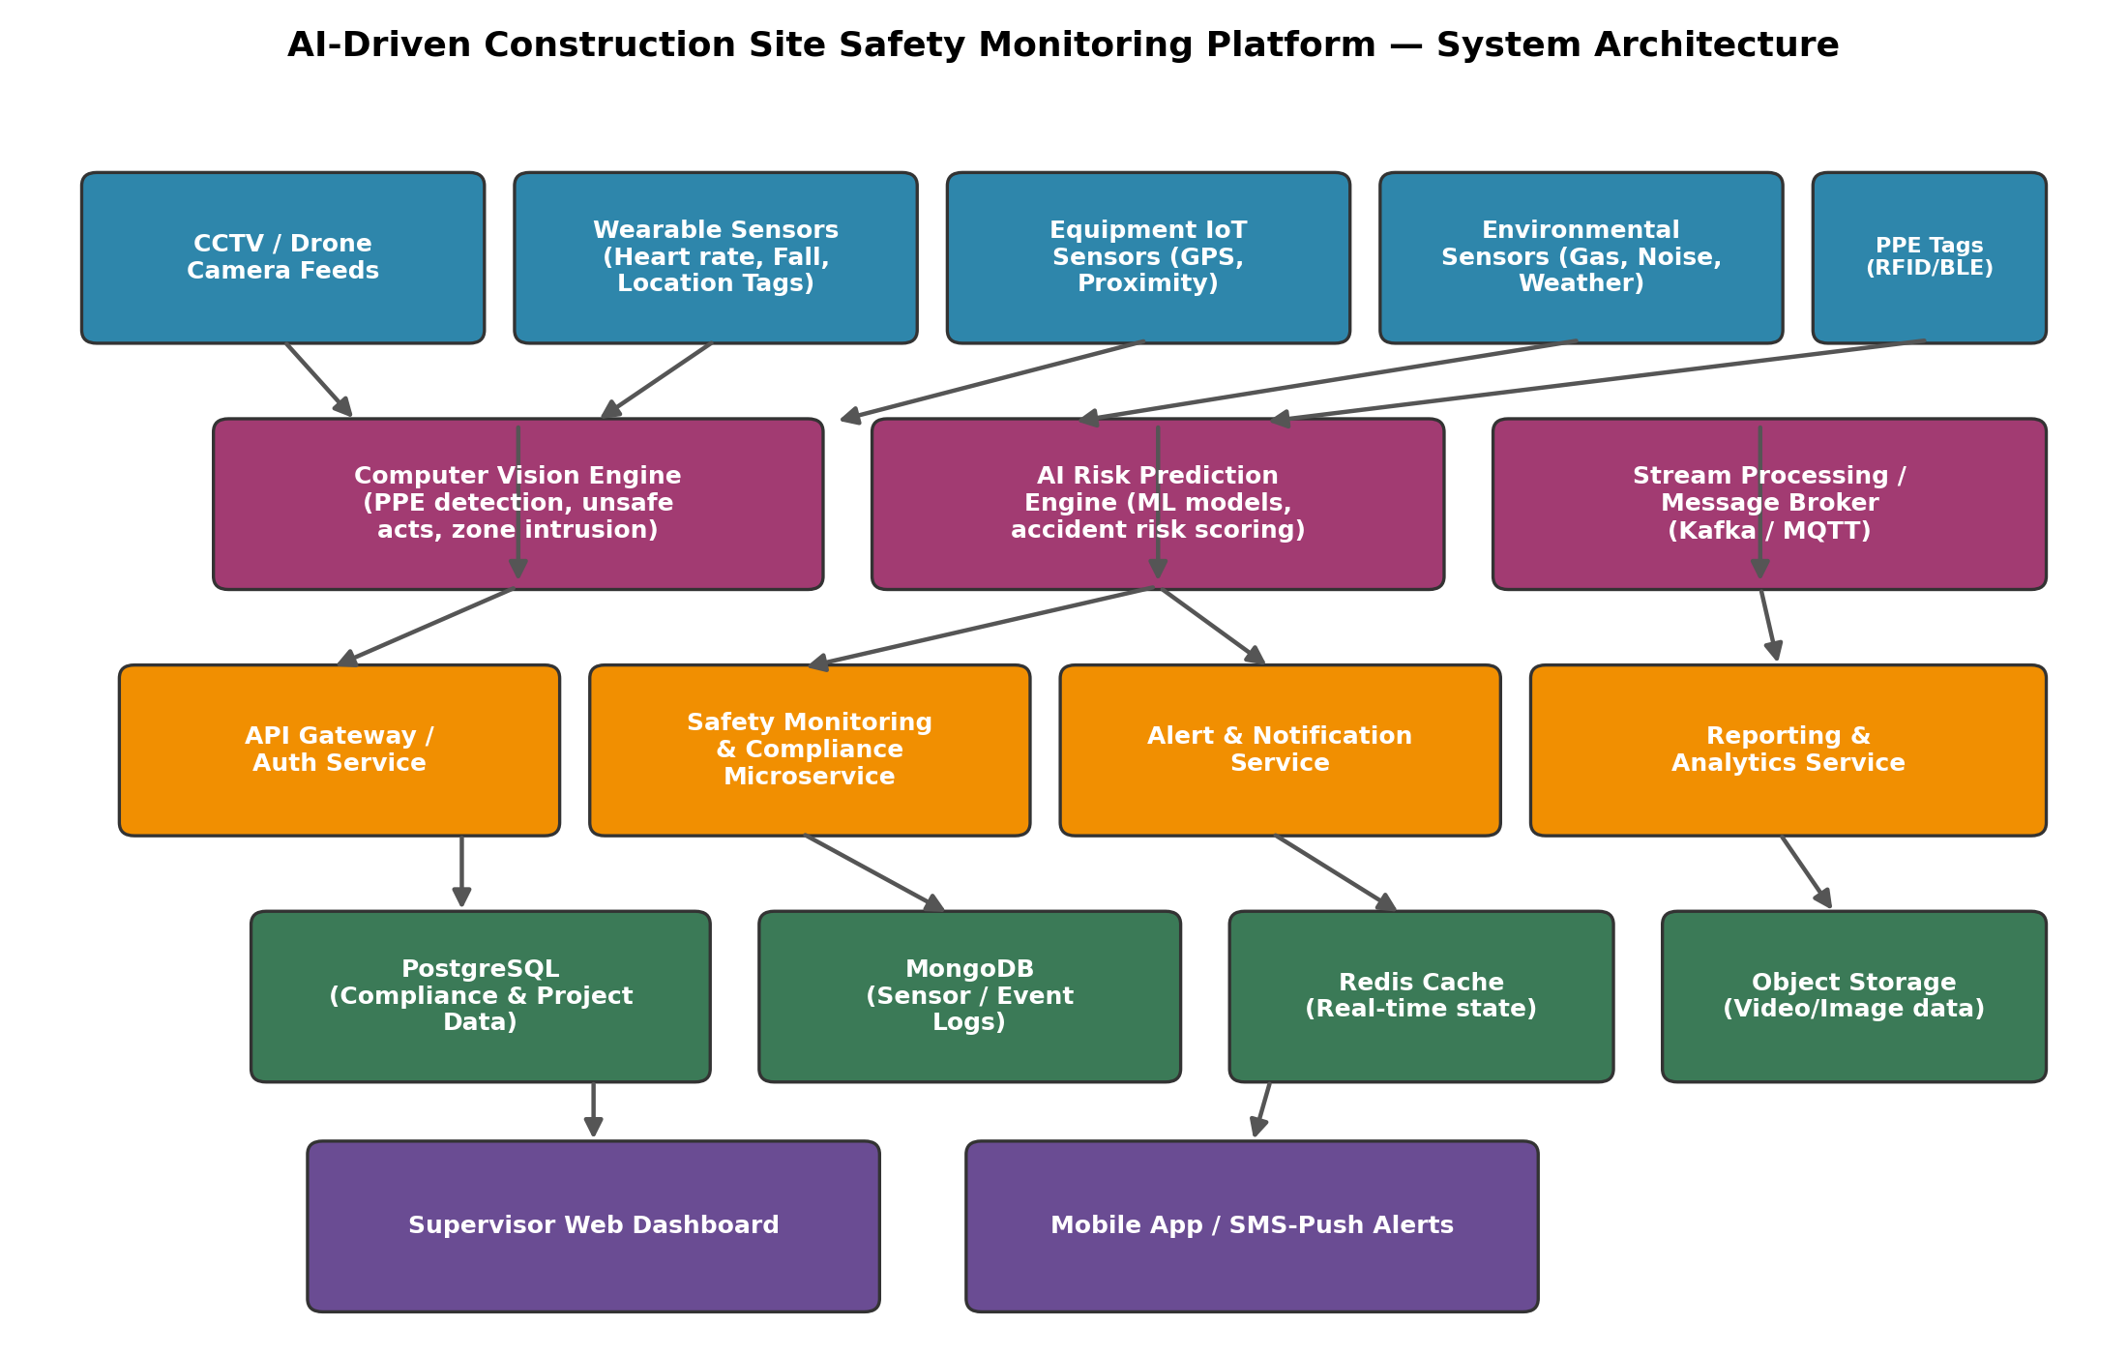
Figure 1: High-level system architecture of the AI-Driven Construction Site Safety Monitoring Platform.

2. Project Structure Design
The repository follows a modular, service-oriented folder structure that mirrors the platform's microservice architecture. Each independently deployable component (backend API, AI inference engine, frontend dashboard, IoT gateway) is isolated in its own top-level folder with its own Dockerfile and dependency manifest, which keeps build and deployment concerns separated and makes the branching/CI strategy described in later sections easy to apply per-component.

2.1 Repository Folder Structure
construction-safety-platform/
├── .git/ # Git internal metadata (auto-managed)
├── .github/
│ └── workflows/
│ └── ci-cd.yml # GitHub Actions pipeline (build, test, deploy)
├── docs/
│ ├── architecture-diagram.png
│ ├── branching-strategy.png
│ └── api-specification.md
├── backend/
│ ├── src/
│ │ ├── controllers/ # Request handlers (alerts, compliance, projects)
│ │ ├── services/ # Business logic (risk scoring, notifications)
│ │ ├── models/ # ORM / database schema definitions
│ │ ├── routes/ # API route definitions
│ │ ├── middleware/ # Auth, logging, error handling
│ │ └── config/ # Environment & DB configuration
│ ├── tests/ # Unit & integration tests
│ ├── Dockerfile
│ ├── package.json
│ └── .env.example
├── ai-inference/
│ ├── models/ # Trained PPE-detection / risk-prediction models
│ ├── src/
│ │ ├── ppe_detector.py
│ │ ├── risk_predictor.py
│ │ └── video_stream_processor.py
│ ├── requirements.txt
│ └── Dockerfile
├── frontend/
│ ├── src/
│ │ ├── components/ # Dashboard widgets, alert panels
│ │ ├── pages/
│ │ └── services/ # API client
│ ├── public/
│ ├── package.json
│ └── Dockerfile
├── iot-gateway/
│ ├── src/ # MQTT subscriber, sensor data normaliser
│ └── Dockerfile
├── database/
│ ├── migrations/
│ └── seed-data/
├── docker-compose.yml
├── docker-compose.prod.yml
├── .gitignore
├── .dockerignore
├── LICENSE
└── README.md
Figure 2: Project repository folder structure.

2.2 Purpose of Major Folders and Files
Folder / File | Purpose
.github/workflows/ | Holds CI/CD pipeline definitions (GitHub Actions) that automatically build, test, and deploy the platform on every push/merge.
docs/ | Stores architecture diagrams, workflow diagrams, and API documentation referenced in this report.
backend/ | Node.js/Django REST API implementing safety monitoring, compliance, authentication and alerting business logic.
ai-inference/ | Python-based computer vision and machine learning service performing PPE detection and accident-risk prediction.
frontend/ | React-based supervisor dashboard and mobile-facing web client for live monitoring and reports.
iot-gateway/ | Service that ingests and normalises data from wearable sensors, equipment sensors and MQTT topics before forwarding to the backend.
database/ | Schema migrations and seed data used to initialise PostgreSQL/MongoDB during deployment.
docker-compose.yml | Defines and orchestrates all services, networks and volumes for local/staging deployment.
docker-compose.prod.yml | Production overrides (replica counts, resource limits, secrets) layered on top of the base compose file.
.gitignore | Excludes build artefacts, dependency folders (node_modules), model binaries, and secrets from version control.
.dockerignore | Prevents unnecessary files (tests, docs, .git) from being copied into Docker build contexts, keeping images small.
LICENSE | Declares the legal terms under which the source code may be used and distributed.
README.md | Entry-point documentation: project overview, setup instructions, and usage guide for new contributors.

3. Git Repository Initialization

3.1 Initialization Steps
The repository was initialised and connected to a remote origin using the following sequence of commands:
# 1. Create the project folder and move into it
mkdir construction-safety-platform && cd construction-safety-platform

# 2. Initialise a new local Git repository
git init

# 3. Configure user identity for commit authorship
git config user.name "Your Name"
git config user.email "your.email@example.com"

# 4. Create foundational files
touch README.md .gitignore LICENSE

# 5. Stage and create the initial commit
git add .
git commit -m "chore: initial commit - project scaffold"

# 6. Rename default branch to main (Gitflow convention)
git branch -M main

# 7. Link the local repository to a remote (GitHub/GitLab)
git remote add origin https://github.com/<org>/construction-safety-platform.git

# 8. Push the initial commit and set upstream tracking
git push -u origin main
Figure 3: Git repository initialization commands.

3.2 Purpose of Essential Git Files
File / Directory | Purpose
.git/ | Hidden directory automatically created by 'git init'. Stores the entire commit history, branch references, staging index and configuration — the actual database of the repository.
.gitignore | Specifies intentionally untracked files (e.g. node_modules/, __pycache__/, .env, *.log, model weight binaries) so they are never accidentally committed.
README.md | First point of reference for any contributor; documents purpose, setup steps, architecture summary and usage instructions.
LICENSE | States the licensing terms governing reuse and distribution of the codebase.
.dockerignore | Analogous to .gitignore but scoped to the Docker build context, preventing bloated or sensitive files from entering images.

4. Git Branching Strategy

4.1 Selected Model: Gitflow
The project adopts the Gitflow branching model, consisting of two permanent branches (main and develop) and three categories of temporary, purpose-specific branches (feature/*, release/*, hotfix/*).
Branch | Role
main | Always reflects the current production-ready, deployed state of the platform. Every commit on main corresponds to a tagged release.
develop | Integration branch where completed features are merged and tested together before a release is cut.
feature/* | Short-lived branches created off develop for a single unit of work, e.g. feature/ppe-detection-model, feature/alert-service, feature/site-dashboard.
release/* | Created from develop when preparing a new version; used for final QA, bug fixes, documentation and version bumping before merging into main and develop.
hotfix/* | Created directly from main to urgently patch a critical production defect (e.g. a false-negative in PPE detection), then merged back into both main and develop.
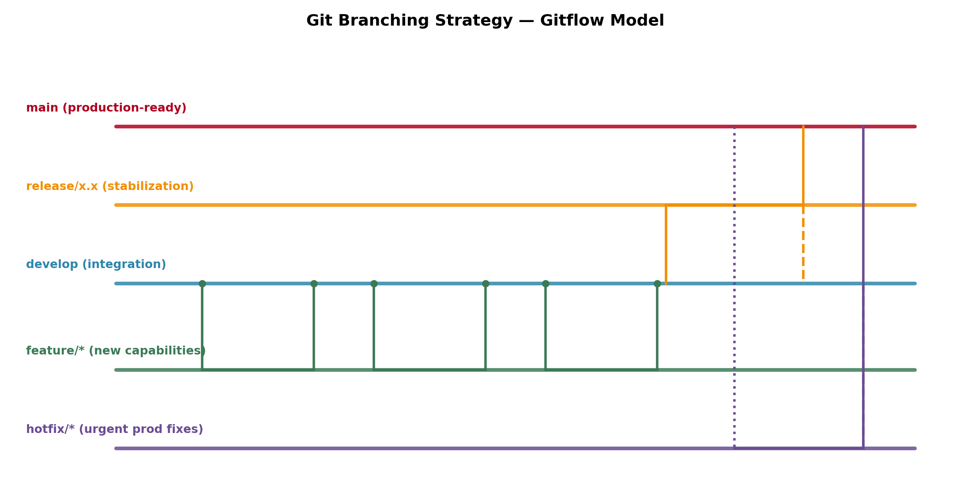
Figure 4: Gitflow branching strategy adopted for the project.

4.2 Justification for the Chosen Model
Gitflow is well suited to this project for several reasons specific to a safety-critical, multi-component platform:
- Safety-critical stability: because the platform issues real-time safety alerts, the main branch must always remain deployable and thoroughly tested; Gitflow enforces this through the release/hotfix gating process.
- Parallel component development: the backend, AI-inference engine, IoT gateway and frontend are developed concurrently by different contributors — isolated feature/* branches prevent unfinished work in one component from destabilising another.
- Controlled release cycles: construction safety features (e.g. a new hazard-detection model) require validation against real datasets before going live; the release/* branch provides a dedicated stabilisation window.
- Rapid incident response: a hotfix/* branch allows an urgent correction — for example, a bug causing missed PPE-violation alerts — to reach production immediately without waiting for the next full release cycle.
- Clear audit trail: regulatory and safety-compliance audits benefit from Gitflow's explicit separation of released, in-progress and emergency-patched code, which the commit/tag history documents transparently.

5. Version Control Workflow
The following demonstrates a realistic end-to-end Git workflow for adding the 'PPE Detection' feature, including branch creation, commits, a simulated merge conflict and its resolution, and synchronisation with the remote repository.

5.1 Feature Branch Creation and Commits
# Ensure develop is up to date before branching
git checkout develop
git pull origin develop

# Create a feature branch for the PPE detection module
git checkout -b feature/ppe-detection-model

# Work on the feature, then stage and commit incrementally
git add ai-inference/src/ppe_detector.py
git commit -m "feat(ai): add YOLOv8-based PPE detection module"

git add backend/src/services/complianceService.js
git commit -m "feat(backend): integrate PPE violation events into compliance service"

git add ai-inference/tests/test_ppe_detector.py
git commit -m "test(ai): add unit tests for PPE detector confidence thresholds"

5.2 Merging into Develop and Conflict Resolution
While integrating the feature branch into develop, a conflict arose because both branches had modified the same configuration section in backend/src/config/index.js (one branch added an AI service endpoint, the other added a notification service endpoint).
git checkout develop
git merge feature/ppe-detection-model

# Output:
# Auto-merging backend/src/config/index.js
# CONFLICT (content): Merge conflict in backend/src/config/index.js
# Automatic merge failed; fix conflicts and then commit the result.

# Open the conflicted file and resolve manually, keeping both entries:
# <<<<<<< HEAD
# notificationServiceUrl: process.env.NOTIFY_URL,
# =======
# aiInferenceUrl: process.env.AI_URL,
# >>>>>>> feature/ppe-detection-model

# After manually merging both config keys:
git add backend/src/config/index.js
git commit -m "merge: resolve config conflict between notification and AI endpoints"

5.3 Repository Synchronisation and Release
# Push the updated develop branch
git push origin develop

# Cut a release branch once develop is feature-complete
git checkout -b release/1.1.0 develop
git commit -am "chore(release): bump version to 1.1.0"

# Merge the stabilised release into main and tag it
git checkout main
git merge --no-ff release/1.1.0
git tag -a v1.1.0 -m "Release 1.1.0: PPE detection module"
git push origin main --tags

# Merge the release back into develop to retain any release fixes
git checkout develop
git merge --no-ff release/1.1.0
git push origin develop

# Clean up merged branches
git branch -d feature/ppe-detection-model release/1.1.0

5.4 Purpose of Each Git Operation
Operation | Purpose
git pull | Synchronises the local branch with the latest remote commits before starting new work, avoiding divergence.
git checkout -b | Creates and switches to a new isolated branch so work-in-progress never affects develop/main.
git add / git commit | Stages and permanently records a logical, reviewable unit of change with a descriptive message.
git merge | Integrates completed work from one branch into another, preserving full history.
Conflict resolution (edit + git add + commit) | Manually reconciles competing changes to the same lines so both contributions are preserved correctly.
git tag | Marks a specific commit as an official, immutable release point (e.g. v1.1.0) for traceability.
git push | Uploads local commits/branches/tags to the shared remote repository for the team and CI/CD pipeline.
git branch -d | Removes branches that have already been merged, keeping the repository uncluttered.

6. Commit History Analysis

6.1 Sample Commit History
A representative excerpt of the project's commit history (as shown by 'git log --oneline --graph') is presented below:
a91f3c2 (HEAD -> main, tag: v1.1.0) merge: release 1.1.0 - PPE detection module
d72e8b1 chore(release): bump version to 1.1.0
5c410aa merge: resolve config conflict between notification and AI endpoints
e6b2ff9 test(ai): add unit tests for PPE detector confidence thresholds
1a08cde feat(backend): integrate PPE violation events into compliance service
9d3a77f feat(ai): add YOLOv8-based PPE detection module
44bb210 docs: update README with AI-inference setup instructions
72cfa61 fix(iot): correct MQTT topic namespace for wearable sensors
f0198e3 feat(iot-gateway): add wearable sensor data normaliser
b6e5d90 feat(frontend): add live hazard-zone map widget
3a9c1f4 feat(backend): implement risk-scoring endpoint
c8127de chore: configure ESLint and Prettier for backend
0e4f5a2 feat(docker): add multi-stage Dockerfile for backend service
77aa019 chore: initial commit - project scaffold
Figure 5: Sample commit history log.

6.2 Commit Message Conventions
All commits follow the Conventional Commits specification: type(scope): short imperative description. This structure directly supports project maintenance in the following ways:
Prefix | Meaning | Maintenance Benefit
feat | A new feature | Enables automatic changelog/release-note generation and clarifies functional growth.
fix | A bug fix | Makes regressions easy to locate via 'git log --grep=fix' during incident investigation.
docs | Documentation-only change | Separates non-functional updates from code changes for cleaner diffs.
test | Adding or updating tests | Signals coverage improvements without functional risk.
chore | Tooling/config/versioning changes | Distinguishes housekeeping commits from feature work.
merge | Integration or conflict-resolution commit | Documents where and why branches were combined, aiding audits.
Because every message is short, imperative, and scoped to a single logical change, the history remains bisectable (git bisect can pinpoint the exact commit that introduced a defect), reviewable, and directly usable for compliance audit trails — a requirement given the safety-critical nature of this platform.

7. Docker Environment Design

7.1 Why Docker Is Suitable for This Project
The safety monitoring platform is composed of heterogeneous services with very different runtime dependencies: a Python/TensorFlow computer-vision engine, a Node.js/Django REST API, a React frontend, an MQTT-based IoT gateway, and multiple databases. Docker is well suited to this environment for the following reasons:
- Consistent environments: the AI-inference service depends on specific versions of TensorFlow, OpenCV and CUDA libraries; Docker guarantees these are identical across every developer machine, the CI pipeline, and production, eliminating 'it works on my machine' failures.
- Microservice isolation: each component (backend, AI engine, frontend, IoT gateway) can be built, versioned and scaled independently as a separate container.
- Portability across edge and cloud: construction sites may run lightweight edge containers for local camera processing while the cloud runs the full analytics stack — the same Docker images work in both contexts.
- Rapid, repeatable deployment: new construction sites can be onboarded by simply running 'docker compose up', instead of manually installing dependencies on each server.
- Resource isolation and scalability: container orchestration allows the AI-inference service (GPU/CPU intensive) to be scaled independently of the lightweight notification service.
- Simplified rollback: tagged Docker images corresponding to Git release tags allow instant rollback to a previous known-good version if a new AI model misbehaves in production.

7.2 Components Requiring Containerization
Component | Containerization Rationale
frontend (React) | Static build served via Nginx; containerized for consistent serving and easy CDN/edge deployment.
backend-api (Node/Django) | Core REST/business-logic service; needs isolated runtime and horizontal scalability behind a load balancer.
ai-inference (Python) | Heavy ML dependencies (TensorFlow/OpenCV/YOLO); benefits most from image-based dependency locking and optional GPU passthrough.
iot-gateway | MQTT subscriber normalising sensor data; isolated so a crash cannot affect the API service.
postgres-db / mongo-db | Official database images with persistent volumes for compliance records and event/sensor logs.
redis-cache | In-memory store for real-time worker/zone state, containerized for quick provisioning.
mqtt-broker | Lightweight broker (e.g. Eclipse Mosquitto) mediating IoT device messages.
notification-service | Dedicated container dispatching email/SMS/push alerts, scaled independently during incident spikes.
nginx-reverse-proxy | Single TLS-terminating entry point routing traffic to the correct backend container.

8. Dockerfile Development

8.1 Backend API Dockerfile (Multi-Stage Build)
The backend service uses a multi-stage build to keep the final production image small by discarding build-time-only tools and dev dependencies.
# ---------- Stage 1: Build ----------
FROM node:20-alpine AS builder

# Set the working directory inside the image
WORKDIR /app

# Copy dependency manifests first to leverage Docker layer caching
COPY package*.json ./
RUN npm ci --omit=dev

# Copy application source code
COPY . .

# Compile / transpile the application (TypeScript build, etc.)
RUN npm run build

# ---------- Stage 2: Production runtime ----------
FROM node:20-alpine AS production

# Create a non-root user for security
RUN addgroup -S appgroup && adduser -S appuser -G appgroup

WORKDIR /app

# Copy only the built artefacts and production dependencies from the build stage
COPY --from=builder /app/node_modules ./node_modules
COPY --from=builder /app/dist ./dist
COPY --from=builder /app/package.json ./

# Set runtime environment variables
ENV NODE_ENV=production
ENV PORT=8000

# Document the port the container listens on
EXPOSE 8000

# Run as the non-root user
USER appuser

# Container-level health check for orchestration tools
HEALTHCHECK --interval=30s --timeout=5s --start-period=10s \
CMD wget -qO- http://localhost:8000/health || exit 1

# Default command to start the service
CMD ["node", "dist/server.js"]
Figure 6: Multi-stage Dockerfile for the backend API service.

8.2 AI-Inference Service Dockerfile
# AI-inference service Dockerfile (Python / TensorFlow)
FROM python:3.11-slim

WORKDIR /app

# Install system libraries required by OpenCV
RUN apt-get update && apt-get install -y --no-install-recommends \
libgl1 libglib2.0-0 && rm -rf /var/lib/apt/lists/*

# Install Python dependencies first for build-cache efficiency
COPY requirements.txt .
RUN pip install --no-cache-dir -r requirements.txt

# Copy trained model weights and source code
COPY models/ ./models/
COPY src/ ./src/

ENV MODEL_PATH=/app/models/ppe_yolov8.pt
ENV PYTHONUNBUFFERED=1

EXPOSE 8501

HEALTHCHECK --interval=30s --timeout=5s CMD curl -f http://localhost:8501/health || exit 1

CMD ["python", "src/video_stream_processor.py"]
Figure 7: Dockerfile for the Python-based AI inference service.

8.3 Instruction-by-Instruction Explanation
Instruction | Purpose
FROM | Selects the base image (e.g. node:20-alpine, python:3.11-slim) that provides the language runtime; slim/alpine variants minimise image size and attack surface.
WORKDIR | Sets the working directory inside the container for all subsequent instructions and the running process.
COPY | Copies files from the build context (host) into the image; dependency manifests are copied before source code to maximise Docker's layer cache reuse.
RUN | Executes a command at build time, e.g. installing OS packages or dependencies, producing a new image layer.
ENV | Defines environment variables (e.g. NODE_ENV, MODEL_PATH) available to the process at runtime.
EXPOSE | Documents the network port the containerized service listens on; used by Compose/orchestrators for networking.
USER | Switches execution to a non-root user, following the principle of least privilege for container security.
HEALTHCHECK | Defines a command Docker periodically runs to determine if the container is 'healthy', enabling automatic restarts/orchestration decisions.
CMD | Specifies the default command executed when the container starts (the main application process).
Multi-stage (AS builder / AS production) | Separates the build environment from the runtime environment so compilers and dev dependencies never ship in the final image.

9. Docker Compose Design
Docker Compose orchestrates all nine services of the platform as a single reproducible stack, defining their build contexts, images, ports, environment variables, dependency order, shared network and persistent volumes.
version: "3.9"

services:
frontend:
build: ./frontend
image: safety-platform/frontend:1.1.0
ports:
- "80:80"
depends_on:
- backend-api
networks:
- safety-net

backend-api:
build: ./backend
image: safety-platform/backend:1.1.0
ports:
- "8000:8000"
environment:
- NODE_ENV=production
- DB_HOST=postgres-db
- MONGO_URI=mongodb://mongo-db:27017/safety
- REDIS_HOST=redis-cache
- AI_SERVICE_URL=http://ai-inference:8501
- JWT_SECRET=${JWT_SECRET}
depends_on:
- postgres-db
- mongo-db
- redis-cache
- ai-inference
networks:
- safety-net

ai-inference:
build: ./ai-inference
image: safety-platform/ai-inference:1.1.0
ports:
- "8501:8501"
volumes:
- model-weights:/app/models
networks:
- safety-net

iot-gateway:
build: ./iot-gateway
depends_on:
- mqtt-broker
networks:
- safety-net

notification-service:
build: ./notification-service
environment:
- SMTP_HOST=${SMTP_HOST}
- SMS_API_KEY=${SMS_API_KEY}
depends_on:
- backend-api
networks:
- safety-net

postgres-db:
image: postgres:16-alpine
environment:
- POSTGRES_DB=safety_compliance
- POSTGRES_USER=${DB_USER}
- POSTGRES_PASSWORD=${DB_PASSWORD}
volumes:
- pgdata:/var/lib/postgresql/data
networks:
- safety-net

mongo-db:
image: mongo:7
volumes:
- mongodata:/data/db
networks:
- safety-net

redis-cache:
image: redis:7-alpine
networks:
- safety-net

mqtt-broker:
image: eclipse-mosquitto:2
networks:
- safety-net

nginx-reverse-proxy:
image: nginx:1.27-alpine
ports:
- "443:443"
volumes:
- ./nginx/nginx.conf:/etc/nginx/nginx.conf:ro
depends_on:
- frontend
- backend-api
networks:
- safety-net

networks:
safety-net:
driver: bridge

volumes:
pgdata:
mongodata:
model-weights:
Figure 8: docker-compose.yml orchestrating the full platform.
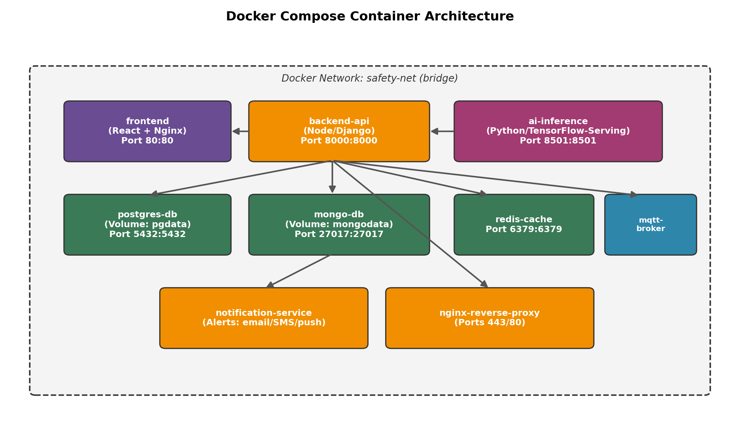
Figure 9: Docker Compose container architecture and inter-service communication.

9.1 Services
Nine services are defined: frontend, backend-api, ai-inference, iot-gateway, notification-service, postgres-db, mongo-db, redis-cache, mqtt-broker, and nginx-reverse-proxy. Each maps to one containerized component identified in Section 7.2, allowing every service to be built, scaled, and redeployed independently.

9.2 Networking
All services join a single user-defined bridge network, safety-net. Docker's embedded DNS allows services to address each other by service name (e.g. backend-api resolves ai-inference and postgres-db directly), removing the need for hard-coded IP addresses. Only the frontend and nginx-reverse-proxy publish ports to the host, minimising the external attack surface.

9.3 Volumes
Volume | Mounted In | Purpose
pgdata | postgres-db | Persists relational compliance and project data across container restarts/rebuilds.
mongodata | mongo-db | Persists high-volume sensor and event logs independent of container lifecycle.
model-weights | ai-inference | Persists trained ML model files so they survive image rebuilds and can be updated without a new image.

9.4 Environment Variables
Sensitive configuration (database credentials, JWT signing secret, SMTP/SMS API keys) is injected via environment variables sourced from a local .env file that is excluded from version control via .gitignore. This keeps secrets out of the image and out of the Git history while allowing different values per environment (development, staging, production).

9.5 Dependencies
The depends_on directive ensures backend-api starts only after its data stores and the AI service are available, and that nginx-reverse-proxy starts only after the services it proxies. In production, this is complemented by each service's HEALTHCHECK (Section 8.3) so dependent services wait for genuine readiness, not just process start.

10. Container Deployment and Testing

10.1 Building and Running the Stack
# Build all service images defined in docker-compose.yml
docker compose build

# Start the full stack in detached mode
docker compose up -d

# Confirm all containers are running and healthy
docker compose ps

# NAME STATUS PORTS
# frontend Up 2 minutes (healthy) 0.0.0.0:80->80/tcp
# backend-api Up 2 minutes (healthy) 0.0.0.0:8000->8000/tcp
# ai-inference Up 2 minutes (healthy) 0.0.0.0:8501->8501/tcp
# postgres-db Up 2 minutes (healthy) 5432/tcp
# mongo-db Up 2 minutes (healthy) 27017/tcp
# redis-cache Up 2 minutes 6379/tcp
# mqtt-broker Up 2 minutes 1883/tcp
# notification-service Up 2 minutes -
# nginx-reverse-proxy Up 2 minutes 0.0.0.0:443->443/tcp
Figure 10: Expected container status output after deployment.

10.2 Testing Procedure
Deployment was verified using a layered testing approach, from individual container health up to full end-to-end functionality:
- Container health verification: 'docker compose ps' and 'docker inspect --format="{{.State.Health.Status}}"' confirm every service reports healthy.
- Log inspection: 'docker compose logs -f backend-api' and 'docker compose logs -f ai-inference' confirm services start without stack traces and successfully connect to their databases/brokers.
- API smoke test: 'curl http://localhost:8000/health' returns HTTP 200, confirming the backend API is reachable through its published port.
- AI inference test: a sample construction-site image is POSTed to 'http://localhost:8501/predict'; the response is validated to contain expected PPE-detection bounding boxes and confidence scores.
- Database connectivity test: the backend's '/api/projects' endpoint is called to confirm it can read/write through to postgres-db and mongo-db over the safety-net network.
- End-to-end alert test: a simulated PPE-violation event is published to the MQTT broker; the notification-service log is checked to confirm an alert was generated and dispatched within the expected time window.
- Teardown test: 'docker compose down' followed by 'docker compose up -d' confirms the stack restarts cleanly and persisted volumes (pgdata, mongodata) retain prior data.
curl -i http://localhost:8000/health
# HTTP/1.1 200 OK
# {"status":"ok","uptime":"142s","db":"connected","ai_service":"connected"}

curl -X POST http://localhost:8501/predict -F image=@sample_site.jpg
# {"detections":[{"class":"no_helmet","confidence":0.94,"bbox":[112,54,210,180]}]}
Figure 11: Sample health-check and AI-inference test responses.
Note: the command sequences and sample outputs above illustrate the deployment and testing procedure to be followed. When executing this assignment in a live environment with Docker and network access, replace the illustrative outputs with actual terminal screenshots as required by the deliverables list.

11. Benefits of Git and Docker
Together, Git and Docker directly support the scale, safety-criticality, and multi-site nature of this platform:

11.1 Collaboration
Gitflow's isolated feature branches let the AI, backend, IoT, and frontend teams work concurrently without blocking one another, while pull requests against develop enforce code review before integration — critical when changes affect life-safety alerting logic.

11.2 Version Management
Every model update, API change, or configuration fix is captured as a traceable, revertible commit. Tagged releases (e.g. v1.1.0) let the team correlate a specific deployed Docker image back to the exact source code and AI model version that produced it — essential for incident investigation.

11.3 Portability
Docker images built once run identically on a developer laptop, the CI runner, an on-site edge server, and the cloud, removing environment drift between the AI-inference dependencies (TensorFlow/OpenCV/CUDA) and the rest of the stack.

11.4 Deployment
Docker Compose reduces new-site onboarding from a multi-hour manual installation to a single 'docker compose up -d' command, while tagged images allow instant rollback if a newly deployed model or service misbehaves.

11.5 Scalability
Because each concern is its own container, the AI-inference and notification services — the two most load-sensitive components during a safety incident spike — can be scaled horizontally (e.g. 'docker compose up -d --scale ai-inference=4') independent of lighter-weight services.

11.6 Maintainability
Conventional-commit history combined with per-service Dockerfiles makes it straightforward to isolate, patch, and redeploy a single faulty component without touching or redeploying the rest of the platform, minimising downtime risk on an active construction site.

12. Challenges and Improvements

12.1 Challenges Encountered
- Large binary artefacts: trained AI model weight files are large and change frequently, which bloats standard Git history over time.
- Merge conflicts in shared configuration: multiple feature branches editing the same configuration or environment files (as demonstrated in Section 5.2) required careful manual reconciliation.
- GPU/hardware access in containers: enabling GPU acceleration for the AI-inference container requires additional runtime configuration (e.g. NVIDIA Container Toolkit) that varies across host operating systems.
- Secrets management: safely supplying database credentials, JWT secrets, and third-party API keys to containers without ever committing them to Git required strict .gitignore and environment-variable discipline.
- Real-time video/stream latency: containerizing the video-processing pipeline introduced additional network hops between the camera source, the AI-inference container, and the alerting service, requiring careful network and volume design to keep detection latency low.
- Multi-site scaling: coordinating consistent configuration and independent data isolation across many concurrent construction-site deployments increases orchestration complexity beyond a single docker-compose.yml file.

12.2 Suggested Improvements and Future Enhancements
Area | Improvement
Large file handling | Adopt Git LFS (Large File Storage) for AI model weights and sample video/image datasets to keep the core repository lightweight.
CI/CD automation | Extend the .github/workflows pipeline to automatically build, test, and push tagged Docker images to a registry on every merge into main.
Orchestration at scale | Migrate from Docker Compose to Kubernetes (or Docker Swarm) for automated scaling, self-healing, and multi-site cluster management.
Secrets management | Integrate a dedicated secrets manager (e.g. HashiCorp Vault or cloud-native secret stores) instead of plain .env files.
Security scanning | Add automated container image vulnerability scanning (e.g. Trivy) as a CI gate before any image is deployed.
Observability | Introduce centralized monitoring and logging (Prometheus/Grafana, ELK stack) across all containers for proactive operational insight.
Edge deployment | Develop lightweight edge-optimised container variants for on-site processing where connectivity to the cloud is intermittent.
Branch automation | Adopt branch-protection rules and mandatory status checks on develop/main to enforce the Gitflow policy automatically rather than by convention.

Expected Deliverables Summary
This report addresses the complete set of deliverables required for the assignment:
- Technical report covering problem analysis through challenges/improvements (this document).
- Git repository structure, initialization steps, and complete illustrative commit history (Sections 2, 3, 6).
- Source code organisation for the assigned AI-Driven Construction Site Safety Monitoring Platform (Section 2).
- Dockerfile(s) for the backend API and AI-inference services, fully explained (Section 8).
- Docker Compose configuration (docker-compose.yml) orchestrating all nine services (Section 9).
- Illustrative command sequences and outputs representing Git operations and Docker execution/testing (Sections 5, 6, 10).
- Architecture, branching-strategy, and container-architecture diagrams (Figures 1, 4, 9).
When submitting this assignment against a live implementation, the illustrative code listings, sample commit hashes, and sample terminal outputs in this report should be replaced with actual repository content and real captured screenshots from your development environment.

