
SOFTWARE REQUIREMENT SPECIFICATION
SafeSite AI
AI-Driven Construction Site Safety Monitoring Platform
CSA1012 — SOFTWARE ENGINEERING
towards the award of the degree of
BACHELOR OF TECHNOLOGY
IN
COMPUTER SCIENCE (AI)
Submitted by
K.P. SREENATH REDDY (192373049)
Under the Supervision of
DR ANITADAVAMANI K
SIMATS ENGINEERING
Saveetha Institute of Medical and Technical Sciences
Chennai — 602105
July 2026

1. Introduction

1.1 Purpose
This Software Requirement Specification (SRS) document defines the functional and non-functional requirements for SafeSite AI, an AI-driven construction site safety monitoring platform. It is derived from a scenario-based requirement analysis of the project's Sprint Planning documentation and is intended to guide design, development, testing, and validation of the system.

1.2 Business Domain
The system operates in the Construction Safety Management / Industrial IoT-AI domain, combining computer vision, IoT sensor telemetry, geofencing, predictive analytics, and real-time alerting to reduce workplace accidents on active construction sites.

1.3 Intended Audience
- Development team (backend, ML, frontend, DevOps engineers)
- Project managers and product owners
- Safety officers and EHS compliance teams evaluating the system
- Quality assurance and validation teams
- Academic evaluators / course instructors

1.4 Definitions, Acronyms and Abbreviations
Term | Definition
PPE | Personal Protective Equipment
EHS | Environment, Health and Safety
mAP | Mean Average Precision (object detection accuracy metric)
TTC | Time To Collision
IoT | Internet of Things
MQTT/RTSP | Lightweight messaging / video streaming protocols used for ingestion
SRS | Software Requirement Specification

2. Problem Description
Construction sites currently rely on manual, periodic inspection to verify PPE compliance and detect hazardous conditions. This approach is reactive: unsafe conditions such as missing PPE, unauthorized entry into hazardous zones, and unsafe proximity to heavy equipment are frequently identified only after an incident has occurred, or during infrequent spot checks. Safety officers cannot continuously monitor every worker across a large site, supervisors lack real-time visibility into violations as they happen, and regulators require tamper-evident historical records that manual processes do not reliably produce.
SafeSite AI addresses this gap by continuously ingesting live video and sensor data from every active site, using computer vision and predictive analytics to detect PPE non-compliance, hazardous-zone intrusions, and equipment-proximity risks in real time, and instantly alerting the right person so unsafe conditions are corrected before they become incidents.

2.1 Existing Challenges
- Manual PPE inspection is slow, inconsistent, and cannot scale to continuous, site-wide coverage.
- Hazardous-zone intrusions and equipment-worker collisions are often detected only after the fact.
- Safety alerts, when they exist, are not prioritized by severity, causing critical issues to be missed among noise.
- Compliance records for audits are fragmented, paper-based, or not tamper-evident.
- There is no predictive visibility into which zones are likely to become high-risk.

2.2 System Objectives
- Provide a real-time ingestion pipeline for camera and IoT sensor data with resilience to network loss.
- Automatically detect PPE compliance with measurable accuracy (target mAP ≥ 0.85).
- Detect hazardous-zone intrusions and equipment-proximity risks and alert relevant personnel within seconds.
- Provide a live composite risk score per zone and, in later releases, predictive risk forecasting.
- Deliver a compliance dashboard and tamper-evident, exportable reports for auditors and management.

3. Scope of the System
The scope covers the Sprint 1 end-to-end 'detect → alert → act' loop on a single pilot site — continuous video ingestion, automated PPE detection, hazardous-zone intrusion detection, and real-time supervisor alerting — together with the broader platform capabilities (equipment-proximity monitoring, predictive risk analytics, compliance dashboard and reporting) planned for subsequent releases across a multi-project portfolio.

In Scope
- Live video/IoT ingestion, buffering, and stream processing
- Computer-vision based PPE and behaviour detection
- Geofenced hazardous-zone and equipment-proximity monitoring
- Real-time, severity-prioritized multi-channel alerting
- Compliance dashboards and tamper-evident report export

Out of Scope (current release)
- Predictive/forecasted risk scoring (deferred until sufficient historical incident data exists)
- Cross-project portfolio dashboard (deferred until multiple pilot sites are live)
- Equipment-proximity collision warning and wearable telemetry ingestion (planned for Sprint 2)

4. Functional Requirements
ID | Requirement | Source Epic
FR-1 | The system shall continuously ingest live video streams from site cameras with under 2-second latency and zero frame loss under normal network conditions. | Data Ingestion
FR-2 | The system shall ingest wearable IoT sensor data in real time to track worker location and status. | Data Ingestion
FR-3 | The system shall buffer ingestion data locally during network interruptions to prevent data loss. | Data Ingestion
FR-4 | The system shall automatically detect presence/absence of required PPE items on each worker in video frames. | PPE Detection
FR-5 | The system shall attach a confidence score to every PPE detection. | PPE Detection
FR-6 | The system shall notify the assigned supervisor when a PPE violation is detected above the acceptance confidence threshold, within 3 seconds. | PPE Detection
FR-7 | The system shall flag unauthorized entry into configurable hazardous zones using geofencing. | Zone Monitoring
FR-8 | The system shall compute time-to-collision (TTC) between workers and equipment and trigger a proximity alert when TTC falls below a configured safety threshold. | Zone Monitoring
FR-9 | The system shall allow safety officers to configure geofence boundaries per site. | Zone Monitoring
FR-10 | The system shall compute and display a live composite risk score (0–100) per zone, recalculated on a fixed cycle. | Risk Analytics
FR-11 | The system shall (future release) predict which zones are likely to become high-risk in the next shift using historical data. | Risk Analytics
FR-12 | The system shall deliver real-time alerts to supervisors via mobile, SMS, and dashboard channels. | Alerting
FR-13 | The system shall rank and deliver queued alerts in descending order of severity. | Alerting
FR-14 | The system shall trigger an audible alarm from a nearby physical beacon when a worker is in immediate danger. | Alerting
FR-15 | The system shall display a dashboard of daily PPE compliance rates and trends. | Reporting
FR-16 | The system shall generate tamper-evident, exportable (PDF/CSV) compliance reports for a selected project and date range within 30 seconds. | Reporting
FR-17 | The system shall (future release) provide a portfolio-level view of safety performance across all active projects. | Reporting

5. Non-Functional Requirements
Category | Requirement
Performance | Video ingestion latency < 2 seconds; PPE inference < 2 seconds/frame; alert delivery within 3 seconds of detection; risk score recalculation every 60 seconds and reflected on dashboard within 5 seconds.
Security | Role-based access control for supervisors, safety officers, auditors, and administrators; encrypted transmission of video/sensor data and alerts; tamper-evident (hash-chained) storage for compliance records.
Reliability | Zero data loss under normal network conditions; local buffering and automatic retry during network interruptions; PPE detection model must sustain mAP ≥ 0.85 on validation footage.
Usability | Supervisor alert feed and compliance dashboard must present real-time information clearly with correct severity and timestamps, usable without specialized training.
Scalability | Architecture must scale from a single pilot site to a multi-project portfolio without redesign of the ingestion or alerting pipeline.
Maintainability | Modular epic-based architecture (ingestion, detection, zone monitoring, analytics, alerting, reporting) to allow independent updates and model retraining.
Availability | Ingestion and alerting pipeline shall be highly available, as it is a hard dependency for every downstream safety function.
Auditability | All violations, alerts, and resolutions must be logged with timestamps and be exportable for regulatory audit.

6. Actors and Use Cases

6.1 Actors
Actor | Type | Description
Site Worker | Primary | Wears PPE and sensors; receives beacon alarms; subject of monitoring.
Site Supervisor | Primary | Receives real-time alerts; monitors dashboard; redirects workers away from hazards.
Safety Officer / EHS Team | Primary | Configures zones/thresholds; reviews detections; generates compliance reports.
Equipment Operator | Primary | Receives proximity/collision warnings; halts operation when alerted.
Project Manager | Secondary | Reviews sprint/portfolio dashboards to track safety ROI.
IT Administrator | Secondary | Maintains ingestion pipeline, platform infrastructure, and uptime.
Regulator / Auditor | Secondary | Requests and reviews tamper-evident compliance reports.
Senior Management / Insurers | Secondary | Views portfolio-level safety and risk trends.
Site Camera / IoT Sensor / Wearable | External System | Streams video and telemetry data into the ingestion pipeline.

6.2 Major Use Cases per Actor
Actor | Use Cases
Site Worker | UC-1 Receive PPE-violation feedback via beacon; UC-2 Receive proximity danger alarm
Site Supervisor | UC-3 View real-time alert feed; UC-4 Receive PPE/zone-intrusion notification; UC-5 View compliance dashboard
Safety Officer | UC-6 Configure geofence boundaries; UC-7 Review PPE detections & confidence scores; UC-8 Generate compliance report
Equipment Operator | UC-9 Receive equipment-proximity warning
Project Manager | UC-10 View sprint/portfolio safety metrics
IT Administrator | UC-11 Monitor/maintain ingestion pipeline health
Regulator / Auditor | UC-12 Request tamper-evident historical report
System (automated) | UC-13 Ingest video/sensor stream; UC-14 Detect PPE compliance; UC-15 Detect zone intrusion; UC-16 Compute composite risk score; UC-17 Prioritize and dispatch alerts

6.3 Use Case Diagram
The diagram below shows actors and their primary interactions with the SafeSite AI system.
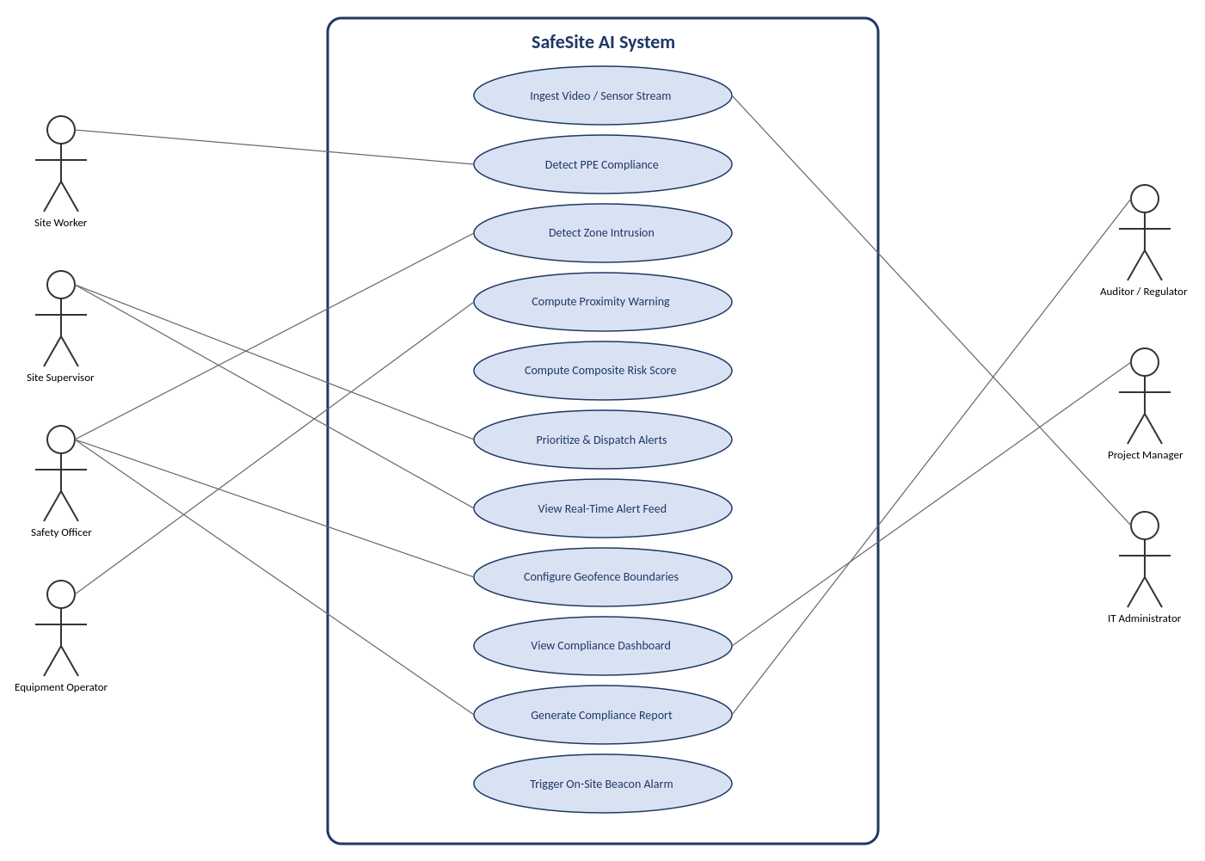

7. Use Case Descriptions

7.1 UC-4: Receive PPE / Zone-Intrusion Notification
Field | Description
Actor | Site Supervisor
Precondition | Camera stream is active; supervisor is assigned to the zone.
Main Flow | 1) System detects PPE violation or zone intrusion. 2) System logs the event with confidence score/timestamp. 3) System dispatches a prioritized alert to the assigned supervisor via mobile/SMS/dashboard within 3 seconds.
Postcondition | Supervisor is notified and can act to correct the unsafe condition.
Exception | If confidence score is below threshold, no alert is raised; event is logged for review only.

7.2 UC-9: Receive Equipment-Proximity Warning
Field | Description
Actor | Equipment Operator, Site Supervisor
Precondition | Worker wearable and equipment IoT position data are being ingested.
Main Flow | 1) System continuously computes distance and time-to-collision (TTC) between worker and equipment. 2) When TTC drops below the safety threshold, system triggers an immediate alert to both operator and supervisor.
Postcondition | Operator halts/adjusts equipment operation before collision.
Exception | Sensor signal loss suspends TTC computation and raises a data-quality alert to IT Administrator.

7.3 UC-8: Generate Compliance Report
Field | Description
Actor | Safety Officer, Regulator/Auditor
Precondition | Project and date range selected; violation logs exist for the period.
Main Flow | 1) Actor selects project and date range. 2) System compiles all logged violations, timestamps, and resolution status. 3) System generates a tamper-evident PDF/CSV export within 30 seconds.
Postcondition | Exportable, tamper-evident report is available for download/audit.
Exception | If no data exists for the range, system returns an empty but validly-signed report.

8. Data Requirements
Data Entity | Key Attributes
Video Stream | Camera ID, site ID, timestamp, frame sequence, stream status
Sensor/Wearable Telemetry | Worker/wearable ID, location (x,y or GPS), timestamp, battery/status
PPE Detection Event | Worker ID, PPE item type, presence flag, confidence score, timestamp, frame reference
Zone / Geofence | Zone ID, site ID, boundary polygon, hazard type, configured thresholds
Proximity/Collision Event | Worker ID, equipment ID, distance, TTC, timestamp, alert status
Risk Score | Zone ID, PPE violation rate, proximity risk, environmental stress index, incident history, composite score, timestamp
Alert | Alert ID, source event, severity, target recipient(s), delivery channel, delivery timestamp, acknowledgement status
Compliance Report | Project ID, date range, violation list, resolution status, hash/tamper-evidence signature
User/Actor Account | User ID, role, site assignment, contact channel(s)
Data retention: violation, alert, and report records must be retained per regulatory audit requirements with tamper-evident integrity. Video streams may use a rolling retention window with archiving of clips linked to logged violations.

9. External Interface Requirements

9.1 User Interfaces
- Supervisor real-time alert feed (web/mobile) showing severity, timestamp, and location.
- Safety officer configuration console for geofence boundaries and detection thresholds.
- Compliance dashboard with daily PPE compliance trends and per-zone risk scores.
- Auditor report-generation interface (project + date-range selector, PDF/CSV export).

9.2 Hardware Interfaces
- Site cameras (RTSP-capable) for video capture.
- Wearable sensors and equipment IoT devices for location/telemetry.
- On-site audible/visual beacons for immediate danger alarms.

9.3 Software Interfaces
- Message queue / streaming platform (e.g., MQTT ingestion into Kafka) for ingestion buffering.
- Computer-vision inference microservice for PPE/behaviour detection.
- Push-notification gateway supporting mobile push, SMS, and dashboard channels.

9.4 Communication Interfaces
- Secure, encrypted network communication (TLS) between edge devices, ingestion pipeline, and platform services.
- APIs for exporting tamper-evident compliance reports to external audit/regulatory systems.

10. System Features
Feature | Summary
Real-Time Data Ingestion | Continuous, buffered ingestion of camera and IoT data resilient to network loss.
PPE & Behaviour Detection | Computer-vision detection of PPE compliance and unsafe behaviour with confidence scoring.
Hazardous Zone & Proximity Monitoring | Geofenced intrusion detection and equipment-to-worker collision warnings.
Predictive Risk Analytics | Live composite per-zone risk scoring; future-release predictive forecasting.
Real-Time Alerting | Severity-prioritized, multi-channel alert delivery including physical beacons.
Compliance Dashboard & Reporting | Trend dashboards and tamper-evident exportable compliance reports.

11. Assumptions and Constraints

11.1 Assumptions
- Pilot site cameras and network infrastructure support RTSP/MQTT streaming.
- Sufficient labeled PPE footage is available to train a model meeting the mAP ≥ 0.85 target.
- Team velocity of approximately 40 story points per two-week sprint remains stable.
- Supervisors and safety officers have mobile devices capable of receiving push/SMS alerts.
- Historical incident data required for predictive risk scoring will be accumulated only after Sprint 1 stories are in production.

11.2 Constraints
Type | Constraint
Technical | Detection latency must stay under 2 seconds/frame; alerting under 3 seconds; dependent on GPU inference availability.
Operational | System must operate reliably on a single pilot site before scaling to multi-project rollout.
Economic | Development is scoped to a fixed sprint capacity (39 of 40 story points used in Sprint 1), constraining feature breadth per iteration.
Legal / Regulatory | Compliance reports must be tamper-evident and audit-ready to satisfy regulator requirements.
Time | Sprint 1 is fixed to a two-week timebox; predictive analytics and portfolio view are explicitly deferred.

12. Validate Requirement Completeness and Consistency

12.1 Stakeholder Coverage Check
Stakeholder | Addressed By
Site Workers | FR-14 (beacon alarm); NFR Usability; UC involving direct safety feedback
Site Supervisors | FR-6, FR-12, FR-13; UC-3, UC-4
Safety Officers / EHS | FR-4, FR-5, FR-9, FR-16; UC-6, UC-7, UC-8
Equipment Operators | FR-8; UC-9
Project Managers | FR-10, FR-17; UC-10
IT Administrators | FR-1, FR-3; NFR Reliability/Availability; UC-11
Regulators / Auditors | FR-16; NFR Security/Auditability; UC-8, UC-12
Senior Management / Insurers | FR-17 (future); NFR Scalability

12.2 Ambiguity, Redundancy, and Gap Review
- Ambiguity resolved: 'real time' has been quantified throughout (2–3 second targets) rather than left undefined.
- Redundancy check: alerting requirements (FR-6, FR-12, FR-13, FR-14) are kept distinct by channel/trigger to avoid overlapping specifications.
- Gap identified: requirements do not yet specify behaviour when multiple PPE items are missing simultaneously — recommend adding a combined-violation prioritization rule.
- Gap identified: no explicit requirement for model retraining cadence as new footage accumulates — recommend adding an MLOps retraining requirement.
- Consistency check: story-level acceptance criteria (Section 3 of source document) align with FR-1, FR-6, FR-8, FR-10, FR-13, and FR-16 with no contradictions found.

12.3 Recommended Improvements
- Add explicit requirements for model retraining frequency and drift monitoring (MLOps).
- Define a formal escalation policy for unacknowledged high-severity alerts.
- Add a data-privacy requirement covering worker video/location data retention and anonymization.
- Specify offline/degraded-mode behaviour beyond buffering (e.g., local edge inference fallback).
- Introduce measurable acceptance thresholds for the predictive risk model once historical data is available.

