Digital Humanities Project

Sreenatha Bhatlapenumarthi
Roll no : 201001106
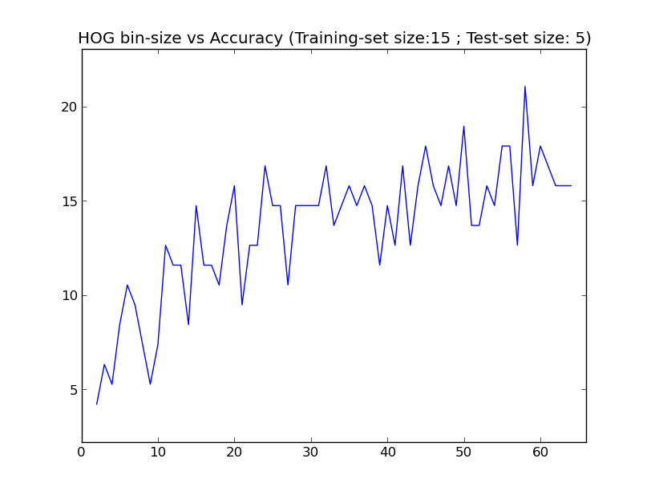

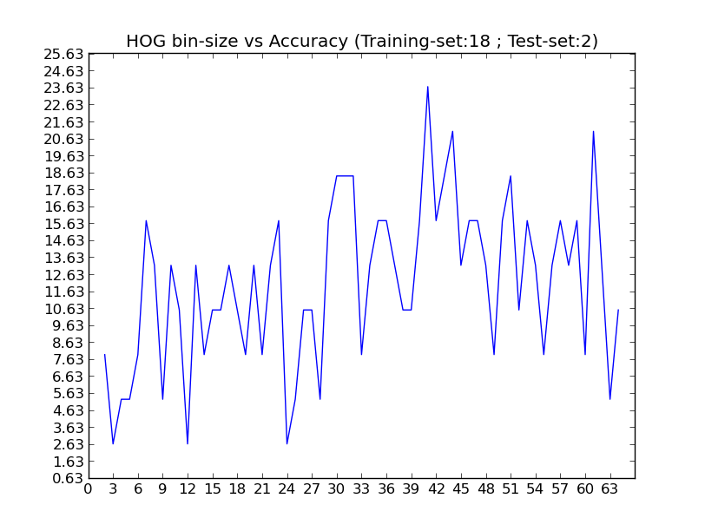
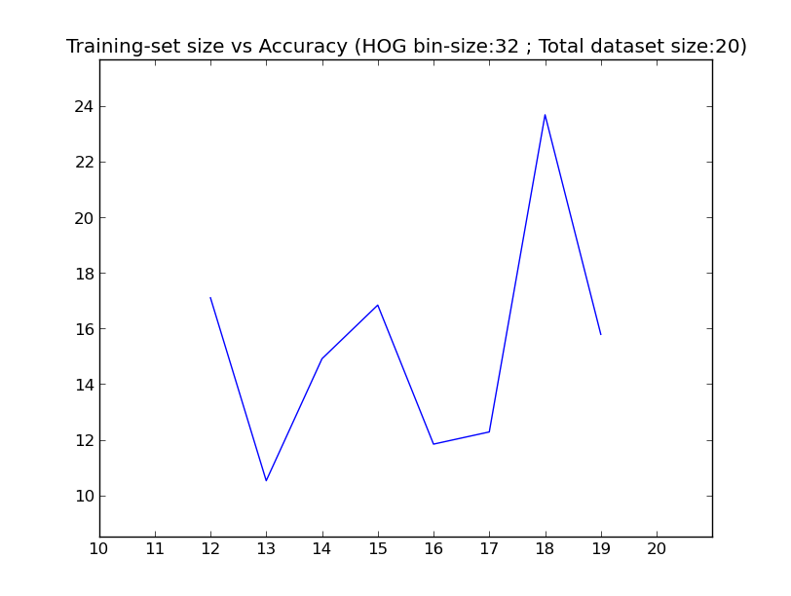

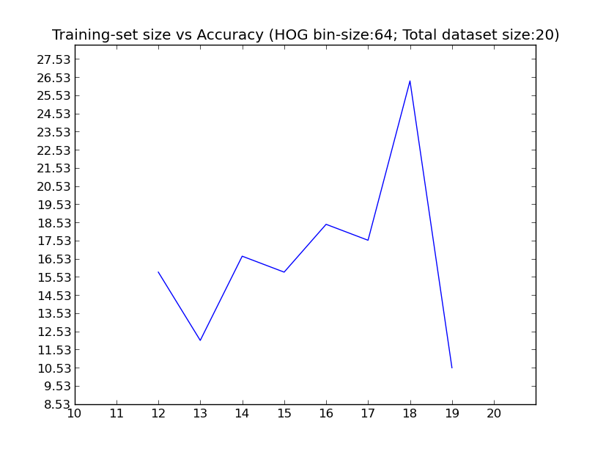
Selected categories of paintings

- Bengali school of art
- Cheriyall scroll
- Company paintings
- Haripur Guler
- Kalighat
- Kangra
- Kerala Mural
- Madhubani
- Manjusha
- Mughal
- Mysore
- Pahari
- Patna
- Phad
- Ragamala
- Rajput
- Shekawati
- Tanjore
- Warli

There is a sudden drop in the accuracy towards the end of the graph of training-set size vs accuracy. This is because when there are 19(out of 20) training images and 1 test image, there is a higher risk of classification. In general, this graph can be extrapolated to attain higher values of accuracy with increasing training-set size.

References

[0] - http://en.wikipedia.org/wiki/Category:Schools_of_Indian_painting
[1] - http://en.wikipedia.org/wiki/Indian_painting
[2] - http://www.itasveer.com/artsmart/articles/gallery/forms-of-indian-paintings

