MIS 5613
Data Mining & Text Analytics
GROUP PROJECT REPORT
Detecting Fake Job Postings: A Data-driven Approach

Presented by,

Sreenath Elisetty
Mohan Renuka Nanda Rayudu Oruganti
Harish Vemula
Harshad Rama Satya Sai Peddoju
Ques 1:
Provide a summary of your dataset, including its source, topic, number of records, and
attributes included. If you obtained the dataset through web crawling, please provide the
codes, and describe how you completed the task.
Ans 1:
Dataset name: Real/Fake Job Posting Prediction
Source: https://www.kaggle.com/datasets/shivamb/real-or-fake-fake-jobposting-prediction/data
Topic: Text classification/ Rating Classification.
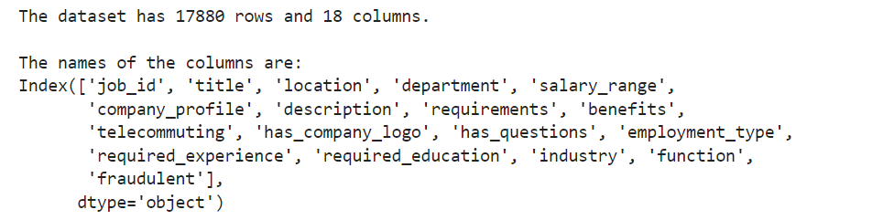
Figure 1: Shape of the Dataset and Data Column Name
Number of records: 17880.
Number of attributes: 18.
The dataset is collected from Kaggle to provide the solution to the pervasive problem of the fake job postings. Kaggle, an online platform for data analytics and predictive modeling competitions, allows to millions of users sharing and developing different kinds of applications. The short description of the attributes in the dataset is as follows
- job_id: A unique identifier for each job posting.
- title: The title of the job listing.
- location: The geographical location where the job is based, typically formatted as "Country, State, City."
- department: The department within the company that the job posting belongs to.
- salary_range: The salary range for the job, usually indicated by a minimum and maximum value.
- company_profile: A brief description of the company posting the job.
- description: A detailed description of the job, including duties, responsibilities, and other relevant information.
- requirements: The qualifications and skills required for the job, including education, experience, and technical competencies.
- benefits: The benefits provided by the employer, such as health insurance, retirement plans, or bonuses.
- telecommuting: A binary indicator of whether the job allows for telecommuting (working remotely).
- has_company_logo: A binary indicator of whether the company's logo is present in the job posting.
- has_questions: A binary indicator of whether the application process includes questions for the applicant.
- employment_type: The type of employment (e.g., Full-time, Part-time, Contract).
- required_experience: The level of experience required for the job (e.g., Entry level, Mid-Senior level, Director).
- required_education: The level of education required (e.g., Bachelor's Degree, Master's Degree, High School).
- industry: The industry to which the job belongs.
- function: The functional role of the job within the company (e.g., Sales, Marketing, Engineering).
- fraudulent: A binary indicator of whether the job posting is identified as fraudulent.

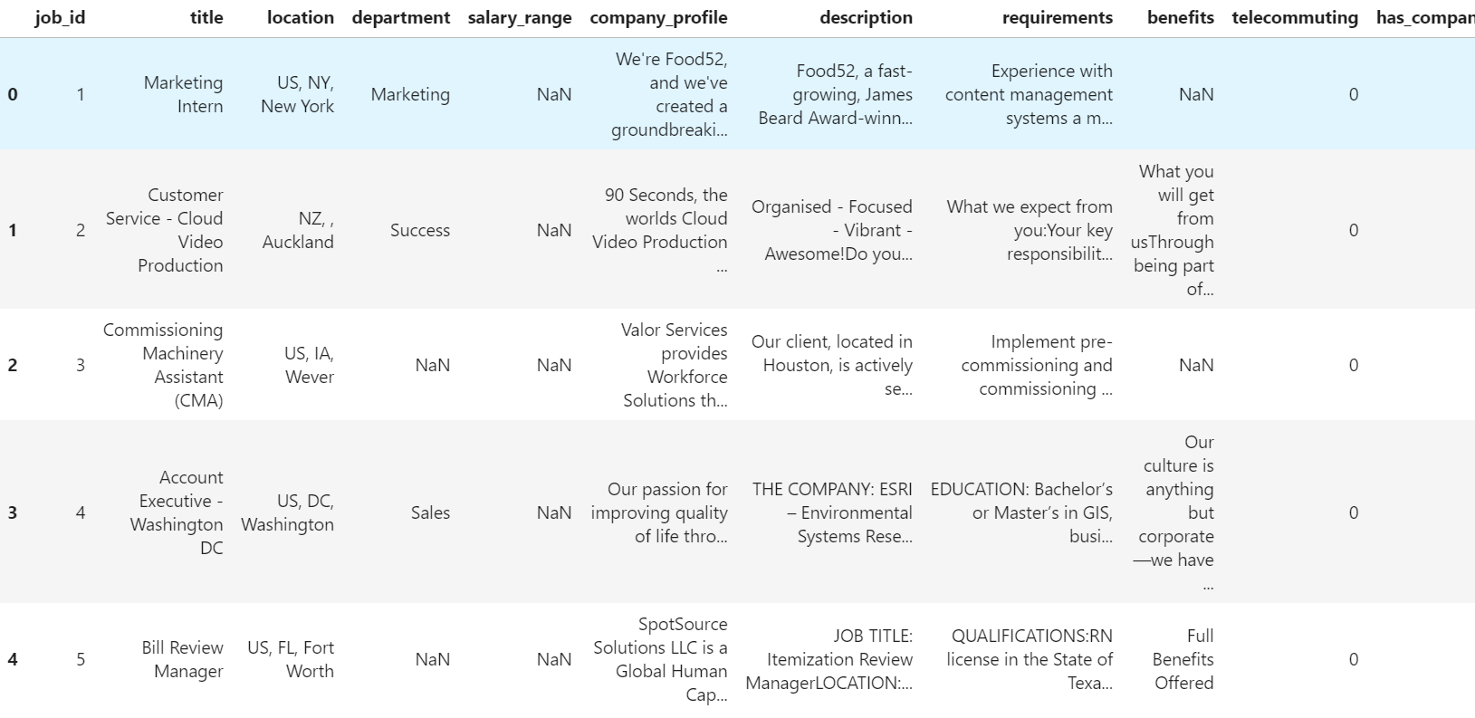
Figure 2: Dataset Preview
There are some attributes in the dataset, that contains some missing values as shown in the below picture.
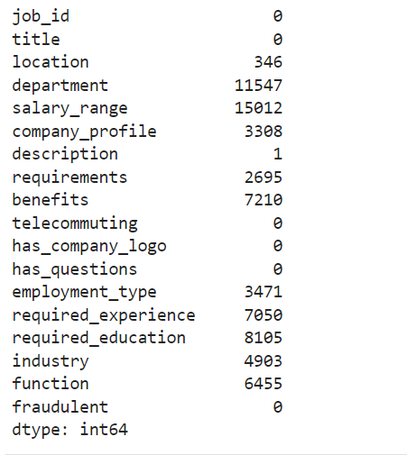
Figure 3: Missing Values Count in the Dataset
Ques 2:
Demonstrate how you preprocessed your dataset, including your codes and examples of
data records before and after preprocessing.
Ans 2:
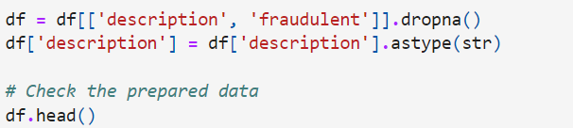
Figure 4: Preparing the Data

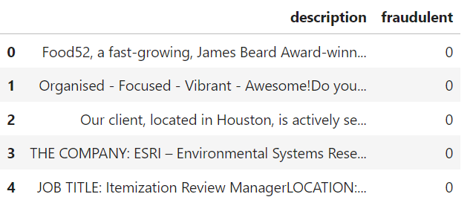
Figure 5: Text Data before Preparation
For preprocessing the dataset, we first narrowed down to essential attributes: 'description' and 'fraudulent', bringing empty rows to discuss the problem. Text 'description' undergoes a uniform to string transformation, which assures consistency. We then embarked on text normalization: normalizing the string downcase, segmenting the text to tokens and removing stopwords from it by using the Natural Language Toolkit (NLTK). We applied the method of filtering words that are not informational deleting them from the text. After that, we were able to revoke the non-sense and leave ergo in the text only the most significant facts. Through the data transformation with the 'cleaned_description', functions as the missing link which demonstrates now the dataset has the exact process to purge the descriptions, and to use them for further in depth analysis and for model training. This is the principle once an attention is pay into it, the result will be out.

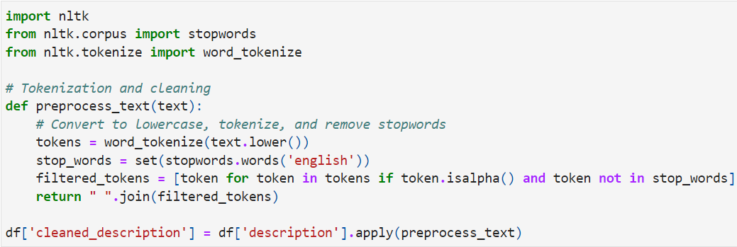
Figure 6: Function for Text Pre-Processing
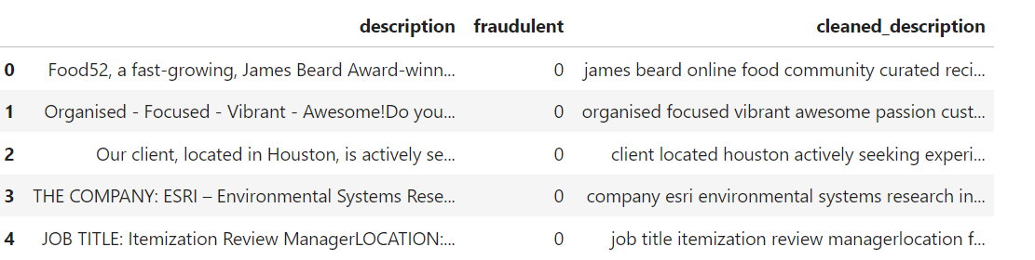
Figure 7: Text Data after Preparation

Ques 3:
Present the descriptive statistics of your dataset and highlight any findings from these
statistics.
Ans:
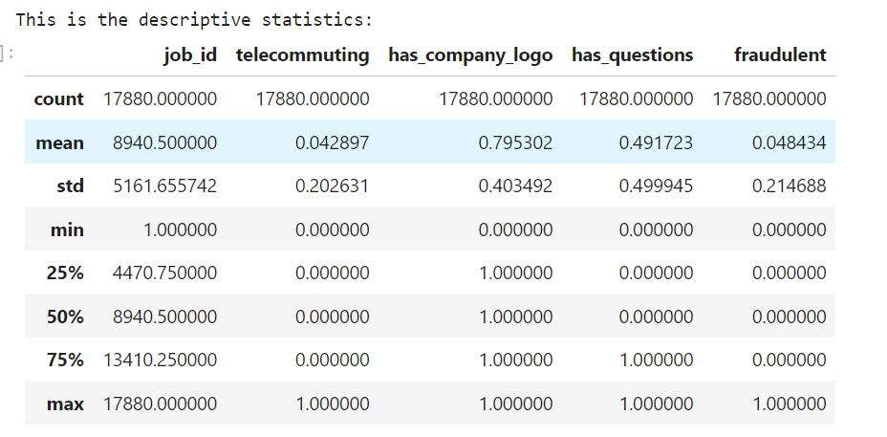
Figure 8: Descriptive Statistics
Job postings attributes are narrated in a descriptive way in order to help us obtain a quantitative summary of this dataset. It can be that analyzed 17,880 records and, on average, 'telecommuting' roles accounted for only 0.04 of the total. The 'has_company_logo' field in general scored fairly high [around ~0.79], implying most ads carried a company logo, therefore it can be assumed credibility. While the 'fake' label averaged in at 0.022, the 'fraudulent' one had a very low mean (~0.048), revealing that a small portion of the postings were obviously fake. This knowledge is an invaluable resource that enables a platform to make the verification measures robust and remain the most trustworthy in respect of the listings.
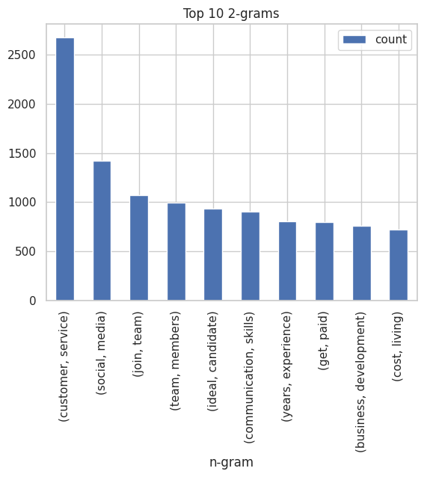
Figure 9: Top 10- 2-Grams
Bi-gram analysis promotes the determination of the most commonly occurring two-word expressions in the job description sections, in which "customer service" is the most frequently appearing and may be explained to a large extent by the requirements for the customer-oriented roles across industries. The prominent usage of such phrases as "team members" and "an ideal candidate" bring out candidate's value towards employers as one who is effective in collaboration and also meets employers' ideal requirements.
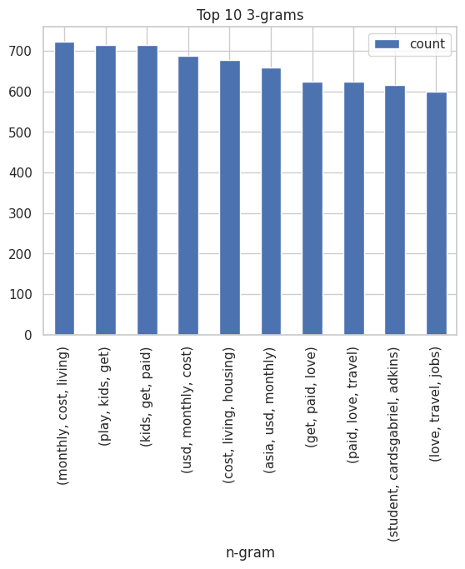
Figure 10: Top 10-3 Trigrams
The trigram distribution features governmental payments and citizen services such as "monthly living cost" and "children receiving pay for their work", which could mean these pages speak about compensation, cost-of-living adjustments, or family benefits. The repetitive mention of financial details certainly gives a strong hint at the necessity of job opening sections with intricate detail information for job seekers which in turn can play a role in applicant selection. The locution "paid love travel" presages a scene that includes job benefits related to travel that definitely will appeal to those who are a bit explorative and who value movement a lot in their career.
Ques 4:
Create basic plots (e.g., line chart, pie chart, column/bar chart, histogram, etc.) of your
dataset and discuss any observations drawn from these plots.
Ans:
Fraudulent Distribution
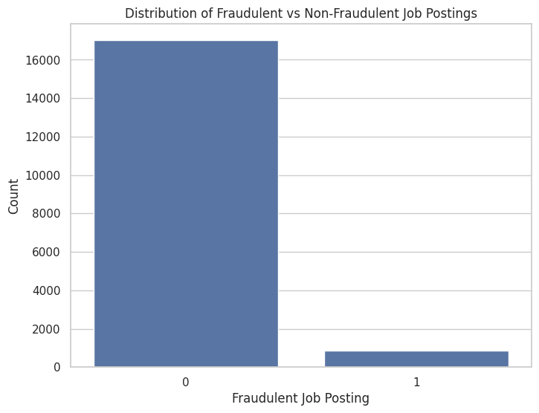
Figure 11: Distribution of Fraudulent vs Non-Fraudulent Job Postings
The graph illustrates a huge gap where there are over 16,000 postings on jobs that are not part of the fraud while as opposed to just 1,000 with fraudulent job posts. This means that a mere 5% of the listed job posts have label as fraudulent. Hence, one must be aware despite the lesser prevalence.
Logo Presence and Job Posting Authenticity
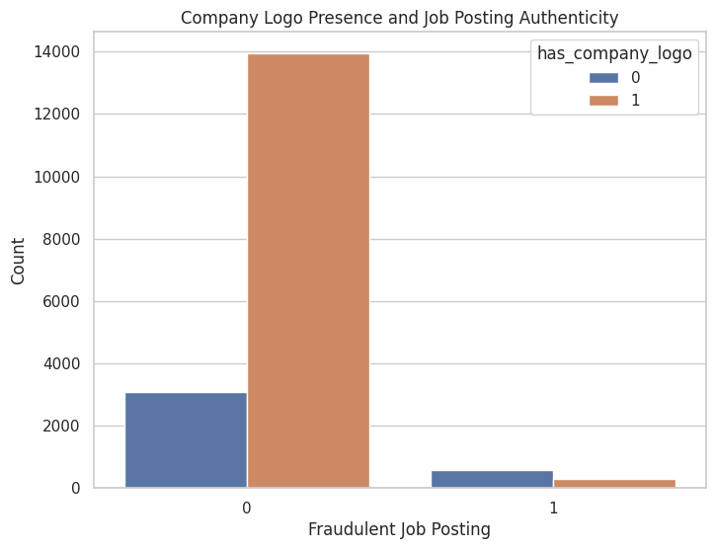
Figure 12: Logo Presence and Job Posting Authenticity
The absence of company logos is also interesting in the sense that they were present in approximately 13,000 genuine posts, while in fake posts this number was less than 2,000. While authentic postings carry logos 56% of the time and those without logos 44% of the time, logos alone cannot guarantee the truthfulness of a posting.
Top Industries with Highest number of Jobs
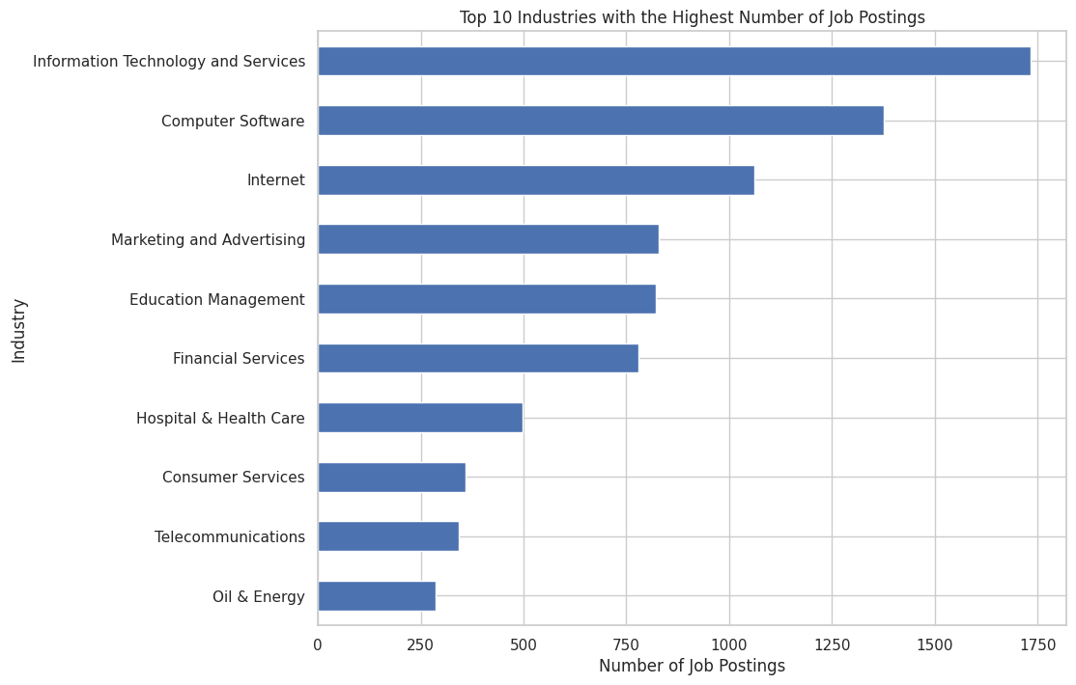
Figure 13: Top 10 Industries with Highest number of Job Posts
'Information Technology and Services' is the largest group with 1,750 vacancies, the others like 'Hospital & Health Care' = approximately 500. Those facts indicate higher demand for tech-related occupations, where 'Computer Software' and 'Internet' almost as much can be found.
Association between Employment Type and Fraudulent Job Posting
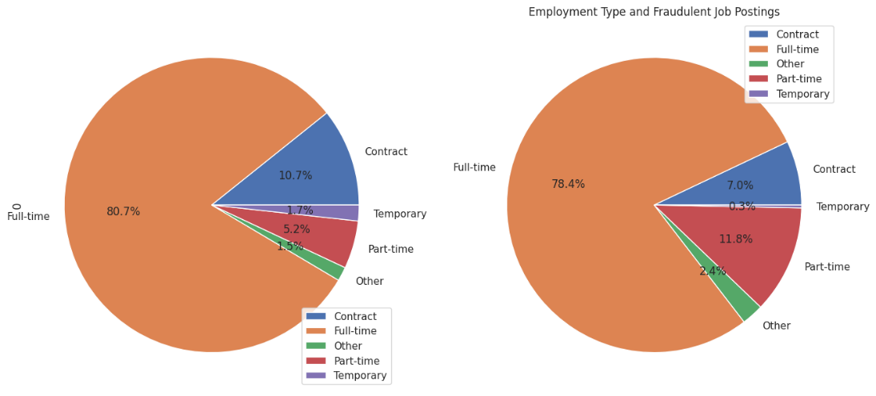
Figure 14: Employment Type and Fraudulent Job Posting
Full-time jobs make up 80.7% of the non-fraudulent advertisements and are a tad lower at 78.4% on the qv fraudulent ones. Part-timers occupy 5.2% of those legitimate jobs which then rise to 11.8% of fake postings across the web. As a matter of fact, this is one of bad guys’ tactics to lure job seekers seeking flexible work arrangements.
Job Posting Requirements Length and Authenticity
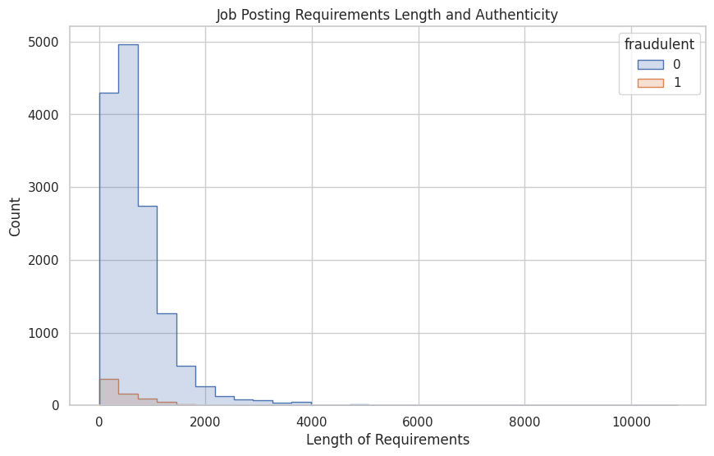
Figure 15: Job Posting Requirements Lengths and Authenticity
The histogram demonstrates evidently that the bulk of legitimate job postings contain the requirement lengths which are mainly concentrated in the bucket of 0-2,000 characters. Through the other side of the coin, fake postings demonstrate fewer requirement length consistency, while their counts are distributed more evenly across the different lengths, near none.
Word Cloud
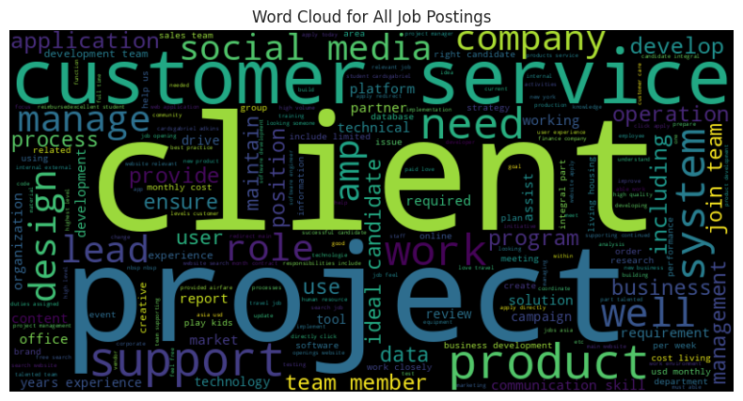
Figure 16: Word-Coud for all Job Postings
The most frequently repeated words such as "customer," "service," "project," and "management" would imply a job sphere of service-oriented positions with project management experience. The term "support" being repeatedly present and emphasized highlights the role of those who provide support – in other words – members of a business ecosystem.
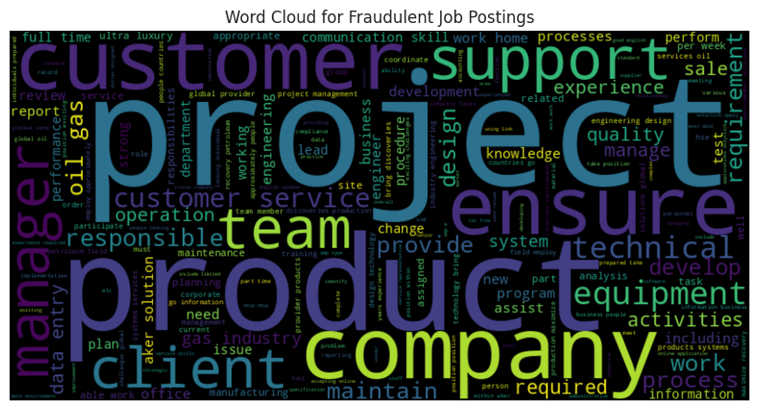
Figure 17: Word-Cloud for Fraudulent Job Posting
One of the typical techniques used by the fraudsters is a usage of well-known phrases like "customer", "client" or "support" in an idea that they try to arouse a feeling of similarity and trust among job seekers. These marketing tricks are called like "ultra" or "luxury", but such surprise peppy words might be the signs for the untrustworthy ads.
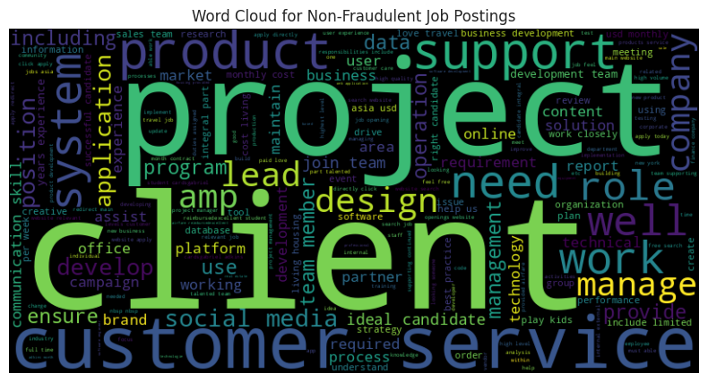
Figure 18: Word-Cloud for Non-Fraudulent Job Posting
Compared to non-fraudulent cases, the employments are not also criminalized. Hence, the professional terms such as "development," "management," and "application" are used to describe the market with a major focus on development and managerial attachments. These terms are meant to highlight the fact that customers should be regarded as individuals and proper help should be provided to them.
Term Frequency Distribution
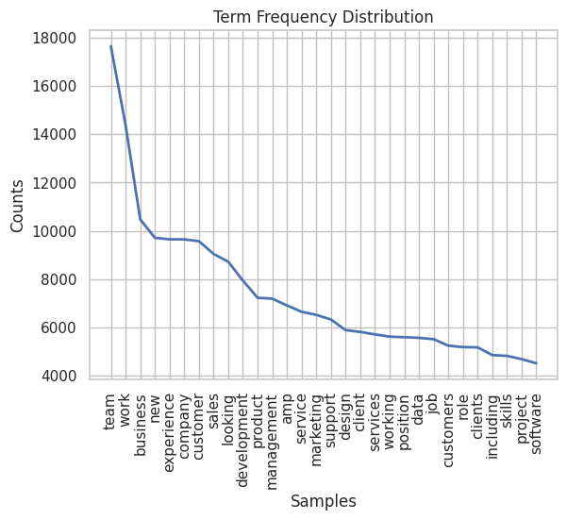
Figure 19: Term Frequency Distribution
This Term Frequency Distribution graph demonstrates an abrupt drop in the major feature of this distribution is the tenderness of term, which often represents key competency and simple task such as "team," "business," and "experience." However, the frequency of terms is significantly decreasing representing, which only a small number of terms is very common, but a large number of terms is rare.
Heat-map for Top Words in Fraudulent vs Non-Fraudulent Jobs
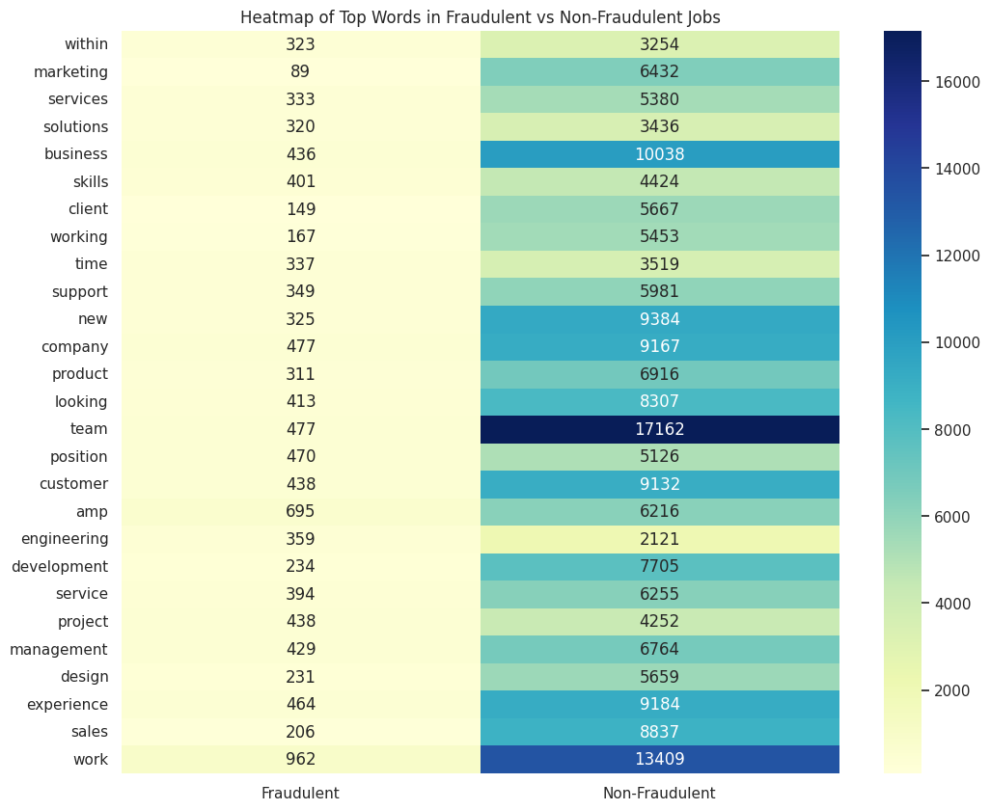
Figure 20: Heat-Map of Top Wprds in Fraudulent vs Non-Fraudulent Jobs
The Heatmap of Top Words in Fraudulent vs Non-Fraudulent Jobs shows the sharing of some words, but different frequency in both ends. Among these terms are words such as "team","business," and "customer", which are frequently found in authentic posting. With color differentiation in the two categories, implying their distribution, the discrepancy in intensity gives us a pictorial representation of it. While HTML tags such as "amp" (short of "amp") and the word "customer" are present in both available, these are more abundant in non-fraudulent listings, especially specifying customer service commitment in description of legitimate jobs.
Ques 5:
Explain how you selected your train/test dataset and provide the code used.
Ans:
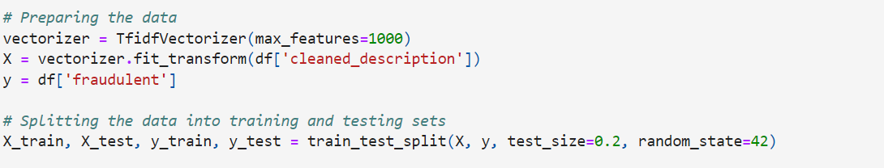
The train/test set was created from stratified sampling to ensure that both sets reflect the whole variety of data characteristics. With the help of sklearn.model_selection.train_test_split function, we split the data into 80% for training and the remaining 20% as a test set to preserve the balance of the true and false job postings. random_state parameter set to 42 was done for the sake of reproducibility. The text data was vectorized using TfidfVectorizer to convert the job descriptions after cleaning into numerical data well suited for the model. It took only the top 1000 features into consideration to select only the prominent words belonging to the data.

Ques 6:
Describe why you chose to use classification/prediction/clustering and the reasons for
your choice.
Ans:
Classification method was chosen mainly for its efficiency in classifying the data into groups that have pre-defined categories that are fundamental in differentiating between fake and actual advertised jobs. The labeled structure where the data is divided into two groups to make predictions is an implication towards supervised learning, in which past data feeds future predictions. Different from clustering, the classification operation enables the use of the labels, which are known, to train the model, this means that the model will predict with a more focused and accurate way. Furthermore, goal to automate the detection of fraud by postings of this nature also is driven by the need for a model making sharp distinctions trained on labeled samples.
Ques 7:
Specify the classifier you will use and explain your rationale for selecting it.
Ans:
Since a Decision Tree Classifier is easy to understand and comprehend and easily handles both numeric and categorical data, it was chosen. Its organization and hierarchy is very appropriate for binary classification problems such as separating fake and real job ads. First model training made evident a great potential, given fair balance between precision and recall, especially for true posts, which were classified with an extremely high accuracy. Fine-tuning through GridSearchCV promoted the model as well, determining more suitable parameters such as `max_depth` and `min_samples_leaf`, which greatly enhance the precision of torpedoed job postings. The ROC curves from both original and tuned models helped us to estimate the true positive and false positive rates, which were used for choosing the actual threshold level to classify the samples. A classifier's competence in matching such patterns within the data, made it suitable for us as an analytic tool in forecasting.
Ques 8:
Discuss your decision to use feature selection and the reasons behind it.
Ans:
The main point responsible for coming up with feature selection, was the cause of improving the precision and effectivness of the model. It does so by the reduction of the volume of uninformative and irrelevant content; thereby, helping to avoid overfitting by hiring model, which models learning and ends up by the decrease in the training time, thereby making it easier to focus on the features of job posting that are authentic to that particular job. It gets ever more critical in situations where there are a lot of dimensions in the data, as not all features have the same importance in the connection with the target variable in such cases.

Ques 9:
Indicate the type of text analysis you will perform and justify your choice.
Ans:
In the case of the data which will be discussed, we will carry out text classification subject to supervision using TFIDF as our text analysis method. Hence, this approach is legitimated as it rightly forms the component of words significance that the occupational descriptions entail and deforms the terms that occur unceasingly in every document. Through this balance, the content of each post gets a depth understanding , besides differentiating the scams form others is exactly what the analysis is about. TFIDF has already gained a reputation in the struggle with text classification tasks, so it is really a suitable exercise for our task.

Ques 10:
Describe how you will evaluate your model and how to interpret the results.
Ans:
The testing of our classification algorithms' performance is measured by the degree at which they correctly predict fraudulent job postings. The used metrics are precision, recall, f1-score, and accuracy – those are the values that definition matrix provides. Further, the ROC curve as well as AUC will be where the model will be evaluated based on its sensitivity to the probability of having either class within a certain threshold. Through precision of positive predictions we will treat the metrics of accuracy, balance the precision with the number of positive cases recognized and f1-score will become a composing parameter of the task. High values in corresponding metrics spell well for the model performance. ROC curve draws a graph depicting a changing ratio of true to false positives across different thresholds levels. The area under the curve is the AUC and its values are interpreted as follows: the bigger the AUC, the more accurate the classifier, the value of 1 means that the classifier is perfect, and the value of 0.5 shows that the classifier performs no better than chance.

Decision Tree Evaluation

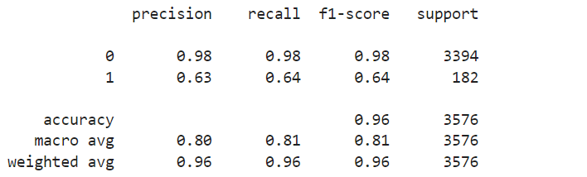
Figure 21: Classification Report of Decision Tree
The classification reports are the instruments that are used to get the quantitative insights into the performance history of the Decision Trees model, which is before and after tuning. For the initial Decision Tree model, the precision for benign postings is high, which supports the fact that the model is extremely effective in determining who does not commit a crime from among those that it labels as non-criminals. The recall is another indicator with a high value for this class, which implies that the model perfectly recreates most posts (apart from fraudulent ones). The F1-score, a precision and recall through balance indicator, has been shown to be high as well and suggest a good model especially for the class non-fraudulent class.
For fraudulent postings, we observe a reasonably high precision score, though somewhat lower than for true postings, which implies that only 63% of times when the model predicts a post is a fake, it is in fact true. We have the recording accuracy of 64% across all fraudulent postings which means we have 4% failed case in total number of posting. The F1-score for fraudulent publications reprimanded the machine learning developed model that still needs improvement which can lower false threats and false-alarm records.
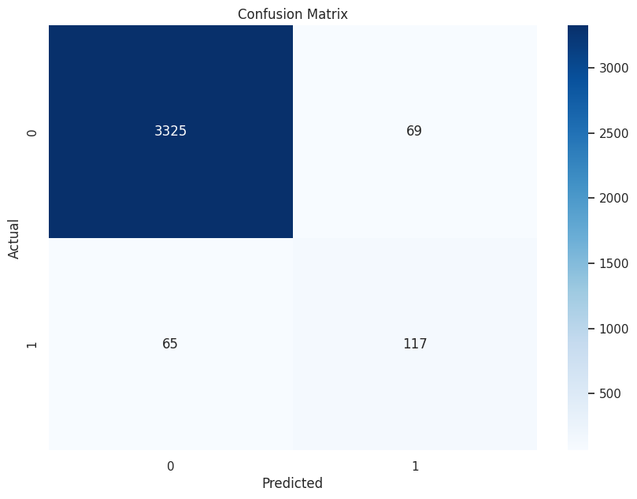
Figure 22: Confusion Matrix of Decision Tree
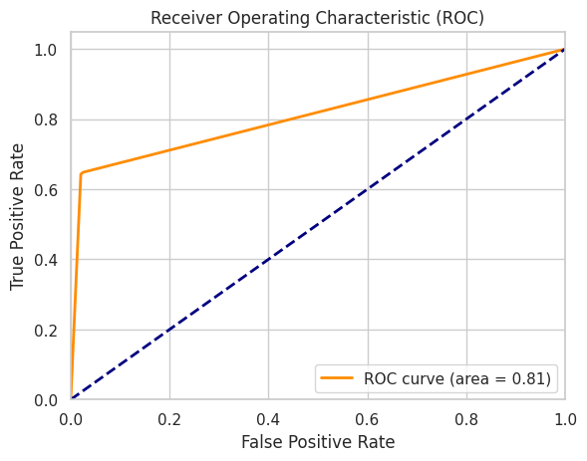
Figure 23: ROC Curve for Decision Tree

Tuned Decision Tree Evaluation
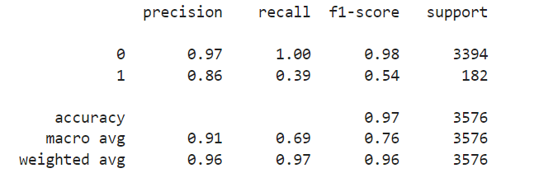
Figure 24: Classification Report of Tuned DecisionTree Mode
Following the model tuning, the precision of fraudulent postings becomes a lot better, it means that the model is generating less false-positives; it’s 86% accurate in cases when it sees fraud. The second approach is to use a generative language model, which leads to a big jump in accuracy to 89%. However, this also implies a sizable decrease in recall to 39%, which means that the model now misses a vast number of fraudulent postings—it is only able to correctly identify 39% of them. This trade-off becomes visible in the F1-score for the fraud class, it is lower than before, however, the model seems to be more conservative with its flagging fraud out, but at the same time not catching as many fraud cases.

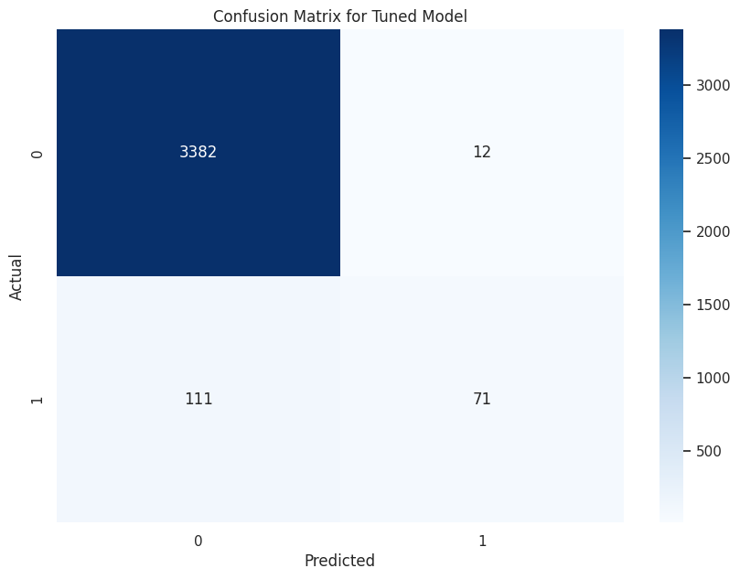
Figure 25: Confusion Matrix for Tuned Decision Tree
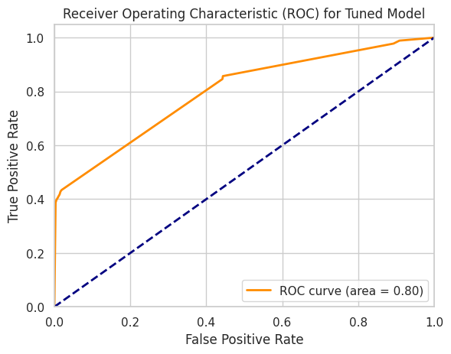
Figure 26: ROC Curve For Tuned DecisionTree Model

Ques 11:
If possible, present a plot of your model.
Ans:
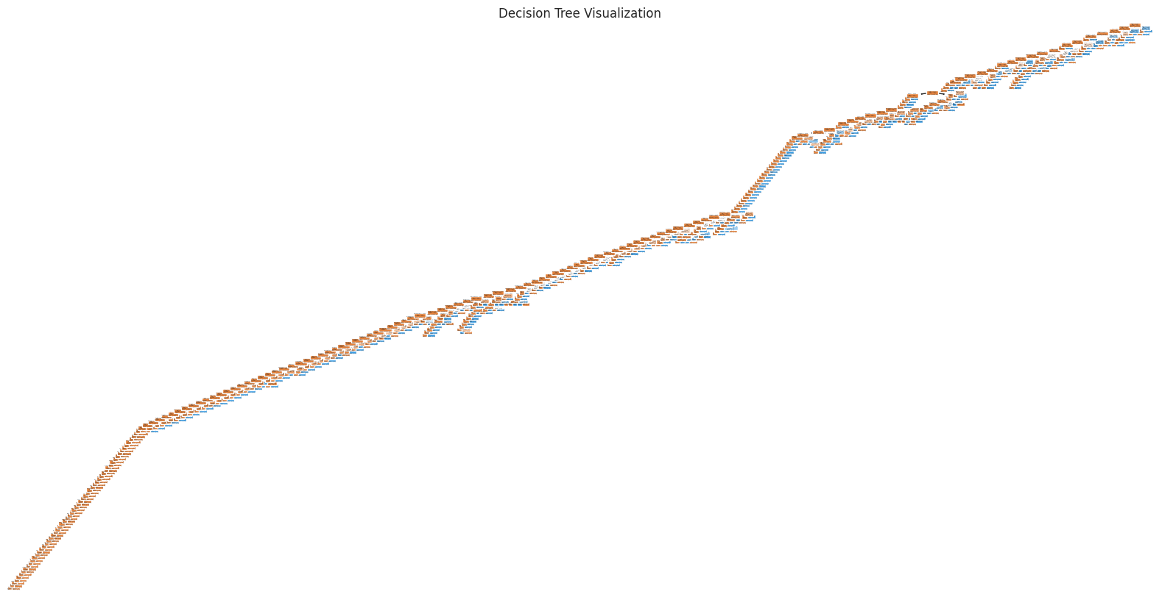
Figure 27: Plot for Decision Tree Model
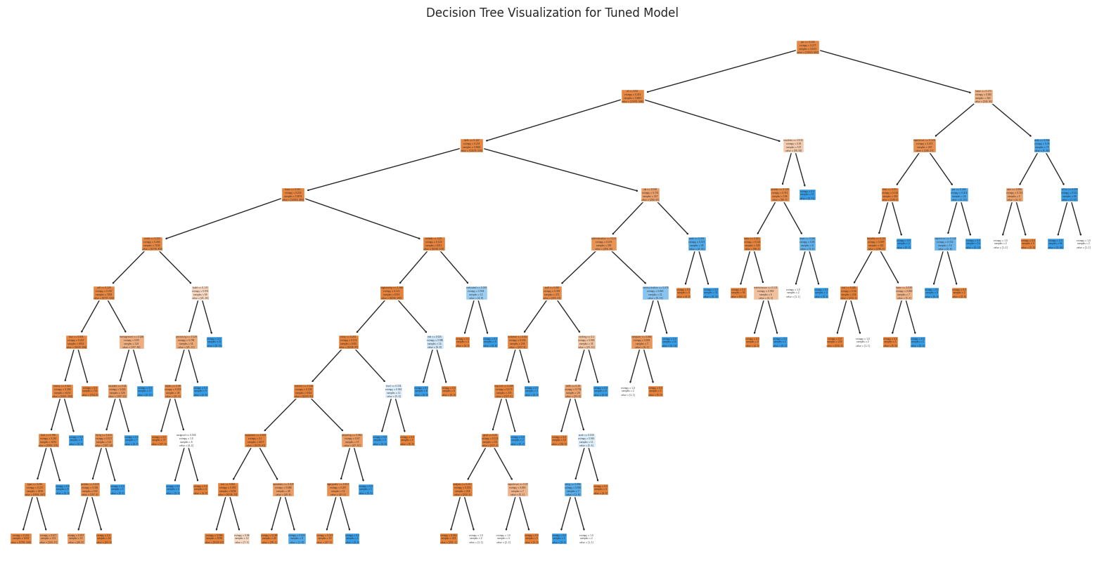
Figure 28: Plot for Tuned DecisionTree Model
Ques 12:
Summarize your findings from the dataset and outline the decisions/actions you propose
based on your report.
Ans:
The dataset had led us to the fact that certain parameters, such as an image of the company logo, can specify the job posting as official. Besides, some certain industries both for short time work and what work type are more liable to be exposed to false ads. Our model would have the capacity to differentiate spam postings from real ones which can then be used by job platforms as a tool to alert users of possible scams to help them avoid them and in turn, increase user trust and protection. Results show that platforms should to dive deep into the advertisements without using companies logos seriously and be watchful in those industries that are completely never green.
Ques 13:
You may also include any other interesting topics in your report
Ans:
Exploratory data analysis circumscribed the architecture of enriched understanding. Unlike word clouds, which if often used for the purpose of feature engineering, word clouds showed the underlying terms found in both fraudulent and non-fraudulent job postings and they might be useful in both the process of feature engineering and in developing better domain-specific preprocessing steps. The bi-gram and tri-gram analysis revealed a set of common phrases and expressions. This helped discovering the job description language's subtleties and intricacies at a deep level. This way, the researchers can work on their model accuracy through these findings and help the stakeholders be more literate about fraudulent job content, enabling them to create stronger fraud detection systems in the future.

