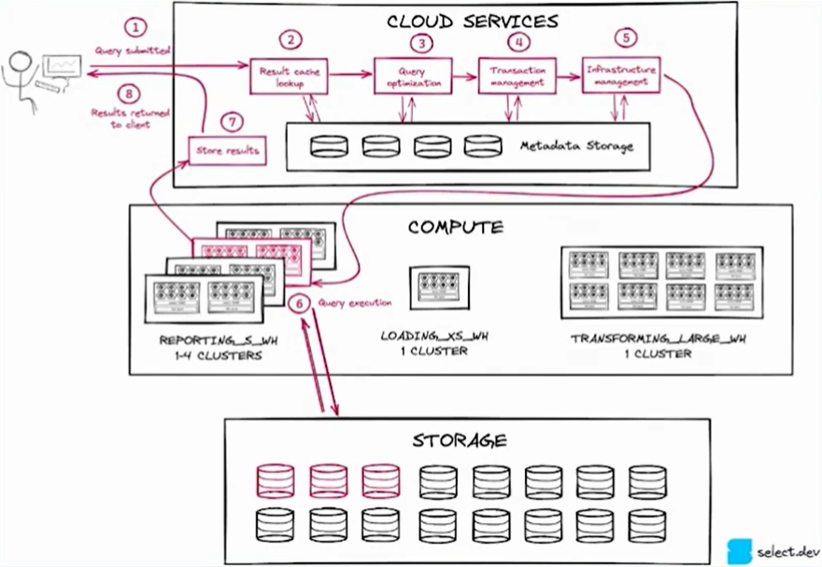
https://select.dev/posts/snowflake-query-profile
https://select.dev/posts/snowflake-warehouse-sizing

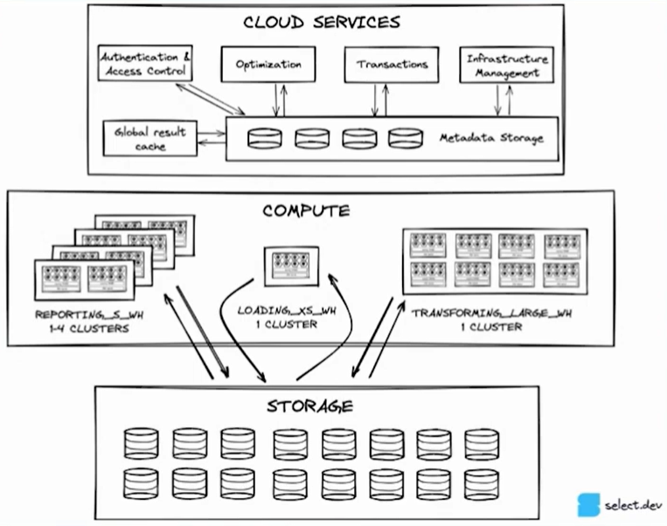
RWDS
Role
Warehouse
Database
Schema
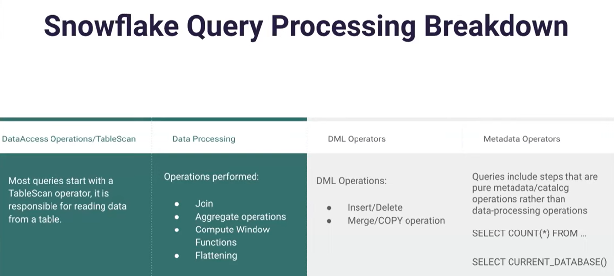
https://docs.snowflake.com/en/user-guide/query-acceleration-service
https://teej.ghost.io/understanding-the-snowflake-query-profile/
https://www.aicg.com/blog
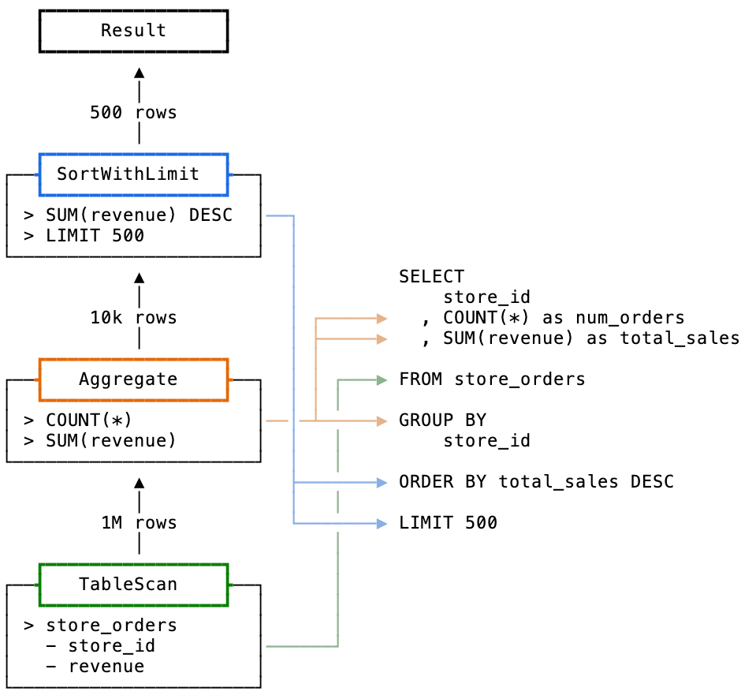 | SELECT  store_id  , COUNT(*) as num_orders  , SUM(revenue) as total_sales  FROM store_orders  GROUP BY  store_id

Query History:
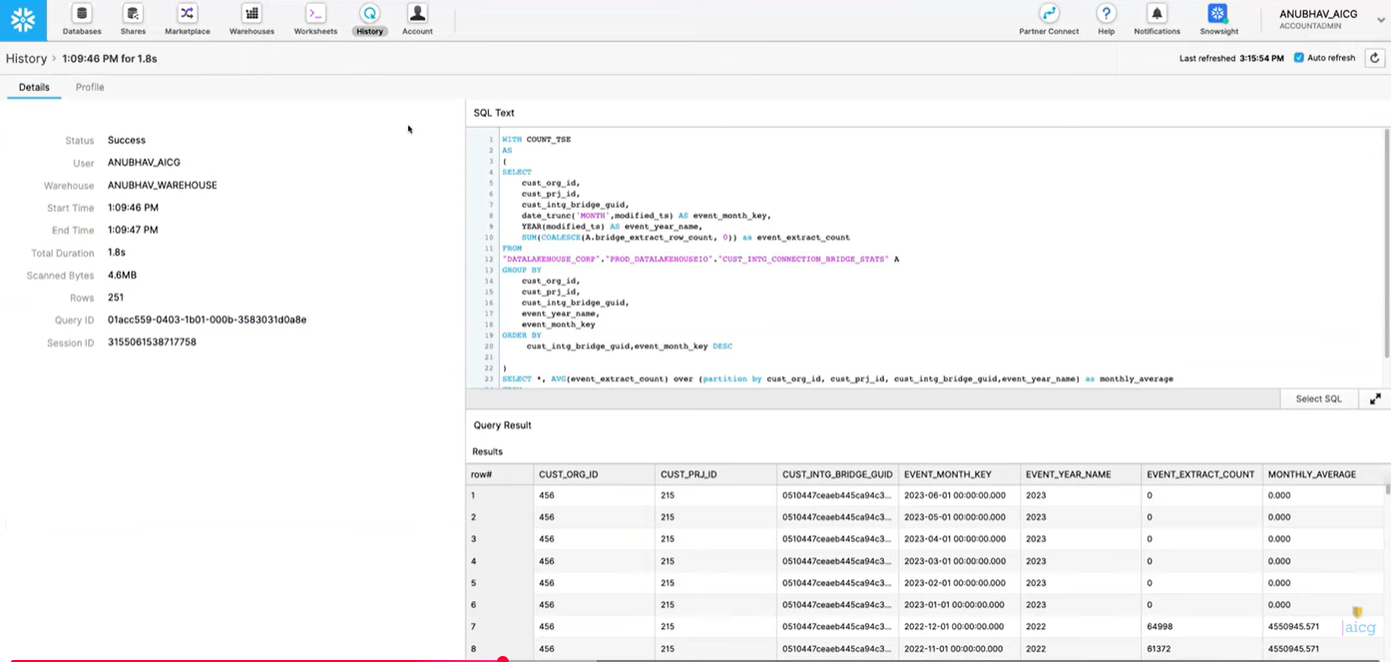

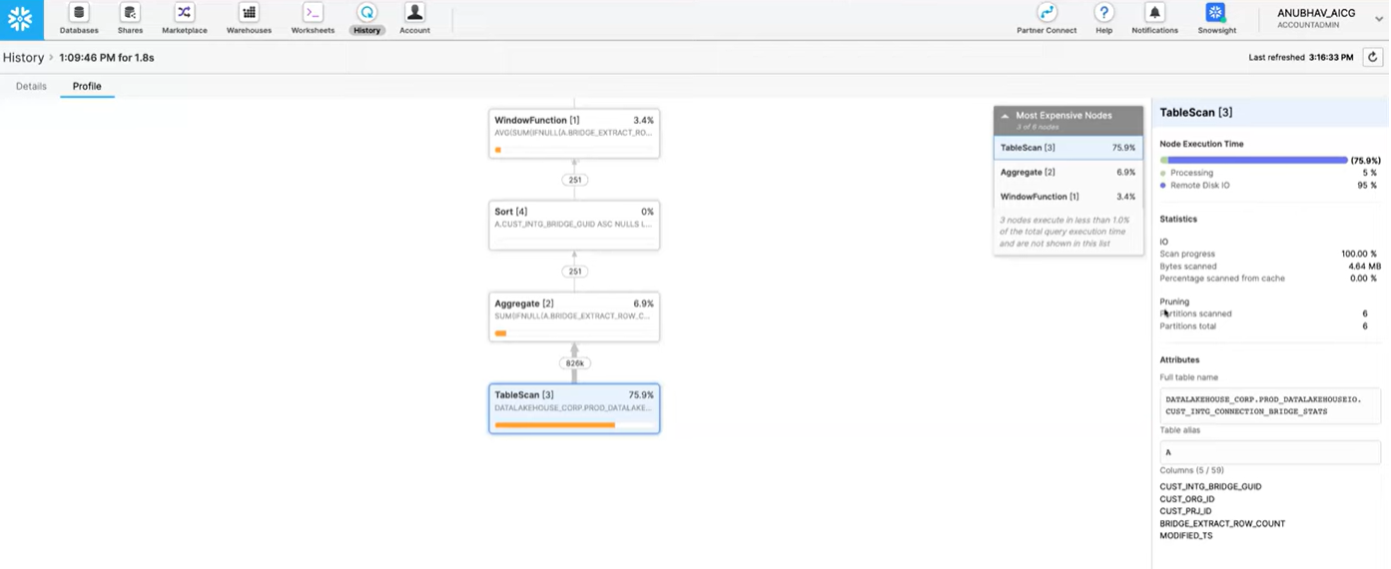

Common Query Problems
- Exploding joins
  - Avoid cartesian products
- UNION without ALL
- Queries too large fit in memory
- Use a large warehouse
- Process in smaller batches
- Inefficient Pruning
  - If pruning then partitions scanned < total partitions

Query Acceleration Service
https://docs.snowflake.com/en/user-guide/query-acceleration-service
Todo:
https://docs.snowflake.com/en/user-guide/tutorials/query-acceleration-service

Compare Query Performance
SELECT LAST_QUERY_ID();
SELECT query_id,
query_text,
warehouse_name,
total_elapsed_time
FROM TABLE(snowflake.information_schema.query_history())
WHERE query_id IN ('<non_accelerated_query_id>', '<accelerated_query_id>')
ORDER BY start_time;

SHOW WAREHOUSES LIKE 'my_wh'
Common reasons that queries are ineligible
Some queries are ineligible for query acceleration. The following are common reasons why a query cannot be accelerated:
- There aren’t enough partitions in the scan. If there aren’t enough partitions to scan, the benefits of query acceleration are offset by the latency in acquiring resources for the query acceleration service.
- Even if a query has a filter, the filters might not be selective enough. Alternatively, if the query has an aggregation with GROUP BY, the cardinality of the GROUP BY expression might be too high for eligibility.
- The query includes a LIMIT clause that prevents acceleration. QAS automatically determines which queries with LIMIT clauses (including those without ORDER BY) can be accelerated.
- The query includes functions that return nondeterministic results (for example, SEQ or RANDOM).
Execute the following statement to help determine if query acceleration might benefit a specific query:
SELECT PARSE_JSON(SYSTEM$ESTIMATE_QUERY_ACCELERATION('8cd54bf0-1651-5b1c-ac9c-6a9582ebd20f'));
Identify the queries in the past week that might benefit the most from the service by the longest amount of query execution time that is eligible for acceleration:
SELECT query_id, eligible_query_acceleration_time
FROM SNOWFLAKE.ACCOUNT_USAGE.QUERY_ACCELERATION_ELIGIBLE
WHERE start_time > DATEADD('day', -7, CURRENT_TIMESTAMP())
ORDER BY eligible_query_acceleration_time DESC;

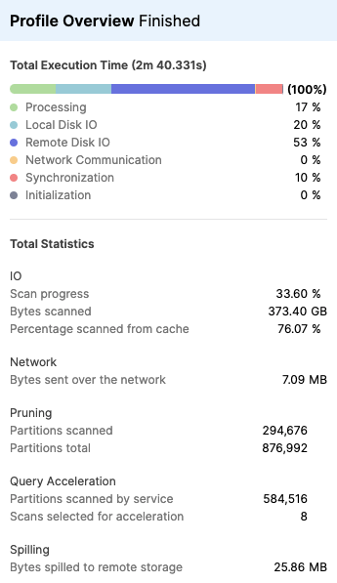

Data pruning
Data pruning (most commonly called partition pruning, query pruning, or micro-partition pruning) in Snowflake is one of the most important performance features of the platform. It allows Snowflake to dramatically speed up queries by skipping huge amounts of data that definitely cannot match your query filters — without ever reading it.
Core Idea: Snowflake Doesn't Store Data Like Traditional Databases
Snowflake stores tables in immutable micro-partitions (small files of roughly 50–500 MB uncompressed, often ~16–256 MB compressed).
- Every time you load/insert/update/delete data → Snowflake creates new micro-partitions (it never modifies old ones).
- Each micro-partition automatically collects very rich metadata, most importantly:
  - min and max values for every column
  - count of distinct values (in many cases)
  - null counts
  - other statistics
This metadata lives separately and is very cheap & fast to read.
How Pruning Actually Works (Step-by-Step)
When you run a query like:
SQL
SELECT *
FROM sales
WHERE order_date >= '2025-01-01'
AND region = 'Northeast'
AND amount > 1000;
Snowflake's query optimizer does this before reading almost any real data:
- Reads only the metadata of all (or many) micro-partitions of the table.
- For each micro-partition, checks:
  - Does the min/max range of order_date overlap with ≥ '2025-01-01'?
  - Does the min/max (or bloom filter / other stats) of region possibly include 'Northeast'?
  - Does the min/max of amount possibly include values > 1000?
- If any of these conditions clearly show "no rows in this micro-partition can match", Snowflake prunes (skips) that entire micro-partition — it never downloads or scans the actual data file.
- Only the micro-partitions that might contain matching rows are actually read → often just 1–5% of the table (or less).
In well-structured workloads, Snowflake regularly prunes 95–99%+ of the data before scanning anything.
Types of Pruning in Snowflake
- Filter pruning (most common) — based on WHERE clause predicates using min/max ranges
- Column pruning — within the remaining micro-partitions, only read the columns actually needed (Snowflake is columnar)
- Top-K / LIMIT pruning — for queries with ORDER BY + LIMIT, stops scanning once it knows no better rows exist in remaining partitions
- JOIN pruning — advanced forms can prune one side of a join early
- Search optimization pruning — when you pay for the Search Optimization Service, you get even finer pruning on point lookups, IN lists, etc.
What Makes Pruning Great vs. Poor?
Factor | Good Pruning (fast queries) | Poor Pruning (slow & expensive)
Data loading pattern | Time-series / monotonically increasing keys | Random inserts, heavy updates/deletes
Filter columns | Frequently filtered columns are low-cardinality & naturally ordered | High-cardinality filters on un-clustered columns
Clustering | Natural or explicit clustering key aligns with common filters | High overlap of min/max values across partitions
Typical pruning efficiency | 90–99%+ partitions pruned | < 50% pruned (scans almost everything)
You can check pruning effectiveness with:
- SYSTEM$CLUSTERING_INFORMATION('your_table')
- Query profile (look for "Partitions scanned" vs "Partitions pruned")
- ACCOUNT_USAGE.TABLE_PRUNING_HISTORY view
In short: Pruning = not processing data you don't need → it's often the #1 reason Snowflake queries are fast and cheap even on multi-petabyte tables. Getting your data naturally ordered (or using clustering keys) to help pruning is one of the highest-ROI performance tunings in Snowflake.
Bottom line: Yes — a query with no effective filter is usually "bad" in Snowflake terms because it disables the platform's #1 performance feature (pruning), forcing full scans and driving up cost/time unnecessarily on anything beyond toy-sized tables.

if we have micro parition it creates a metadata for each partition, does it downloads the data from file only when it matches. the file work independetly for any updates or inserts that may happen during transaction

Yes — your understanding is mostly correct, and I'll clarify it step by step based on how Snowflake actually works under the hood.
1. Metadata is created for each micro-partition at creation time
- Every time Snowflake loads/inserts data → it automatically creates new micro-partitions (immutable files/objects in cloud storage, ~50–500 MB uncompressed).
- At the moment of creation, Snowflake computes and stores rich metadata for that micro-partition in its cloud services layer (fast & separate from data files):
  - min/max values for every column
  - number of distinct values (approx. in many cases)
  - null counts
  - other stats (bloom filters for some equality predicates, etc.)
- This metadata is guaranteed correct because micro-partitions are immutable — once written, the data & metadata never change.
2. During a query: Does Snowflake download data files only for matching micro-partitions?
Yes — exactly.
The process is:
- Snowflake's query optimizer reads only the metadata of all (or a large sample of) relevant micro-partitions for the table. This is very fast & cheap — metadata is tiny and cached/optimized.
- For each micro-partition, it checks the metadata against your query's WHERE predicates (and sometimes JOIN conditions).
  - If the metadata proves no possible matching rows (e.g., filter value outside min/max range) → prune (skip) that entire micro-partition → no data file is downloaded or read.
  - If the metadata shows it might contain matches (ranges overlap or no decisive info) → Snowflake downloads/reads the actual data file(s) for that micro-partition from cloud storage.
- Then, within those remaining micro-partitions:
  - It applies column pruning (reads only needed columns — columnar format).
  - Applies the full filter again (metadata is approximate for some cases).
  - Returns matching rows.
→ Result: On well-pruned queries, Snowflake often reads only 1–10% (or less) of the total data files — huge savings in I/O, time, and credits.
If no filter → almost nothing gets pruned → reads nearly all data files → expensive.
3. How do inserts, updates, deletes work with immutable micro-partitions?
Micro-partitions are immutable by design — Snowflake never modifies an existing file. This is key for concurrency, time travel, zero-copy cloning, etc.
- INSERT (new rows):
  - Creates new micro-partitions with the new data.
  - Old ones stay untouched.
  - New metadata generated only for the new partitions.
- UPDATE or DELETE (or MERGE):
  - Snowflake reads the affected rows from old micro-partitions (using pruning where possible).
  - Applies the changes logically.
  - Writes new micro-partitions containing the updated/deleted version of the data.
  - Marks the old micro-partitions as obsolete (logically deleted) in metadata — they are no longer visible in current queries.
  - Old ones are not immediately deleted from storage → they enable Time Travel (query as-of past timestamps) and Fail-safe (7-day recovery).
  - After the retention period (Time Travel + Fail-safe), Snowflake garbage-collects them to reclaim storage.
→ Important: Updates/deletes can temporarily create more micro-partitions and some fragmentation (wider min/max ranges → weaker future pruning). This is why clustering keys + automatic/re-clustering help reorganize data over time for better pruning.
Quick Summary Table
Operation | Downloads existing data files? | Creates new micro-partitions? | Old partitions modified? | Impact on pruning (future queries)
INSERT | No (unless streaming/very small) | Yes — new ones only | No | Usually good (fresh metadata)
UPDATE / DELETE | Yes (reads affected old ones) | Yes — replacement ones | No — marked obsolete | Can worsen temporarily (fragmentation)
SELECT (with filter) | Only for non-pruned partitions | No | No | Excellent if good clustering
SELECT (no filter) | All relevant partitions | No | No | Poor — full scan
This immutable + metadata-driven approach is one of Snowflake's biggest architectural wins — it enables massive scale, concurrency without locks, and aggressive pruning.
If you have a specific scenario (e.g., heavy-update table and poor pruning), or want to see how to check this in Query Profile / SYSTEM$CLUSTERING_INFORMATION, let me know!

