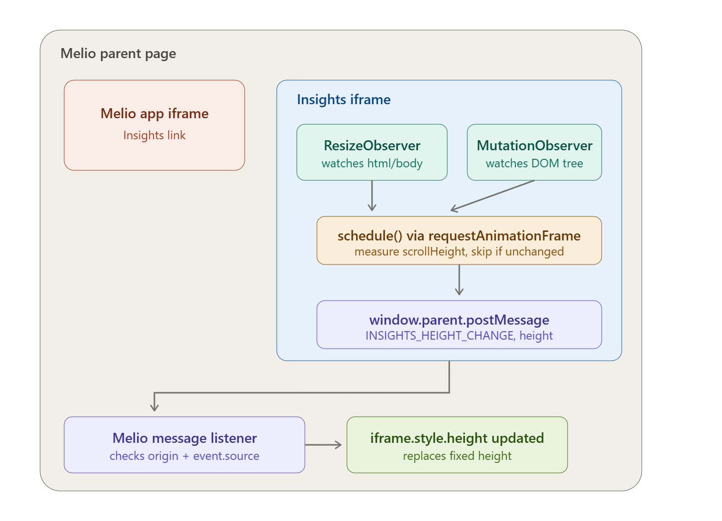
The teal boxes are the actual "observer pattern" piece (ResizeObserver/MutationObserver) — they detect layout changes inside the Insights iframe. That feeds into the amber debounce step, then the purple postMessage call crosses the iframe boundary into Melio's listener, which validates and applies the new height to the iframe element.

DOM change → ResizeObserver / MutationObserver (DOM observers, inside iframe)
→ postMessage event (the notification to the subscriber)
→ Melio's message listener (the subscriber)
→ iframe.style.height updated

