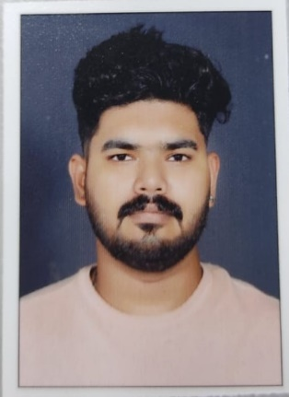

VISHNU TV

Thrikkazhikunnuvariyam
Valambilimangalam
Sreekrishnapuram
Palakkad
Pin:679513
Kerala
Pho:8943460925
Mail ID: vishnuvariyer@gmail.com

- Objective

To acquire a challenging position by utilizing my technical skill. I would
Constantly look out for challenges , which would help me to acheive my personal and professional goals.

- Strengths

- Flexible Personality.
- Hard Working.
- Co-operations as team member.
- Good Communication.

- Achievements

- Able to Prove Best Employee of the Organization Timely complete the work
- Flexibility & adaptability to work in any environment
- Good team player & positive Attitude.

- Educational Qualification

SL.NO | Course | College/School | PERCENTAGE
1 | SSLC | SREEKRISHNAPURAM HSS | 75
2 | PUC | SREEKRISHNAPURAM HSS | 73
3 | ITI | MALAMPUZHA GOVT ITI | 77
4 | DIPLOMA  (TOOL&DIE) | KUNNAMKUKAM GOVT POLYTECHNIC | 82
5 | POST DIPLOMA  (TOOL DESIGNING) | PURSUING | 8.6

- Additional Qualification

- Auto Desk Fusion
- Auto Cad, master Cam
- Basic computer
- MS Office Excel,Word,Power Point
- CNC Programing

- Previous Employer

- Company - LIBRA ENGINEERING WORK
- Designation - TOOL ROOM MICHINING.(CONVENCTIONAL)
- Duration - 1 YEAR

Personal Information
I considered myself to be a friendly type person and good team player. I have good analytical approach towards any kind of situations along with excellent problem solving skills.

Name : Vishnu T V
Father’s Name : Venugopalan TV
Sex : Male
Date of Birth : 19-08-1998
Status : Single
Religion : Hindu
Nationality : Indian
Passport No : -
Email : vishnuvariyer@gmail.com

Languages known : Malayalam, English,Tamil

