**COMPONENTS**

1. **ACS71230A**

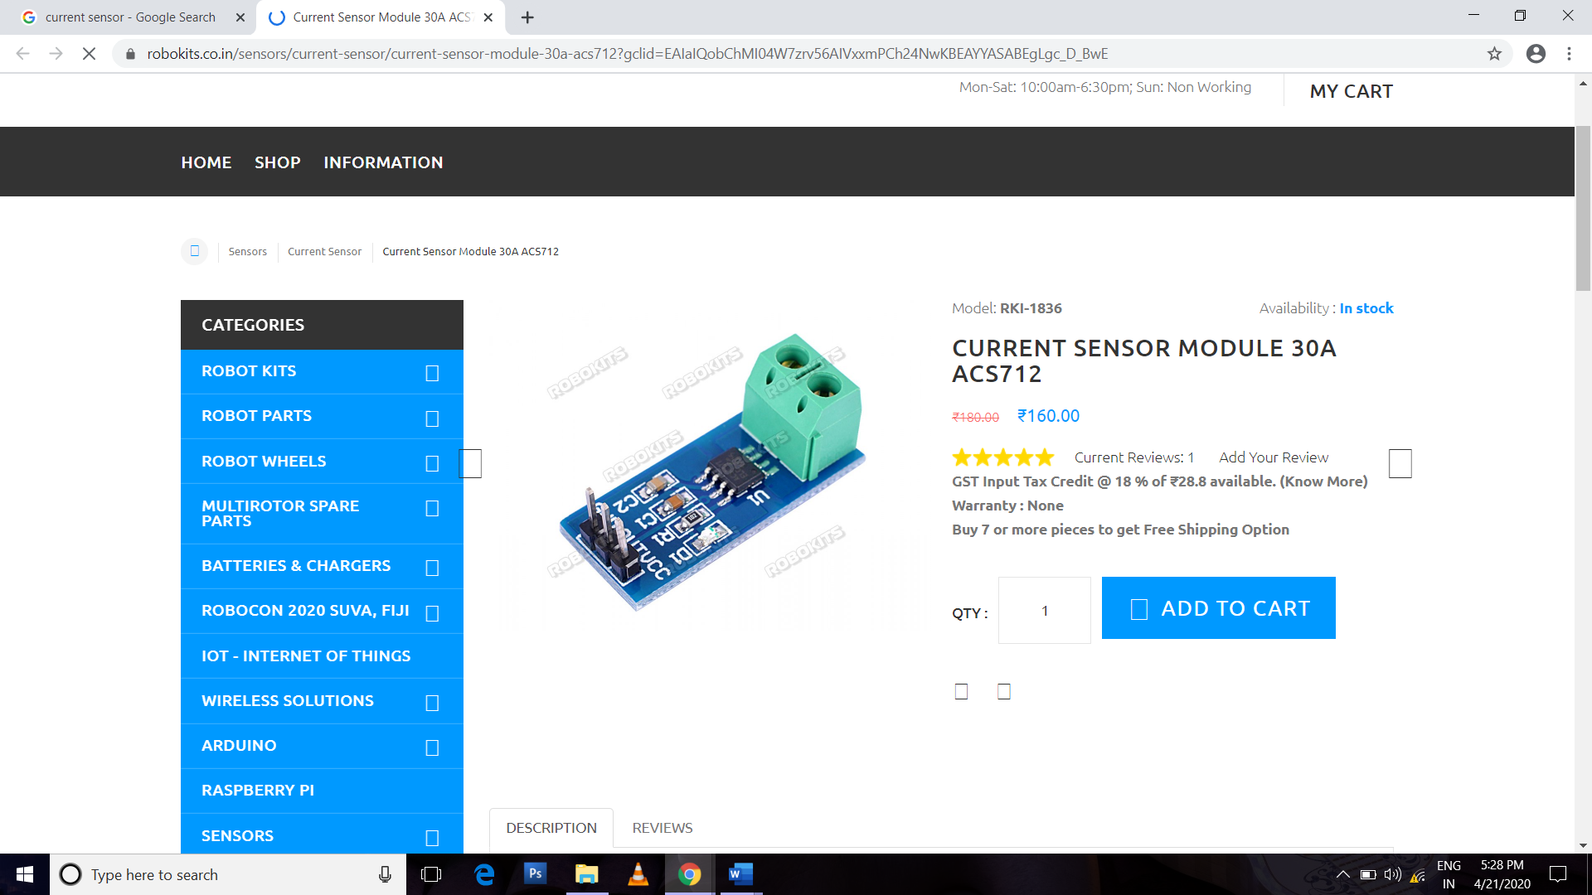

1. **PIR**

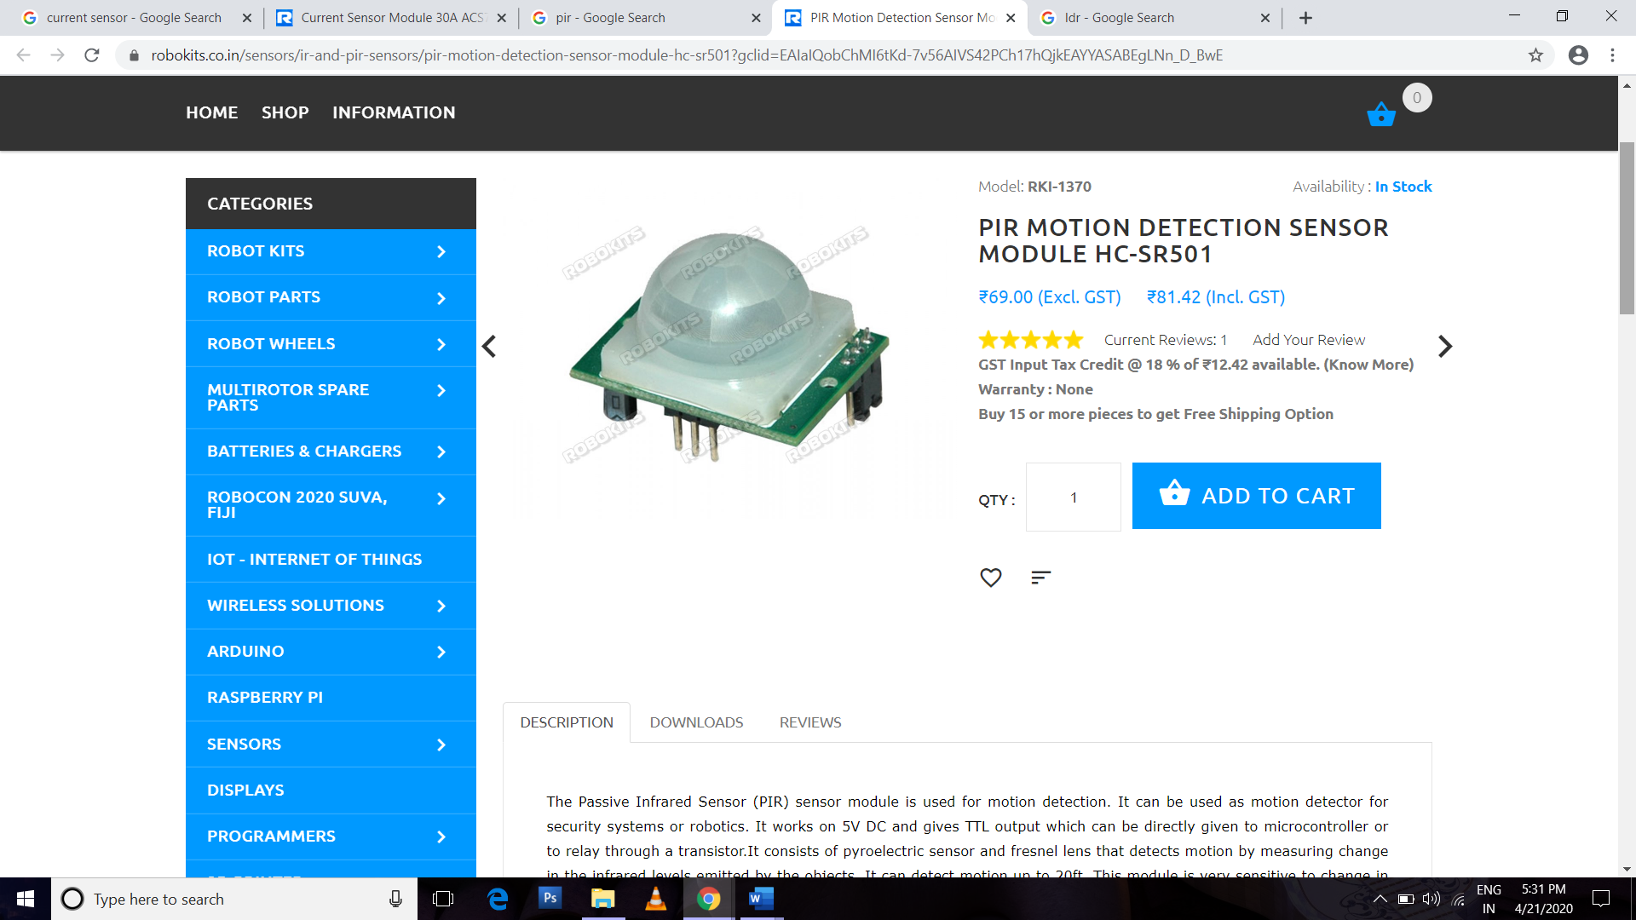

1. **Relay Module**

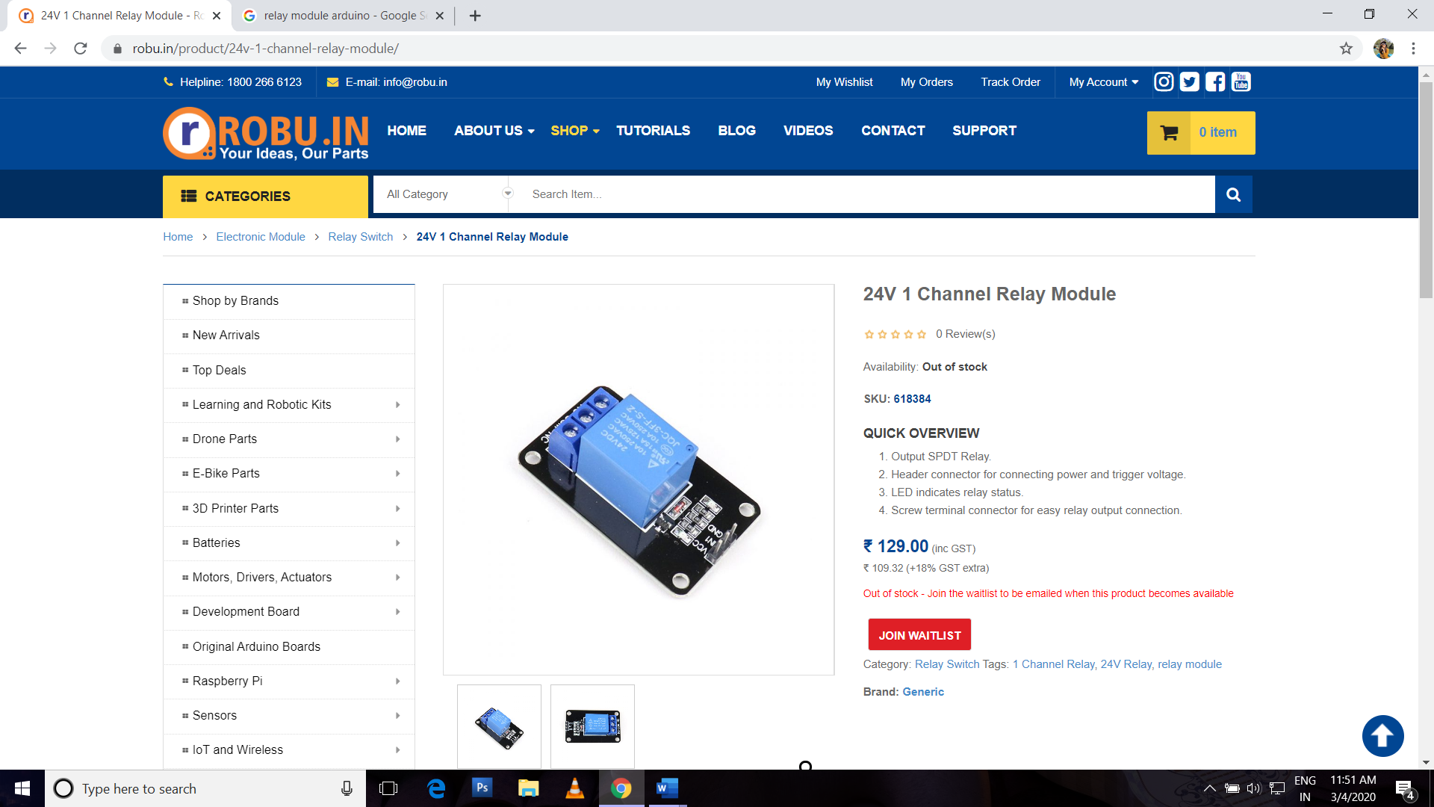

1. **LDR * 5**

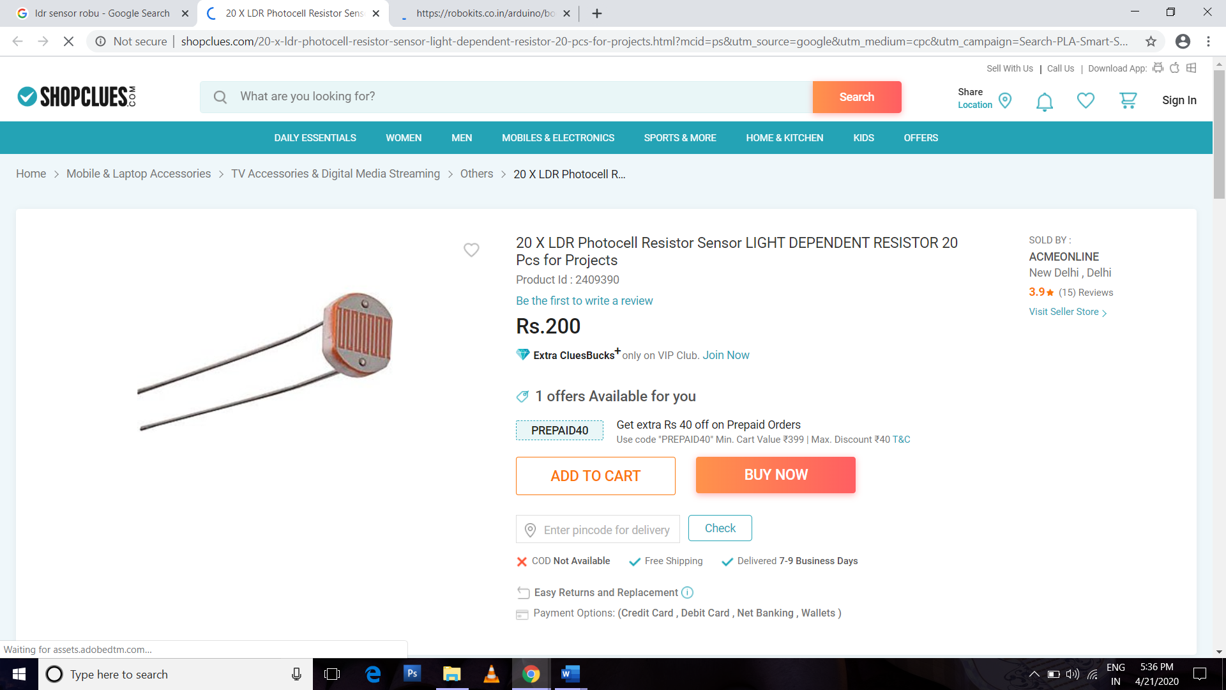

1. **Atmega328**

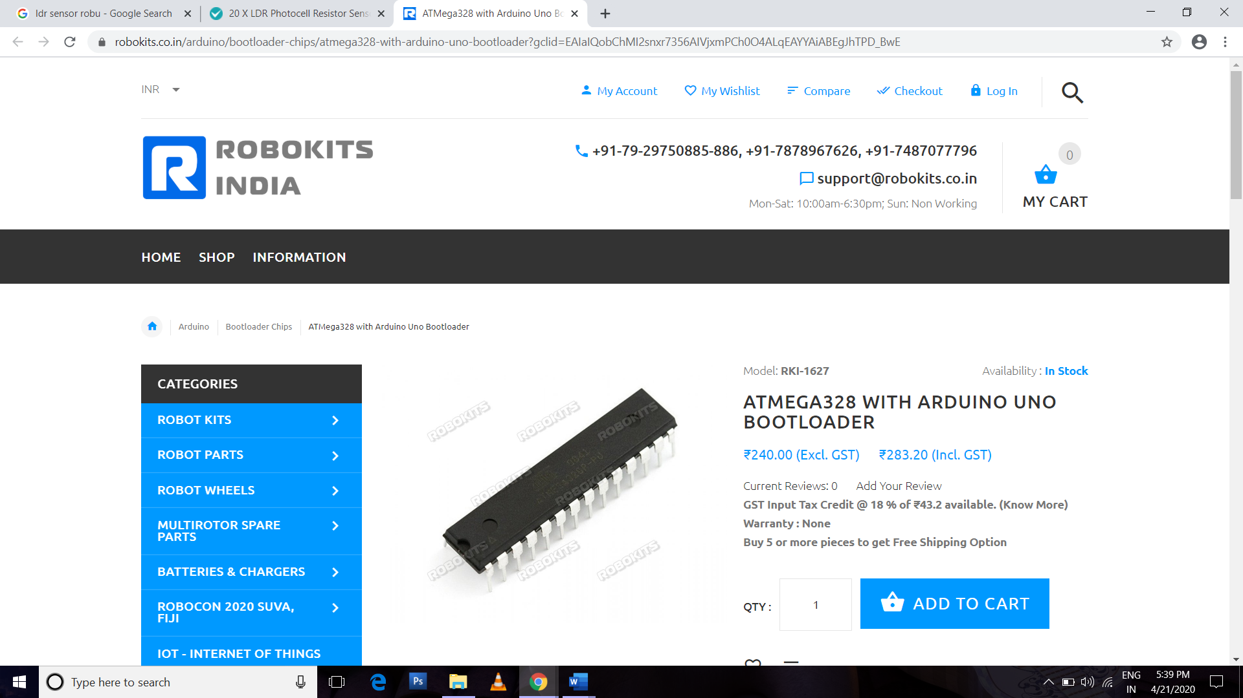

1. **GSM800sim**

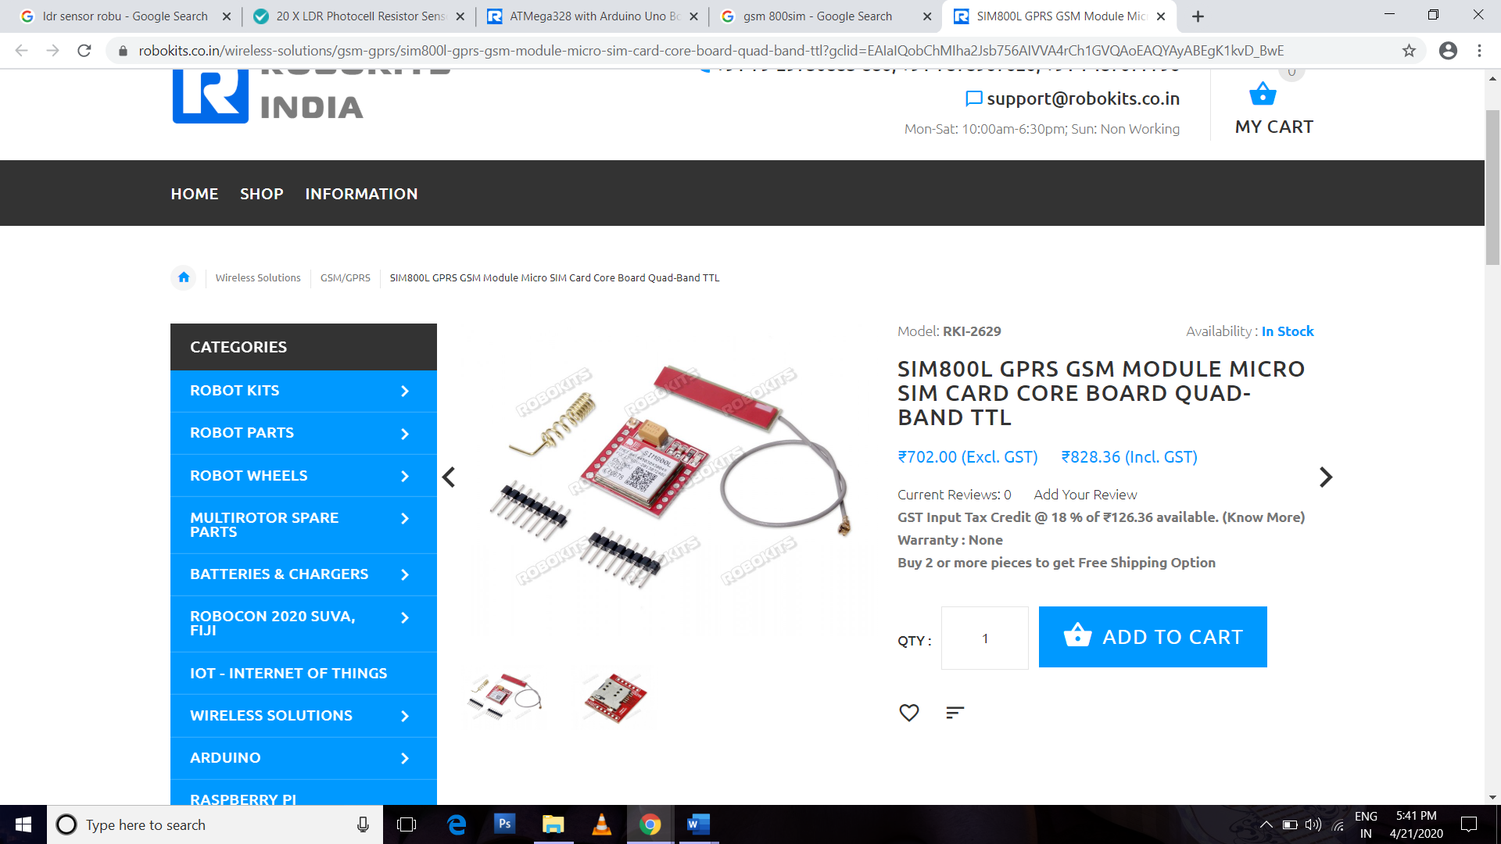

1. **LED ac bulb**
2. **Jumper wires**