Week 3
Task 1: To Create Main Loop, Display Prompt, Read User Input, Handle Exit Conditions, Design Control Flow Diagram, Test Interactive Loop
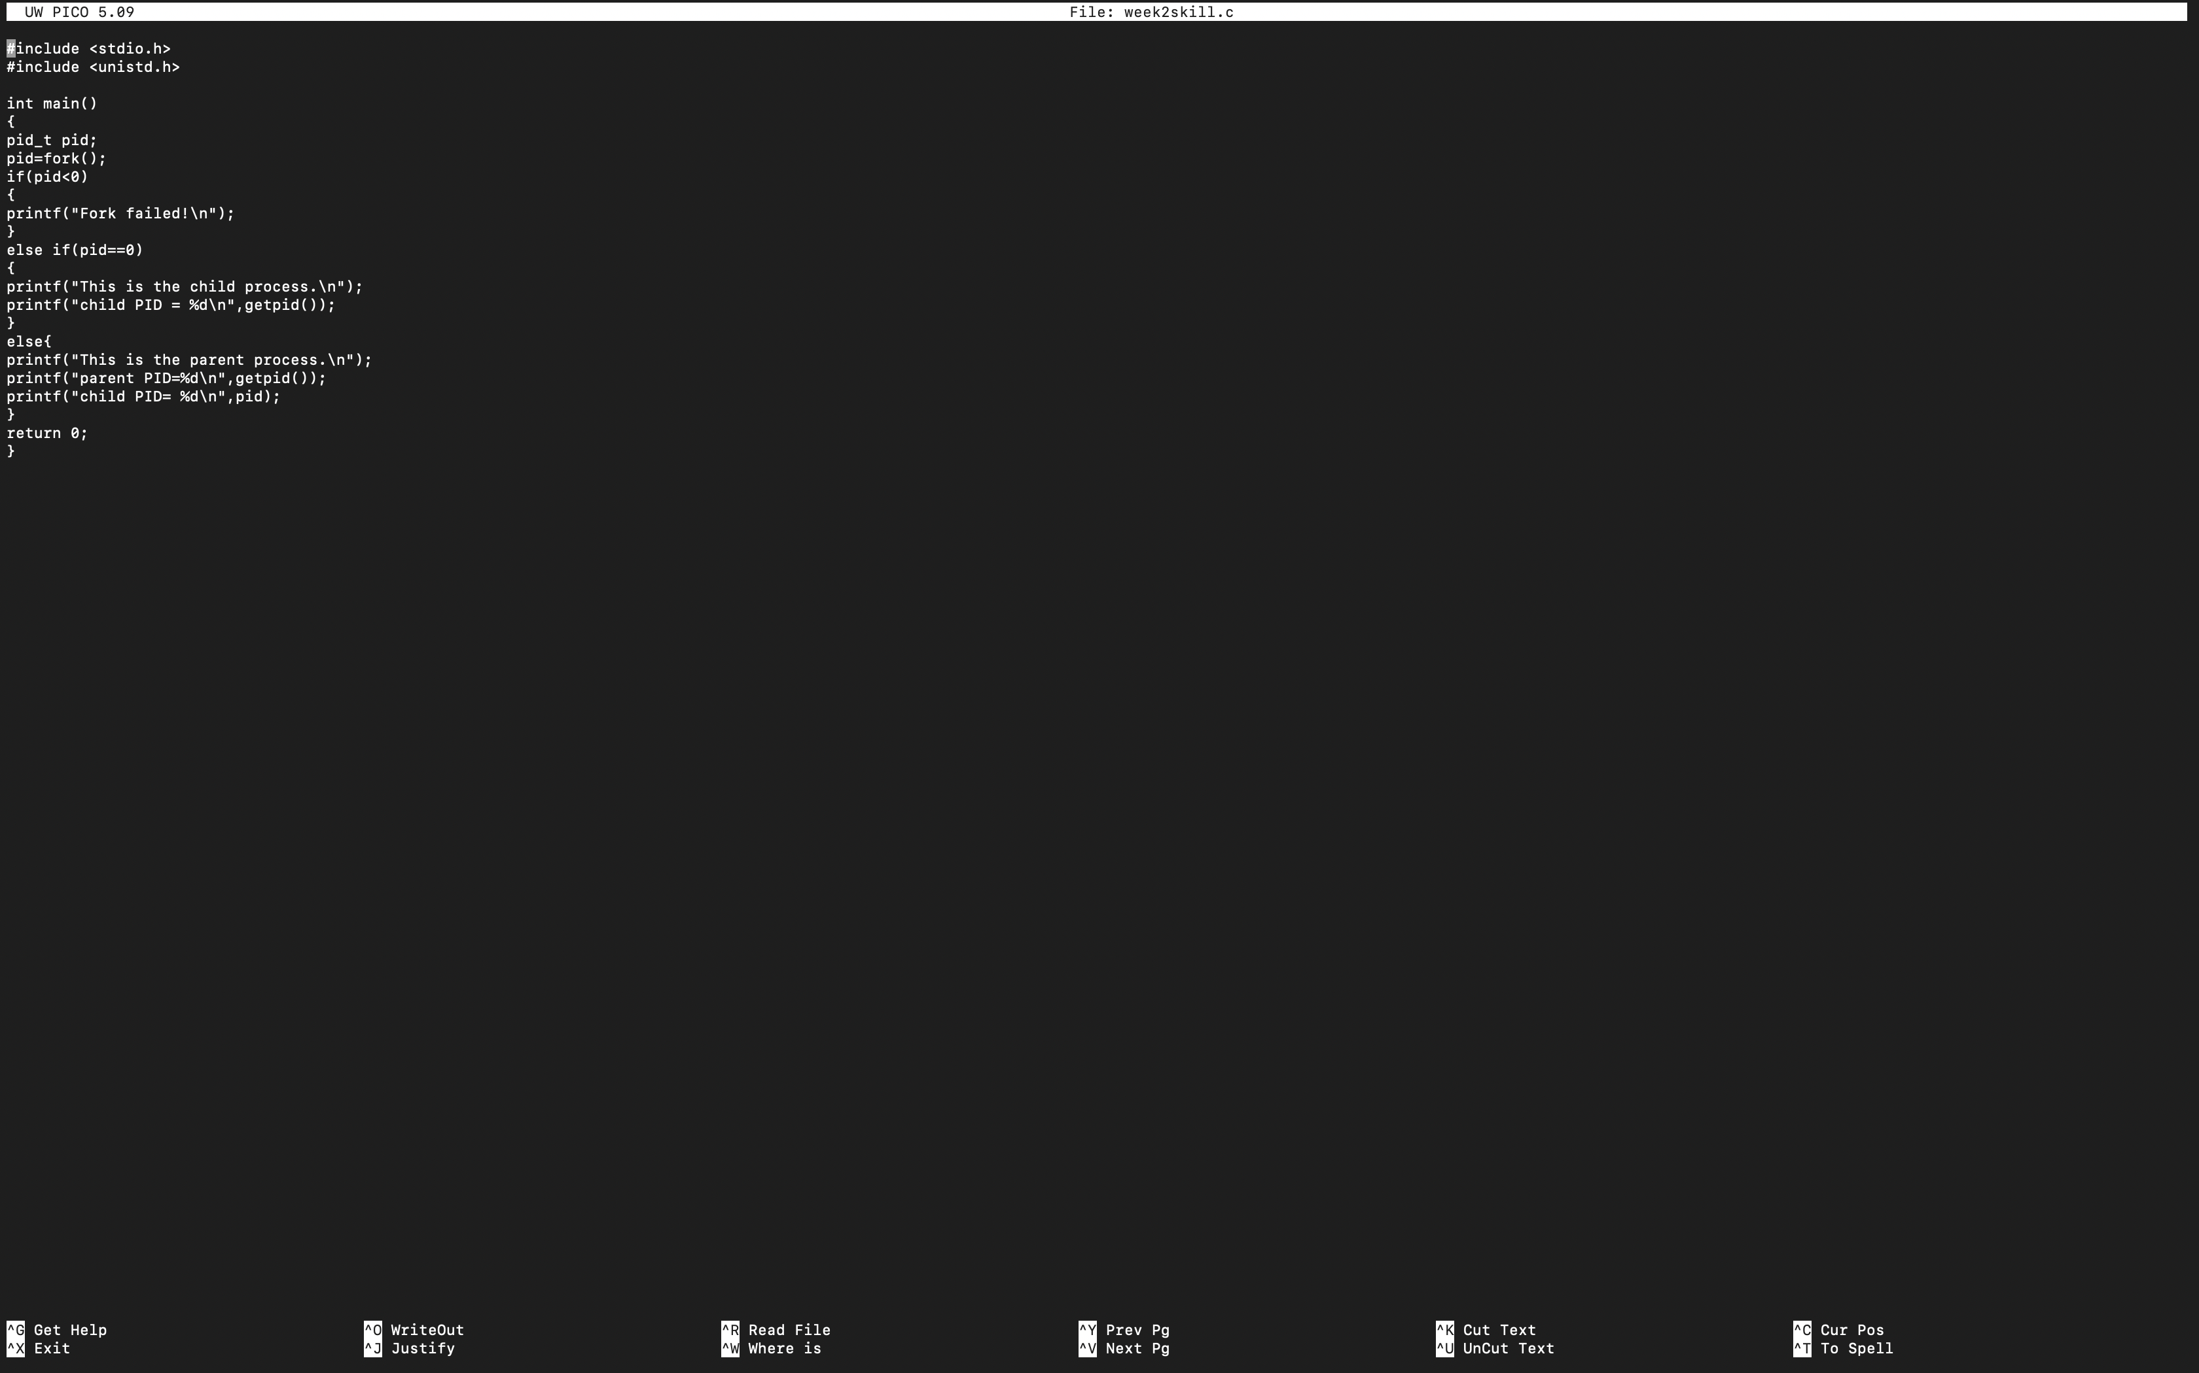
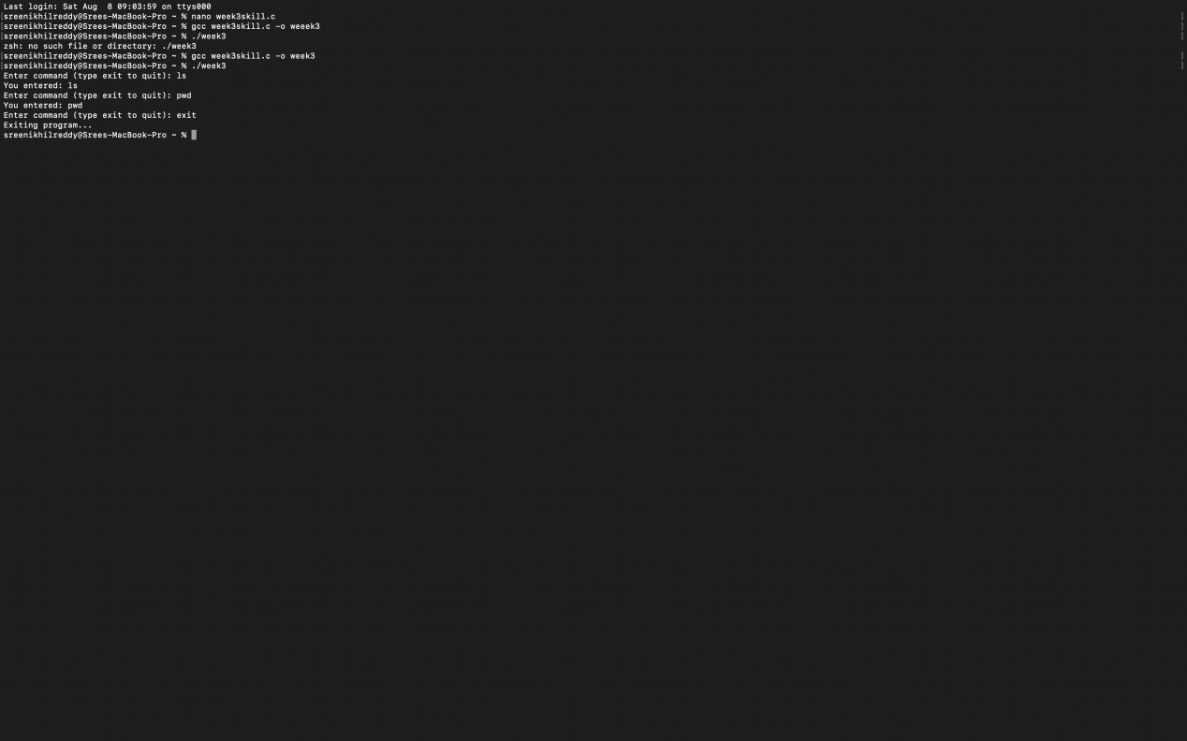
Task 2: Using the following system calls, copy the content from File1.txt to
- Open()
- Read()
- Write()
- Close()
Flag | Purpose
O_RDONLY | Open for read only
O_WRONLY | Open for write only
O_RDWR | Open for both read and write
O_CREAT | Create file if it does not exist
O_TRUNC | Truncate (empty) an existing file
O_APPEND | Append data to the end of the file
O_EXCL | Fail if file already exists (used with O_CREAT)
