**API Automation Task**

API automation task is a test project build with the python basics to check the API request and response for the server details mentioned below. The python code is run in Command prompt or Windows PowerShell to view the list of TV guide for selected channel in *.csv format.

**Using the Postman tool**

* The EPG Data response was captured using the following request: <https://fvau-api-prod.switch.tv/content/v1/epgs/> ,

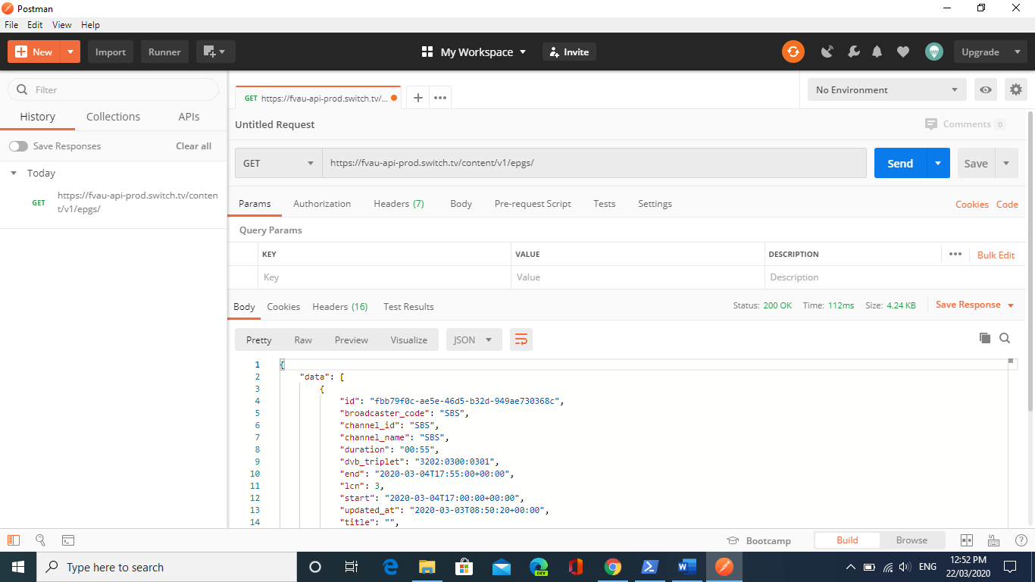

* The response for list of all available channel can be captured using the request: <https://fvau-api-prod.switch.tv/content/v1/channels/?limit=3>

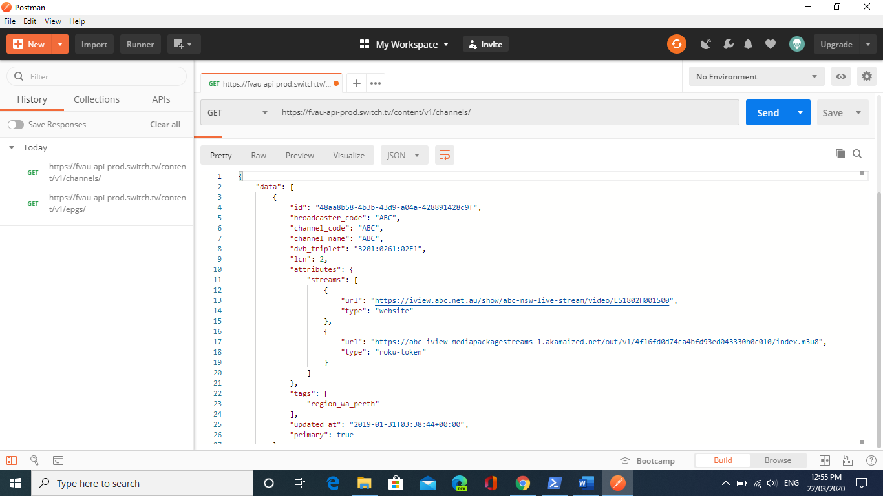

* The list of program for a particular channel from current system date to next date can be captured using the following request: <https://fvau-api-prod.switch.tv/content/v1/epgs/3202:0300:0301/?start=2020-03-20&end=2020-03-21&limit=100&offset=0&more=true&sort=start>   [ Here start - Start date of Program, end -  End date of Program, limit - 100 (Limits records to 100), sort - start (Sort by start date)].

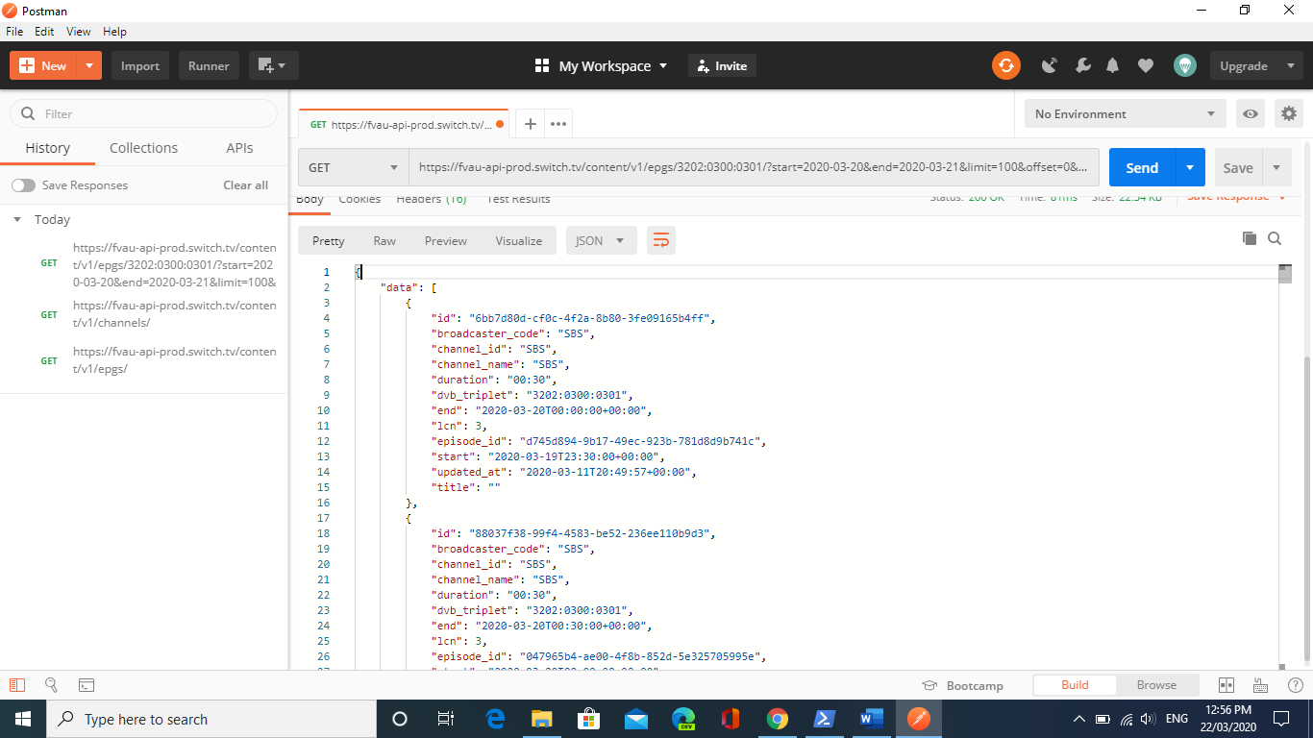

Using the basic phyton code the API request was sent, and its corresponding response was captured.

**To run the Python Code**:

1. Copy and paste the code attached in the folder in the local system for e.g. C:\Temp.
2. Using the command prompt or Windows PowerShell go to the respective folder and Run the python file e.g. py apitask.py

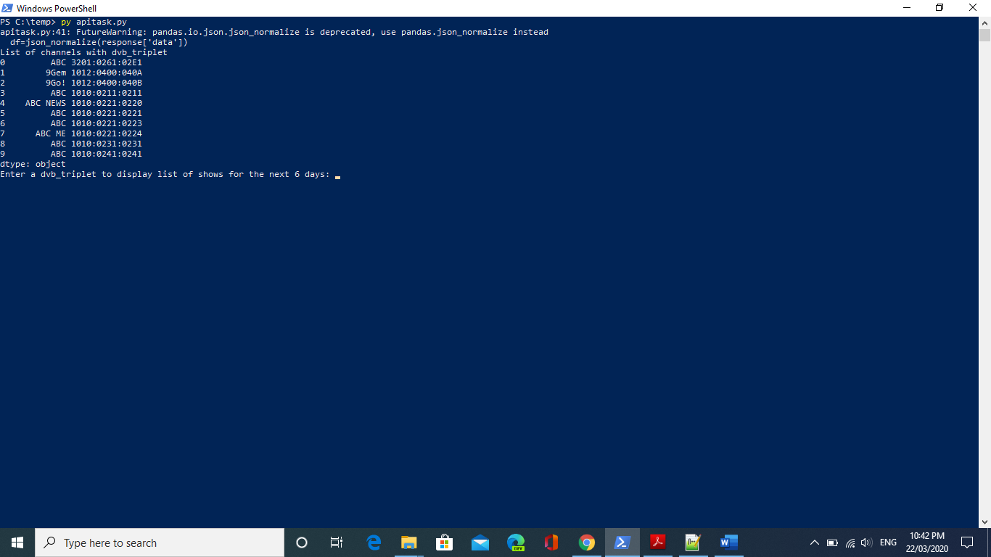

1. Enter the dvb_triplet from the list provided and Hit enter e.g. 1012:0400:040A.
2. An data.csv file will be generated with the list of shows for the next seven days from the current system date.
3. In addition to that 3channel_data.csv file will be generated with the list of shows for next seven days from the current system date. But the dvb_triplet values are statically entered in the source code.

**Test Cases**:

1. To verify the sorting order of dvb_triplet based on the system date,
2. To verify list of programs for the given dvb_triplet in the data.csv file,
3. To verify list of programs for the given dvb_triplet from current system date to next six days in the data.csv file.
4. To verify the list of program for the static data given inside the source code namely [9Gem- epg’1012:0400:040A’, 9Go! – epg’1012:0400:040B’, ABC- epg‘1010:0211:0211’] in 3channel_data.csv file.
5. To verify the list of programs for the static data given inside the source code from current system date for next six days in 3channel_data.csv file.
6. To verify deletion of the old of old data.csv and 3channel_data.csv file when a new dvb_triplet is queried in the Command prompt or Windows PowerShell.

**GIT Download link**:

<https://github.com/sreeniranjan/Apitask.git>

**Files in GIT**:

README.md

Apitask.py

API_automation_task.pdf