

**Product Dissection for PriceLabs**

**Company Overview:**

PriceLabs is a revenue management and dynamic pricing platform designed for owners and managers of short-term rental properties. Founded in 2014, It uses data-driven algorithms, customizable rules, and real-time market insights to help property owners optimize their pricing, maximize occupancy, and increase revenue. Founded with the goal of making pricing automation accessible and flexible, PriceLabs has become a leading SaaS solution for vacation rentals, integrating with platforms like Airbnb, Vrbo, and various Property Management Systems (PMS).

**Product Dissection and Real-World Problems Solved by PriceLabs:**

PriceLabs, a top platform for dynamic pricing and revenue management for short-term rental properties, tackles a number of urgent issues that property managers and individual hosts encounter in the cutthroat hospitality industry of today. PriceLabs presents an automated, intelligent, and adaptable technology that transforms the way price decisions are made in a sector where revenue potential is closely linked to pricing accuracy and market reactivity. Setting nightly rental prices and managing availability across platforms is a historically difficult operation that PriceLabs streamlines with its user-centric interface and robust data-driven backend.

The manual and error-prone nature of pricing schemes is one of the biggest issues that PriceLabs resolves. It can be difficult for property managers and owners, particularly those with several listings, to routinely modify prices in response to seasonality, holidays, local events, and booking patterns. With its dynamic pricing engine, PriceLabs tackles this issue by using algorithms to analyze current market conditions, booking volume, competitor rates, and other demand indicators in order to recommend the best pricing on a daily basis. By maintaining competitive rates that are in line with current demand, this automation not only lessens the operational load but also boosts booking efficiency and profitability.

PriceLabs' Market Dashboards and Portfolio Analytics also address the issue of information scarcity and ambiguity in decision-making. In order to make well-informed judgments, many independent hosts and smaller property managers lack access to professional tools and market research. By providing information on regional market trends including typical occupancy rates, pricing bands, booking windows, and seasonality patterns, PriceLabs fills this knowledge gap. By providing customers with actionable intelligence, these visual dashboards help companies improve their pricing strategies and better understand how their listings compare to those of their competitors.characteristics of different property types, locations, and customer segments. All things considered, PriceLabs adds value for property managers and real estate investors by providing performance-tracking tools for their whole portfolio. Users are better able to assess listing performance and make long-term strategic decisions when they have access to information on revenue, occupancy, and price efficiency. Such thorough insight into portfolio performance improves both tactical and strategic decision-making in a highly competitive and data-sensitive sector. By resolving the practical issues of manual labor, market ambiguity, inconsistent multi-platform management, and lack of customisation, PriceLabs successfully revolutionizes the way short-term rental pricing is managed. It is an essential tool for anyone wishing to grow or improve their rental business since it combines automation, data science, and user empowerment into a single, integrated platform.

PriceLabs is more than just a pricing tool; it's a complete revenue management solution that uses automation and data science to help property managers and hosts of short-term rentals navigate the market's complexities, maximize their revenue potential, optimize their pricing strategies, and ultimately run more successful and efficient businesses. By replacing hunches with data-driven choices, responding quickly to market shifts, optimizing occupancy, offering insightful information, and freeing up hosts' time, it addresses real-world issues.

**Case Study: Real-World Problems and PriceLabs Solutions**

PriceLabs addresses several critical challenges faced by vacation rental owners, property managers, and hoteliers.

**Problem 1**: **Manual Pricing is Time-Consuming**

**Real world challenge:**  
Property managers and hosts spend hours manually updating prices based on changing seasons, demand, and local events.

**PriceLabs Solutions**:

* Uses automated dynamic pricing to adjust prices daily.
* Factors in seasonality, market trends, competitor rates, booking pace, and more.
* Saves time and increases accuracy.

**Problem 2**: **Revenue Loss Due to Improper Pricing**

**Real world challenge:**  
Setting prices too high or too low can lead to low occupancy or lost revenue.

**PriceLabs Solutions**:

* Ensures prices are optimized daily to balance occupancy and income.
* Recommends minimum and maximum price thresholds.
* Helps maximize RevPAR (Revenue per Available Rental).

**Problem** **3: Lack of Data for Informed Decisions**

**Real world challenge:**  
Many small-scale property owners don’t have access to data on local markets or competitors.

**PriceLabs Solutions**:

* Provides Market Dashboards showing occupancy trends, rate distributions, and booking patterns.
* Allows data-driven pricing strategies, even for non-technical users.

**Problem** **4: Difficulty Managing Multi-Platform Listings**

**Real world challenge:**  
Listings across multiple platforms (Airbnb, Vrbo, etc.) need consistent pricing and availability settings.

**PriceLabs Solutions**:

* Syncs with over 70+ PMS and OTA platforms.
* Maintains a centralized calendar to push pricing and rules to all connected platforms.
* Reduces double-bookings and pricing errors.

**Problem** **5: Limited Customization in Most Tools**

**Real world challenge:**  
Other pricing tools may not allow customization based on personal strategy or local knowledge.

**PriceLabs Solutions**:

Offers **fully customizable pricing rules** like:

* Last-minute discounts
* Length-of-stay pricing
* Orphan night rules
* Event-specific overrides

**Problem** **6: No Portfolio-Level Performance Tracking**

**Real world challenge:**  
Property managers with multiple listings struggle to compare performance.

**PriceLabs Solutions**:

Provides **Portfolio Analytics** with metrics like:

* Occupancy rate
* Average daily rate
* Monthly revenue
* Booking pace

**Top Features of PriceLabs**

**Dynamic Pricing:** Daily rental rates are automatically modified in response to local events, market demand, and booking patterns**.  
Market dashboards**: Help with strategic decision-making by providing information on rival pricing, market trends, and occupancy rates. **Portfolio Analytics**: Gives you performance data for your listings, such revenue and occupancy rates, so you can keep an eye on and improve your portfolio. **Revenue Estimator Pro:** Forecasts possible profits for properties by using market trends and historical data.   
**Pricing Customizations:** Gives customers the ability to apply rules for particular dates or seasons and determine base, minimum, and maximum rates.   
**Integrations:** Easily interfaces with a number of booking websites, including Airbnb and VRBO, and property management systems (PMS).

**Schema Description**

The primary entities, their characteristics, and the connections between them that power the platform's dynamic pricing and rental management system are captured and represented by the PriceLabs schema.**1. User Entity**

* **UserID (Primary Key):** Unique identifier for each user.
* **Name:** Full name of the user.
* **Email:** Email address used for contact and login.
* **PhoneNumber:** User's mobile or contact number.
* **UserType:** Type of user (e.g., owner, manager) — *enum*.
* **RegistrationDate:** Date the user registered on the platform.

**2. Property Entity**

* **PropertyID (Primary Key)**: Unique identifier for each property.
* **Title**: Display name of the property.
* **Description**: Detailed description of the property. *(NOT NULL)*
* **Price**: Base price set for the property. *(decimal)*
* **Location**: Physical location/address of the property.
* **PropertyType**: Type/category of property (e.g., villa, apartment).
* **OwnerID (Foreign Key referencing User Entity)**: Owner of the property.
* **LocalityID (Foreign Key referencing Locality Entity)**: Geographical area the property is located in.
* **Area**: Size of the property (e.g., in square feet).
* **Amenities**: List of available amenities. *(NOT NULL)*
* **Status**: Property availability status — *enum*.

**3. Listing Entity**

* **ListingID (Primary Key)**: Unique identifier for each listing.
* **PropertyID (Foreign Key referencing Property Entity)**: The property being listed.
* **PlatformName**: Platform or channel (e.g., Airbnb, Booking.com).
* **StartDate**: Listing start date.
* **EndDate**: Listing end date. *(NOT NULL)*
* **Currency**: Currency code (e.g., USD, INR) for pricing.

**4. Calendar Entity**

* **CalendarID (Primary Key)**: Unique calendar entry ID.
* **ListingID (Foreign Key referencing Listing Entity)**: The associated listing.
* **Date**: Specific date of the calendar entry.
* **Available**: Whether the listing is available on this date *(boolean)*.
* **Price**: Price for the specific day *(decimal)*.
* **MinimumStay**: Minimum required stay on this date *(integer)*.

**5. PricingRule Entity**

* **RuleID (Primary Key)**: Unique identifier for the pricing rule.
* **ListingID (Foreign Key referencing Listing Entity)**: The listing the rule applies to.
* **RuleType**: Category/type of the pricing rule *(integer)*.
* **AdjustmentValue**: Value to adjust the price *(decimal)*.
* **StartDate**: Rule activation date.
* **EndDate**: Rule deactivation date.

**6. Locality Entity**

* **LocalityID (Primary Key)**: Unique identifier for each locality.
* **City**: Name of the city.
* **AreaName**: Specific area or sub-locality.
* **ZipCode**: Postal code of the locality.

**7. MarketData Entity**

* **MarketID (Primary Key)**: Unique ID for each market data record.
* **LocalityID (Foreign Key referencing Locality Entity)**: The locality the data applies to.
* **AveragePrice**: Average market price *(decimal)*.
* **OccupancyRate**: Average occupancy rate *(decimal)*.
* **DemandIndex**: Calculated demand index *(decimal)*.

**8. AnalyticsReport Entity**

* **ReportID (Primary Key)**: Unique identifier for each analytics report.
* **ListingID (Foreign Key referencing Listing Entity)**: The listing being analyzed.
* **DateGenerated**: When the report was created.
* **OccupancyRate**: Listing’s occupancy rate *(decimal)*.
* **Revenue**: Total revenue generated *(decimal)*.
* **AverageDailyRate**: Average daily rate *(decimal)*.
* **BookingsCount**: Total number of bookings *(integer)*.
* **ReportPeriodStart**: Start date of the reporting period.
* **ReportPeriodEnd**: End date of the reporting period.

**Relationships are:**

* **UserID (Primary Key in User)**: Unique identifier for each user.
* **OwnerID (Foreign Key in Property referencing UserID)**: Refers to the owner of the property.  
  → Each user can list multiple properties, but each property is owned by only one user.
* **PropertyID (Primary Key in Property):** Unique identifier for each property.
* **PropertyID (Foreign Key in Listing referencing Property):** Refers to the property being listed.  
  → Each property can have multiple listings over time, but each listing refers to one property.
* **LocalityID (Primary Key in Locality)**: Unique identifier for each locality.
* **LocalityID (Foreign Key in Property referencing Locality)**: Refers to the locality where the property is located.  
  → Each property belongs to one locality, but a locality can have many properties.
* **ListingID (Primary Key in Listing)**: Unique identifier for each listing.
* **ListingID (Foreign Key in Calendar referencing Listing)**: Refers to the listing’s availability details.  
  → Each listing can have multiple calendar entries, but each calendar entry refers to one listing.
* **ListingID (Primary Key in Listing)**: Unique identifier for each listing.
* **ListingID (Foreign Key in PricingRule referencing Listing)**: Refers to the listing’s pricing logic.  
  → Each listing can have multiple pricing rules, but each rule is applied to one listing.
* **ListingID (Primary Key in Listing)**: Unique identifier for each listing.
* **ListingID (Foreign Key in AnalyticReport referencing Listing)**: Refers to the listing’s performance report.  
  → Each listing can have multiple analytic reports, but each report is tied to one listing.
* **LocalityID (Primary Key in Locality)**: Unique identifier for each locality.
* **LocalityID (Foreign Key in MarketData referencing Locality)**: Refers to market trends for that locality.  
  → Each locality can have multiple market data entries, but each market data entry is for one locality.

**ER-Diagram:**

Let's construct an ER diagram that vividly portrays the relationships and attributes of the entities within the Pricalabs schema. This ER diagram will serve as a visual representation, shedding light on the pivotal components of Pricelabs's data model. By employing this diagram, you'll gain a clearer grasp of the intricate interactions and connections that define the platform's dynamics.

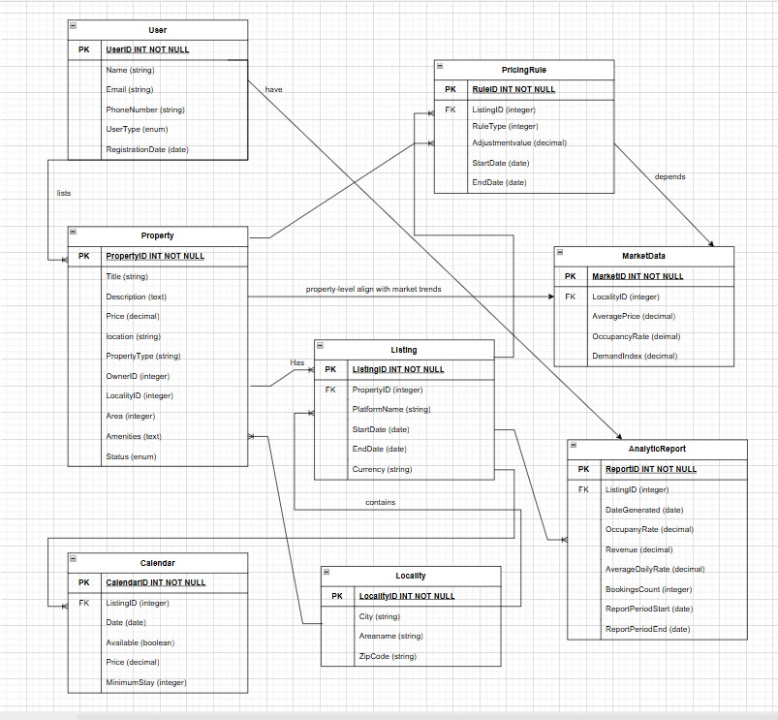

**Conclusion:**

The fundamental functions of a dynamic pricing and property management system are captured by the well-organized, relational PriceLabs schema. Referential integrity is ensured by the suitable primary and foreign keys and the precise definition of each entity. Property performance may be tracked in depth over time thanks to relationships like listing-to-analytics, property-to-listing, and user-to-property. By adding regional and temporal context, supporting entities like Calendar, PricingRule, and MarketData enhance the usefulness. All things considered, the design facilitates scalability, data consistency, and precise analytics—all of which are necessary for practical pricing intelligence platforms.