1. Created database db1 and in that db created a table temp with the contents loaded through load command.
2. Select \* from temp;

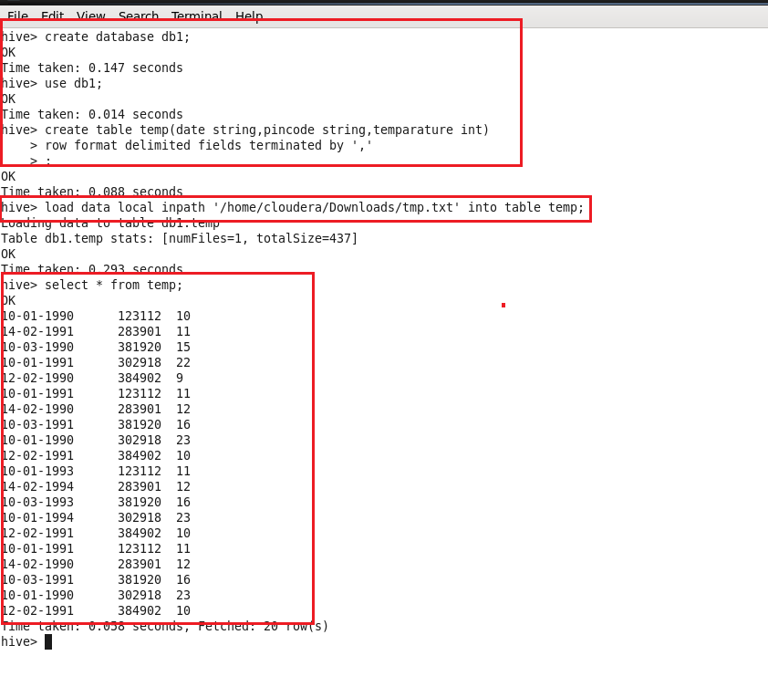

1. Similarly created database in mysql and created an empty table temp.
2. By using sqoop export I will load the data from hdfs to mysql

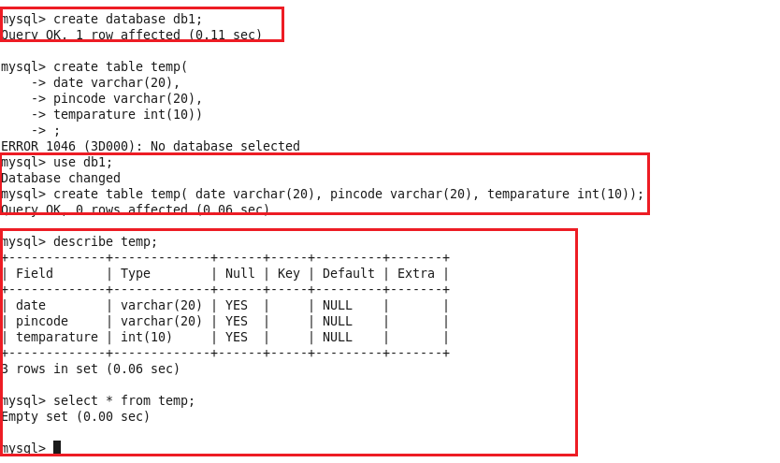

Sqoop export command to load the data from hdfs to mysql:

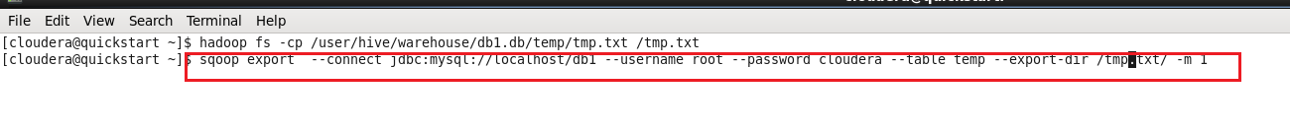

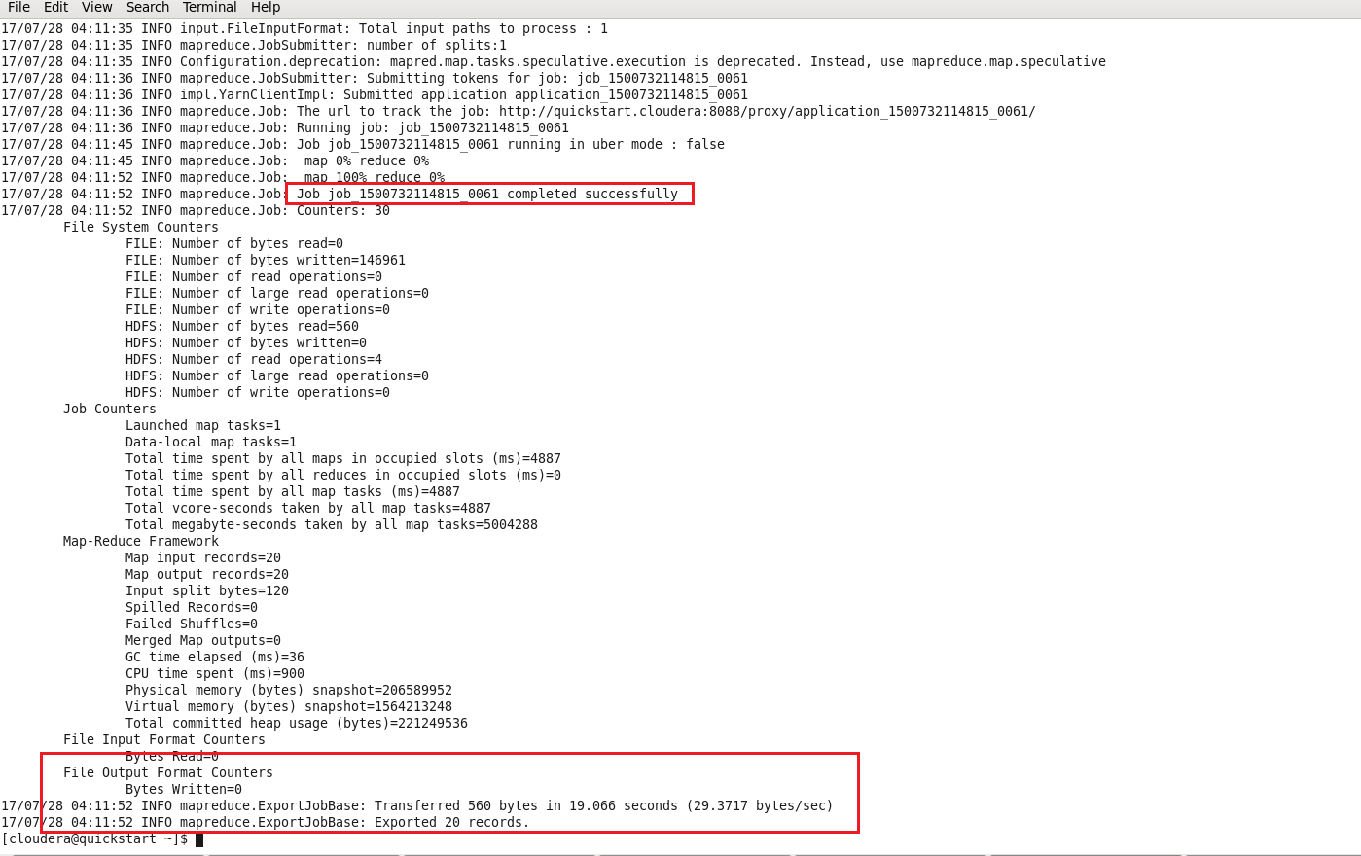

We can check the results of the above command by logging into mysql and by

Select \* from temp; #in MYSQL

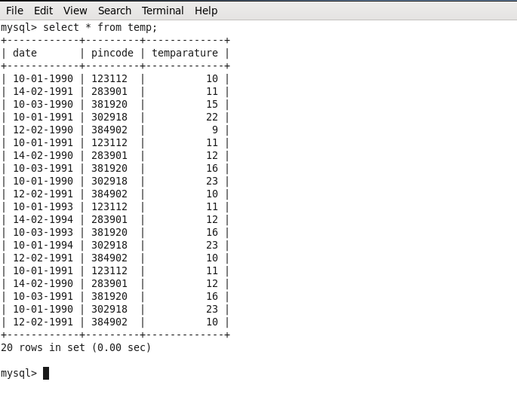

Now we have to import data from MYSQL to HDFS using Sqoop import command as follows:

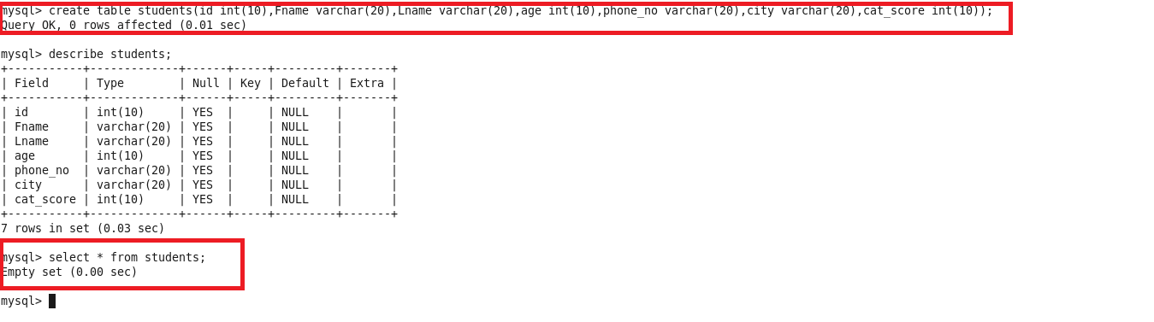

Here we have to insert some data into mysql table and then perform the sqoop import command.

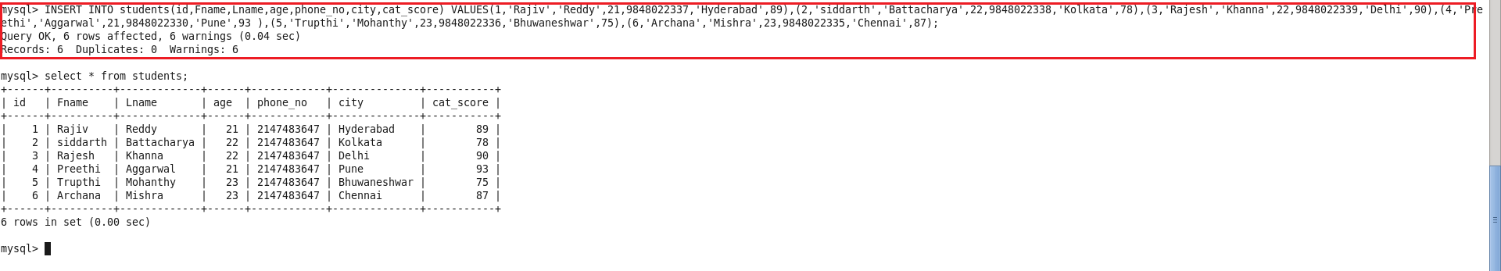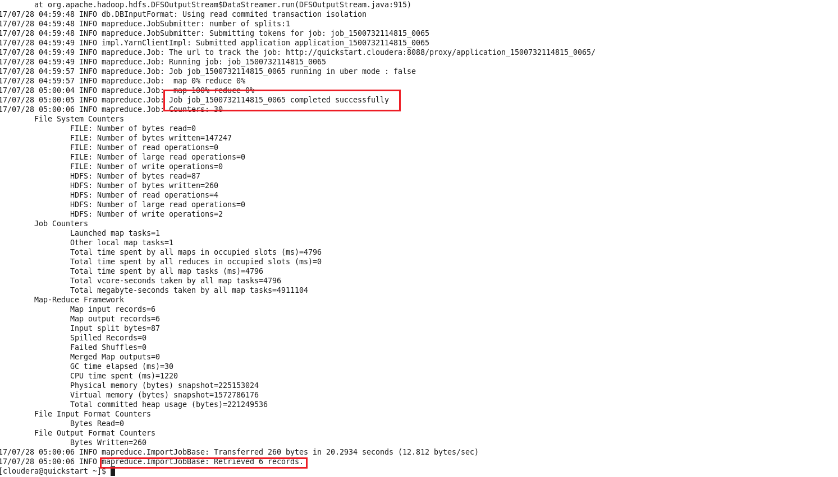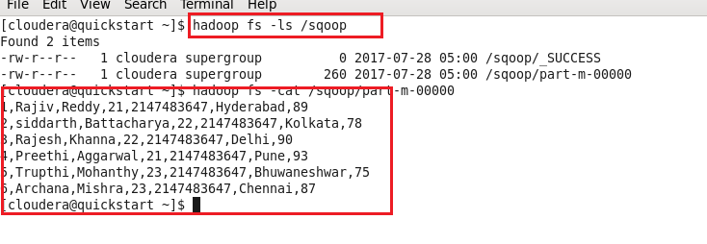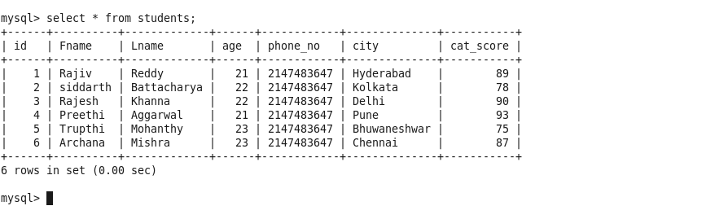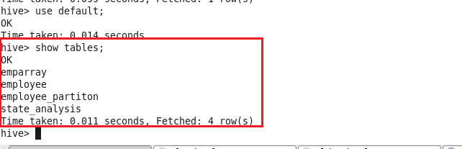

Now we will create data transfer between MYSQL to HIVE using hive import and create hive table command as follows: with Sqoop import and we are importing only selected columns in mysql table.

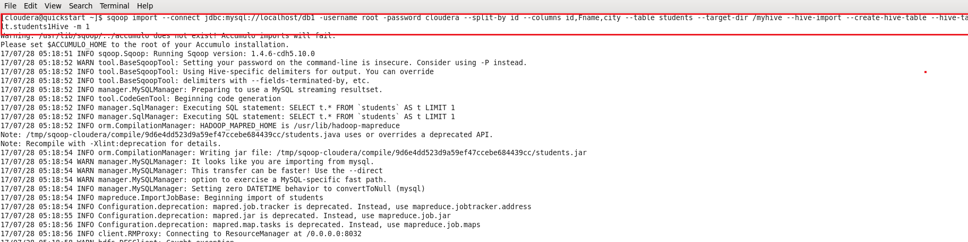

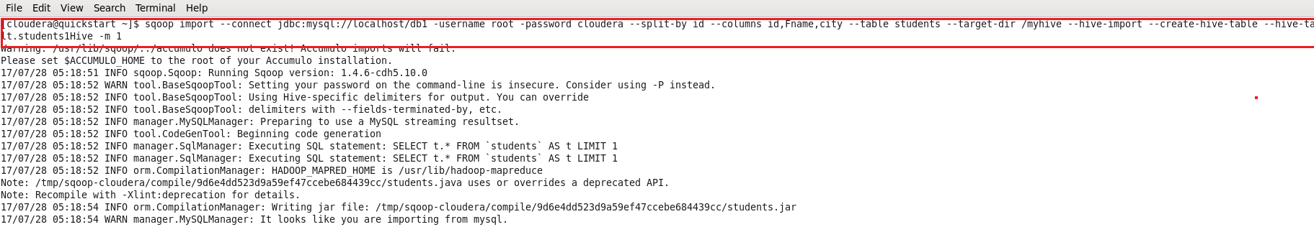

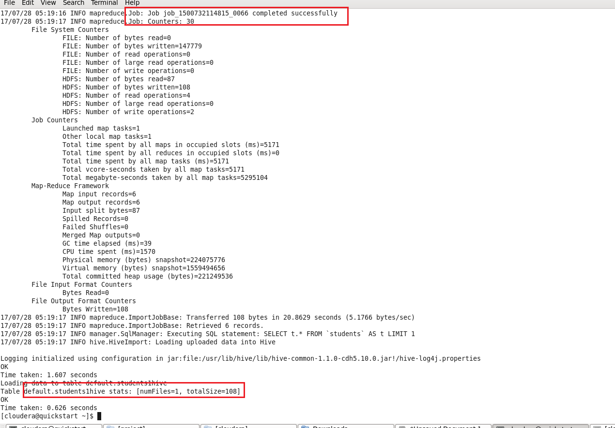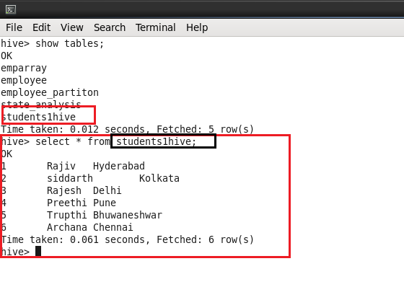

Now we will export data of selected columns from Hive to MYSQL using sqoop export command

