1. Here we will perform incremental import of MYSQL data into hive table using sqoop import -append option.
2. We will create hive table directly with the sqoop import options as –hive import and – create hive table
3. Later onwards it will be incremental actions done with sqoop –append and increment last modified option.

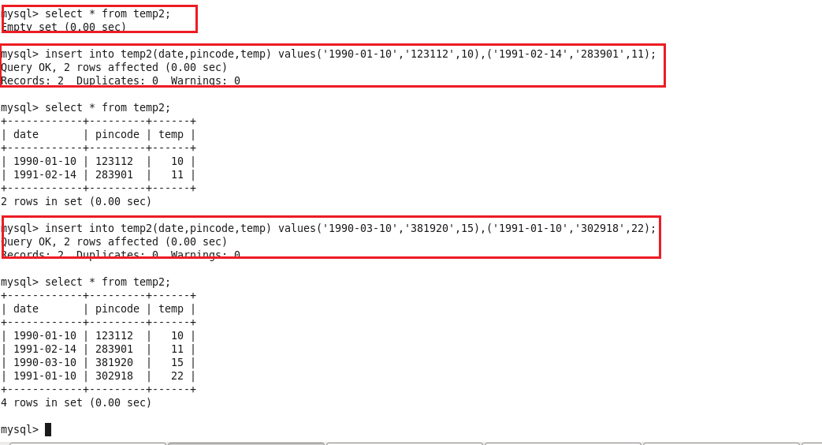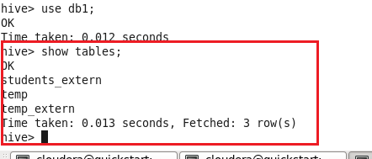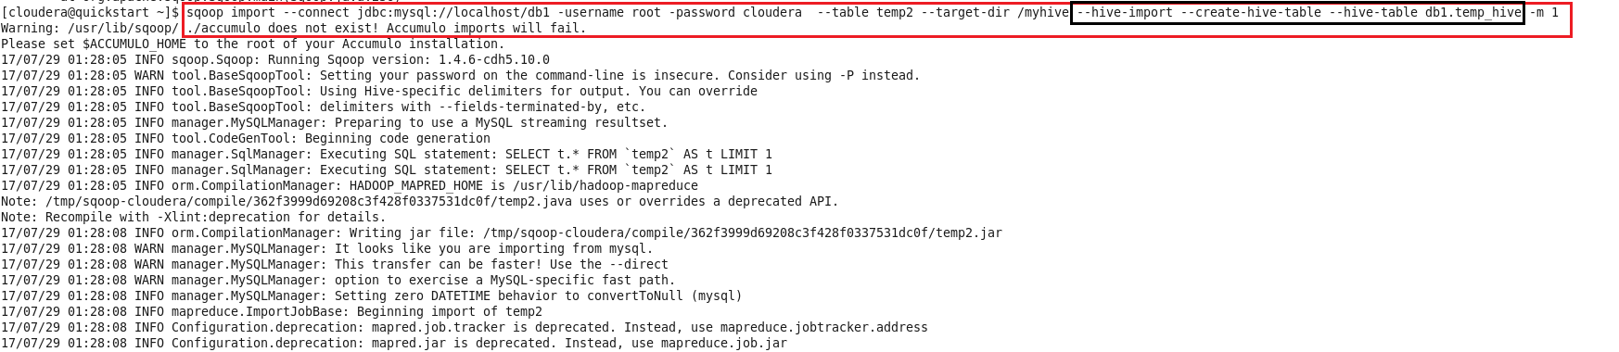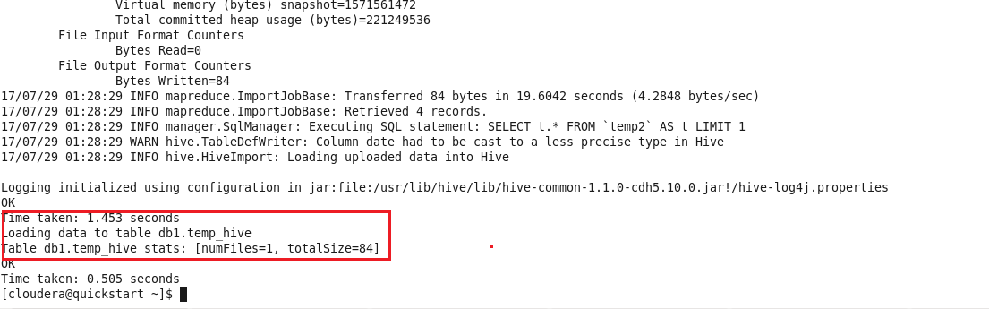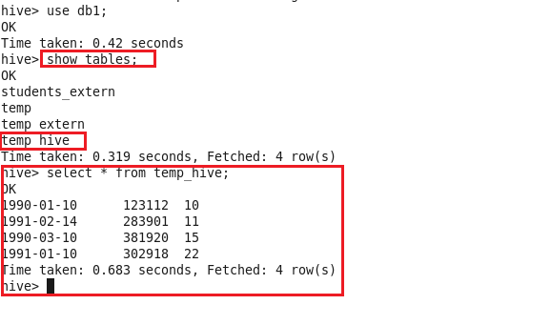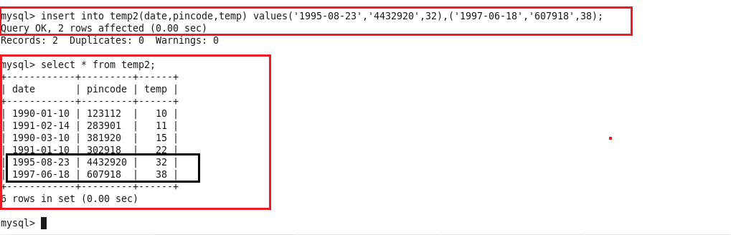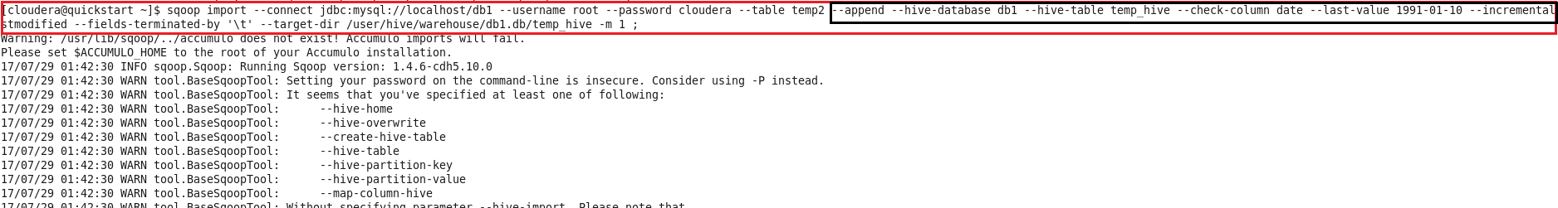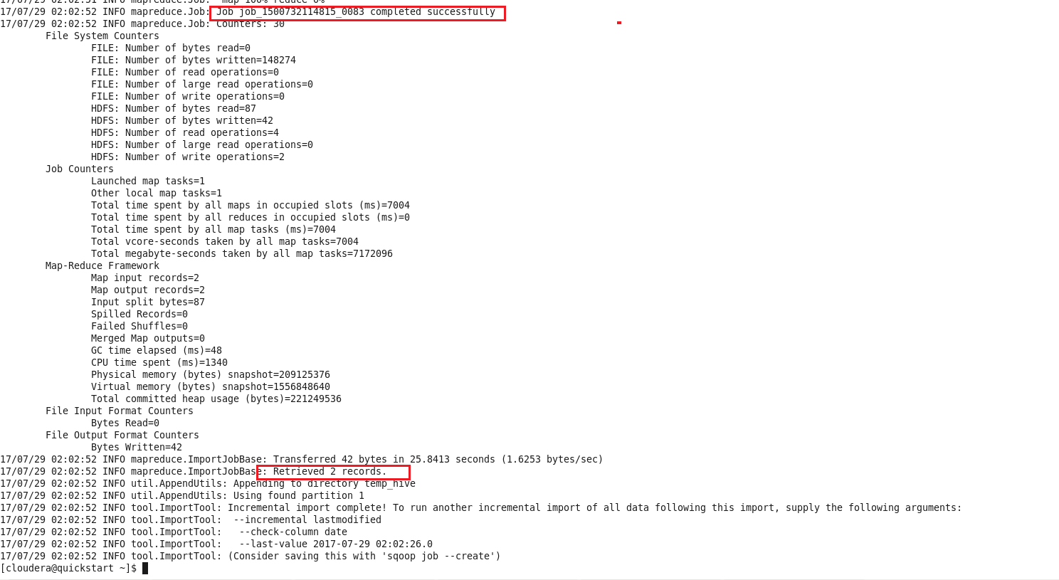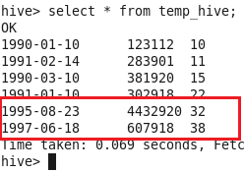

Here you can observe the last two updates valuesin MYSQL that are reflected in hive table using sqoop incremental omport command.