Step:1

To create the table employee with the required fields.

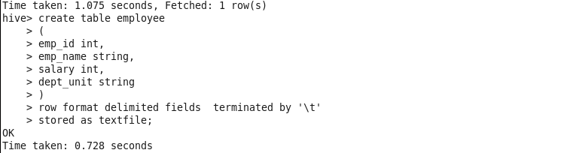

Step:2

Load the data into the created table from Local file system.

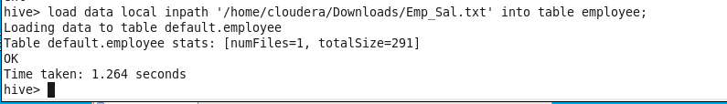

Dataset :

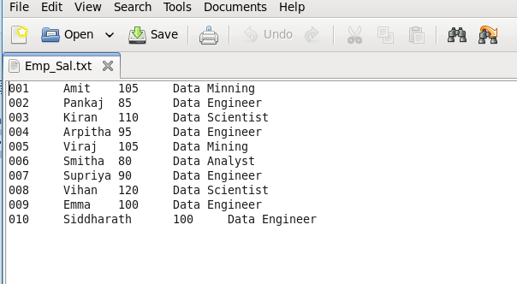

Step:3

Code to create employee whose salaries are less than 100 compared to their immediate employee with higher salary in the same unit.

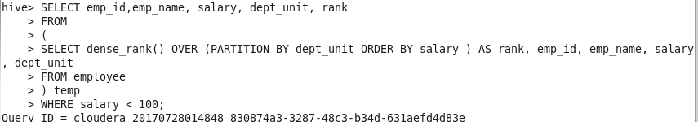

Output:

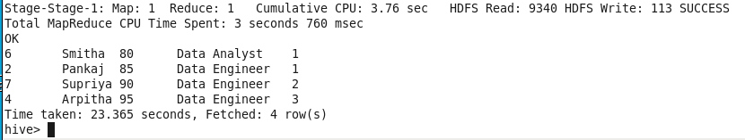

Step:4

Average salary as per department wise.

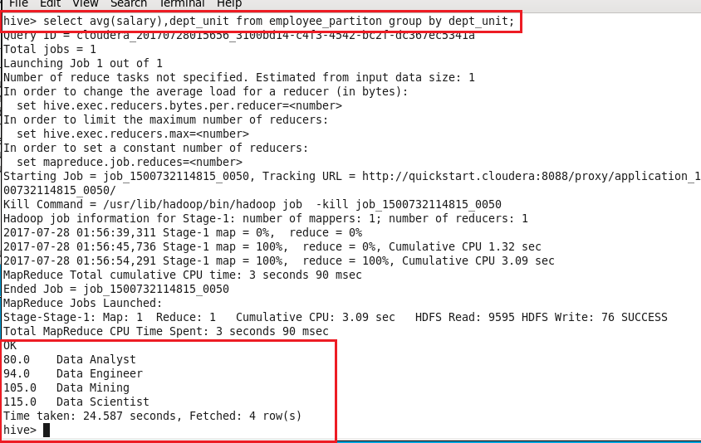

Step:5 Average salary of the employee as per department wise.

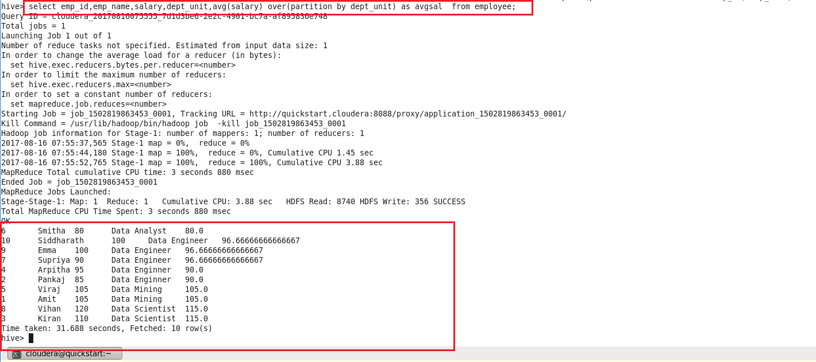

Step:6

Employees whose salary is greater than average salary of the department.

