Java Program of Hive UDF function to implements functionality of string concatenation.

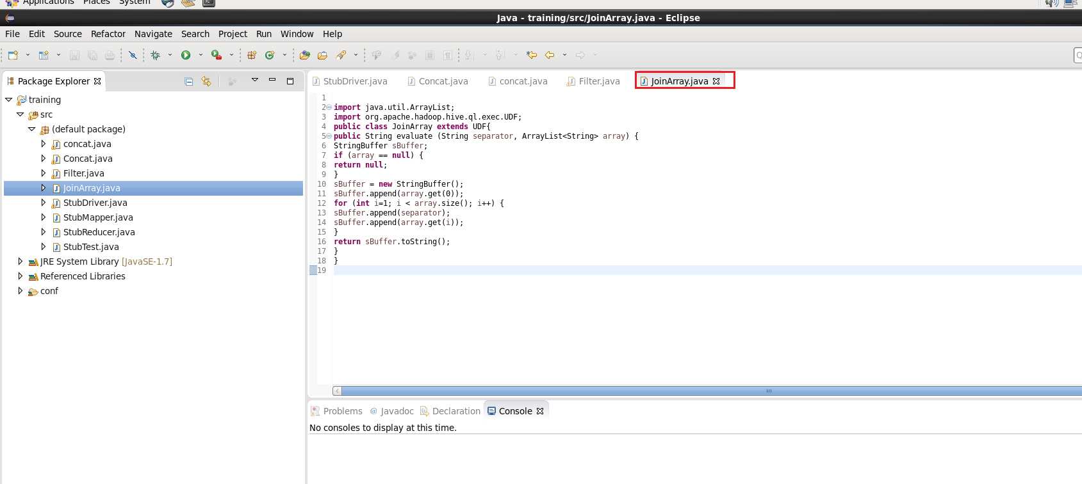

Making Runnable Jar to use the functionality in Pig Shell

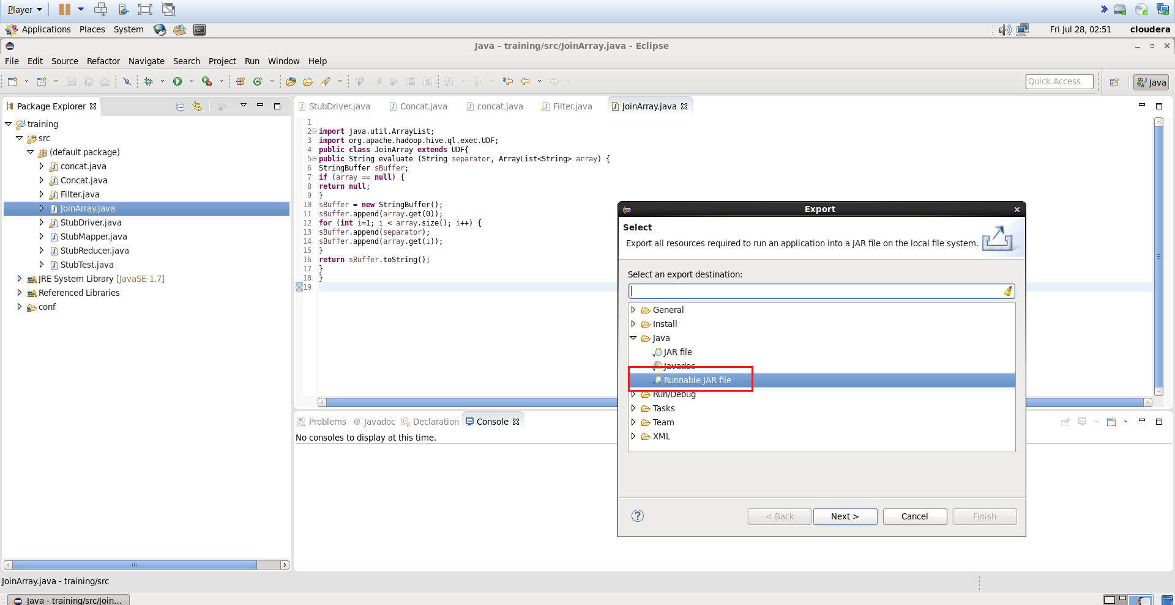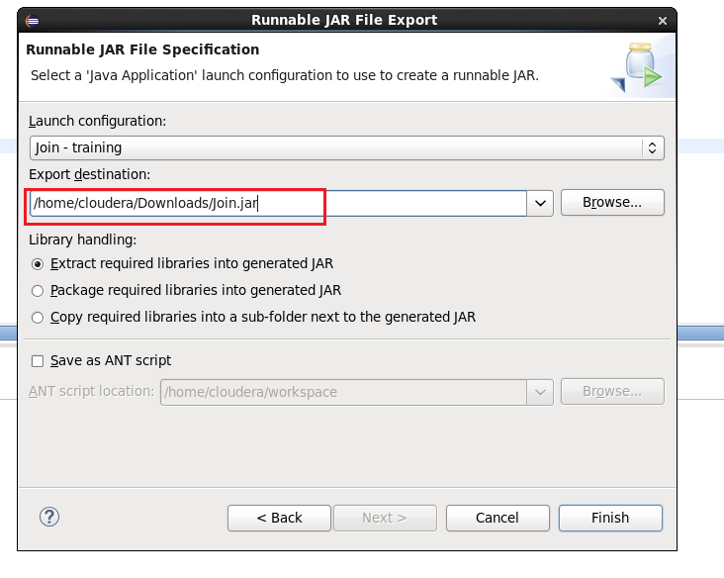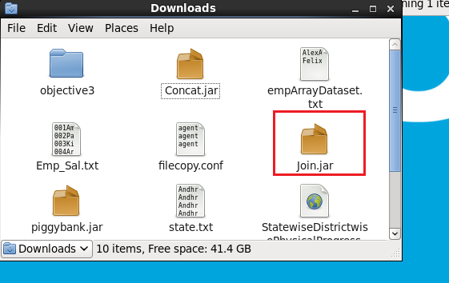

Dataset that has employee data:

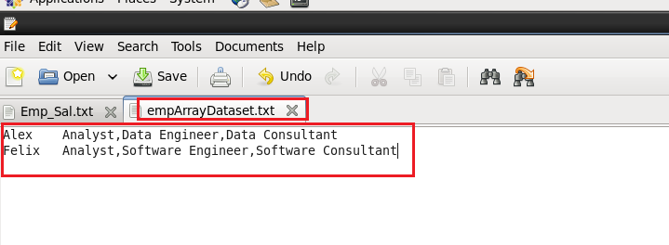

Created a table emparray to load the dataset into this table

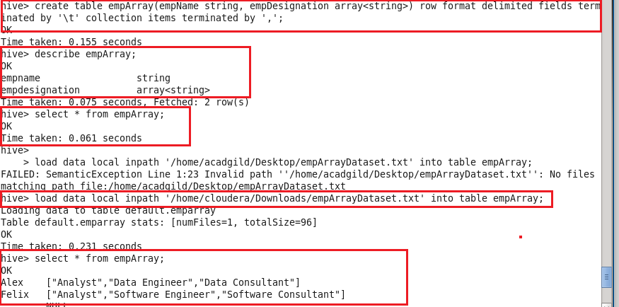

Query to run full scan of table:

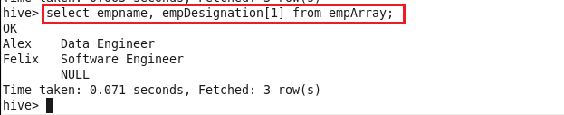

Now we have added Join jar file which we help to use the functionality of Join operation and Alex is the string separator.

Output:

