Step :1 create a table with name ‘clicks’ and column family ‘hits’ with max number of versions as 5

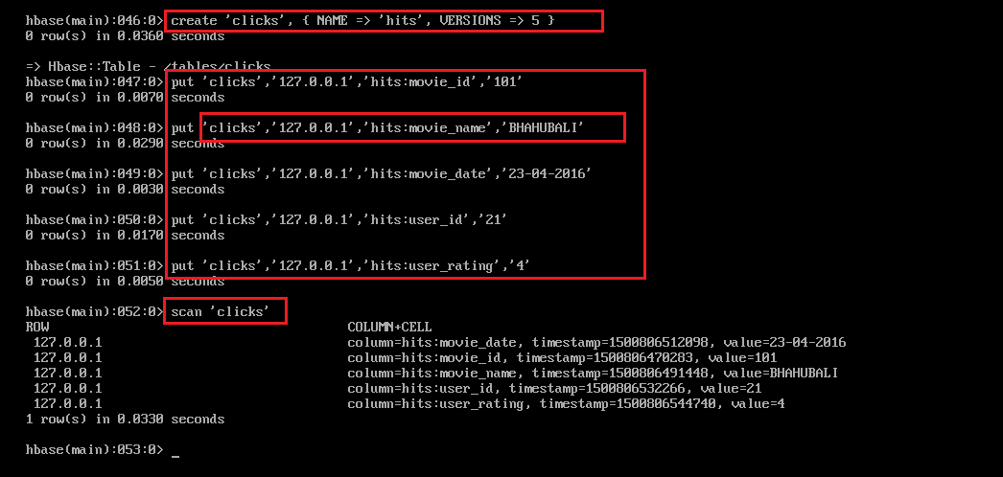

Here we have created 5 columns under ‘hits ‘column family with IP address as row key.

Step :2 create different values for the same column so that we can observe the different version values stored in the same table under same column family.

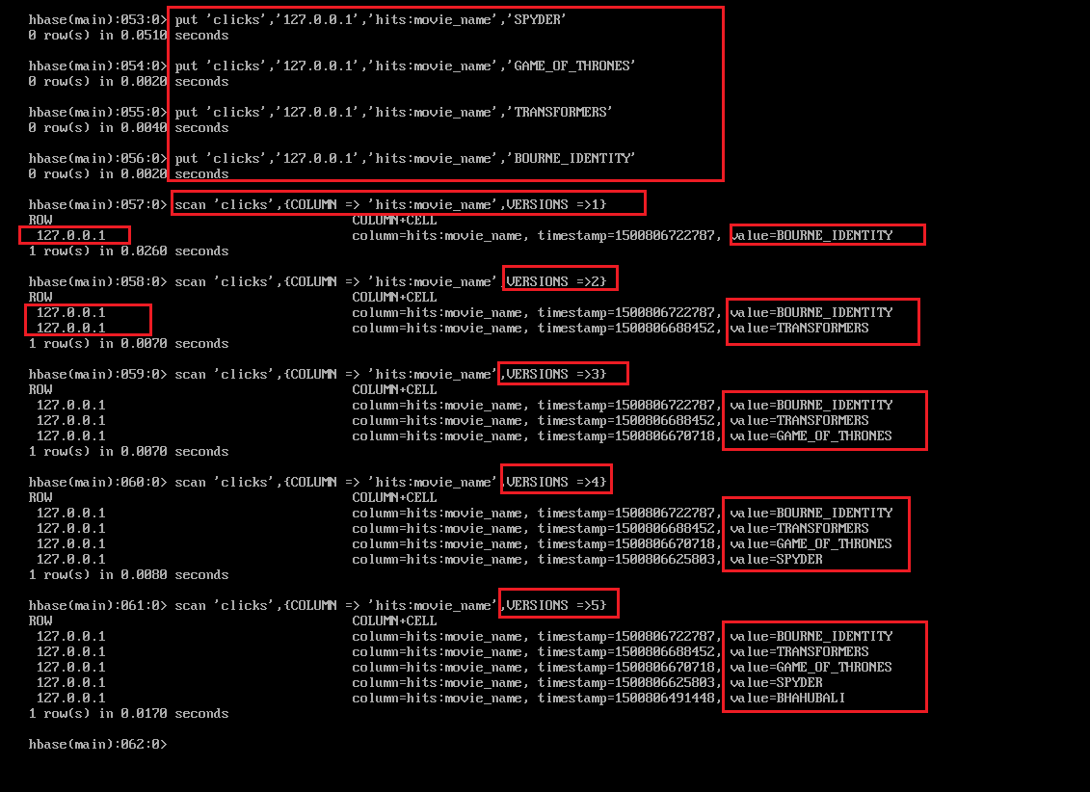

In the above screenshot we can observe the five different values stored for same column family ‘hits’ of column movie_name and in each version you can see the modified values stored under each version name.

Step :3

Created another IP address as row key and follow the same steps as of previous row key.

