**Example of Streaming Application**

**Overview**

The example streaming application shows an example of an application that can be deployed using the PNDA Deployment Manager. (See the platform-deployment-manager project for details.)

The application is a tar file containing binaries and configuration files required to perform Spark Kafka stream processing.

This example application reads random generated messages from Kafka topic and display on the console.

**Requirements**

* [Maven](https://maven.apache.org/docs/3.0.5/release-notes.html) 3.0.5
* [Java JDK](https://docs.oracle.com/javase/8/docs/technotes/guides/install/install_overview.html) 1.8

## Package Structure

The package structure is as follows:

spark-streaming-consumer-app-2.3.1.tar.gz

spark-streaming-consumer-app-2.3.1

sparkStreaming (Component type)

examples

application.properties

log4j.properties

properties.json

spark-streaming.jar

* Packages are archived and compressed using tar and gzip and take the name of the associated artefact and version, following [strict versioning](http://legacy.python.org/dev/peps/pep-0386).
* Packages must have a three part version number, e.g. spark-streaming-consumer-app-2.3.1.tar.gz.
* The folder inside the package tar must have the same name as the archive .
* The component types are taken from a controlled list.
* Component names are chosen by the package developer and will be used by the Deployment Manager.
* Each component type has a distinct structure specification.

**Build**

Edit the streaming-app/pom.xml file with the correct dependencies. Refer to the Cloudera or Hortonworks version matrix to work out what version this should be.

To build the example applications use:

mvn clean package

This command should be run at the root of the repository and will build the application binary, and the application package. It will create a package file in the app-package/target directory. It will be called spark-streaming-consumer-app-2.3.1.tar.gz.

**Files in the package**

* **application.properties:** config file used by the Spark Streaming Scala application.
* **log4j.properties:** defines the log level and behaviour for the application.
* **properties.json:** contains default properties that may be overridden at application creation time.

## Upload Package into Package Repository

It is possible to temporarily expose the package repository API with kubectl port forwarding:

kubectl -n pnda port-forward service/pnda-package-repository 8888

Then you can use curl to post a package to the package repository:

curl -XPUT "[http://localhost:8888/packages/ spark-streaming-consumer-app-2.3.1.tar.gz?user.name=](http://localhost:8888/packages/app-0.0.1.tar.gz?user.name=)" --data-binary "@ spark-streaming-consumer-app-2.3.1.tar.gz"

Then you can verify the upload by fetching the list of packages:

curl "localhost:8888/packages?user.name="   
[{"name": "app", "latest_versions": [{"version": "2.3.1", "file": " spark-streaming-consumer-app-2.3.1.tar.gz"}]}]

**Deploying the package and creating an application**

The PNDA console can be used to deploy the application package to a cluster and then to create an application instance. The console(http://console.pnda.io) is available on port 80 on the edge node.

When creating an application in the console, ensure that the Kafka topic "random_ip_topic" is created thru Kafka Manager UI(http://kafka-manager.pnda.io).

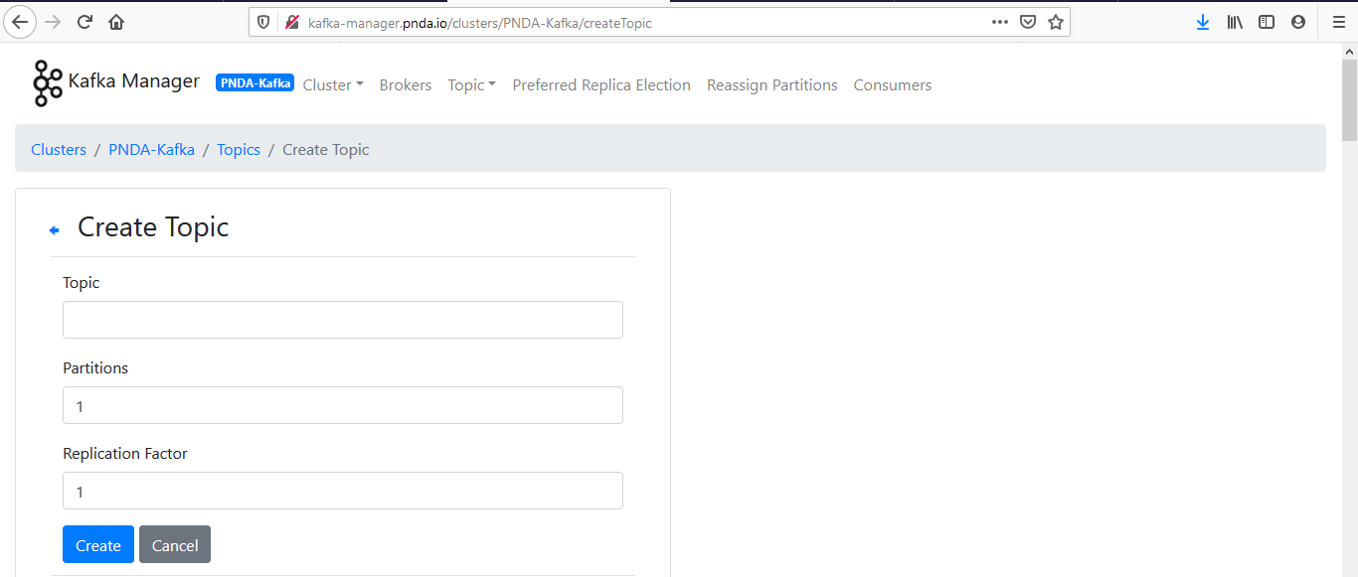

To make the package available for deployment it must be uploaded to a package repository. The package should be uploaded by manually into PNDA package repository.

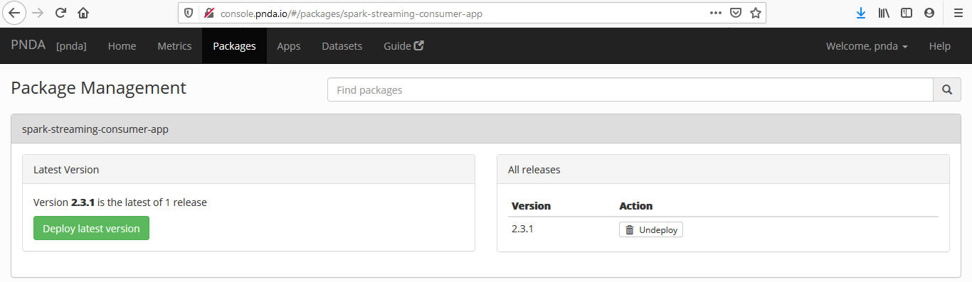

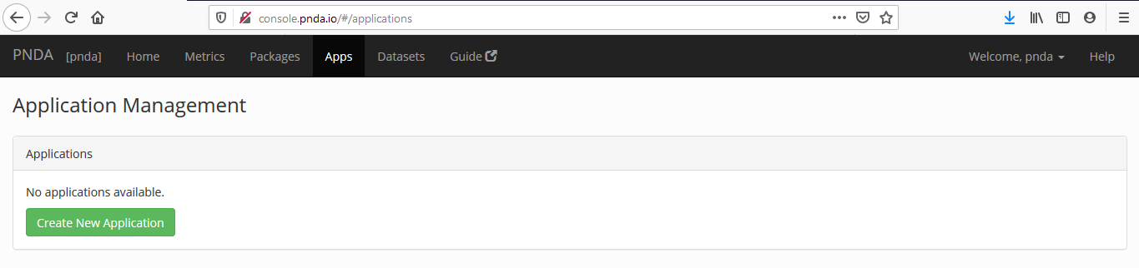

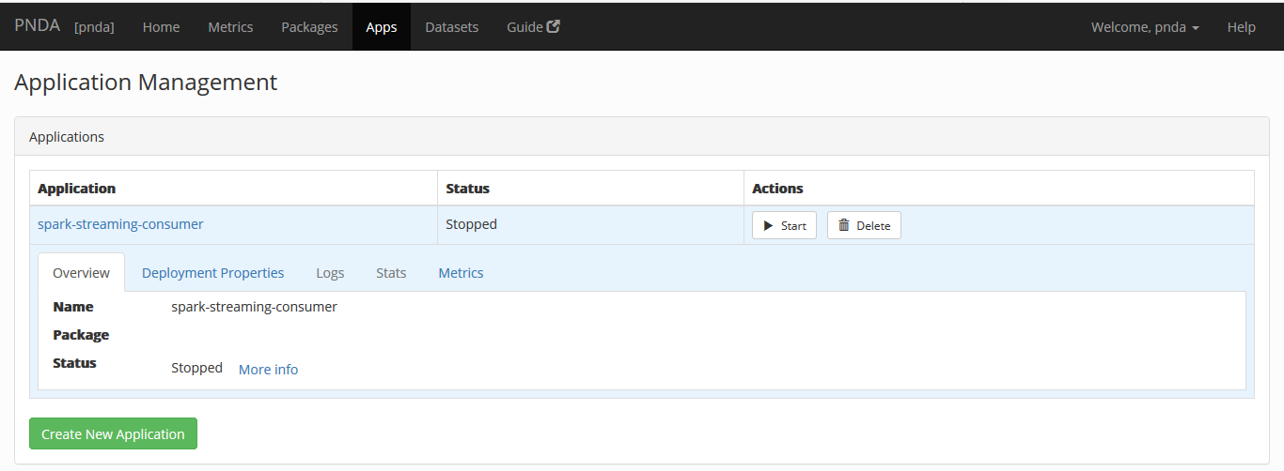

**Launch Spark Application on K8S**

Once application created in Application Management then start the application which will launch Kubernetes POD on the host cluster.

