Kidney

<https://www.webmd.com/kidney-stones/picture-of-the-kidneys>

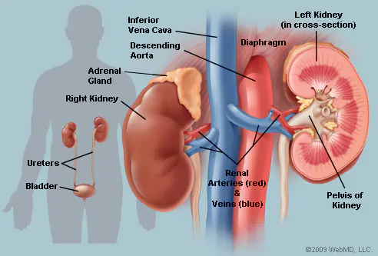

The [kidneys](https://www.webmd.com/urinary-incontinence-oab/picture-of-the-kidneys) are a pair of bean-shaped organs on either side of your [spine](https://www.webmd.com/back-pain/discs-of-the-spine), below your ribs and behind your belly. Each kidney is about 4 or 5 inches long, roughly the size of a large fist.

The kidneys' job is to filter your [blood](https://www.webmd.com/heart/anatomy-picture-of-blood). They remove wastes, control the body's fluid balance, and keep the right levels of [electrolytes](https://www.webmd.com/drugs/drug-3399-oral+electrolytes+oral.aspx). All of the blood in your body passes through them several times a day.