**Liver**

<https://www.webmd.com/digestive-disorders/picture-of-the-liver>

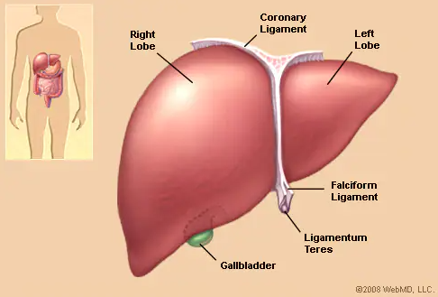

The liver is a large, meaty organ that sits on the right side of the belly. Weighing about 3 pounds, the liver is reddish-brown in color and feels rubbery to the touch. Normally you can't feel the liver, because it's protected by the rib cage.

The liver has two large sections, called the right and the left lobes. The gallbladder sits under the liver, along with parts of the pancreas and intestines. The liver and these organs work together to digest, absorb, and process food.

The liver's main job is to filter the blood coming from the digestive tract, before passing it to the rest of the body. The liver also detoxifies chemicals and metabolizes drugs. As it does so, the liver secretes bile that ends up back in the intestines. The liver also makes proteins important for blood clotting and other functions.