**ATM Locator Service:**

* Create a spring boot application to expose the REST APIs with the following definition.
* The application should invoke an external service to gather a list of atms:

https://www.ing.nl/api/locator/atms/

**Repository Details: https://github.com/sreenivasvanguri/MyService**

**JAR File**: atmlocator-0.0.1-SNAPSHOT.jar

[INFO] --- maven-install-plugin:2.5.2:install (default-install) @ atmlocator ---

[INFO] Installing C:\Users\cnu4u\Downloads\atmlocator\target\atmlocator-0.0.1-SNAPSHOT.jar to C:\Users\cnu4u\.m2\repository\com\mobiquity\assignment\atmlocator\0.0.1-SNAPSHOT\atmlocator-0.0.1-SNAPSHOT.jar

[INFO] Installing C:\Users\cnu4u\Downloads\atmlocator\pom.xml to C:\Users\cnu4u\.m2\repository\com\mobiquity\assignment\atmlocator\0.0.1-SNAPSHOT\atmlocator-0.0.1-SNAPSHOT.pom

[INFO] ------------------------------------------------------------------------

[INFO] BUILD SUCCESS

[INFO] ------------------------------------------------------------------------

[INFO] Total time: 02:27 min

[INFO] Finished at: 2021-02-03T21:24:09+05:30

[INFO] ------------------------------------------------------------------------

**Deployment**:Deploy *atmlocator-0.0.1-SNAPSHOT.jar* in TOMCAT Server

● The application should expose following APIs and return a well-formed JSON response

○ An API to get a list of all the atms : <http://localhost:8080/locations>

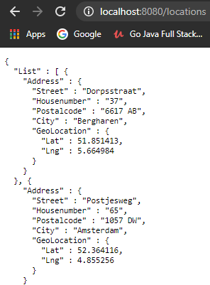

● An API to filter the atms by city: [http://localhost:8080/locations/Amsterdam](http://localhost:8080/locations)

