1. Create a User assigned managed identity (Search for Managed Identity in the Azure Portal)

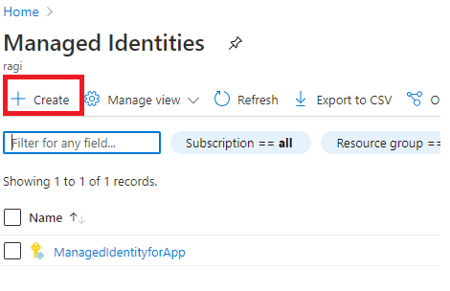

1. Provision a Virtual Machine in Azure

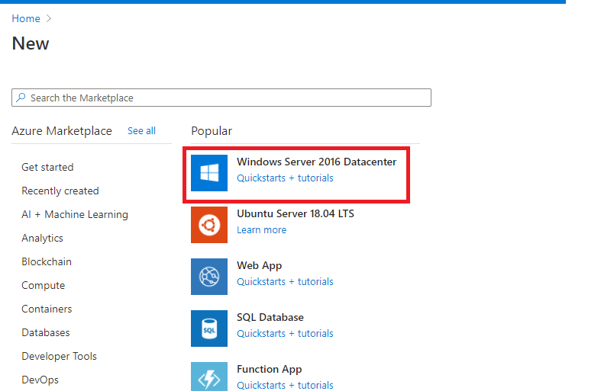

1. Set User assigned Managed identity to Virtual Machine

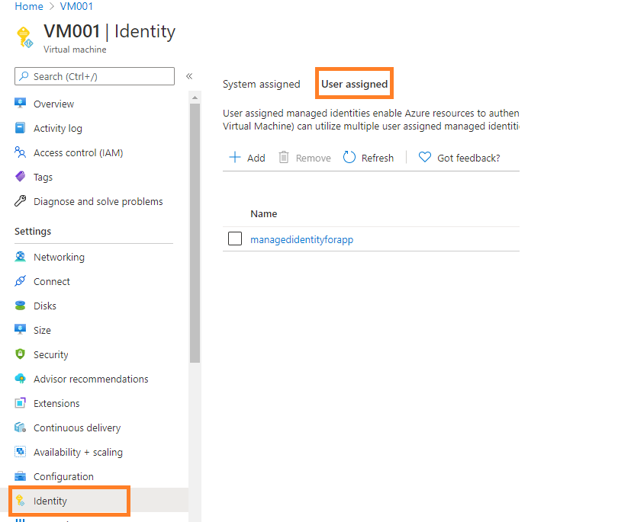

1. Provision an Azure App Config

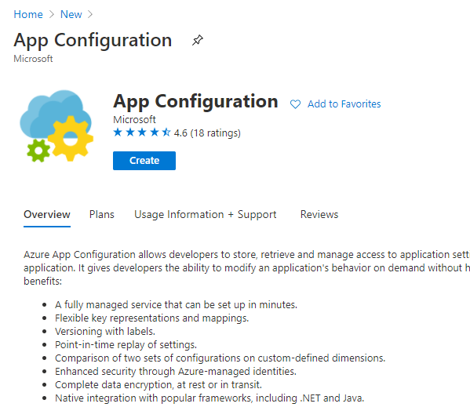

1. Set User assigned managed identity to Azure App Config

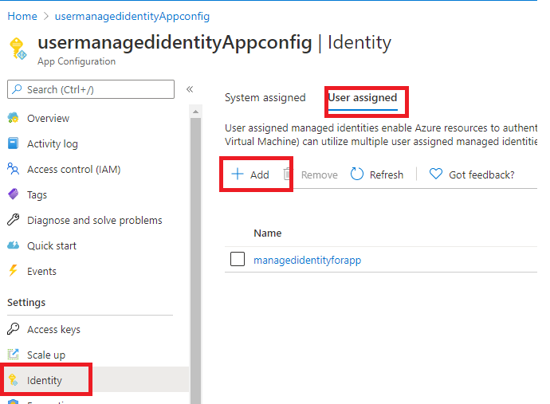

1. Assign permission to User managed identity for accessing Azure App Config

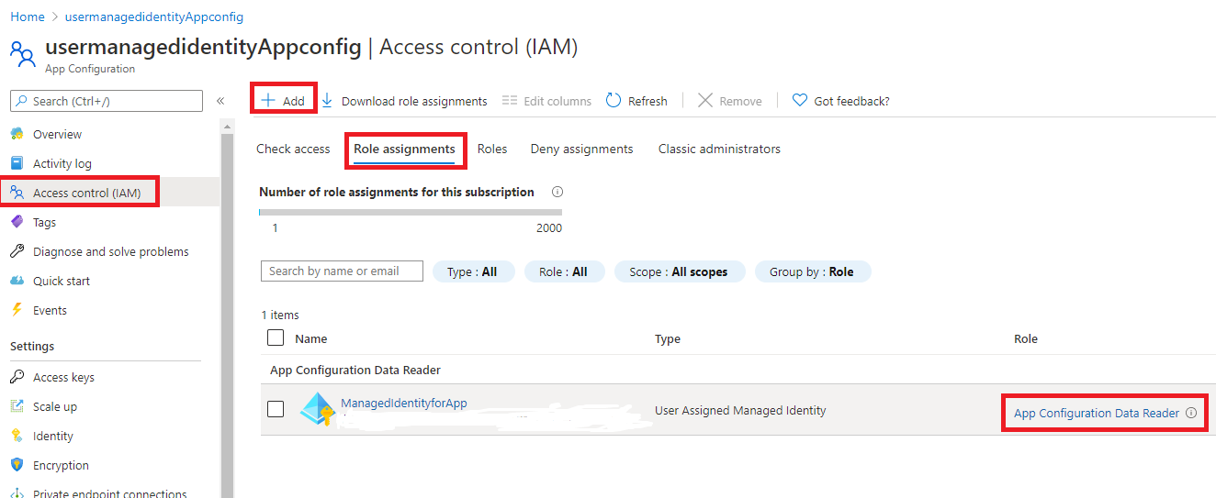

1. Create a key in Azure App Config for the application

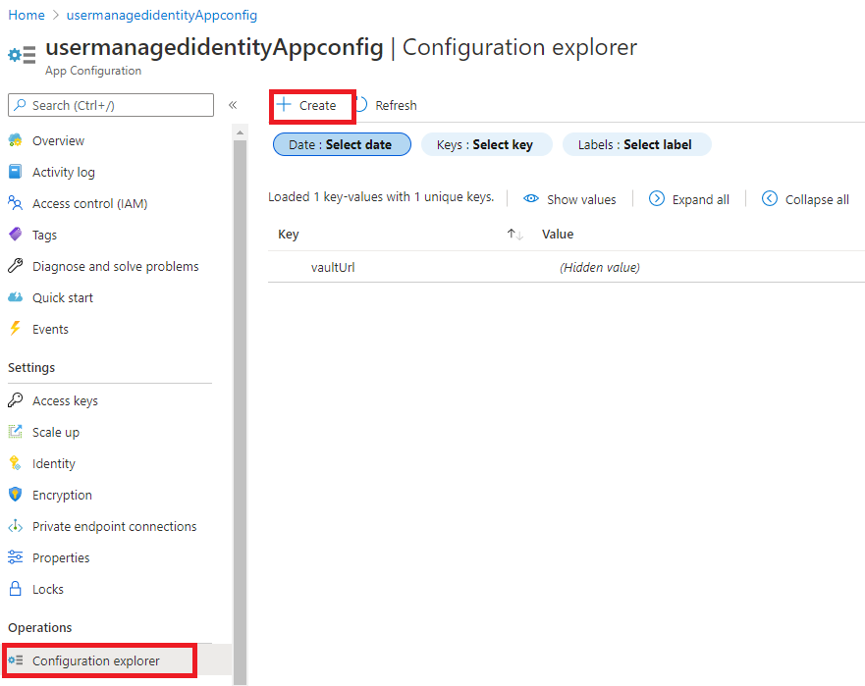

1. Provision Azure Key Vault

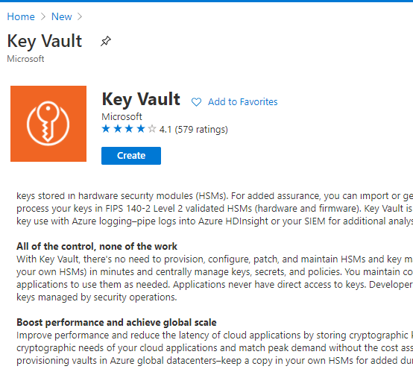

1. Assign permission to User managed identity for accessing Azure Key Vault

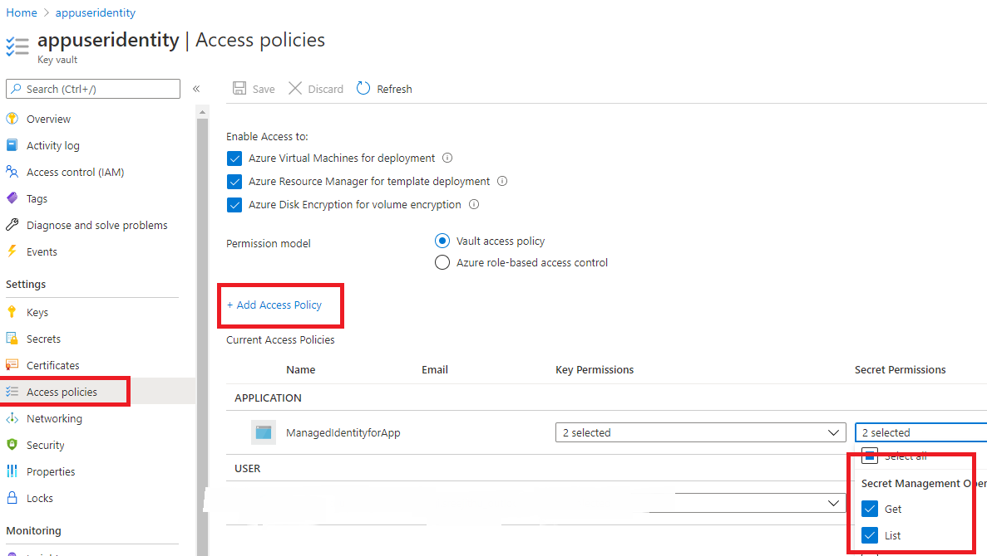

1. Create a Secret in Azure Key vault

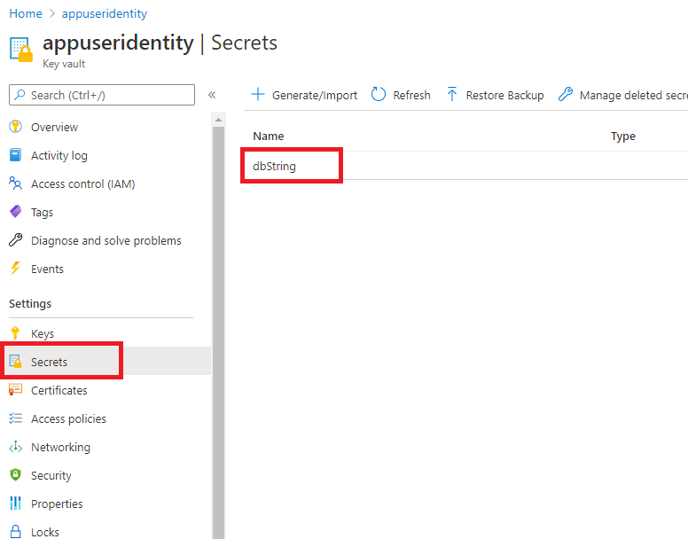

1. Provision a SQL DB

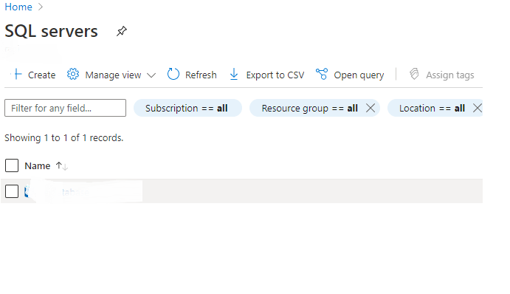

1. Create a database

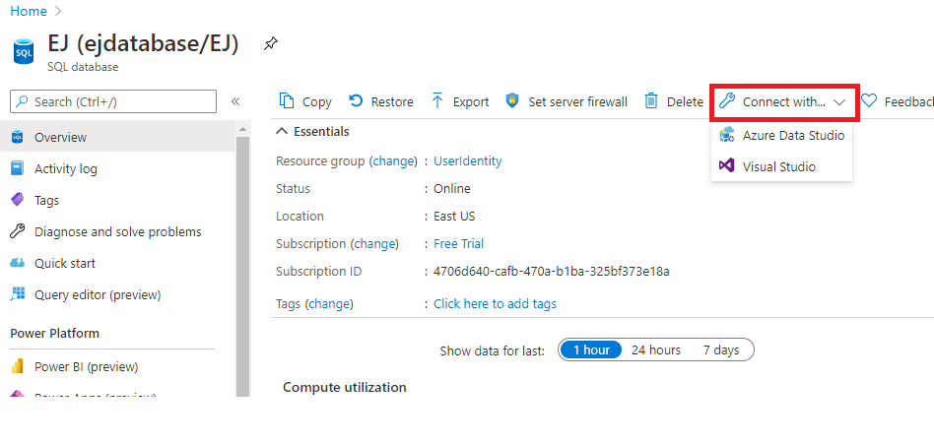

1. Create a contained user in the database and execute the following commands



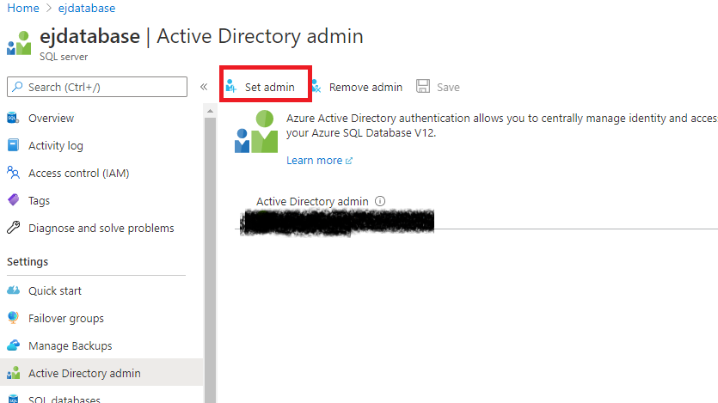

a.Create User [User-assigned managed identity] FROM EXTERNAL PROVIDER

b. ALTER ROLE db_datareader ADD MEMBER [User-assigned managed identity]

c. ALTER ROLE db_datawriter ADD MEMBER [User-assigned managed identity]



