Couchbase Setup

URL : http://localhost:8091 (ip where it is running)

1. Screen 1 , click setup

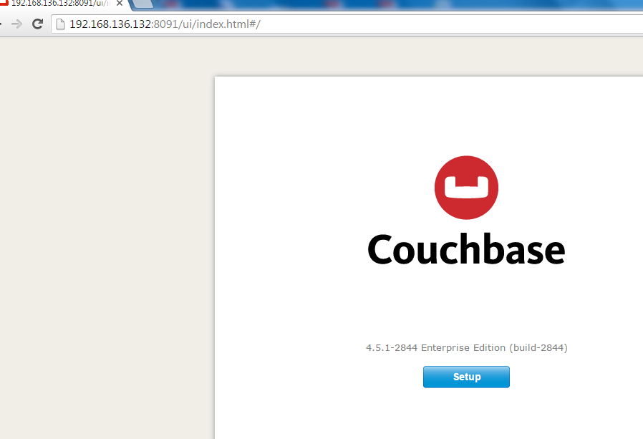

1. Screen 2

Choose the default option, click next

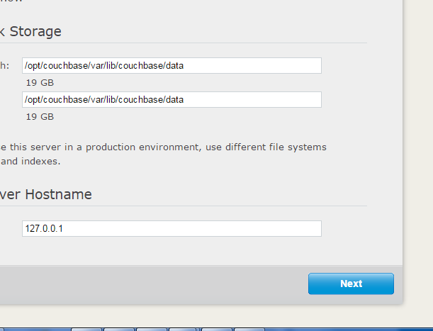

1. Screen 3

Click next (no option selected) , no sample buckets

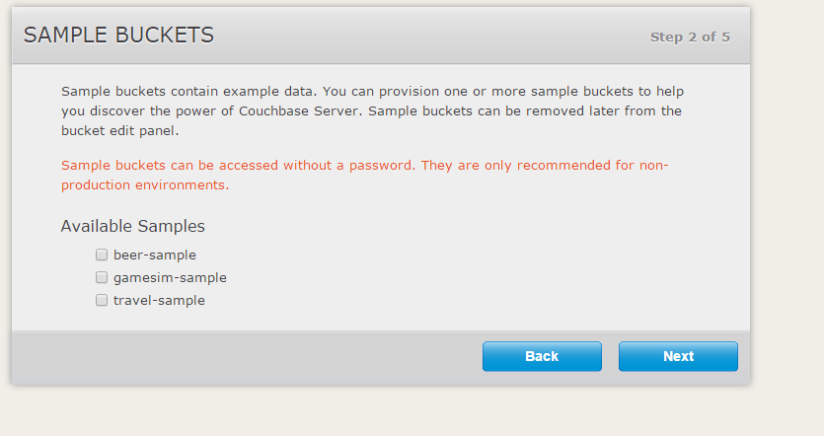

1. Screen 4 , click skip

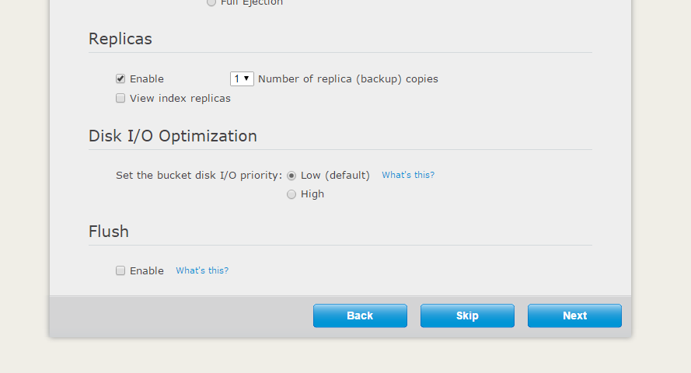

Screen 5, check I agree, click next

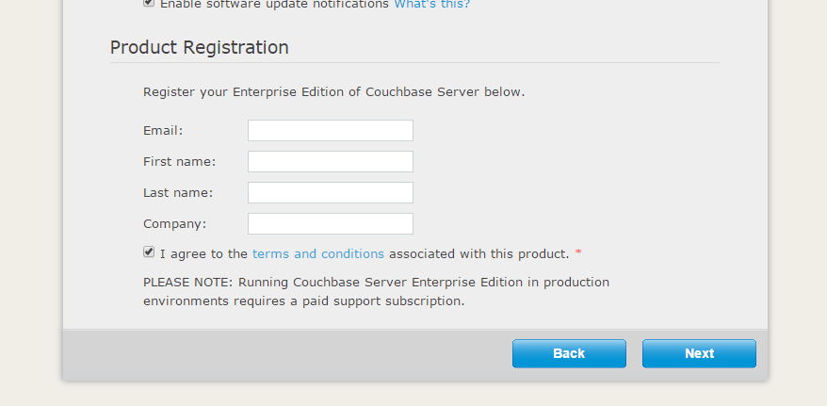

Screen 6, choose a password, and click next

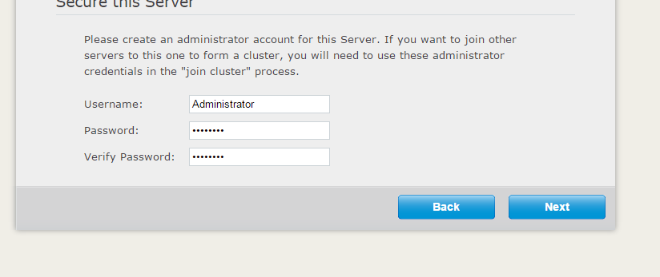

Screen 7, Select option, data bucket, and create new data bucket

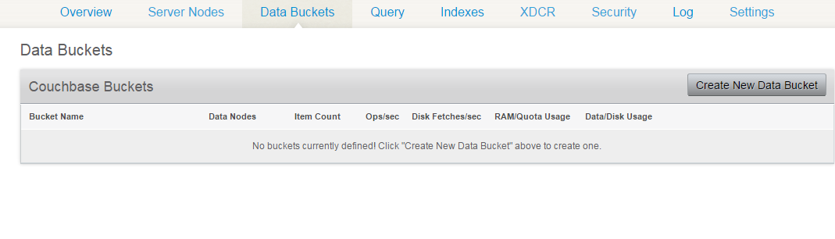

Screen 8, Enter bucket name USER_PROFILE (**important, name should be same),** deselect replication and Click create

