Employee Attrition & Turnover Insights Report
Data‑Driven Analysis of IBM HR Analytics Dataset

Project Metadata
Prepared By: Gurram Sree Pavani
Email: sreepavani8112001@gmail.com
Date of Preparation: 2025-12-03

1. Problem Statement
Organizations face increasing pressure to understand the underlying factors that contribute to employee attrition and overall workforce stability. Employee turnover carries significant financial implications, including the costs of recruitment, onboarding, productivity loss, and the impact on organizational morale. Using historical HR records, companies can uncover trends and patterns to understand why employees leave and which workforce segments are most at risk.
The IBM HR analytics dataset provides a comprehensive snapshot of workforce demographics, job roles, compensation, workload, satisfaction levels, and tenure attributes. Containing 1,470 employee records and 35 variables, it offers a rich foundation for detailed analysis. Key fields include Age, Attrition (Yes/No), Department, JobRole, MonthlyIncome, JobSatisfaction, StockOptionLevel, TotalWorkingYears, YearsAtCompany, and various satisfaction and performance metrics.
This study aims to answer essential HR questions: What is the overall attrition rate? Which employee groups—defined by age, job department, or overtime status—exhibit higher turnover? How do compensation, satisfaction scores, and stock options correlate with attrition? Insights generated from this analysis will support HR leadership in designing data‑driven strategies aimed at improving retention, optimizing workloads, and enhancing overall employee experience.
The overarching objective is to quantify attrition levels, identify high‑risk segments, and provide actionable insights that enable more informed workforce planning and employee engagement initiatives.

2. Techniques and Tools Used

2.1 Data Understanding
- Loaded IBM HR dataset using Python, Pandas
- Reviewed 35 variables across demographics, job details, satisfaction, and tenure
- Understood business meaning of features

2.2 Data Cleaning & Preprocessing
- Checked and confirmed dataset completeness
- Ensured correct numeric data types for Age, MonthlyIncome, TotalWorkingYears
- Encoded categorical variables for analysis
- Created AgeGroup buckets and AttritionRate measures
- Validated distributions and value ranges

2.3 Exploratory Data Analysis (EDA)
- Generated descriptive statistics
- Calculated attrition rate (~16%) and total attritions (~237)
- Analyzed attrition by gender, department, age group, overtime, stock option level
- Compared satisfaction metrics and income between attrition segments

2.4 Data Quality & Feature Engineering
- Identified constant columns (EmployeeCount, StandardHours)
- Created KPIs: AttritionRate, AvgMonthlyIncome, AvgJobSatisfaction
- Encoded Attrition as binary target for advanced analytics

2.5 Visualization & Dashboard (Power BI)
- Built KPI cards for attrition rate, employee count, attritions, income, satisfaction
- Developed charts for department, age group, overtime, stock options
- Added slicers for Department, JobRole, Gender, AgeGroup, EducationField, OverTime
- Enabled interactive exploration of attrition drivers

3. Tools & Technologies Summary
Category | Tools / Technologies | Purpose
Data Processing | Python, Pandas, NumPy | Data loading, cleaning, analysis
Notebook Env | Jupyter Notebook | EDA and documentation
Visualization | Microsoft Power BI | Interactive dashboards
Data Source | IBM HR Analytics Dataset | Employee demographic and job data
File Format | CSV / Excel | Raw data storage

4. Key Findings & Insights
- Overall attrition rate ~16% with 237 departures out of ~1,000 employees
- Highest attrition in Sales and Human Resources departments
- Young employees (18–25) show significantly higher attrition than older groups
- Employees working overtime have much higher attrition rates
- Lower stock option levels and lower satisfaction scores correlate with higher turnover

5. Dashboard Screenshots & Interpretation
Figure 1: Employee Attrition & Turnover Insights Dashboard
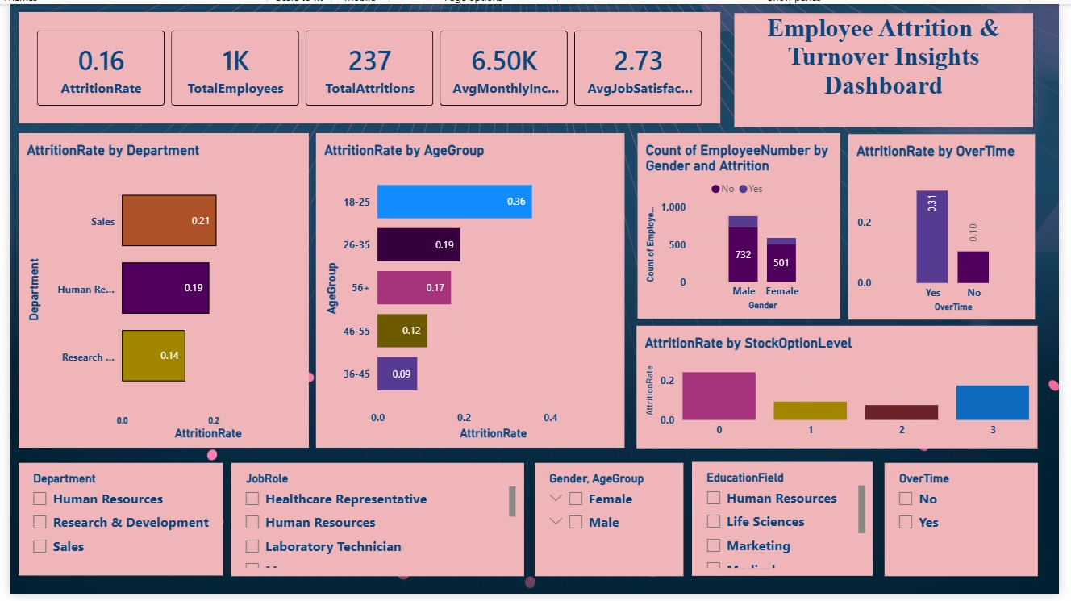

6. Conclusion & Recommendations
This analysis highlights critical drivers of employee attrition, including age, job department, overtime, stock option levels, and satisfaction scores. Sales and HR departments exhibit higher turnover and may require targeted retention initiatives. Younger employees show strong mobility tendencies, suggesting the need for improved career growth pathways and mentorship programs.
HR leadership should consider reviewing workload and overtime policies, strengthening recognition and development programs, and enhancing job satisfaction initiatives. Future work may include predictive modeling to identify at‑risk employees and ongoing monitoring via the Power BI dashboard to inform strategic workforce planning.

