Uber Trip Demand Analysis Report
Patterns of Daily Trips and Active Vehicles by Dispatch Base

Project Metadata
Prepared By: Gurram Sree Pavani
Email: sreepavani8112001@gmail.com
Date of Preparation: 2025-12-03

1. Problem Statement
Understanding trip demand patterns is essential for ride-hailing companies operating in dense metropolitan areas like New York City. Efficient fleet deployment, improved dispatch operations, and reduced customer wait times depend on accurate insights into daily and weekly demand fluctuations. With multiple dispatch bases serving thousands of daily riders, identifying how demand varies across bases and dates becomes critical for strategic planning.
This project analyzes 354 daily Uber trip records across several dispatch bases between January 1, 2015 and February 28, 2015. Each record contains the number of active vehicles, total trips, dispatch base identifier, and trip date. Dispatch base identifiers include B02512, B02617, B02682, B02764, and B02765, representing different operational hubs across the city.
Key operational questions guide the analysis: What is the total trip volume over the period? How many vehicles were actively serving riders? How does demand evolve over time, and which days of the week display the highest or lowest trip counts? Which dispatch bases generate the highest trip volume, and how efficient are they based on trips-per-vehicle? Answers to these questions support better planning, fleet allocation, surge preparation, and operational optimization across bases.
The objective of this study is to quantify overall demand, identify temporal patterns, and compare base performance to inform data-driven decisions for improving fleet efficiency and rider service availability.

2. Techniques and Tools Used

2.1 Data Understanding
- Loaded Uber NYC trip dataset using Pandas
- Reviewed key fields: dispatching_base_number, date, active_vehicles, trips
- Understood dispatch base identifiers (e.g., B02512, B02617, B02682, B02764, B02765)

2.2 Data Cleaning & Preprocessing
- Converted date column to datetime format
- Checked for missing values and duplicates across 354 rows
- Verified correct numeric types for active_vehicles and trips
- Created derived fields: DayOfWeek and TripsPerVehicle
- Validated numeric distributions (active_vehicles avg ≈ 1307, trips avg ≈ 11667)

2.3 Exploratory Data Analysis (EDA)
- Calculated total trips (~4.13M) and total active vehicles (~463K)
- Computed average trips per vehicle (~8.92)
- Summarized trips in final 7 days (~141K)
- Conducted daily time-series analysis to identify demand peaks
- Evaluated day-of-week demand trends
- Compared dispatch base performance metrics

2.4 Visualization & Dashboard (Power BI)
- Built KPI cards (total trips, total active vehicles, trips per vehicle, last 7-day trips)
- Developed time-series and day-of-week charts
- Created dispatch base comparison charts and tables
- Added filters for date range and base selection

3. Tools & Technologies Summary
Category | Tools / Technologies | Purpose
Data Processing | Python, Pandas, NumPy | Loading, cleaning, aggregation
Notebook Env | Jupyter Notebook | EDA and documentation
Visualization | Power BI | Dashboards and KPIs
Data Source | Uber NYC Trips Dataset | Daily demand by dispatch base
File Format | CSV | Raw data storage

4. Key Findings & Insights
- Total demand of ~4.13M trips served by ~463K active vehicles
- Average fleet utilization of ~8.9 trips per vehicle
- Consistent early-period trip peaks followed by a downward trend
- Weekly seasonality observed in day-of-week patterns
- Dispatch bases differ significantly in total trips and efficiency

5. Dashboard Screenshots & Interpretation
Insert dashboard images here. Visuals include full dashboard, time-series chart, day-of-week bars, and base comparison table.
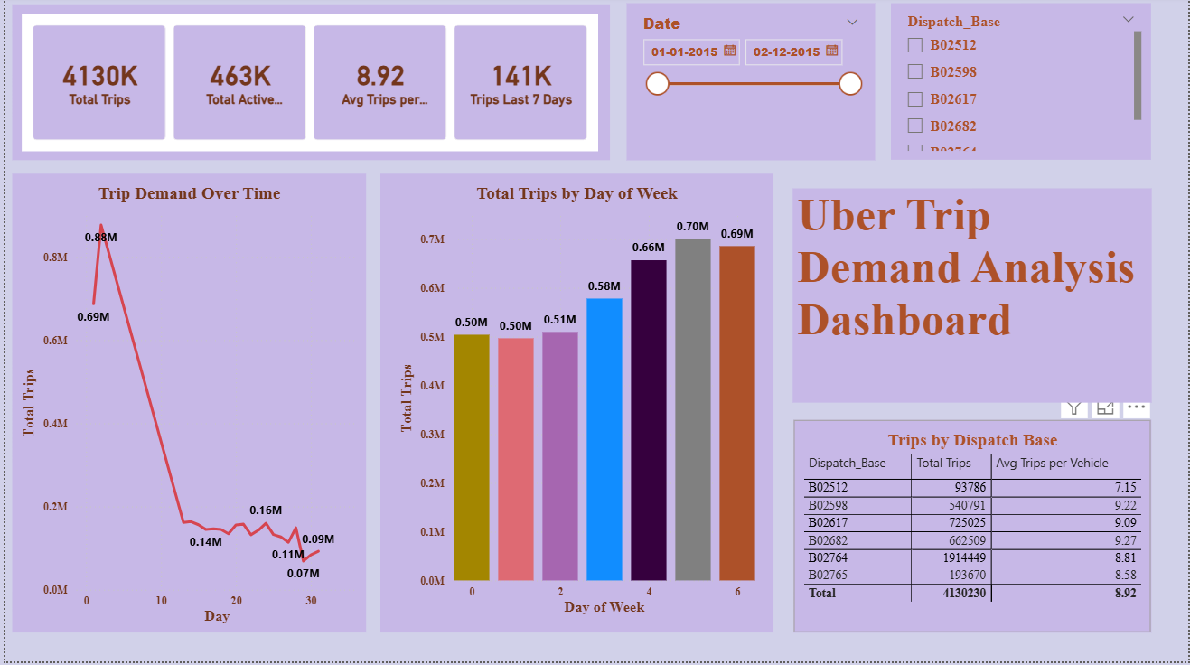

6. Conclusion & Recommendations
This Uber trip demand analysis reveals meaningful insights into daily demand patterns, day-of-week variations, and differences across dispatch bases. Peaks in early January gradually taper off, suggesting temporal factors such as weather, holidays, or operational changes. Weekly seasonality provides opportunities for informed scheduling, while base-level analysis highlights where additional capacity may be required.
Recommendations:
- Align fleet allocation with high-demand days and base locations
- Monitor weekly trends to optimize driver incentives and surge pricing
- Investigate low-efficiency bases to improve performance
- Incorporate weather, event, and holiday data for enhanced forecasting
Future work may include predictive demand modeling and hourly-level analysis to further enhance operational decision-making.

