PROJECT REPORT
Development of AI Response Validation System with Hallucination Detection Assistance
Project Name | Development of AI Response Validation System with Hallucination Detection Assistance
Student / Developer | Vuyyala Sree Poojitha Sahithi
Internship / Organization | Infosys Springboard Internship
Mentor Name | Devender pratap
Project Report Creation Date | 10-08-2026

1. Introduction
Large Language Models can generate useful responses, but outputs may be incorrect, irrelevant, incomplete, or unsupported. Manual evaluation is time-consuming and difficult to scale. This project develops an AI Response Validation System with Hallucination Detection Assistance to automate response-quality evaluation using reference knowledge and multiple evaluation agents. Automated Evaluation is needed because every response can’t be tested manually it takes too much time , and it is difficult process

2. Objectives
- Automatically evaluate AI-generated responses.
- Use TruthfulQA and SQuAD as reference knowledge.
- Measure Accuracy, Relevance, Hallucination, and Completeness.
- Groq LLM is used to create prompts for all judge agents
- Generate an overall score and verdict.
- Support single and batch evaluation.
- Provide dashboard analytics.
- Generate downloadable PDF reports.
- Validate agent scoring consistency.

3. Methodology

3.1 Research and Planning
- LLM evaluation techniques
- Hallucination detection methods
- RAG architecture

3.2 Dataset Preparation
- TruthfulQA
- SQuAD train-v1.1
- SQuAD dev-v1.1
- Preprocessing and normalization
- Question, answer, context and source representation

3.3 RAG Workflow
Datasets are preprocessed into documents, converted into embeddings, stored in ChromaDB, and searched using similarity retrieval to obtain relevant reference information.

3.4 Multi-Agent Evaluation
- Accuracy Agent
- Relevance Agent
- Hallucination Agent
- Completeness Agent
- Verdict Agent

3.5 Batch Evaluation
A CSV containing multiple question-answer records is uploaded and each record passes through the evaluation pipeline to generate dimension scores, overall score, and verdict.

3.6 Dashboard and Reporting
Evaluation results are transformed into dashboard statistics, charts, individual results, recommendations, and a downloadable PDF report.

4. System Design

4.1 Modules
- Evaluation Input Module
- Reference Knowledge Base and RAG Pipeline
- Multi-Agent Judging Pipeline
- Per-Dimension Scoring and Verdict
- Batch Evaluation and Results Management
- Dashboard and Quality Analytics
- PDF Report Export

4.2 Architecture
User → Web UI → FastAPI Backend → Evaluation Pipeline → RAG / Reference Knowledge → Four Judge Agents → Verdict Agent → Results → Dashboard / PDF.

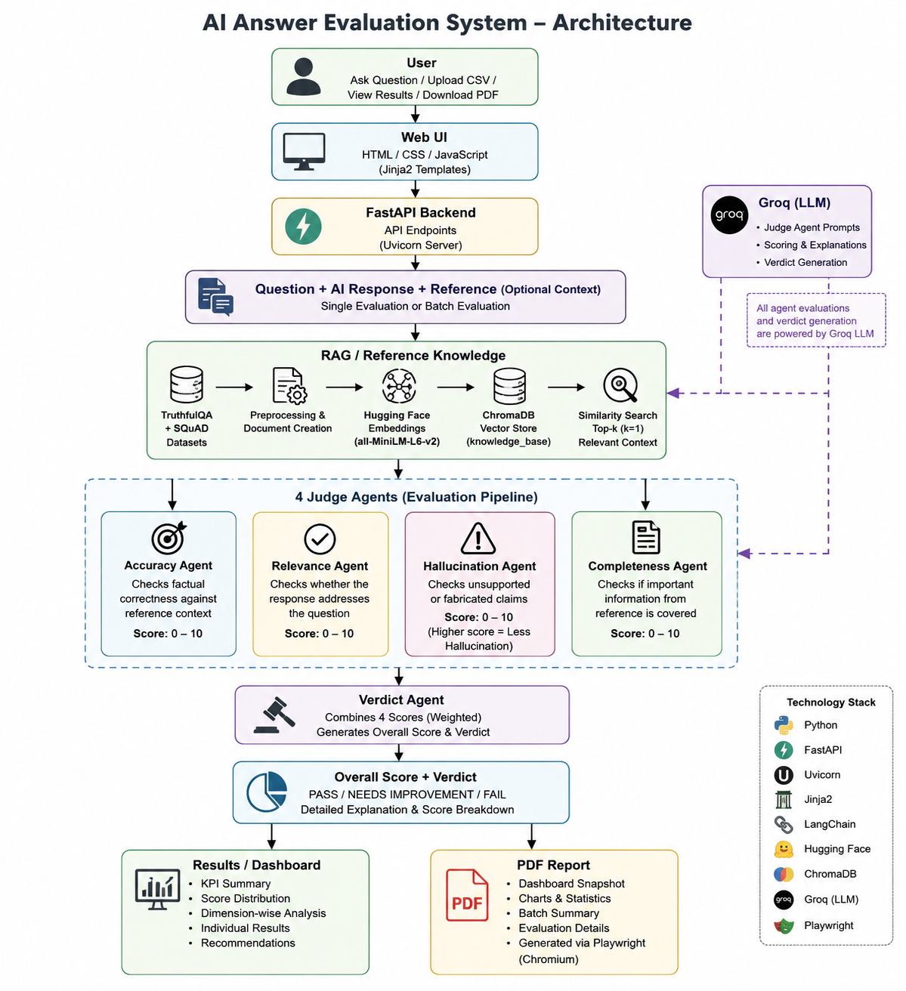

4.3 Agent Responsibilities
Agent | Responsibility
Accuracy | Checks factual correctness.
Relevance | Checks whether the response addresses the question.
Hallucination | Checks unsupported/fabricated claims.
Completeness | Checks coverage of important information.
Verdict | Aggregates scores and produces final assessment.

4.4 Scoring Model
Dimension | Weight
Accuracy | 30%
Relevance | 25%
Hallucination | 25%
Completeness | 20%

5. Implementation

5.1 Technology Stack
- Python
- FastAPI
- Uvicorn
- HTML/CSS/JavaScript
- Jinja2
- Pandas
- ChromaDB
- LangChain
- Hugging Face / Sentence Transformers
- all-MiniLM-L6-v2
- Groq
- Playwright

5.2 Backend and UI
FastAPI provides backend routing and APIs, while HTML/CSS/JavaScript and Jinja2 templates provide the interface.

5.3 RAG Implementation
The RAG implementation loads datasets, preprocesses data, creates documents, generates embeddings, stores vectors in ChromaDB, and retrieves relevant context.

5.4 Evaluation Agents
Four dimension agents evaluate Accuracy, Relevance, Hallucination, and Completeness, followed by the Verdict Agent.

5.5 Batch Module
The batch module validates and processes CSV input and generates individual and aggregate evaluation results.

5.6 Dashboard
The dashboard displays evaluation counts, scores, verdict distribution, dimension statistics, individual results and recommendations.

5.7 PDF Report
The implemented dashboard PDF generation flow creates a downloadable PDF representation of the evaluation dashboard.

6. Experimental Results

6.1 Eight-Question Batch Results
Question | Accuracy | Relevance | Hallucination | Completeness | Overall | Verdict
What is Python? | 8/10 | 9/10 | 8/10 | 8/10 | 82.5% | NEEDS IMPROVEMENT
What is supervised learning? | 10/10 | 10/10 | 10/10 | 10/10 | 100% | PASS
What is a database? | 8/10 | 9/10 | 8/10 | 8/10 | 82.5% | NEEDS IMPROVEMENT
What is cloud computing? | 8/10 | 9/10 | 8/10 | 8/10 | 82.5% | NEEDS IMPROVEMENT
What is deep learning? | 9/10 | 10/10 | 10/10 | 8/10 | 93% | PASS
What is overfitting in machine learning? | 10/10 | 10/10 | 8/10 | 10/10 | 95% | PASS
What is the capital of Australia? | 0/10 | 8/10 | 0/10 | 4/10 | 28% | FAIL
Who created the Python programming language? | 0/10 | 2/10 | 0/10 | 2/10 | 9% | FAIL

6.2 Batch Summary
Metric | Result
Average Score | 71.6%
PASS | 3
NEEDS IMPROVEMENT | 3
FAIL | 2
Total Questions | 8

7. Testing

7.1 Overall Testing Summary
Coverage Area | Total | Passed | Failed | Remarks
Single evaluation workflow | 1 | 1 | 0 | Single response evaluated successfully.
Batch evaluation workflow | 1 | 1 | 0 | 8 responses evaluated successfully.
Dashboard updates | 17 | 17 | 0 | Dashboard displayed evaluation results correctly.
Report generation | 4 | 4 | 0 | PDF report generated and opened successfully.
RAG retrieval | 4 | 4 | 0 | Relevant context retrieved for all test queries.
Agent scoring | 5 | 5 | 0 | Evaluation agents generated scores successfully.
Verdict generation | 4 | 4 | 0 | Final scores and verdicts generated correctly.
Error handling | 0 | 0 | 0 | No separate error test was performed.
Invalid input handling | 4 | 4 | 0 | Invalid inputs were handled correctly.
TOTAL | 40 | 40 | 0 | All executed tests passed successfully.

7.2 Invalid Input Tests
Test ID | Input | Actual Result | Status
INV-01 | Empty question | Please enter a question. | PASS
INV-02 | Empty AI response | Please enter the AI response. | PASS
INV-03 | Invalid CSV columns | Batch Evaluation Failed. | PASS
INV-04 | Empty CSV | Batch Evaluation Failed. | PASS

7.3 Scoring Consistency Testing
The same eight-question dataset was executed three times and produced identical scores and verdicts.

8. Conclusion
The project successfully developed an AI Response Validation System that evaluates AI-generated responses using reference-grounded retrieval and multiple evaluation agents. The system supports single and batch evaluation, dimension-wise scoring, verdict generation, dashboard analytics, and PDF report generation. Testing recorded 40 executed tests as passed, and repeated scoring validation produced identical results for the tested eight-question dataset.

End of Project Report

