Technical Documentation
Development of AI Response Validation System with Hallucination Detection Assistance

1. Project Overview
Project title: Development of AI Response Validation System with Hallucination Detection Assistance.
The system evaluates AI-generated responses using reference knowledge, Retrieval-Augmented Generation (RAG), multiple evaluation agents, verdict generation, a dashboard, and PDF reporting.
Main features:
• Single evaluation
• Batch evaluation
• RAG retrieval
• Multi-agent scoring
• Verdict generation
• Dashboard visualization
• PDF report generation

2. Problem Statement
Large Language Models can generate responses that are incorrect, irrelevant, incomplete, or contain hallucinated information. Manual evaluation of these responses is time-consuming and difficult to perform consistently. This system automates response-quality evaluation using trusted reference data and multiple evaluation agents.

3. Objectives
• Automatically evaluate AI-generated responses.
• Use trusted knowledge from TruthfulQA and SQuAD.
• Measure Accuracy, Relevance, Hallucination, and Completeness.
• Generate an overall score and verdict.
• Support batch evaluation.
• Provide dashboard visualization.
• Generate a downloadable PDF report.

3. System Architecture

RAG retrieves relevant reference information from TruthfulQA and SQuAD using ChromaDB, which is provided to the evaluation pipeline.
Four judge agents—Accuracy, Relevance, Hallucination, and Completeness—use Groq LLM to evaluate the response and generate individual scores.
The Verdict Agent combines these scores to produce the overall score and verdict, which are displayed on the Dashboard and used to generate the PDF report.
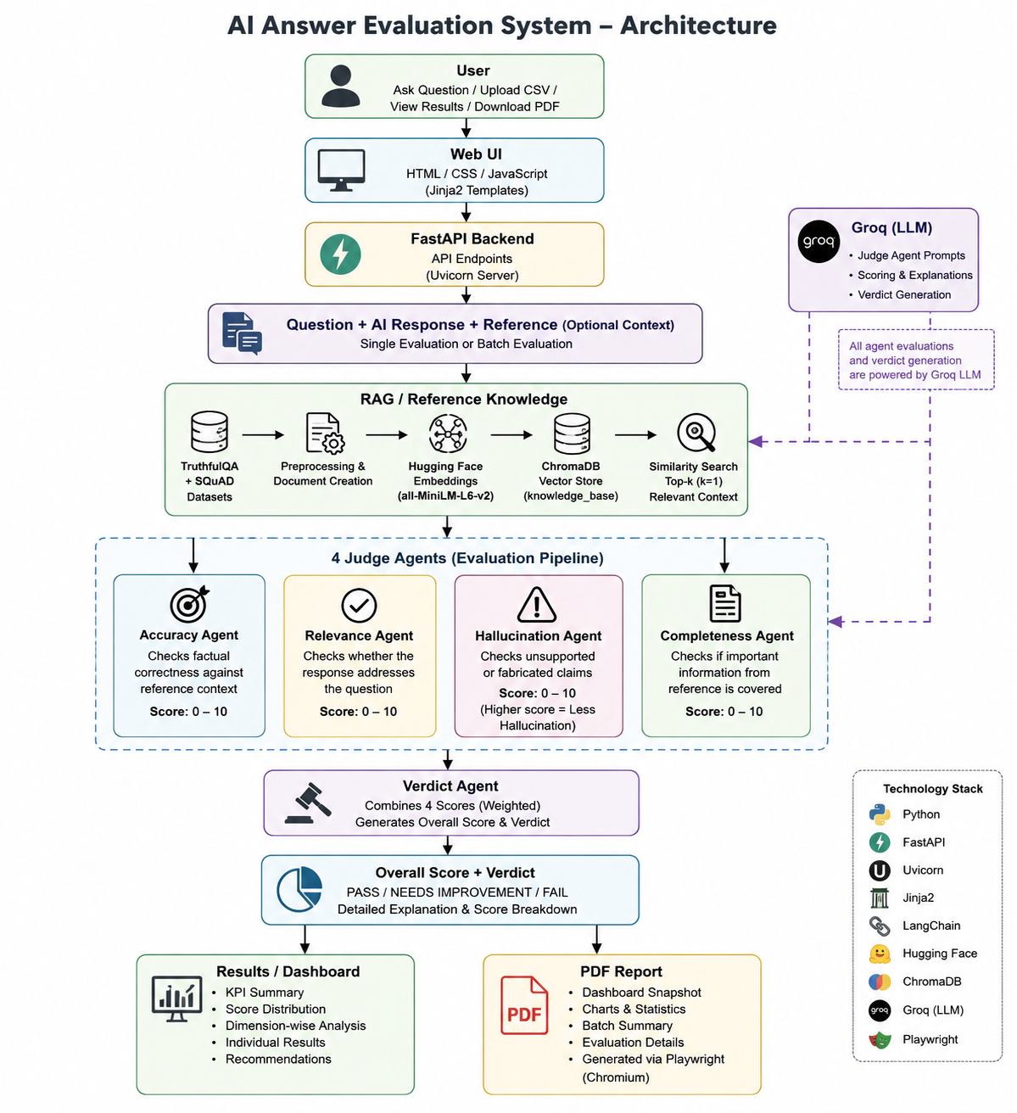

5. Technology Stack
Actual implementation:
• Python — Core development
• FastAPI — Backend/API
• Uvicorn — Application server
• HTML/CSS/JavaScript — Frontend
• Jinja2 — HTML templates
• Pandas — CSV/data processing
• ChromaDB — Vector database
• LangChain — Document/vector-store integration
• Hugging Face — Embedding model
• all-MiniLM-L6-v2 — Text embeddings
• Groq — LLM evaluation
• Playwright — Dashboard PDF generation
The implementation uses HuggingFaceEmbeddings with sentence-transformers/all-MiniLM-L6-v2 and ChromaDB for the vector store.

6. Folder Structure
Actual project structure:
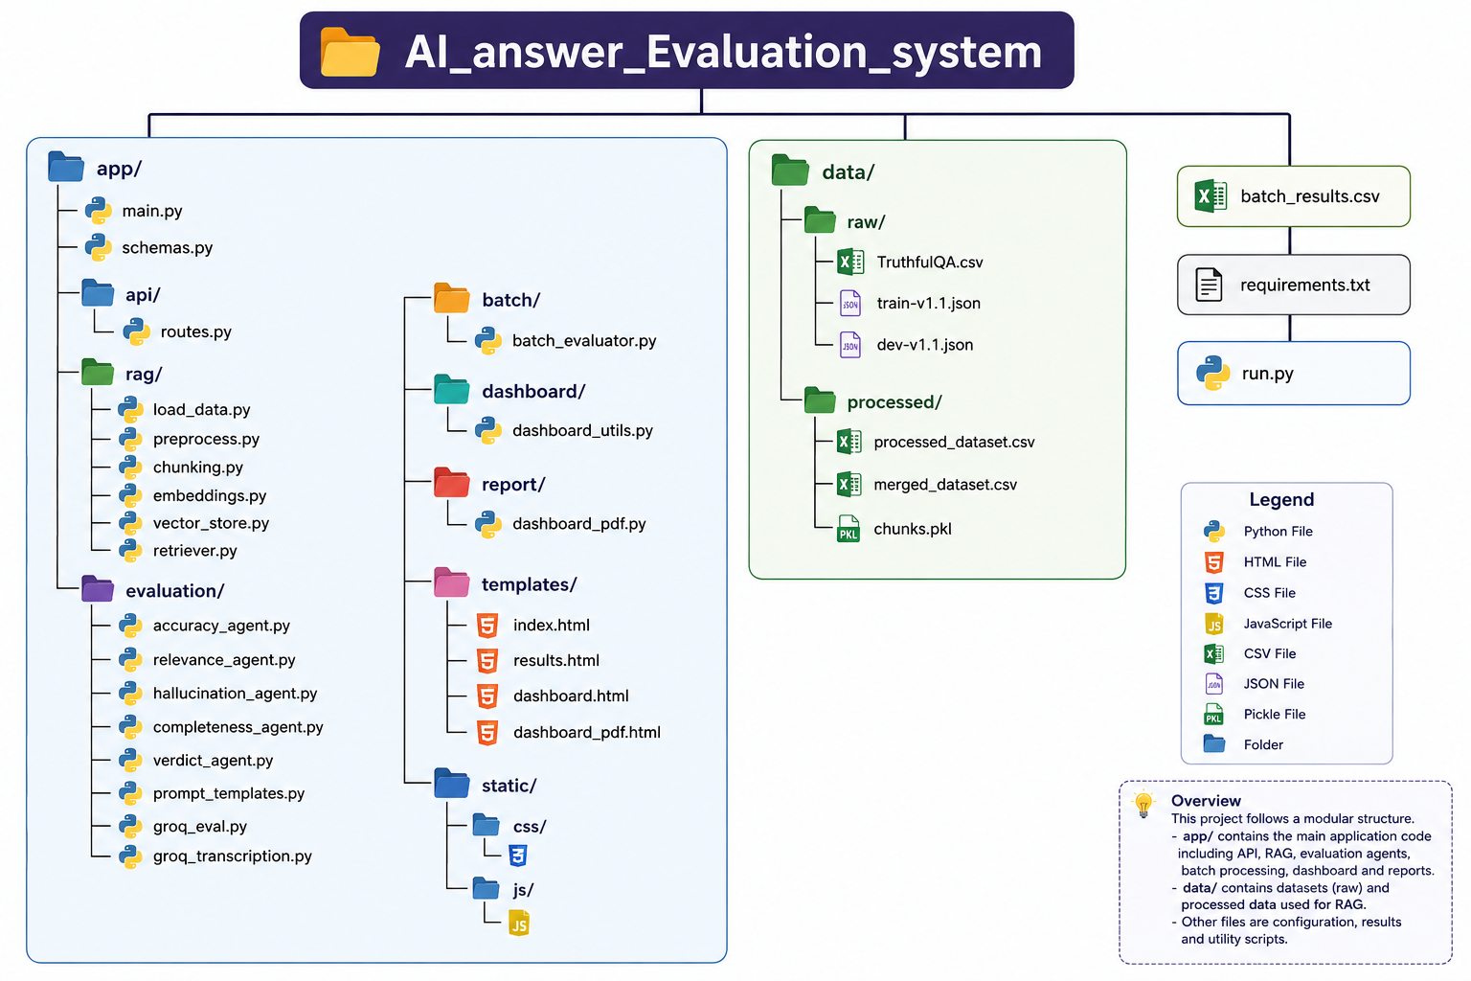

7. Installation Guide
Create and activate the Python environment:
python -m venv env
env\Scripts\activate
pip install -r requirements.txt
python run.py
Open the application at: http://127.0.0.1:8000
Also configure the required Groq API key/environment variables if required by the implementation. The Hugging Face embedding model may be downloaded when the RAG components are initialized.

8. API Documentation
The FastAPI backend provides routes for single evaluation, batch evaluation, voice transcription, dashboard data, and report generation.
Method | Endpoint | Purpose
GET | / | Loads the main AI Response Evaluator interface.
GET | /results | Displays the evaluation results page.
GET | /dashboard | Loads the evaluation dashboard.
GET | /dashboard-data | Returns dashboard statistics and evaluation data.
POST | /evaluate | Evaluates a single AI response using Accuracy, Relevance, Hallucination, Completeness, and Verdict agents.
POST | /batch-evaluate | Accepts a CSV file and performs batch evaluation for multiple questions.
POST | /transcribe | Accepts an audio file and converts the voice input into text using the transcription module.
GET | /download-batch-results | Downloads the generated batch_results.csv file.
GET | /dashboard/pdf | Loads the dashboard PDF template with the current evaluation data.
GET | /download-dashboard-pdf | Generates and downloads the evaluation dashboard as a PDF.

9. Database / Vector DB
Database in this project refers to ChromaDB, which is used as the vector database rather than a traditional SQL database.
Workflow:
TruthfulQA + SQuAD → Preprocessing → Processed Dataset → QA Documents → Hugging Face Embeddings → ChromaDB → Similarity Search → Relevant Reference Context
The implementation stores documents in the Chroma collection named knowledge_base.

10. RAG Workflow
Step 1 — Dataset Loading: TruthfulQA and SQuAD are loaded.
Step 2 — Preprocessing: datasets are converted into a common structure containing Question, Answer, Context, and Source.
Step 3 — Document Creation: each QA pair becomes a LangChain Document with metadata.
Step 4 — Embedding: all-MiniLM-L6-v2 converts text into vectors.
Step 5 — ChromaDB: embeddings are stored in the vector database.
Step 6 — Retrieval: the user question is converted into an embedding and similarity search retrieves the most relevant document.
The current retriever uses similarity_search_with_score() with k = 1 and displays source, question, answer, content, and similarity score.
RAG testing included two TruthfulQA queries and two SQuAD queries. All four returned relevant context and passed.

11. Agent Description
Accuracy Agent — Checks factual correctness against the reference/retrieved context.
Relevance Agent — Checks whether the response directly addresses the question.
Hallucination Agent — Checks unsupported or fabricated claims.
Completeness Agent — Checks whether important information from the reference is covered.
Verdict Agent — Combines the four scores and produces the Overall Score, PASS / NEEDS IMPROVEMENT / FAIL verdict, and summary.

12. Scoring Logic
Final implementation weights:
• Accuracy — 30%
• Relevance — 25%
• Hallucination — 25%
• Completeness — 20%
The weighted score is converted into a percentage and then used to generate the final verdict according to the thresholds implemented in the project.

13. Dashboard Explanation
Dashboard components include:
• Average Score
• Total Evaluations
• PASS count
• Needs Improvement count
• FAIL count
• Average Accuracy
• Average Relevance
• Average Hallucination
• Average Completeness
• Hallucination Frequency
• Average Overall Score
• Verdict distribution
• Dimension-wise chart
• Batch Summary
• Individual Evaluation Results
• Improvement Recommendations
• PDF Download

14. Report Generation
PDF generation is Playwright-based, not ReportLab-based.
The implementation uses Playwright/Chromium to load the dashboard page, wait for the dashboard/charts, and generate an A4 PDF.
Workflow:
Dashboard → PDF Download → Playwright / Chromium → dashboard_pdf.html → Evaluation Dashboard PDF

15. Testing Results
Coverage Area | Total Tests | Passed | Failed | Remarks
Single evaluation workflow | 1 | 1 | 0 | Single response evaluated successfully.
Batch evaluation workflow | 1 | 1 | 0 | 8 responses evaluated successfully.
Dashboard updates | 17 | 17 | 0 | Dashboard displayed all evaluation results correctly.
Report generation | 4 | 4 | 0 | PDF report generated and opened successfully.
RAG retrieval | 4 | 4 | 0 | Relevant context retrieved for all test queries.
Agent scoring | 5 | 5 | 0 | All four evaluation agents generated scores successfully.
Verdict generation | 4 | 4 | 0 | Final scores and verdicts generated correctly.
Error handling | 0 | 0 | 0 | No separate error test was performed.
Invalid input handling | 4 | 4 | 0 | Invalid inputs were handled correctly.
TOTAL | 40 | 40 | 0 | All executed tests passed successfully.

17. Limitations
• Evaluation depends on LLM-generated judge scores.
• RAG quality depends on the quality of the stored reference dataset.
• The current knowledge base is limited to TruthfulQA and SQuAD.
• Retrieval currently returns the top matching document.
• Groq/API availability can affect evaluation.
• The system is primarily designed for English text evaluation.
• Large datasets may require more processing time.

18. Future Work
• Add more benchmark datasets.
• Add more evaluation dimensions.
• Add authentication/user management.
• Add persistent evaluation history.
• Improve error handling.
• Add automated monitoring.
• Improve scalability for larger datasets.

