AI Response Quality Evaluator Agent

Table of Contents :
- 1. Introduction
- 1.1 Problem Statement
- 1.2 Project Objective
- 2. Designing the system
- 2.1 High-Level Architecture
- 2.2 Agent Responsibilities
- 2.3 Scoring Dimensions
- 2.4 Data Models
- 2.5 Orchestration Flow
- 3. Tech Stack

1.1 Problem Statement:
Large Language Models (LLMs) can generate useful answers, but sometimes they produce incorrect or unsupported information, called hallucinations. Checking every AI-generated response manually takes a lot of time and effort.
This project aims to build an AI Response Quality Evaluator Agent that automatically evaluates AI-generated responses. It uses a trusted knowledge base and quality metrics to identify incorrect information and improve the reliability of AI responses.

1.2 Project Objective:
The objective of this project is to build an automated system that evaluates AI-generated responses. The system retrieves relevant information from a trusted knowledge base using RAG and compares it with the AI response. It then measures quality using metrics such as Groundedness, Answer Relevance, Context Relevance, and Faithfulness to provide accurate and reliable evaluation results.

2. Designing the system

2.1 High-Level Architecture:

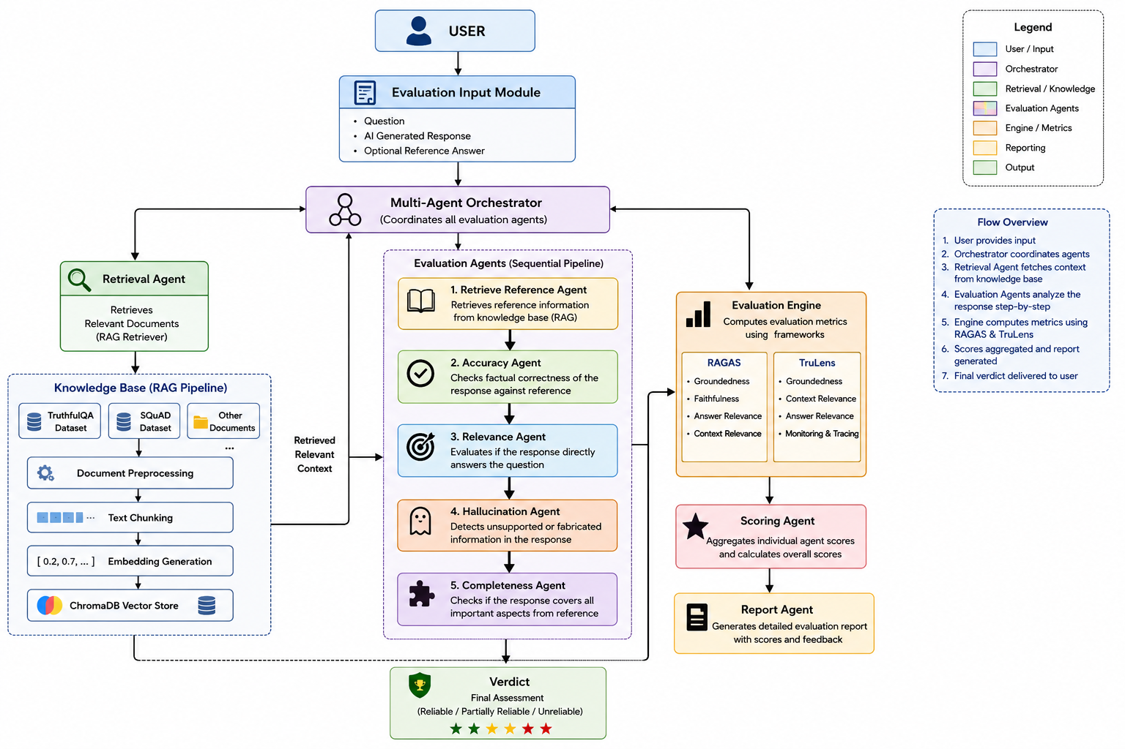

Architecture Explanation:
The designed system evaluates AI-generated responses using a Retrieval-Augmented Generation (RAG) pipeline and a multi-agent architecture.
The process starts when the user submits a question, an AI-generated response, and an optional reference answer through the Evaluation Input Module.
The Multi-Agent Orchestrator manages the complete workflow by coordinating all the evaluation agents. It first calls the Retrieval Agent, which searches the knowledge base and retrieves the most relevant reference documents from the ChromaDB Vector Database.
The knowledge base is created using trusted datasets such as TruthfulQA and SQuAD. These datasets are preprocessed, split into smaller chunks, converted into embeddings, and stored in ChromaDB for similarity search.
The retrieved reference is then passed to different evaluation agents: Reference Agent, Accuracy Agent ,Relevance Agent ,,Hallucination Agent, Completeness Agent
The outputs from these agents are sent to the Evaluation Engine, where RAGAS and TruLens calculate evaluation metrics such as Groundedness, Faithfulness, Answer Relevance, and Context Relevance.
During development, LangSmith is used to trace the RAG pipeline, debug the workflow, and monitor agent execution. OpenAI Evals is used to evaluate the overall system on benchmark datasets and compare different versions of the application.
Finally, the Scoring Agent combines all the metric scores into a final score, and the Report Agent generates a report showing the overall score, individual metric scores, detected issues, and recommendations for improvement.

2.2 Agent Responsibilities:
Agent | Responsibility
Multi-Agent Orchestrator | Manages the complete workflow and coordinates all evaluation agents.
Retrieval Agent | Retrieves relevant documents from the ChromaDB knowledge base.
Reference Agent | Prepares the retrieved reference context for evaluation.
Accuracy Agent | Checks whether the AI response is factually correct.
Relevance Agent | Verifies whether the response answers the user's question.
Hallucination Agent | Detects unsupported or fabricated information.
Completeness Agent | Checks whether all important points are covered.
Scoring Agent | Combines all scores into an overall evaluation score.
Report Agent | Generates the final evaluation report and verdict.

2.3 Scoring Dimensions:
Scoring Dimensions are the different evaluation criteria used to calculate the final score.
Metric | Description
Accuracy | Measures whether the AI response is factually correct.
Relevance | Checks whether the response answers the user's question.
Groundedness | Verifies whether the response is supported by the retrieved reference documents.
Faithfulness | Ensures the generated response does not add unsupported information.
Hallucination | Detects fabricated or unsupported content in the response.
Completeness | Checks whether all important points are covered.
Overall Score | Combines all evaluation metrics into a final quality score.

2.4 Data Models:
Data models define how information is organized, stored, and processed within the system. They provide a structured format for handling input data, reference knowledge, and evaluation results.
The designed system uses three data models :
a. Input Data Model
This model represents the information provided by the user for evaluation.
It includes:
Question AI Generated Response Optional Reference Answer
b. Knowledge Base Data Model
This model represents how trusted reference data is stored in the RAG knowledge base.
After preprocessing datasets such as TruthfulQA and SQuAD, the data is stored as:
Document ID Source Text Chunk Embedding Vector
C. Evaluation Result Data Model
This model represents the output generated after the evaluation process.
It includes:
Accuracy Score Relevance Score Groundedness Score Hallucination Score Completeness Score Overall Score Final Verdict

2.5 Orchestration Flow:
The Multi-Agent Orchestrator controls the execution of all agents and ensures that each step is performed in the correct order.
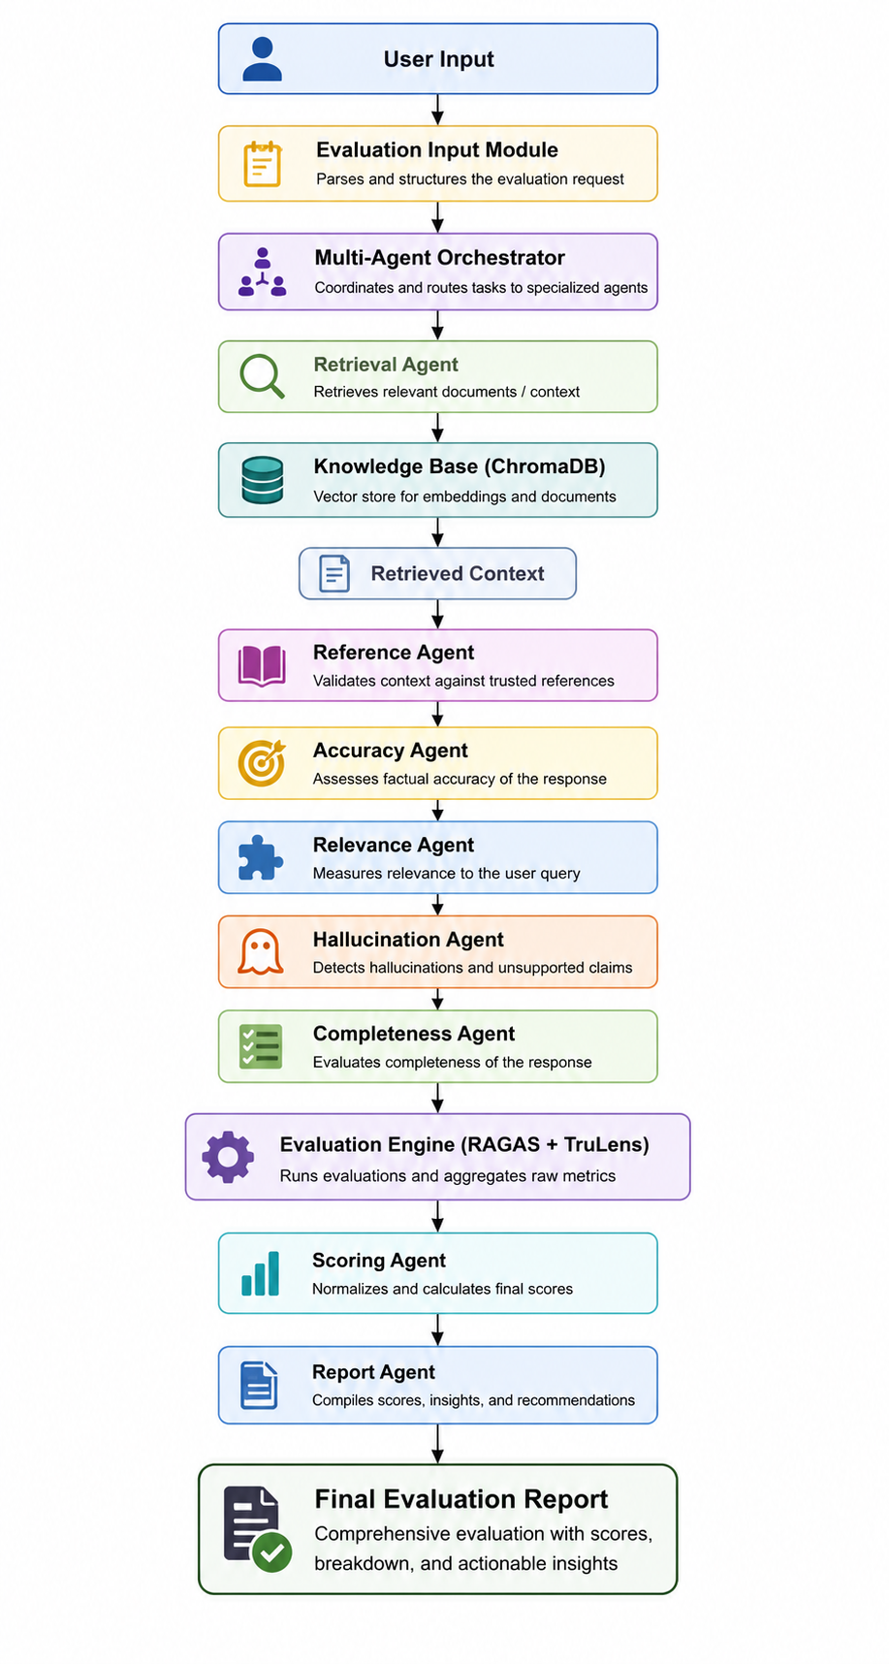

3. Tech Stack
Technology / Tool | Purpose
Python | Core programming language used to build the evaluation system.
FastAPI | Backend API framework for handling evaluation requests and responses.
HTML, CSS & JavaScript | Frontend interface for user interaction.
LangChain | Builds the RAG pipeline and manages LLM workflows.
OpenAI GPT | Generates AI responses and assists in evaluation tasks.
OpenAI Embeddings | Converts text into embedding vectors for semantic search.
ChromaDB | Stores embeddings and retrieves relevant reference documents.
TruthfulQA | Trusted QA dataset used to build the knowledge base.
SQuAD | Question-answering dataset used for the RAG knowledge base.
RAGAS | Evaluates response quality using metrics
TruLens | Monitors, traces, and evaluates LLM application performance.
LangSmith | Traces the RAG pipeline, monitors agent execution, and helps debug the workflow during development.
OpenAI Evals | test and compare the performance of different versions using evaluation datasets.
GitHub | Version control and to store code in repository.
VS Code | Primary development environment.
Render | Deploys and hosts the evaluation system online.

