Blood Bank Management System

Project Documentation

Technology : Java (Swing), MySQL, JDBC, Apache Maven
IDE : Apache NetBeans
Author : Sreerag Belraj
Date : 03 March 2026

1. Introduction
The Blood Bank Management System (BBMS) is a desktop application developed using the Java programming language with the Swing GUI framework. Its primary objective is to digitise and streamline the management of blood bank operations, encompassing donor registration, patient management, blood stock tracking, and blood request processing.
Traditional blood bank record-keeping is error-prone, time-consuming, and difficult to scale. BBMS addresses these challenges by providing an intuitive graphical interface that enables healthcare staff to perform full CRUD (Create, Read, Update, Delete) operations on all key data entities with minimal training.
The system connects to a MySQL relational database through JDBC, ensuring data persistence, integrity, and reliability. The project is built and managed using Apache Maven, which handles all external dependencies and simplifies the build process.

1.1 Objectives
- Maintain complete records of blood donors, including contact details and blood group.
- Register and track patients requiring blood transfusions.
- Monitor real-time blood stock levels for each blood group.
- Manage and monitor blood requests, tracking approval status.
- Provide a secure login mechanism to restrict application access.
- Offer an intuitive Dashboard for navigating between all modules.

1.2 Scope
The current version of BBMS covers four core management modules: Donor Management, Patient Management, Blood Stock Management, and Request Management. The system is intended for single-institution use and operates as a standalone desktop application. Future enhancements may include network/multi-user support, report generation, and integration with external health information systems.

1.3 Technologies Used
Technology | Purpose
Java (JDK 17+) | Core programming language
Java Swing | GUI framework for desktop forms
JDBC | Database connectivity layer
MySQL | Relational database for data storage
Apache Maven | Build tool and dependency management
Apache NetBeans IDE | Integrated development environment

1.4 Database Schema
The MySQL database consists of the following tables:
Table | Primary Key | Key Columns
BloodGroup | group_id | group_name
Donor | donor_id | name, age, phone, group_id (FK)
Patient | patient_id | name, disease, phone, group_id (FK)
BloodStock | stock_id | group_id (FK), units_available
BloodRequest | request_id | patient_id (FK), group_id (FK), units_required, status

2. Class Diagram
The following UML class diagram illustrates the structure of the Blood Bank Management System. Each class is shown with its attributes and methods. Dependency relationships show how the UI frame classes interact with the DBConnection utility and with each other.
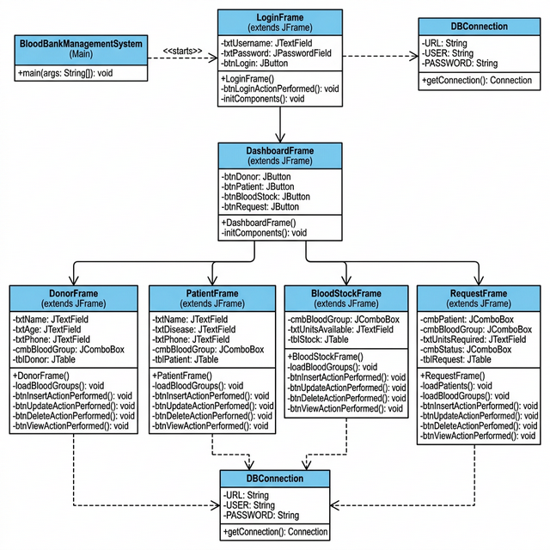
Figure 0 – UML Class Diagram of Blood Bank Management System

2.1 Class Descriptions
Class | Type / Parent | Responsibility
BloodBankManagementSystem | Main entry point | Launches the LoginFrame to start the application.
DBConnection | Utility / connection package | Provides a static JDBC Connection to the MySQL database.
LoginFrame | extends JFrame | Handles user authentication and opens DashboardFrame on success.
DashboardFrame | extends JFrame | Central navigation: opens Donor, Patient, Stock, and Request frames.
DonorFrame | extends JFrame | CRUD operations on blood donor records (name, age, phone, blood group).
PatientFrame | extends JFrame | CRUD operations on patient records (name, disease, phone, blood group).
BloodStockFrame | extends JFrame | Tracks blood inventory by group; Insert/Update/Delete/View stock levels.
RequestFrame | extends JFrame | Manages blood requests: links patient, blood group, units needed, and status.

3. System Screenshots
The following screenshots demonstrate the key screens of the Blood Bank Management System captured during runtime.
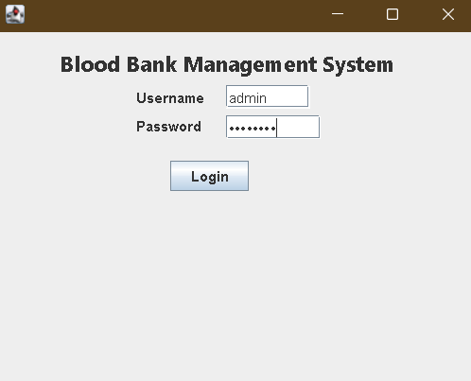
Figure 1 – login page for access

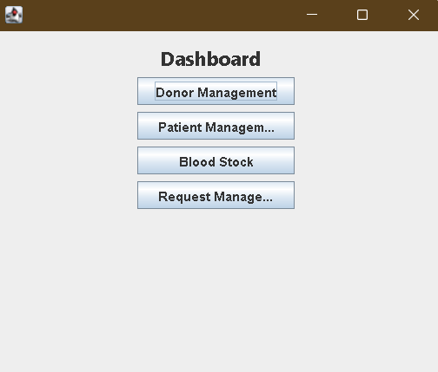
Figure 2 – Dashboard: main navigation screen providing access to all modules

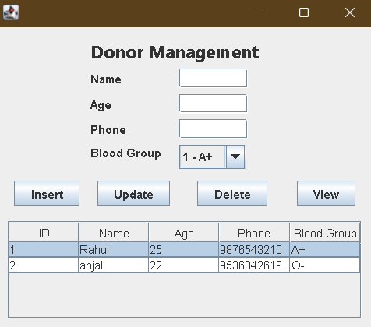
Figure 3 – Donor Management: register and manage blood donor records

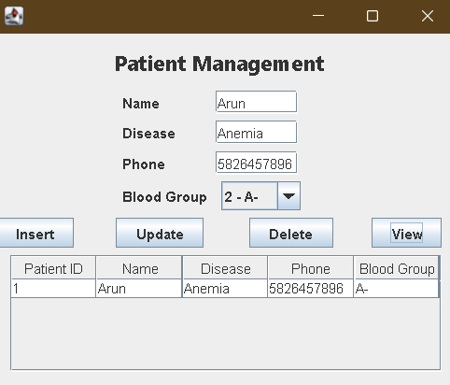
Figure 4 – Patient Management: register and manage patient records

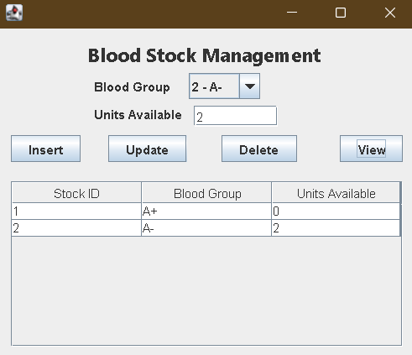
Figure 5 – Blood Stock Management: track available blood units by group

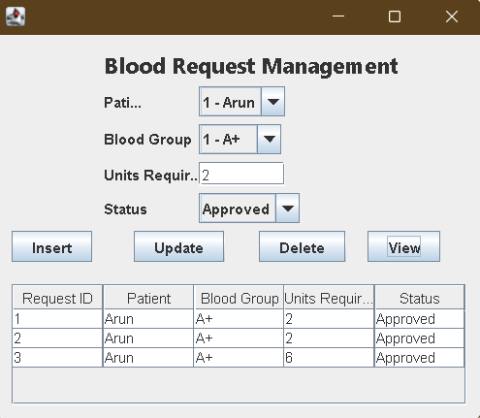
Figure 6 – Blood Request Management: manage patient blood requests and approvals

