**Project Report**

Date: 05/09/2017

**Course**: CIS 602-02 Data Visualization

**Name**: Sreerag Marar

**ID:** 01660933

**Project Summary**

The goal of the project is to show a visualization of the European football leagues with each Country leagues and their comparison. The goal is compare different leagues and see how each fair compared to the others based on the goals scored. The concentration of the league is based on the English Premier League. The main motive of the visualization is to advocate why Premier League is a superior league to other leagues

**Dataset:**

The dataset used is from [api.football-data.org](http://api.football-data.org).

It provides all the league information right from the League table, fixture, players, market value, squad value and so on.

Below attached some of the screenshots of the same.

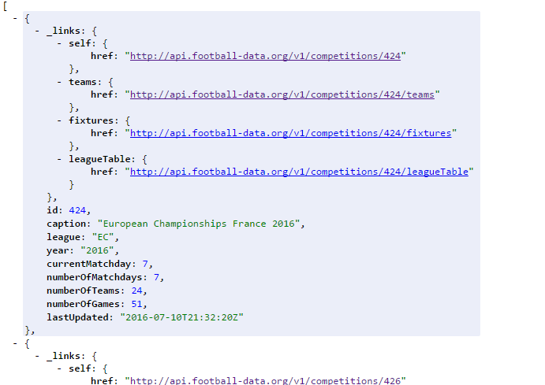

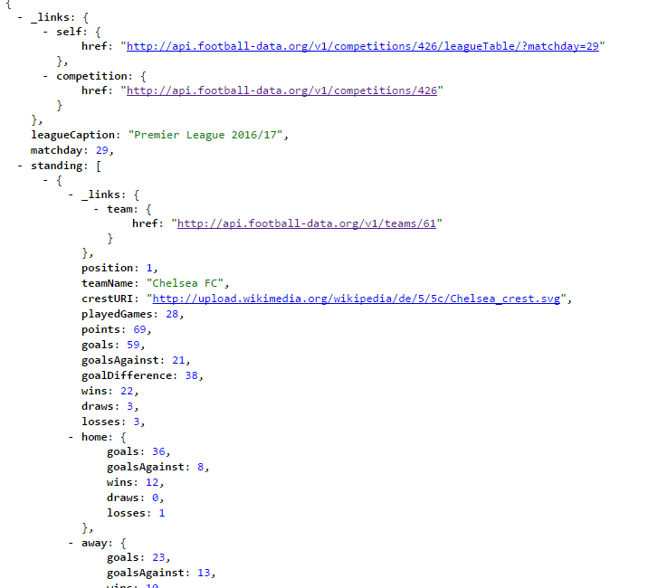

3.

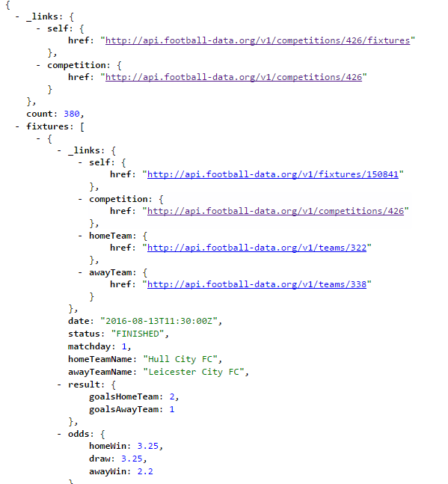

The dataset is in JSON format with the /competition JSON as the master dataset. We have _links for teams, fixtures, leagueTable for each league in the /competition JSON file. For each JSON file (ex. For each team, we have sub links for team info and player info).

The other dataset used for the squad value is custom generated JavaScript based on the data extracted from

<https://www.transfermarkt.com/premier-league/startseite/wettbewerb/GB1>

**Goal of the Visualization:**

Following are some of the task the project helps us answer: -

* How is the football league distributed based on the goals?
* Why is English Football superlative and dominant compared to other leagues?
* Why is Premier League more competitive than other leagues?
* How is the weekly trend in the EPL and how it impacts in the league position and points gained or dropped?
* How the teams fare compared to the top 10 teams in the League and the stats behind it?
* Why is the team who has better stats in certain aspect lagging than the other teams with lesser values based on the money spent by each team?

**Visualization 1:**

A sunburst viz is used initially to showcase all the leagues based on the number of goals scored in each country and leagues. The viz helps identify the compare the goal wise comparison of each country with other. The viz interacts in such a way that if we click a section, it gives the top 4 league information and then top 4 team comparison. Some of the marks and channels used are shape and color.

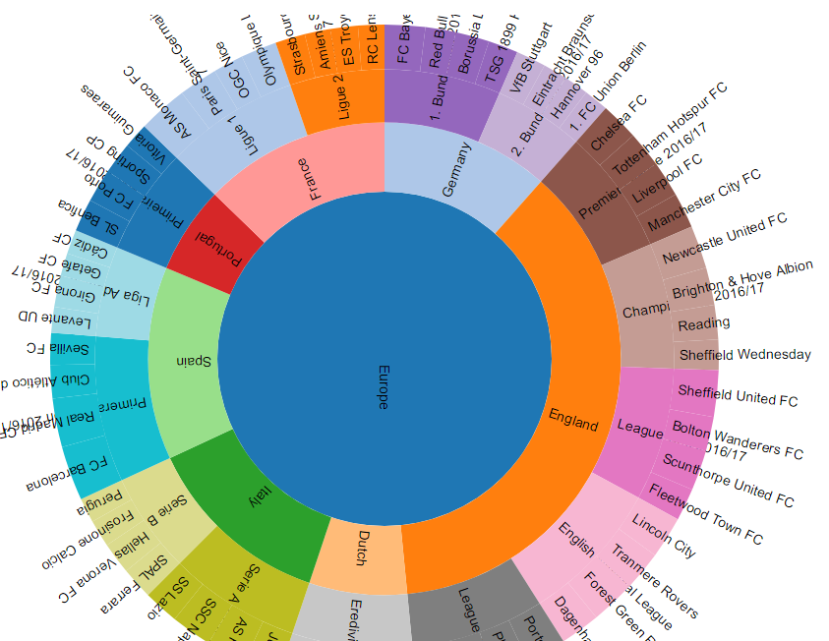

On hovering to a section, it gives the count of goals scored for that section. So, the viz helps initiate the argument that England is better for it has higher goals count of 1500 to the next best i.e. Spain 529. The viz answers the question 1 and 2 with the sunburst

**Visualization 2**

On clicking the Premier League section in sunburst, it navigates to the Line chart which shows a week by week progress of the team and their games. The line chart shows how each team fare every week and how their game influence their table position. As we can see the, the first half of the season i.e. from gameday 1 – 16, the line charts are random which shows erratic behavior of the league. The charts show how uncertain the league position is. For example, Swansea City FC has a position of 3 on day 1, to 8 on day 5 and 18 on day 36, whereas Arsenal has a position of 14 on day 1,7 on day 5 and 2 on day 10 but again drops to 5 on day 36. The trend in the gameday and its impact in the league table position answers the question 3 and 4 as to why the league is so competitive.

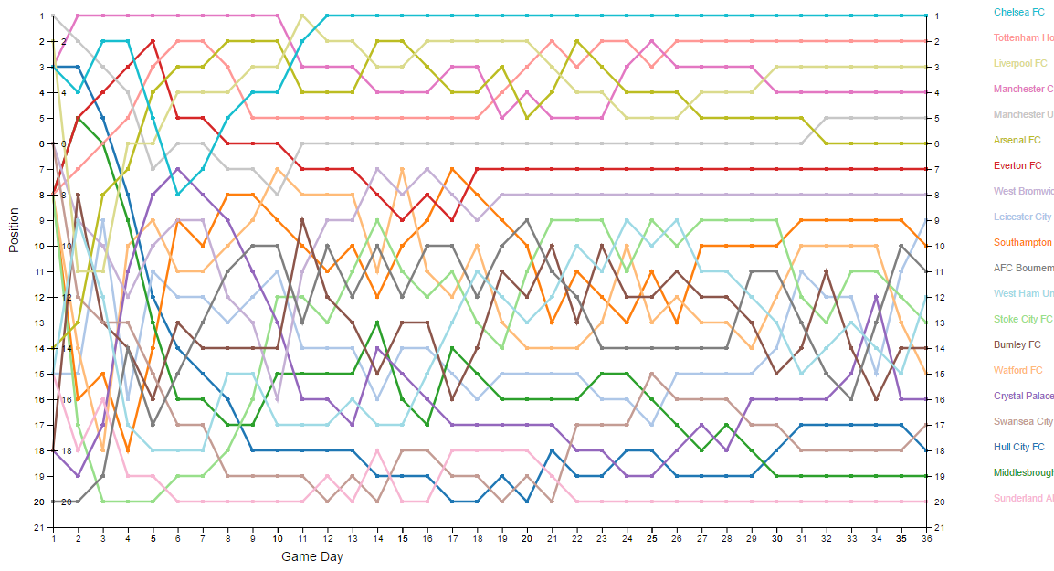

**Visualization 3:**

On clicking a specific team’s line, we open a new viz of group to stack bar chart. This graph helps us compare the team’s performance to the top 10 teams based on goals scored. For instance, if we select Everton, we can see that Everton has scored only 42 goals and given away 29 goals. Since, Manchester United is 7th in the league, if we compare it with 5th position team United, we can see that although United has scored less goals than Everton i.e. 38, they have conceded less goals than Everton 19. So, we can counter the reason for the dip in goals given using the next visualization. The viz helps us to give clear picture about question 5.

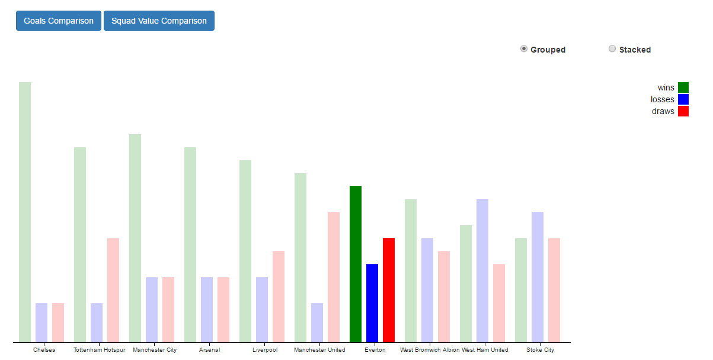

**Visualization 4:**

As we saw in the previous graph, how we can compare the teams goal record to other teams, we saw how Everton despite scoring more goals than a better placed team falls behind, due to more goals given away. We can see in the graph what can be the prospective reason behind it. The viz shows the squad values of each team i.e. the money spent by each team on their attack, midfield and defense.

So, if we look at the average squad money spent in the league, we can see that around $6k million is spent on attack, around $8k million is spent on mid and around $9 million on defense. So, comparing with the league average, we can see that Everton has spent less money on mid and defense. As defense determines the goals given, we can infer from the viz the possible reason why Everton lags in position. The viz answers the question 6 as to how a team squad value relates it to its performance.

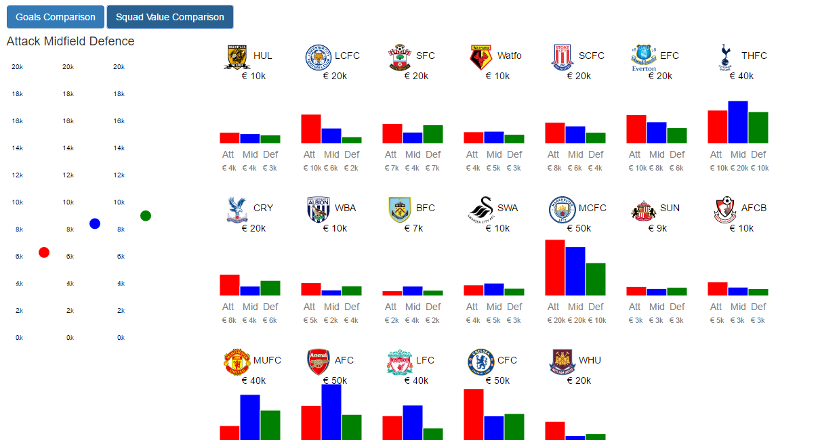

**Goal of the Visualization:**

Following are some of the task the project helps us answer for the leagues shown: -

* When do the teams drop points and position (Timeline)?
* Why do the team drop points during a certain timeline?
* How is the squad value spread across the league?
* What is the impact of improper/proper transfer expenses in the market?
* Comparison of players and their contract to correlate with new transfer need.
* What is the relationship between the squad expenses to the progress achieved? If found erratic, what is the reason?

**Languages and tools used:**

Apart from D3 and HTML, CSS and JavaScript, following are some of the frameworks or extensions to be used:

* Bootstrap
* JQuery.
* Ajax
* Sublime Text

Below mentioned are the links used for the project:

<https://bl.ocks.org/mbostock/aca51512895bd03855efa67aebec474b>

<https://github.com/d3/d3/wiki/Gallery>

<https://eplstatistics.wordpress.com/>

<http://bl.ocks.org/WilliamQLiu/bd12f73d0b79d70bfbae>

<https://www.theguardian.com/sport/interactive/2013/jan/30/nfl-salaries-team-position#baltimore-ravens,san-francisco-49ers>

<http://thestoryoftheseason.com/>

<http://the-beautiful-table.com/la-liga>

<http://www.footipedia.com/Arsenal/2014-2015-season-stats/season-summary#.WNG85zsrK01>

<https://soccershirtsonline.com/graphs.html?year=2012&league=1>

<http://bl.ocks.org/phuonghuynh/54a2f97950feadb45b07>

<https://bl.ocks.org/d3noob/257c360b3650b9f0a52dd8257d7a2d73>

<http://bl.ocks.org/WilliamQLiu/76ae20060e19bf42d774>

<https://bl.ocks.org/mbostock/3887051>

<https://bl.ocks.org/guilhermesimoes/8913c15adf7dd2cab53a>

<http://bl.ocks.org/mbostock/3943967>

<https://bl.ocks.org/mbostock/3371592>

<http://bl.ocks.org/mashehu/de923d763a53d523596ba81c6d1f3233>

<https://www.transfermarkt.com/premier-league/startseite/wettbewerb/GB1>