sree_mal_inscript Keyboard Layout and Instructions

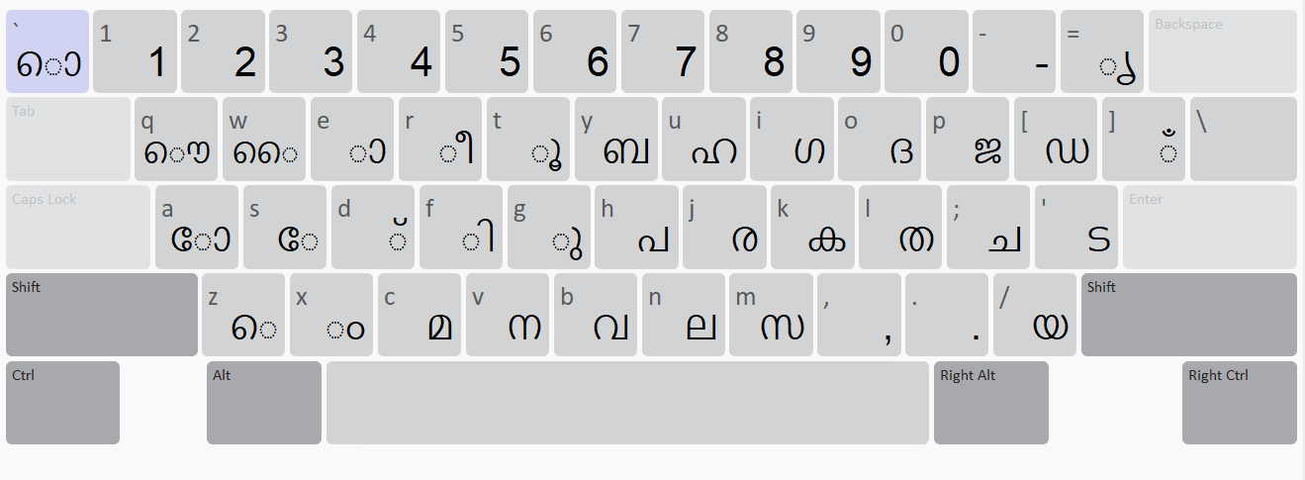
\ is Zero Width Joiner

Shift Pressed
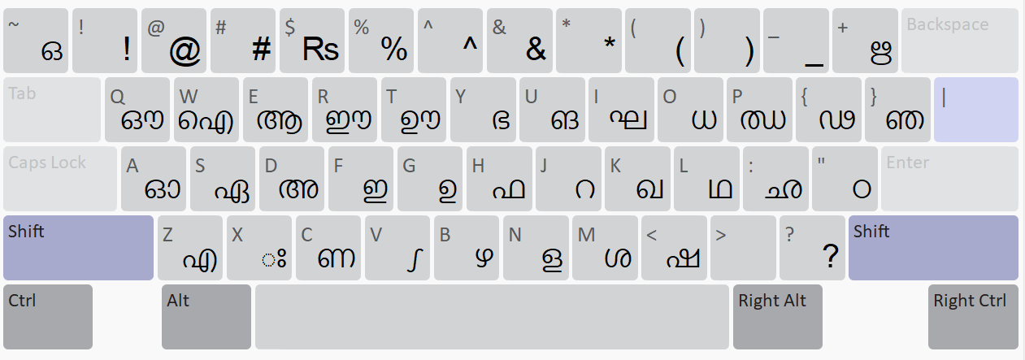
| is Zero Width Non-Joiner Key

Shift + Ctrl Pressed

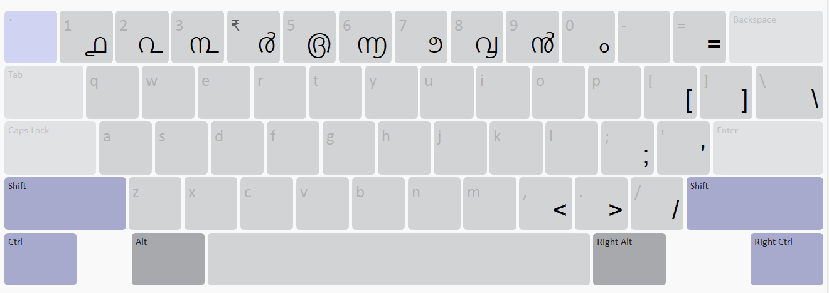

Shift + Alt Pressed

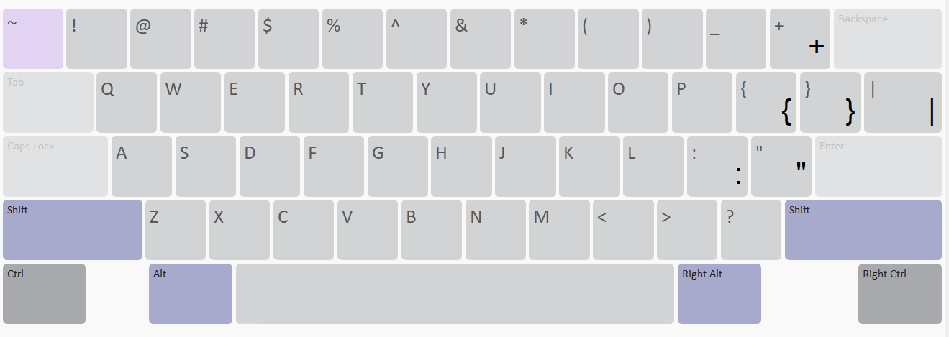
How to Create Joined Conjuncts
Example:
Typing ക്ക => k + d + k
Typing ക്ത => k + d + l

How to Create Non-Joined Conjuncts

Example:
Typing ക്‌ക => k + d + | + k
Typing ക്‌ത => k + d + | + l

How to Create Chillaksharas

Example:
Typing ക്‍ => k + d + \k
Typing ൾ => shift n + d + \
Typing ൺ => shift c + d + \
Typing ൻ => shift v + d + \
Typing ൽ => n + d + \
Typing ർ => j + d + \

