**0SMART BIN**



**A project report submitted in partial fulfilment of requirement for the course**

**On**

**Smart System Design**

**By**

**K.Sreeram** **2005A41038**

**Narotham 2005A41169**

**Premson 2005A31022**

Under the guidance of

**Mr. A. RAJESHWAR RAO**

Asst. Prof. &Director, Centre for Embedded Systems and IoT, Department of ECE

**Mr. Y. Srikanth**

Ass t. Prof., Department of ECE



**Center for Embedded Systems and IoT**

**SR University**



**CERTIFICATE**

This is to certify that the course project entitled **“Smartbin”** is the Bonafide work carried out by **K.Sreeram(2003A41038),Narotham(2005A41169)and Premson(20054A31022) in** the partial fulfilment of the requirement for the award of course **Smart System Design** during the academic year 2020-2021 under our guidance and Supervision.

**Mr. Rajeshwar Rao Arabelli**

Asst. Prof. & Head, Centre for Embedded Systems and IoT,

Department of ECE

**CONTENTS**

**Chapter No. Description Page No.**

1 ABSTRACT 1

2 HARDWARE TOOLS 2-3

4 RESULT AND DISCUSSION 4-7

5 CONCLUSION 8

6 REFERENCES 9

**1.ABSTRACT**

Smart bin has multiple features and its main feature is garbage segregation. Smart bin will have 4 different compartments for the waste: for plastic waste, for wet waste, for dry waste and lastly for the wastewater from the auto clean feature.

**BLOCK DIAGRAM**

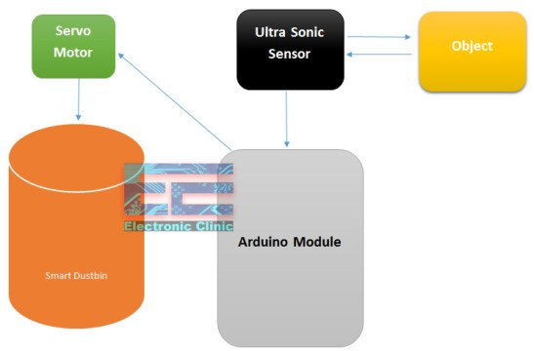

**2.HARDWARE TOOLS**

* **Arduino Uno:**

The Arduino Uno is open-source electronics platform.it is the combination of both hardware and software.it has 14 digital input/output pins, of which 6 can be used as PWM output 6 can be used as analog inputs. The board can be easily connected to the other computer system via USB port.

Arduino Uno can be used supply the power to the board and can act as a serial device to connect the board to a computer system. There are many applications of Arduino uno like developing projects based on code-based control, development of automation system and designing of basic circuit designs.

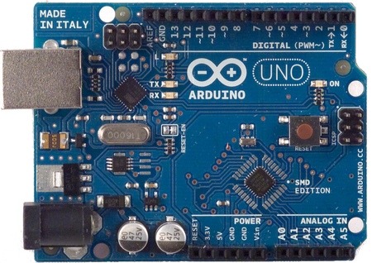

Fig 1

* **Ultrasonic sensor:**

Ultrasonic Sensors also known as transceivers when they both send and receive work on a principle similar to radar or sonar which evaluate attributes of a target by interpreting the echoes from radio or sound waves respectively. Ultrasonic sensors generate high frequency sound waves and evaluate the echo which is received back by the sensor. Sensors calculate the time interval between sending the signal and receiving the echo to determine the distance to an object

This technology can be used for measuring: wind speed and direction (anemometer), fullness of a tank and speed through air or water. For measuring speed or direction, a device uses multiple detectors and calculates the speed from the relative distances to particulates in the air or water. To measure the amount of liquid in a tank, the sensor measures the distance to the surface of the fluid.

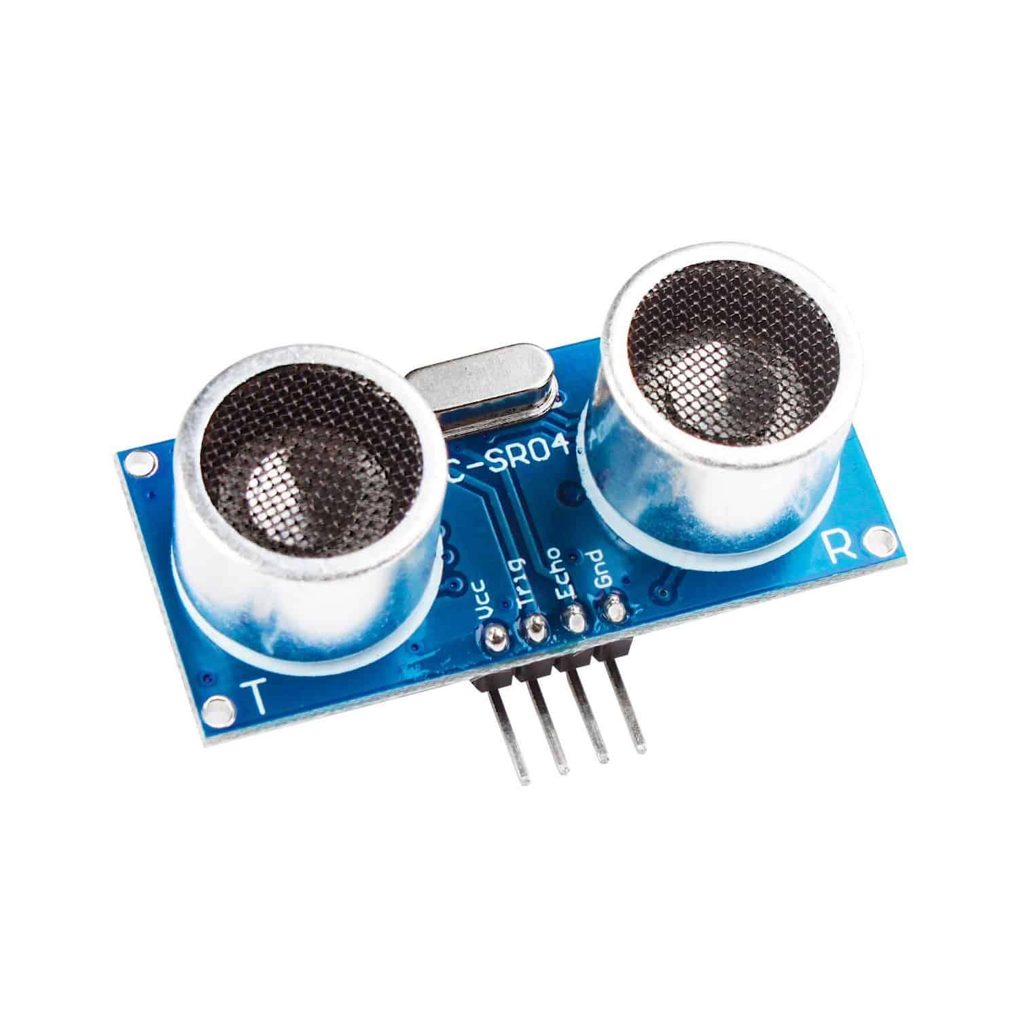

Fig 2

**SERVO MOTOR(SG90)**: A servomotor (or servo motor) is a simple electric motor, controlled with the help of servomechanism. If the motor as a controlled device, associated with servomechanism is DC motor, then it is commonly known as a DC Servo Motor.

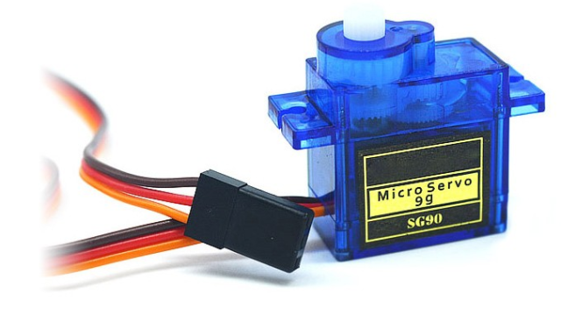

**Fig 3**

**3**.**RESULT AND DISCUSSION**

Finally a prototype for a smart dustbin that automatically opens the lid upon detection of human hand. It doesn’t require any mechanical energy to be applied in order to open the lid is designed and built.

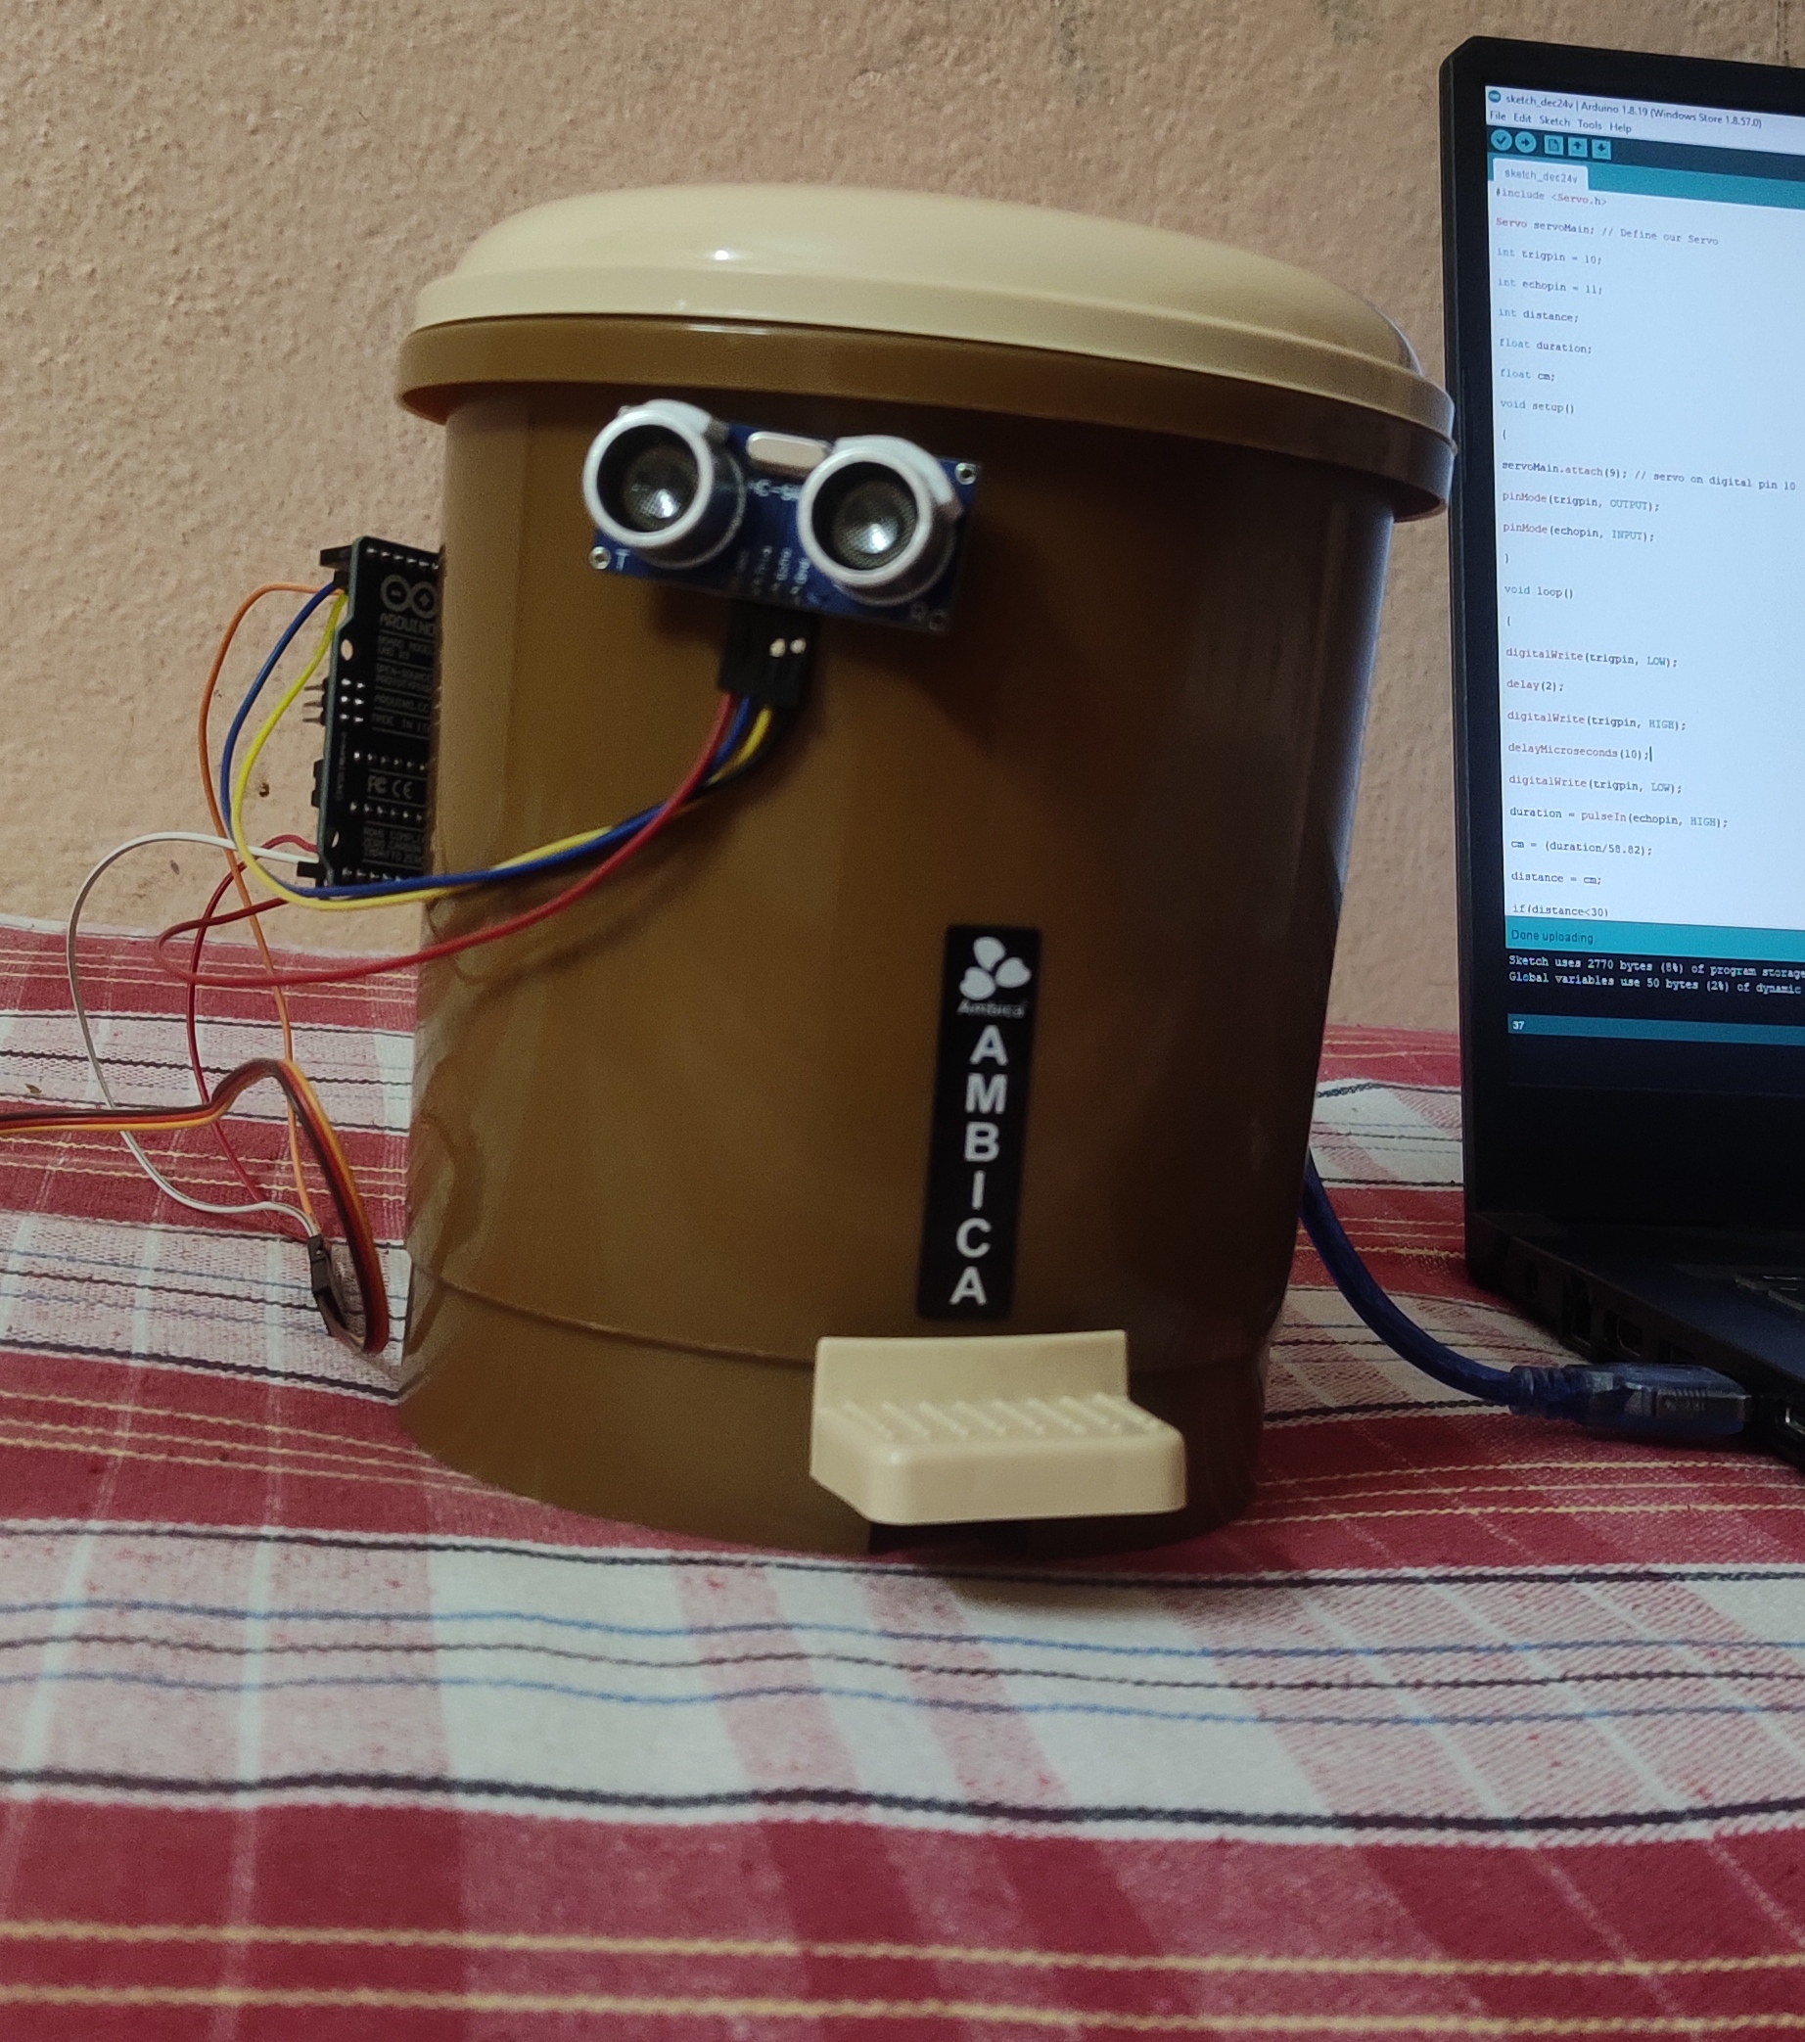

Servo Motor SG-90

Red Pin (Servo Motor) with Arduino 5v

Black Pin (Servo Motor) with Arduino GND (Ground)

Orange Pin (Servo Motor) with Arduino

Pin 11

Ultrasonic Sensor

VCC (Sensor) with Arduino 5v

Trig (Sensor) with Arduino Pin 5

Echo (Sensor) with Arduino Pin 6

GND (Sensor) with Arduino GND

CODE:

#include <Servo.h>

Servo myservo;

int pos = 20;

const int trigPin = 5;

const int echoPin = 6;

const int led = 13;

long duration;

float distance;

void setup() {

myservo.attach(11);

pinMode(trigPin, OUTPUT);

pinMode(echoPin, INPUT);

pinMode(led, OUTPUT);

}

void loop() {

digitalWrite(trigPin, LOW);

delayMicroseconds(2);

digitalWrite(trigPin, HIGH);

delayMicroseconds(10);

digitalWrite(trigPin, LOW);

duration = pulseIn(echoPin, HIGH);

distance = duration * 0.034 / 2;

if (distance < 20) {

digitalWrite(led, HIGH);

myservo.write(pos + 160); // Open lid

delay(1000); // Stay open for 1 sec

} else {

digitalWrite(led, LOW);

myservo.write(pos); // Close lid

}

delay(300); // Small delay before next reading

}

* CONCLUSION: Using this project, the lid of the dustbin stays closed, so that waste is not exposed (to avoid flies and mosquitos) and when you want dispose any waste, it will automatically open the

**REFERENCES**

* <https://www.google.com/url?sa=i&url=https%3A%2F%2Fwww.teachmemicro.com%2Farduino-uno-pinout-diagram%2F&psig=AOvVaw2HvwpXp0S0AVv6mYXJo-jL&ust=1626186130214000&source=images&cd=vfe&ved=0CAoQjRxqFwoTCIjig97d3fECFQAAAAAdAAAAABAD>
* <https://www.google.com/url?sa=i&url=https%3A%2F%2Fwww.piborg.org%2Fsensors-1136%2Fhc-sr04&psig=AOvVaw1t_DCXLr9ublnTGKl2WxFB&ust=1626186294736000&source=images&cd=vfe&ved=0CAoQjRxqFwoTCOjf4J3e3fECFQAAAAAdAAAAABAD>
* <https://www.google.com/url?sa=i&url=https%3A%2F%2Fdumblebots.com%2F2019%2F04%2F01%2Farduino-tutorial-buzzing-buzzers%2F&psig=AOvVaw3F_GDthswOJl9FBjLkYCPq&ust=1626186415978000&source=images&cd=vfe&ved=0CAoQjRxqFwoTCPDZuNne3fECFQAAAAAdAAAAABAE>
* <https://www.google.com/url?sa=i&url=https%3A%2F%2Fwww.instructables.com%2FUsing-Infrared-Sensor-With-Arduino%2F&psig=AOvVaw3auK4ChSKlTPHp-ZPTc0fL&ust=1626186502521000&source=images&cd=vfe&ved=0CAoQjRxqFwoTCODt0v3e3fECFQAAAAAdAAAAABAE>
* <https://www.google.com/url?sa=i&url=https%3A%2F%2Fwww.instructables.com%2FHow-to-use-an-RGB-LED-Arduino-Tutorial%2F&psig=AOvVaw3C5Q30LD2_lh4-JrIGfsxK&ust=1626186596995000&source=images&cd=vfe&ved=0CAoQjRxqFwoTCNClz6ff3fECFQAAAAAdAAAAABAM>
* <https://www.google.com/url?sa=i&url=https%3A%2F%2Fwww.distrelec.biz%2Fen%2Fneopixel-ring-12-rgb-led-adafruit-1643%2Fp%2F30091150&psig=AOvVaw0GZjnvYJqBbjNCQ-mXHC-M&ust=1626186701974000&source=images&cd=vfe&ved=0CAoQjRxqFwoTCPCQ8dnf3fECFQAAAAAdAAAAABAK>
* <https://www.google.com/url?sa=i&url=https%3A%2F%2Fwww.generationrobots.com%2Fen%2F401948-flex-sensor-22.html&psig=AOvVaw2Cu54B9fQYtXmXxXRyz7AP&ust=1626186769799000&source=images&cd=vfe&ved=0CAoQjRxqFwoTCIDojvnf3fECFQAAAAAdAAAAABAD>