**AUTOMATIC TOLL COLLECTION AND GATE OPERATION USING IMAGE PROCESSING**

Capstone initial report



Submitted To

**School of Electronics and Electrical Engineering**

# By

# CHALLA NAGA TEJA - 11603089

# JASTI NAGENDRA BABU - 11603632

# MARAM SREERAMA REDDY - 11610529

# PASUPULATI ACHYUTH KUMAR - 11602722

# Under the Guidance of

# Ms. Gaganpreet Kaur Marwah

**DEPARTMENT OF ELECTRONICS AND COMMUNICATION ENGINEERING,**

**LOVELY PROFESSIONAL UNIVETSITY,**

**PHAGWARA, PUNJAB (INDIA) – 144411**

**DECLARATION**

We hereby declare that the project work entitled “AUTOMATIC TOLL COLLECTION AND GATE OPERATION USING IMAGE PROCESSING” is an authentic record of our own work carried out as requirements of Capstone Project for the award of degree of B. Tech in ECE from Lovely Professional University, Phagwara, under the guidance of Assistant Professor, Ms. Gaganpreet Kaur Marwah, during August-November 2019. The contents of this Capstone project, in full or in parts, have neither been taken from any other source nor have been submitted to any other Institute or University for award of any degree or diploma.

# CHALLA NAGA TEJA - 11603089

# JASTI NAGENDRA BABU. - 11603632

# MARAM SREERAMA REDDY - 11610529

# PASUPULATI ACHYUTH KUMAR - 11602722

**ACKNOWLEDGEMENT**

We take this opportunity to present my votes of thanks to all those guideposts who really acted as lightening pillars to enlighten my way throughout this project that has led to successful and satisfactory completion of this study.

We are really grateful to Ms. Gaganpreet Kaur Marwah for providing me with an opportunity to undertake this project and providing us with all the facilities. We are highly thankful to ma’am for this active support, valuable time and advice, whole-hearted guidance, sincere co-operation and painstaking involvement during the study and in completing the assignment of preparing the said project plan within the time stipulated.

Lastly, we thankful to all those, particularly the various friends who have been integument in creating proper, healthy and conductive environment and including new and fresh innovative ideas for us during the project, without their help, it would have been extremely difficult for us to prepare the project plan in a time bound framework.

**ABSTRACT**

In this project we examine the images and the respective information of the vehicles for automating the process of toll collection and making it more efficient and perfect.

On any toll booth the vehicle has to stop for paying the toll. But in this system, a camera is used for capturing the image of the vehicle’s number plate. The captured image would be converted into text using Automatic number plate recognition system, and the toll would be cut from the customer’s account in the application we have created and the gate would be opened.

Moreover in our system if a vehicle is stolen and an entry is being made in the central database by the police, then if the vehicle passes through the toll booth, then a silent alarm would buzz which would indicate the operator at the toll booth, that the vehicle is a stolen one.

For the identification of the vehicle the information of the vehicles is already stored on the central database, so the captured number would be sent to the server received at the toll, and the server would take care of the billing.

By using system we would also monitor the speed of the vehicles on the highways, by installing our system at different parts of the highway.

#### **TABLE OF CONTENTS**

**Topic Page no.**

Declaration …………………………………………………………………………………. i

Acknowledgement …………………………………………………………………………. ii

Abstract …………………………………………………………………………………….. iii

Table of contents …………………………………………………………………………… iv

**CHAPTER**

1. **Introduction …………………………………………………………………… 07**
2. **Technologies used ……………………………………………………………… 09**

2.1 High resolution cameras ……………………………………………………. 09

2.2 Raspberry Pi ………………………………………………………………... 10

2.3 Central Database ……………………………………………………………. 13

1. **Block Diagram …………………………………………………………………….. 14**
2. **Working ……………………………………………………………………………. 15**
3. **Objectives ………………………………………………………………………….. 16**
4. **Novelty ……………………………………………………………………………... 16**
5. **Advantages ………………………………………………………………………… 16**
6. **Future Scope ……………………………………………………………………… 17**
7. **Conclusion …………………………………………………………………………. 17**
8. **References ………………………………………………………………………….. 18**

#### **LIST OF FIGURES**

**Figure Page no.**

2.1 Camera used for image capturing …………………………………………….……….. 9

2.2 Camera module …...………………………………………………………………… 10

2.3 Raspberry pi architecture ………………………………………………………….… 11

2.3 Raspberry pi 3 ……………………………………………………………………….… 12

3.1 Block diagram of the toll collection system …………………………………………… 14

**INTRODUCTION**

The purpose of this project is collection the toll according to the vehicles and build the real time application which recognizes vehicle’s license number plate at the entry gate. Automatic toll collection is considered as one of the intelligent transport system. It is aimed at making toll collection more efficient, reliable, safe and environmental friendly. Presently, the customers have to wait at the toll gate to pay the collectors, creating a traffic congestion, pollution and of course a lot of frustration. This Automatic toll collection successfully removes the unnecessary traffic delays, keeps an eye on any car that might not be lawfully registered. Automated toll collection is fast becoming a global accepted way of toll collection.

Image processing toll booths system is used as a system for the fast and efficient collection of tolls at the toll plazas. This is possible as the vehicles passing at the toll plaza do not need to stop to pay the toll, and the payment automatically takes place from the account of the users on the web application we create. This system used the technology of Automatic number plate recognition system.

Automatic vehicle identification system is used for the purpose of effective control. License plate recognition is a form of automatic vehicle identification. It is an image processing technology used to identify vehicles by using only their license plates. Real time license plate recognition plays a major role in automatic monitoring of traffic rules and monitoring the law enforcement on public roads. Since every vehicle carries a unique license plate, no external cards, tags or transmitters are required.

In this Toll collection system, the Automatic vehicle classification system verifies the classification of the vehicles automatically as the vehicle is already classified at the time of registration. The Traffic controller system is a computer system which manages the traffic in a single row or inline why using traffic signals and sensors.

Central server is used for processing payments, for more security and maintaining the records of each customer and their toll transactions. It stores the data coming from different toll plazas. A local computer of every toll plaza is connected to the central server through the internet. The consumer/owner of the vehicle has to register at the central server prior any transaction and may deposit money in their account. Automatic vehicle identification and classification totally depends on the vehicles number plate.

**TECHNOLOGIES USED:**

1. **High resolution cameras**

* Digital imaging devices, such as digital camera contain in-built image processing system for the applications such as computer vision, multimedia and surveillance.
* Information about the visual scene is acquired by the camera by first focussing and transmitting the light through optical system and then sampling the visual information using a image sensor and analog to digital converter. Typically zoom and focus motors control the focal position of the camera.
* In our system we use this camera to capture the images of the vehicles, process them to retrieve the vehicle’s registration number and hence the owners data from the central server.

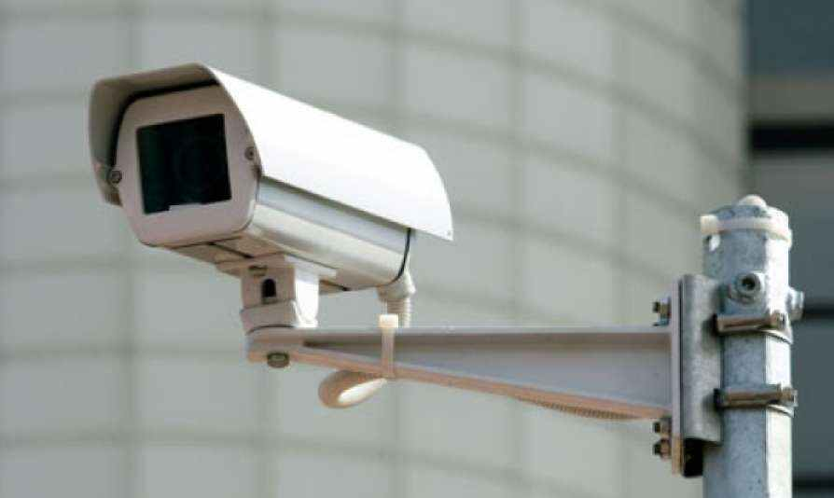

fig 2.1

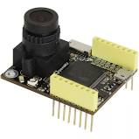

fig 2.2

1. **Raspberry Pi**

* The Raspberry Pi is a low cost, credit-card sized computer that plugs into a computer monitor or TV, and uses a standard keyboard and mouse. It is a capable little device that enables people of all ages to explore computing, and to learn how to program in languages like Scratch and Python. It’s capable of doing everything you’d expect a desktop computer to do, from browsing the internet and playing high-definition video, to making spreadsheets, word-processing, and playing games.
* Raspberry Pi is contained on a single circuit board and features ports for:
  + HDMI
  + USB 2.0
  + Composite video
  + Analog audio
  + Power
  + Internet
  + SD Card
* We use this to process the image captured, number plate retrieval and also acts as a mediator between the Image processing using and the central database.
* Raspberry Pi has an ARMv6 700 MHz single-core processor, a VideoCore IV GPU and 512MB of RAM. it uses an SD card for its operating system and data storage.
* The Raspberry Pi officially supports Raspbian, a lightweight linux OS based on Debian.

General specifications:

* Processor: Broadcom BCM2835
* CPU: ARM 1176JZFS (ARM 11 w/ v6 core, floating pt @ 700MHz)
* GPU: Videocore IV GPU ○ RAM: 512 MB
* USB: 2 USB 2.0
* Network: Ethernet
* Video out: HDMI
* Audio out: 3.5 mm jack
* SD Card Storage (Up to 32GB)
* Micro USB power
* Display Serial Interface Port (DSI)
* Camera Serial Interface Port (CSI)
* 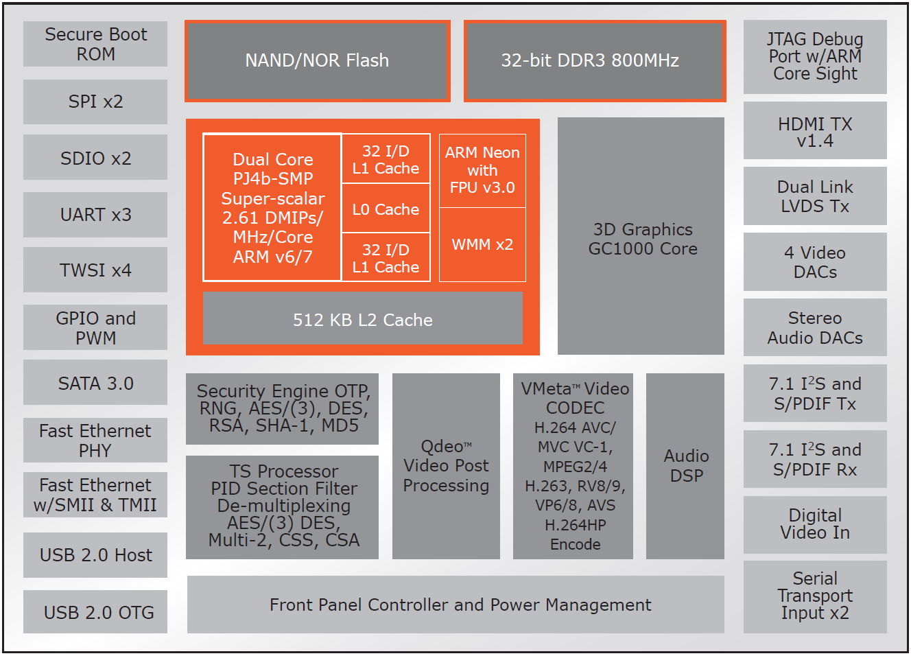

fig 2.3

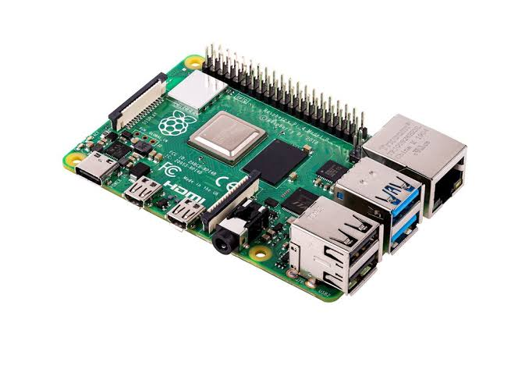

fig 2.4

1. **Central Database**

* A Web application (Web app) is an application program that is stored on a remote server and delivered over the Internet through APIs.
* Web applications can be designed for a wide variety of uses and can be used by anyone; from an organization to an individual for numerous reasons. Commonly used Web applications can include webmail, online calculators, or e-commerce shops.
* In this Image processing system we use a Python/Django webserver to process the requests sent by the toll collection system, which may include bill generation, payment processing, invoice retrieval, sending notifications to the customers, contacting authorities for various reasons etc.
* An SQL server is used for storing the data of the vehicles, digital record keeping of toll transactions and vehicle movements.

**Block Diagram:**

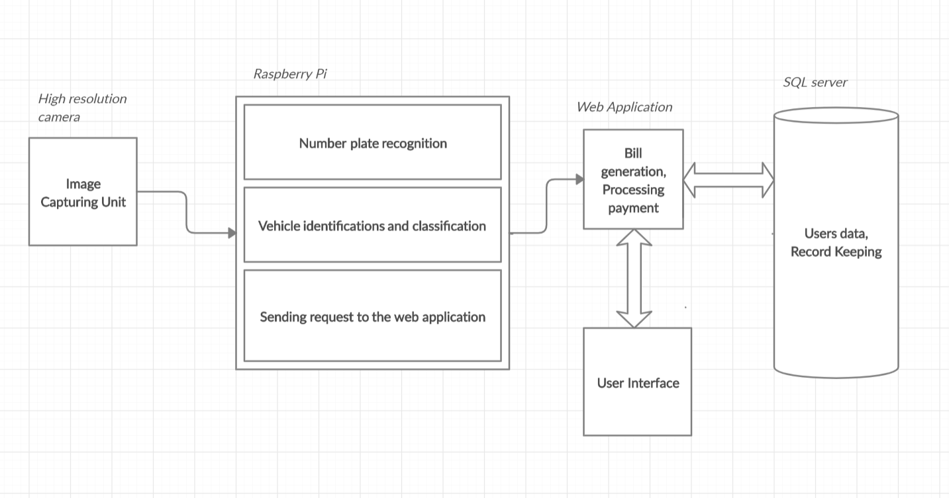

fig 3.1

**Working:**

* The project seeks to solve the problem of heavy delay and traffic congestion faced at the toll plaza by vehicles trying to hit the toll charged roads.
* It consists of an image processing system which constantly monitors and captures the images of the vehicles entering the toll road.
* For each vehicle, it then processes its images to retrieve the vehicle’s registration number which helps in fetching the owners billing information from our web servers.
* As soon as the vehicle enters/leaves the toll chargeable road, a bill would be auto-generated and shared with the owner’s email and mobile number. The bill amount would be calculated by the logic we define within the server.
* A grace period would be mentioned for the bill to be cleared off. In failure of doing so late fee would be added to the total amount for a level-2 grace period. Further failure in paying the bill would blacklist the vehicle from using the govt roads, and on the next capture of the vehicle the information will be shared to the local road traffic authorities.

The system further helps in:

* Capturing stolen vehicles.
* Monitoring the movements of the vehicles as needed by the vigilance authorities.

**Objectives:**

* Automate the process of toll collection.
* Reduction of traffic congestion at the toll plaza.
* Reduction of man power needed in the present system.
* Elimination of human errors by installing a computerized system.
* Help police/vigilance department in monitoring the vehicle movements.
* Help in detecting unlawful driving actions such as not wearing helmets, seat belts, over speeding of vehicles etc.
* Digitalizing and securing payment system and record keeping.

**Novelty:**

* Automation of toll collections.
* Minimum to no intervention of man eliminates possible human errors.
* Installing secure digital payment system.
* Constant monitoring of vehicles.

**Advantages:**

* Minimization/Elimination of delay and traffic congestion faced by the vehicles at the toll plaza.
* Automation of toll charges billing. Auto-deduction of amount as needed.
* Securing and digitalizing payments.
* Eliminating possible human errors.
* Minimizing the need of man power.
* Monitoring of the vehicle movements as required.
* Centralizing information, Record keeping using databases.

**Future Scope:**

* Secure record keeping of vehicles entering the toll plaza, as well as vehicle moments help in

1. Data analytics
2. Help police forces to monitor vehicle movements any time in the past which may help in solving some case.
3. Development around the present system to computerize the traffic system more and more.

**Conclusion:**

* The primary objective of the project is to automate the process of toll collection. The hardware system we are going to develop is going to help us with the same.
* While meeting the primary objective of the project i.e. to reduce the time spent by the vehicles at the toll plaza, we also by means of it help in fulfilling other objectives like securing payments, vehicle monitoring etc.

**References:**

1. <http://ijcsn.org/IJCSN-2016/5-2/Vehicle-Counting-and-Automated-Toll-Collection-System-using-Image-Processing.pdf>
2. <http://www.iaeme.com/MasterAdmin/UploadFolder/IJCET_09_03_015/IJCET_09_03_015.pdf>
3. <http://ijarcet.org/wp-content/uploads/IJARCET-VOL-4-ISSUE-5-1922-1927.pdf>
4. <http://meseec.ce.rit.edu/551-projects/spring2017/2-3.pdf>