HIERARCHY MANAGER CONFIGURATION

Business Case:
- Need to maintain affiliation among Customers
- Need to have Professional to Account Hierarchy
- Need to have Account to Account Hierarchy

High Level Design Steps:

- Creation of Entity Base Object: Existing Base Object CUSTOMER storing customer data (both PROF and ACCT Customer Types) will be converted to an Entity Base Object.

After converting the Base Object to Entity Base Object, following changes will occur in the Base Object table:
Following columns will be added to the "CUSTOMER" Base Object:
- BO_CLASS_CODE
Constraints for following columns will be added to the "CUSTOMER" Base Object:
- BO_CLASS_CODE

- Creation of Entity Types: Create Entity Types PROF and ACCT for the Entity Base Object.

- Creation of Hierarchies: Create the following Hierarchies: PROF Hierarchy and ACCT Hierarchy.

- Creation of Relationship Base Object: Create Relationship Base Object as shown below to store the relationship data.

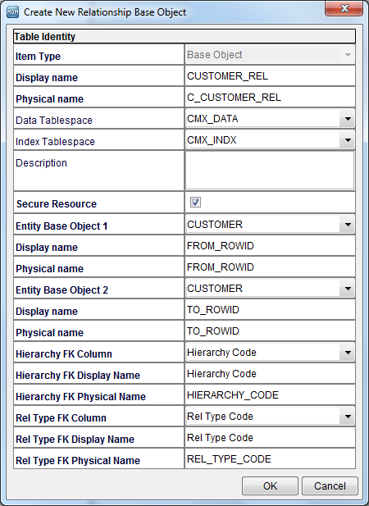

- Creation of Relationship Types: We are here to have 2 types of relationship/affiliations:

Relationship Type | Description | Entity Type 1 | Entity Type 2 | Direction | Hierarchies
PROF_TO_ACCT | Professional to Account | PROF | ACCT | Entity 1 to Entity 2 | PROF Hierarchy
ACCT_TO_ACCT | Account to Account | ACCT | ACCT | Entity 1 to Entity 2 | ACCT Hierarchy

- Creation of Profile: The default profile can be used or a new profile can be created.

Here, we are creating a new profile ‘Customer Profile’. Both the relationship types are mapped to this profile.

- Creation of HM Packages:
Packages need to be PUT Enabled

Base Object | Object Name | Primary table | Package Name | Query Group Name | Query name | Label Pattern | Tooltip Pattern
EBO | ACCT | CUSTOMER | PKG_HM_CUST_ACCT | QRG_CUSTOMER | QRY_CUSTOMER_ACCT | ORG_NAME | ROWID_OBJECT|BO_CLASS_CODE
 | PROF |  | PKG_HM_CUST_PROF |  | QRY_CUSTOMER_PROF | FULL_NAME | ROWID_OBJECT|BO_CLASS_CODE
RBO | ACCT_TO_ACCT | CUSTOMER_REL | PKG_CUSTOMER_REL | QRG_CUSTOMER_REL | QRY_CUSTOMER_REL | --NA-- | FROM_ROWI-> TO_ROWID|Rel Type Code|Hierarchy Code
 | PROF_TO_ACCT

View of the Hierarchy from Hierarchy manager:

The Hierarchy finally will be somewhat like this (based on your input data)
[We have used dummy data to show the Hierarchy]:

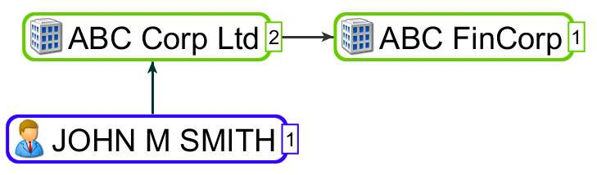

Interpretation of the above Hierarchy:

- The professional John M Smith is related to the organization ABC Corp Ltd, which means that John M Smith may be/is employed in the organization ABC Corp Ltd.
- The organization ABC Corp Ltd is again related to ABC FinCorp, which means that ABC FinCorp is a subsidiary organization of the parent organization ABC C

