**MONGODB QUESTIONS.**

1. Create database Employee in MONGODB and make Collection with name "EmployeeDetails"

|  |  |  |  |
| --- | --- | --- | --- |
| **EmpId** | **EmpName** | **Salary** | **Designation** |
| 101 | Ram | 15000 | Clerk |
| 102 | Shyam | 20000 | Administrator |
| 103 | Hari | 10000 | Supervisor |
| 104 | Sita | 15000 | Clerk |
| 105 | Rose | 20000 | Administrator |
| 106 | Maria | 25000 | Manager |

1. Insert Records into EmployeeDetails Collection
2. List all the details of employees in a neat format.
3. Find Document From the EmployeeDetails collection where name begins with S
4. Update Salary Of Employee where Name is "Sita" by +1000
5. Add a New Field Date of Joining to document with name "DOJ"
6. Find sum of salaries of employees with designation as “clerk”
7. Delete a document having employee id with 106.
8. Create a user with name “Mohan” and give read/write role to the user for Employee database.

2. Create database Student in MONGODB and make Collection with name "StudentDetails"

|  |  |  |  |
| --- | --- | --- | --- |
| **RollNo** | **Name** | **Age** | **Course** |
| 101 | Anna | 20 | MCA |
| 102 | Catherine | 21 | MTECH |
| 103 | Denna | 22 | BTECH |
| 104 | Sam | 25 | MCA |
| 105 | Karthik | 24 | MCA |
| 106 | Aravind | 20 | MCA |

* 1. Insert Records into StudentDetails Collection
  2. List all the details of Students in a neat format.
  3. Find Document From the StudentDetails collection where name begins with A
  4. Update course Of student to Mtech whose rollno is 106
  5. Add a New Field Date of Joining to document with name "DOJ"
  6. Find total number of students who opted MCA.
  7. Delete a document having RollNo 104.
  8. Create a user with name “Mohan” and give read/write role to the user for Student database.

3. Create database Vehicle in MONGODB and make Collection with name "VehicleDetails"

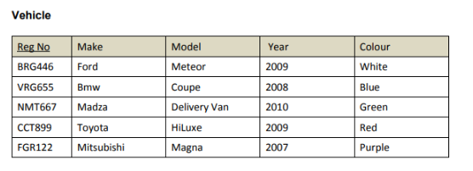

1. Insert Records into VechicleDetails Collection
2. List all the details of Vehicle in a neat format.
3. Find Document From the VehicleDetails collection where make begins with T
4. Update Colour Of vehicle to Blue whose RegNo is FGR122
5. Add a New Field EngineNo to document with name "EnNo"
6. Find total number of vehicles manufactured in the year 2009.
7. Delete a document having RegNo BRG446.
8. Create a user with name “Ram” and give read role to the user for Vehicle database.
9. Create database Book in MONGODB and make Collection with name "BookDetails"

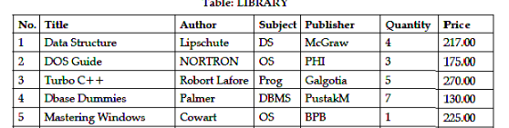

1. Insert Records into BookDetails Collection
2. List all the details of Vehicle in a neat format.
3. Update Author of book to “David” whose No is 2
4. Find total quantity of books in the library.
5. Delete a document having No is 4
6. Create a user with name “Ram” and give read role to the user for Book database.