CSA4723 – DEEP LEARNING FOR DISASTER MANAGEMENT
V.Sree Ruthin Reddy
192324112
21. Performance verification of NN-model using the Two-class data.
Aim: To build a Neural Network classifier for a two-class dataset, train the model, and verify its performance using evaluation metrics such as accuracy, confusion matrix, and classification report.
Algorithm:
Step 1: Import required libraries
Load Python libraries such as NumPy, Pandas, Scikit-learn, Matplotlib, Keras/TensorFlow.
Step 2: Load the two-class dataset
Use a built-in dataset such as:
- Breast Cancer dataset (sklearn)
OR
- Generate synthetic two-class data using make_classification()
Step 3: Preprocess the data
- Split into training and testing sets
- Normalize feature values using StandardScaler
Step 4: Build the Neural Network model
- Create a Sequential model
- Add Dense layers with activation functions
- Compile model with:
  - Loss = binary_crossentropy
  - Optimizer = Adam
  - Metric = accuracy
Step 5: Train the model
Fit the NN on training data for given epochs.
Step 6: Predict using test data
- Get predicted probabilities
- Convert them to class labels (0 or 1)
Step 7: Evaluate performance
Calculate:
- Accuracy
- Confusion Matrix
- Classification Report
Step 8: Visualize results
Optionally plot loss and accuracy curves.
Code:
import numpy as np
import pandas as pd
from sklearn.datasets import load_breast_cancer
from sklearn.model_selection import train_test_split
from sklearn.preprocessing import StandardScaler
from sklearn.metrics import accuracy_score, confusion_matrix, classification_report

import tensorflow as tf
from tensorflow.keras.models import Sequential
from tensorflow.keras.layers import Dense
print("\nAccuracy:", accuracy_score(y_test, y_pred))
print("\nConfusion Matrix:\n", confusion_matrix(y_test, y_pred))
print("\nClassification Report:\n", classification_report(y_test, y_pred))print("\nClassification Report:\n", classification_report(y_test, y_pred))
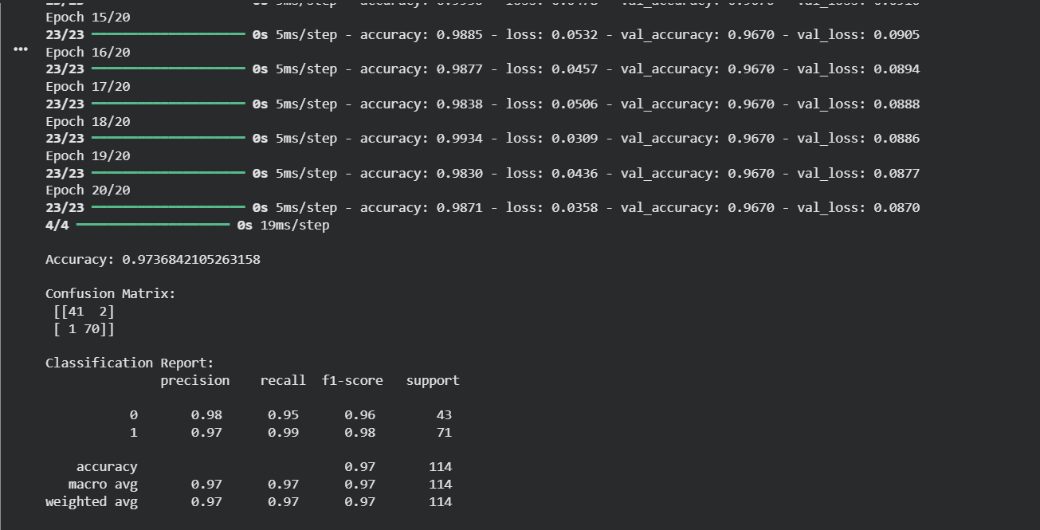
22. Performance verification of NN-model using the multi-class data.
Aim: To build and evaluate a Neural Network classifier on a multi-class dataset by training the model and verifying its performance using accuracy, confusion matrix, and classification report.
Algorithm:
- Import required libraries (NumPy, Pandas, sklearn, TensorFlow/Keras).
- Load a multi-class dataset such as Iris or MNIST.
- Split the dataset into training and testing sets.
- Normalize or standardize the input features.
- Convert labels into one-hot encoded format.
- Build a neural network with multiple Dense layers and softmax output.
- Compile the model using categorical cross-entropy and an optimizer like Adam.
- Train the model using training data for fixed epochs.
- Predict class probabilities on test data and convert them to class labels.
- Evaluate performance using accuracy, confusion matrix, and classification report.
Code:
import numpy as np
import pandas as pd
from sklearn.datasets import load_iris
from sklearn.model_selection import train_test_split
from sklearn.preprocessing import StandardScaler
from sklearn.metrics import accuracy_score, confusion_matrix, classification_report
from tensorflow.keras.utils import to_categorical
from tensorflow.keras.models import Sequential
from tensorflow.keras.layers import Dense

…history = model.fit(X_train, y_train_cat, epochs=30, batch_size=8, validation_split=0.2, verbose=1)

y_pred_prob = model.predict(X_test)
y_pred = np.argmax(y_pred_prob, axis=1)

print("Accuracy:", accuracy_score(y_test, y_pred))
print("Confusion Matrix:\n", confusion_matrix(y_test, y_pred))
print("Classification Report:\n", classification_report(y_test, y_pred))
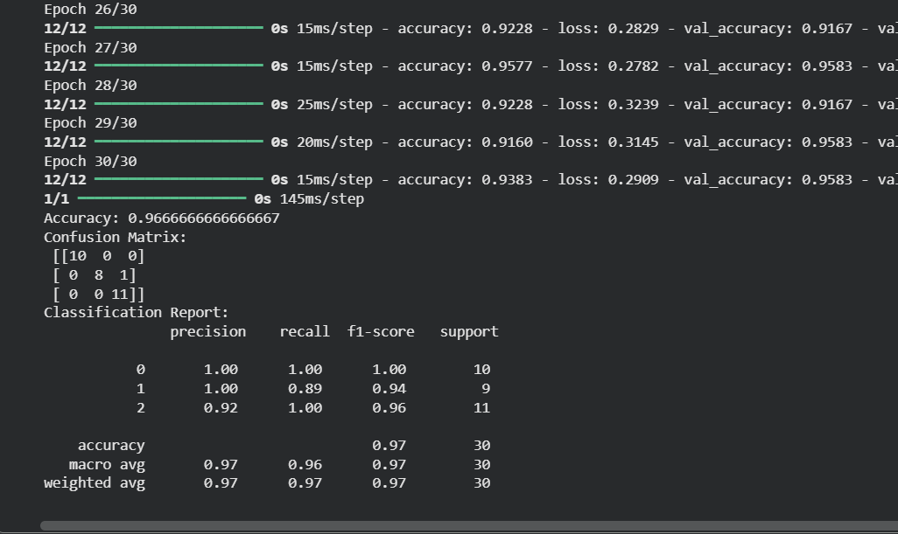

23. Performance verification of NN-model using the circular data.
Aim: To generate circular (non-linearly separable) two-class data, train a Neural Network model on it, and verify its performance using accuracy, confusion matrix, and classification report.
Algorithm:
- Import necessary libraries.
- Generate circular two-class data using make_circles().
- Split the dataset into training and testing sets.
- Normalize features using StandardScaler.
- Build a neural network model using Dense layers.
- Compile the model with binary cross-entropy and Adam optimizer.
- Train the neural network.
- Predict on the test dataset.
- Evaluate performance using accuracy, confusion matrix, and classification report.

Code:
import numpy as np
from sklearn.datasets import make_circles
from sklearn.model_selection import train_test_split
from sklearn.preprocessing import StandardScaler
from sklearn.metrics import accuracy_score, confusion_matrix, classification_report
from tensorflow.keras.models import Sequential
from tensorflow.keras.layers import Dense

X, y = make_circles(n_samples=1200, noise=0.1, factor=0.4, random_state=0)

X_train, X_test, y_train, y_test = train_test_split(X, y, test_size=0.2, random_state=42)

scaler = StandardScaler()
X_train = scaler.fit_transform(X_train)
X_test = scaler.transform(X_test)

model = Sequential()
model.add(Dense(16, activation='relu', input_dim=2))
model.add(Dense(12, activation='relu'))
model.add(Dense(1, activation='sigmoid'))

model.compile(optimizer='adam', loss='binary_crossentropy', metrics=['accuracy'])

history = model.fit(X_train, y_train, epochs=40, batch_size=16, validation_split=0.2, verbose=1)

y_pred_prob = model.predict(X_test)
y_pred = (y_pred_prob > 0.5).astype("int32")

print("Accuracy:", accuracy_score(y_test, y_pred))
print("Confusion Matrix:\n", confusion_matrix(y_test, y_pred))
print("Classification Report:\n", classification_report(y_test, y_pred))
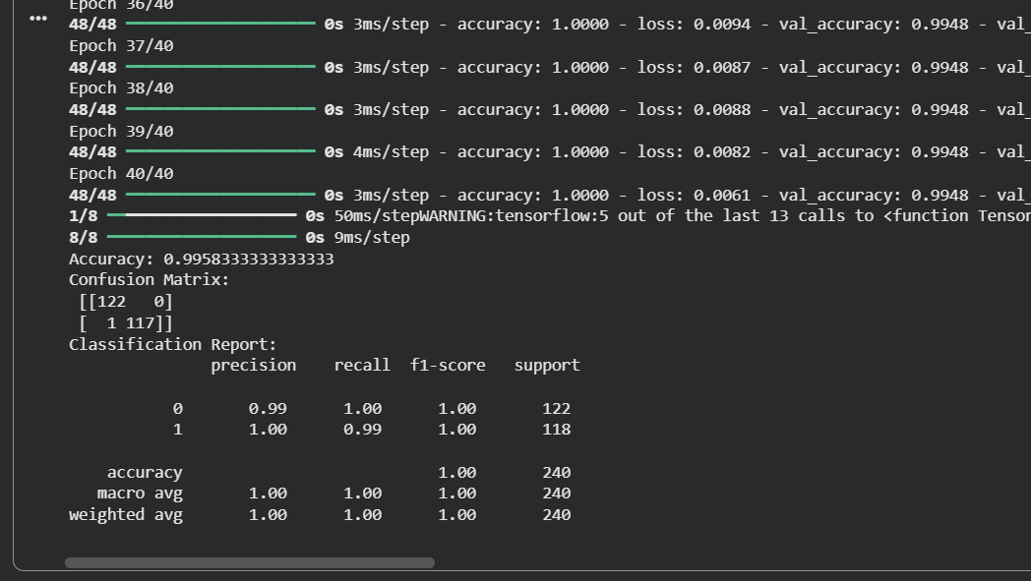
24. Performance verification of NN-model using the spiral data.
Aim: To generate a spiral dataset, train a Neural Network to classify the spiral classes, and verify its performance using accuracy, confusion matrix, and classification report.
Algorithm:
- Import necessary libraries.
- Generate spiral data manually using polar coordinates.
- Assign class labels for multiple spirals.
- Split data into training and testing sets.
- Normalize the features.
- Build a neural network for classification.
- Train the network using training data.
- Predict labels for the test data.
- Evaluate performance using accuracy, confusion matrix, and classification report.
Code:
import numpy as np
from sklearn.model_selection import train_test_split
from sklearn.preprocessing import StandardScaler
from sklearn.metrics import accuracy_score, confusion_matrix, classification_report
from tensorflow.keras.models import Sequential
from tensorflow.keras.layers import Dense

def generate_spiral(n_points, noise=0.2):
n = np.sqrt(np.random.rand(n_points,1)) * 780 * (2*np.pi)/360
d1x = -np.cos(n)*n + np.random.rand(n_points,1)*noise
…
history = model.fit(X_train, y_train, epochs=50, batch_size=16, validation_split=0.2, verbose=1)

y_pred_prob = model.predict(X_test)
y_pred = (y_pred_prob > 0.5).astype("int32")

print("Accuracy:", accuracy_score(y_test, y_pred))
print("Confusion Matrix:\n", confusion_matrix(y_test, y_pred))
print("Classification Report:\n", classification_report(y_test, y_pred))
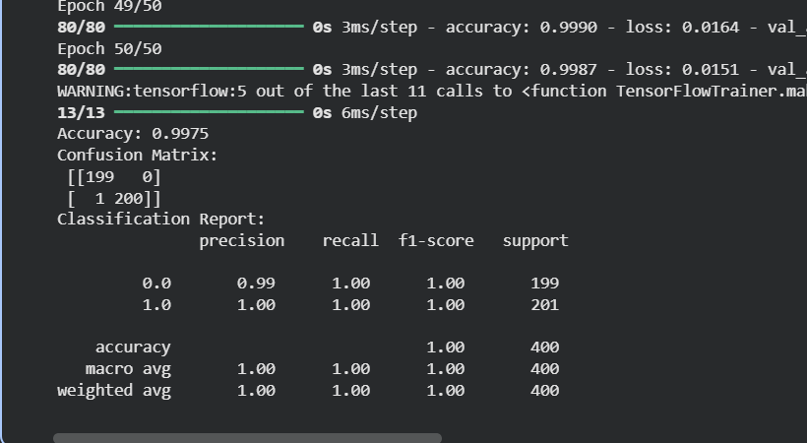

25. Verification of NN-Model with various activation functions and model structure.
Aim: To design and evaluate multiple Neural Network models by varying activation functions and model structures (number of layers, number of neurons) and compare their performance to identify the best configuration.
Algorithm:
- Import necessary libraries.
- Load a dataset (Iris / MNIST / synthetic).
- Split into training and testing sets.
- Scale/normalize input features.
- Define multiple model configurations by varying:
  - Activation functions: relu, tanh, sigmoid
  - Model structures: shallow NN, deep NN
- Train each model separately.
- Predict on test set.
- Compute accuracy for each model.
- Compare results and identify the best model.
Code:
import numpy as np
from sklearn.datasets import load_iris
from sklearn.model_selection import train_test_split
from sklearn.preprocessing import StandardScaler
from sklearn.metrics import accuracy_score
from tensorflow.keras.utils import to_categorical
from tensorflow.keras.models import Sequential
from tensorflow.keras.layers import Dense

data = load_iris()
… results[str(struct) + "_" + act] = acc

for config, acc in results.items():
print(config, ":", acc)
