Histograms:

Assignment1 :

Que 1) Plot a histogram,

10, 13, 18, 22, 27, 32, 38, 40, 45, 51, 56, 57, 88, 90, 92, 94, 99

Ans ) Bins=5

Bin size=100/5=20

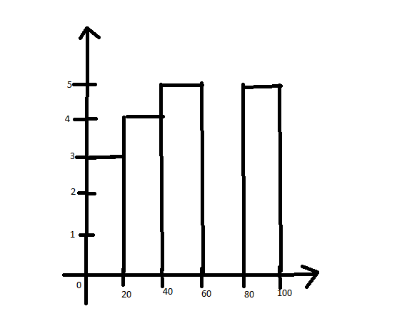

Que 2) In a quant test of the CAT Exam, the population standard deviation is known to be 100. A sample of 25 tests taken has a mean of 520. Construct an 80% CI about the mean.

Ans) σ = 100 , n=25, x̄ = 520 , C.I = 80%

α = 1-C.I=1-0.8=0.2

zα/2=z0.2/2=z0.1

1-0.1=0.9 => zα/2=1.29

Lowerfence = 520-1.29\*(100/√25)

= 494.2

Higher fence= 520+1.29\*(100/5)

= 545.8

Que 3) A car believes that the percentage of citizens in city ABC that owns a vehicle is 60% or less. A sales manager disagrees with this. He conducted a hypothesis testing surveying 250 residents & found that 170 residents responded yes to owning a vehicle.

1. State the null & alternate hypothesis.
2. At a 10% significance level, is there enough evidence to support the idea that vehicle owner in ABC city is 60% or less.

Ans) Ho : po <=60

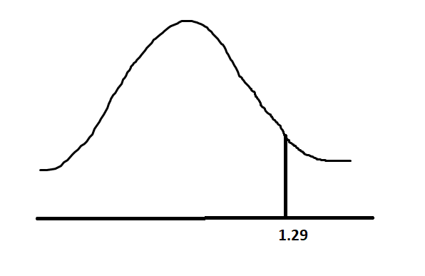H1: p1!=60

n=250,

x=170

= x/n = 170/250 = 0.68

α = 0.1

z-value= 1-0.1 = 0.9 , so value is 1.29

z-test = (0.68-0.6) / (√(0.6\*0.4)/250) = 2.5823

2.5823 > 1.29 , so we reject null hypothesis.

p-value:

z-score = 2.5283

st.deviation under 2.58= 1 - 0.99506 = 0.00494

p-value = 0.00494

p-value < α . so we reject null hypothesis.

Que 4) What is the value of the 99 percentile?

2,2,3,4,5,5,5,6,7,8,8,8,8,8,9,9,10,11,11,12

99 percentile value = (99/100)\* 20 = 19.8 index

(11+12)/2 = 11.5

But the value is 12.

Que 5) In left & right-skewed data, what is the relationship between mean, median & mode?

Draw the graph to represent the same.

 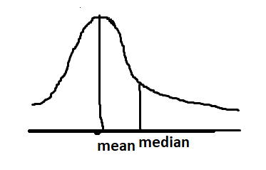 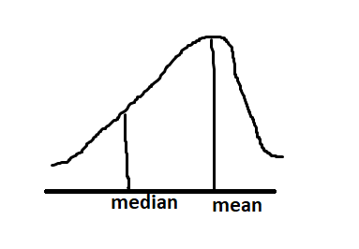

Right skewed Left skewed

Mean < median mean> median