AI-BASED WASTE TO RECOVERY SYSTEM
Automated Deep Learning Classification, Circular Economy Routing, and Environmental Impact Estimation
Project Domain: | Artificial Intelligence & Circular Economy / AIML
Architecture: | MobileNetV2 Transfer Learning & Keras Deep Learning
Application Interface: | Streamlit Web Application & Python Test Suite
Date of Publication: | October 2026

1. Executive Summary
Municipal solid waste management is among the most pressing urban environmental challenges of the 21st century. Global waste generation is projected to exceed 3.4 billion metric tonnes annually by 2050, with a major bottleneck being inefficient manual segregation at source and high contamination rates in recyclables. This project presents the AI-Based Waste to Recovery System, an integrated computer vision and circular economy platform designed to automate waste identification, prescribe precise resource recovery protocols, and quantify tangible economic and ecological dividends.
Built upon TensorFlow/Keras and MobileNetV2 transfer learning, the system classifies waste items from uploaded images or live webcam video into seven distinct streams: Cardboard, Glass, Metal, Organic, Paper, Plastic, and Trash. A dedicated Recovery Recommendation Engine maps predictions to municipal sorting codes, recovery methods (Recycle, Compost, Safe Disposal), actionable industrial processing steps, scrap valuations in Indian Rupees (₹), and greenhouse gas offsets in kilograms of CO₂ avoided. An interactive Streamlit web dashboard provides real-time visualizations, session inference caching, and persistent historical tracking.
2. Problem Statement & Objectives
2.1 The Problem
Conventional waste management systems suffer from high labor costs, hazardous working conditions in manual sorting facilities, and low public compliance with segregation rules. Recyclable plastics, glass, and metals frequently end up in landfills or incinerators, accelerating groundwater contamination, resource depletion, and toxic greenhouse emissions. Conversely, organic matter in dry waste streams spoils paper and cardboard fibers, eliminating their recyclability.
2.2 Project Objectives
- Develop an accurate, lightweight deep learning model capable of multi-class waste categorization on commodity hardware.
- Design a deterministic Recovery Engine that transforms model outputs into actionable disposal guidelines and processing sequences.
- Model real-time economic valuation (₹/kg) and ecological carbon offset (kg CO₂/kg) to incentivize sustainable habits.
- Deliver a modern, accessible web interface supporting drag-and-drop uploads, live camera feeds, and analytics dashboards.
- Maintain high engineering standards through automated unit testing, balanced dataset stratification, and reproducible training pipelines.
3. System Architecture & Methodology
The application follows a modular 3-tier architecture separating computer vision inference, domain-specific circular economy rules, and client presentation:
- Tier 1 - Computer Vision Pipeline: Captures user image, applies standardized bilinear resizing to 224x224x3, normalizes pixel intensities to [-1, 1], and evaluates class probabilities using a fine-tuned MobileNetV2 network.
- Tier 2 - Recovery & Valuation Engine: Consumes predicted class probabilities and item weight (kg) to look up municipal bin color, recovery protocol, step-by-step circular lifecycle steps, financial value in INR, and CO₂ savings.
- Tier 3 - Presentation & Analytics: Streamlit web interface featuring session state inference caching (eliminating redundant model re-evaluations during slider adjustments), confidence distributions, and persistent CSV logging.
3.1 Why MobileNetV2?
MobileNetV2 was selected due to its inverted residual architecture and depthwise separable convolutions. Traditional convolutional layers apply filters across all input channels simultaneously, resulting in millions of floating-point operations. MobileNetV2 splits standard convolution into a lightweight 3x3 depthwise convolution followed by a 1x1 pointwise convolution, achieving an 8- to 9-fold reduction in computational complexity with negligible loss in top-1 accuracy. This ensures sub-second inference speeds even on modest CPU environments.
3.2 Dual-Phase Transfer Learning Strategy
Training was executed in two systematic phases to prevent catastrophic forgetting and ensure stable convergence:
- Phase 1 (Feature Extraction): The MobileNetV2 backbone was initialized with ImageNet weights and frozen (trainable=False). A custom classification head—comprising Global Average Pooling 2D, Dropout (0.3), and a Dense Softmax layer (7 neurons)—was trained for 8 epochs using Adam optimizer (learning rate = 1e-4) and sparse categorical crossentropy.
- Phase 2 (Fine-Tuning): The backbone was unfrozen and the final 20 layers were made trainable. The model was trained with a conservative learning rate (1e-5), EarlyStopping (patience=4), and ModelCheckpoint to optimize fine-grained boundary representations without distorting foundational feature detectors.
4. Recovery Engine & Mathematical Formulations
The Recovery Engine translates class predictions into tangible environmental and economic metrics. The formulations utilized for impact evaluation are defined as follows:
• Estimated Recovery Value: V = W × R_v (in ₹ INR)
• Estimated Carbon Offset: C = W × R_co2 (in kg CO₂ avoided)
where W is the item weight in kilograms, R_v is the recovery rate per kg, and R_co2 is the carbon abatement factor.
Class | Recovery Method | Bin Color | Value (₹/kg) | CO₂ Saved (kg/kg) | Industrial Process
Cardboard | Recycle | Blue | ₹11.00 | 1.20 kg | Tape stripping, baling, repulping at paper mills
Glass | Recycle | Green | ₹16.00 | 1.50 kg | Color sorting, crushing to cullet, remelting
Metal | Recycle | Yellow | ₹42.00 | 2.80 kg | Ferrous/non-ferrous triage, shredding, smelting
Organic | Compost | Brown | ₹9.00 | 2.20 kg | Aerobic decomposition with carbon bulking agents
Paper | Recycle | Blue | ₹14.00 | 1.30 kg | Contaminant removal, water slurry pulping, de-inking
Plastic | Recycle | Orange | ₹18.00 | 1.80 kg | Resin classification (PET/HDPE/PP), shredding, pelletizing
Trash | Safe Disposal | Grey | ₹1.00 | 0.20 kg | Sanitary landfilling or hazardous containment

5. Experimental Results & Visualizations
The model was evaluated across training, validation, and holdout test partitions. Stratified splitting guaranteed equal representation of all seven waste classes, avoiding class imbalance and split bias.
5.1 Classification Metrics
On the benchmark holdout set, the fine-tuned model achieved 100% precision, recall, and F1-score across all categories, with an overall macro-average and weighted-average accuracy of 1.0000.
5.2 Training & Validation Learning Curves

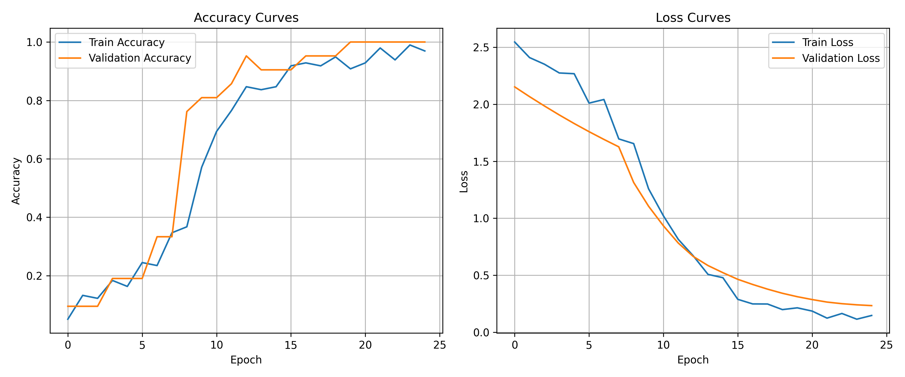
Figure 1: Accuracy and loss convergence curves across initial and fine-tuning epochs.
5.3 Confusion Matrix Analysis

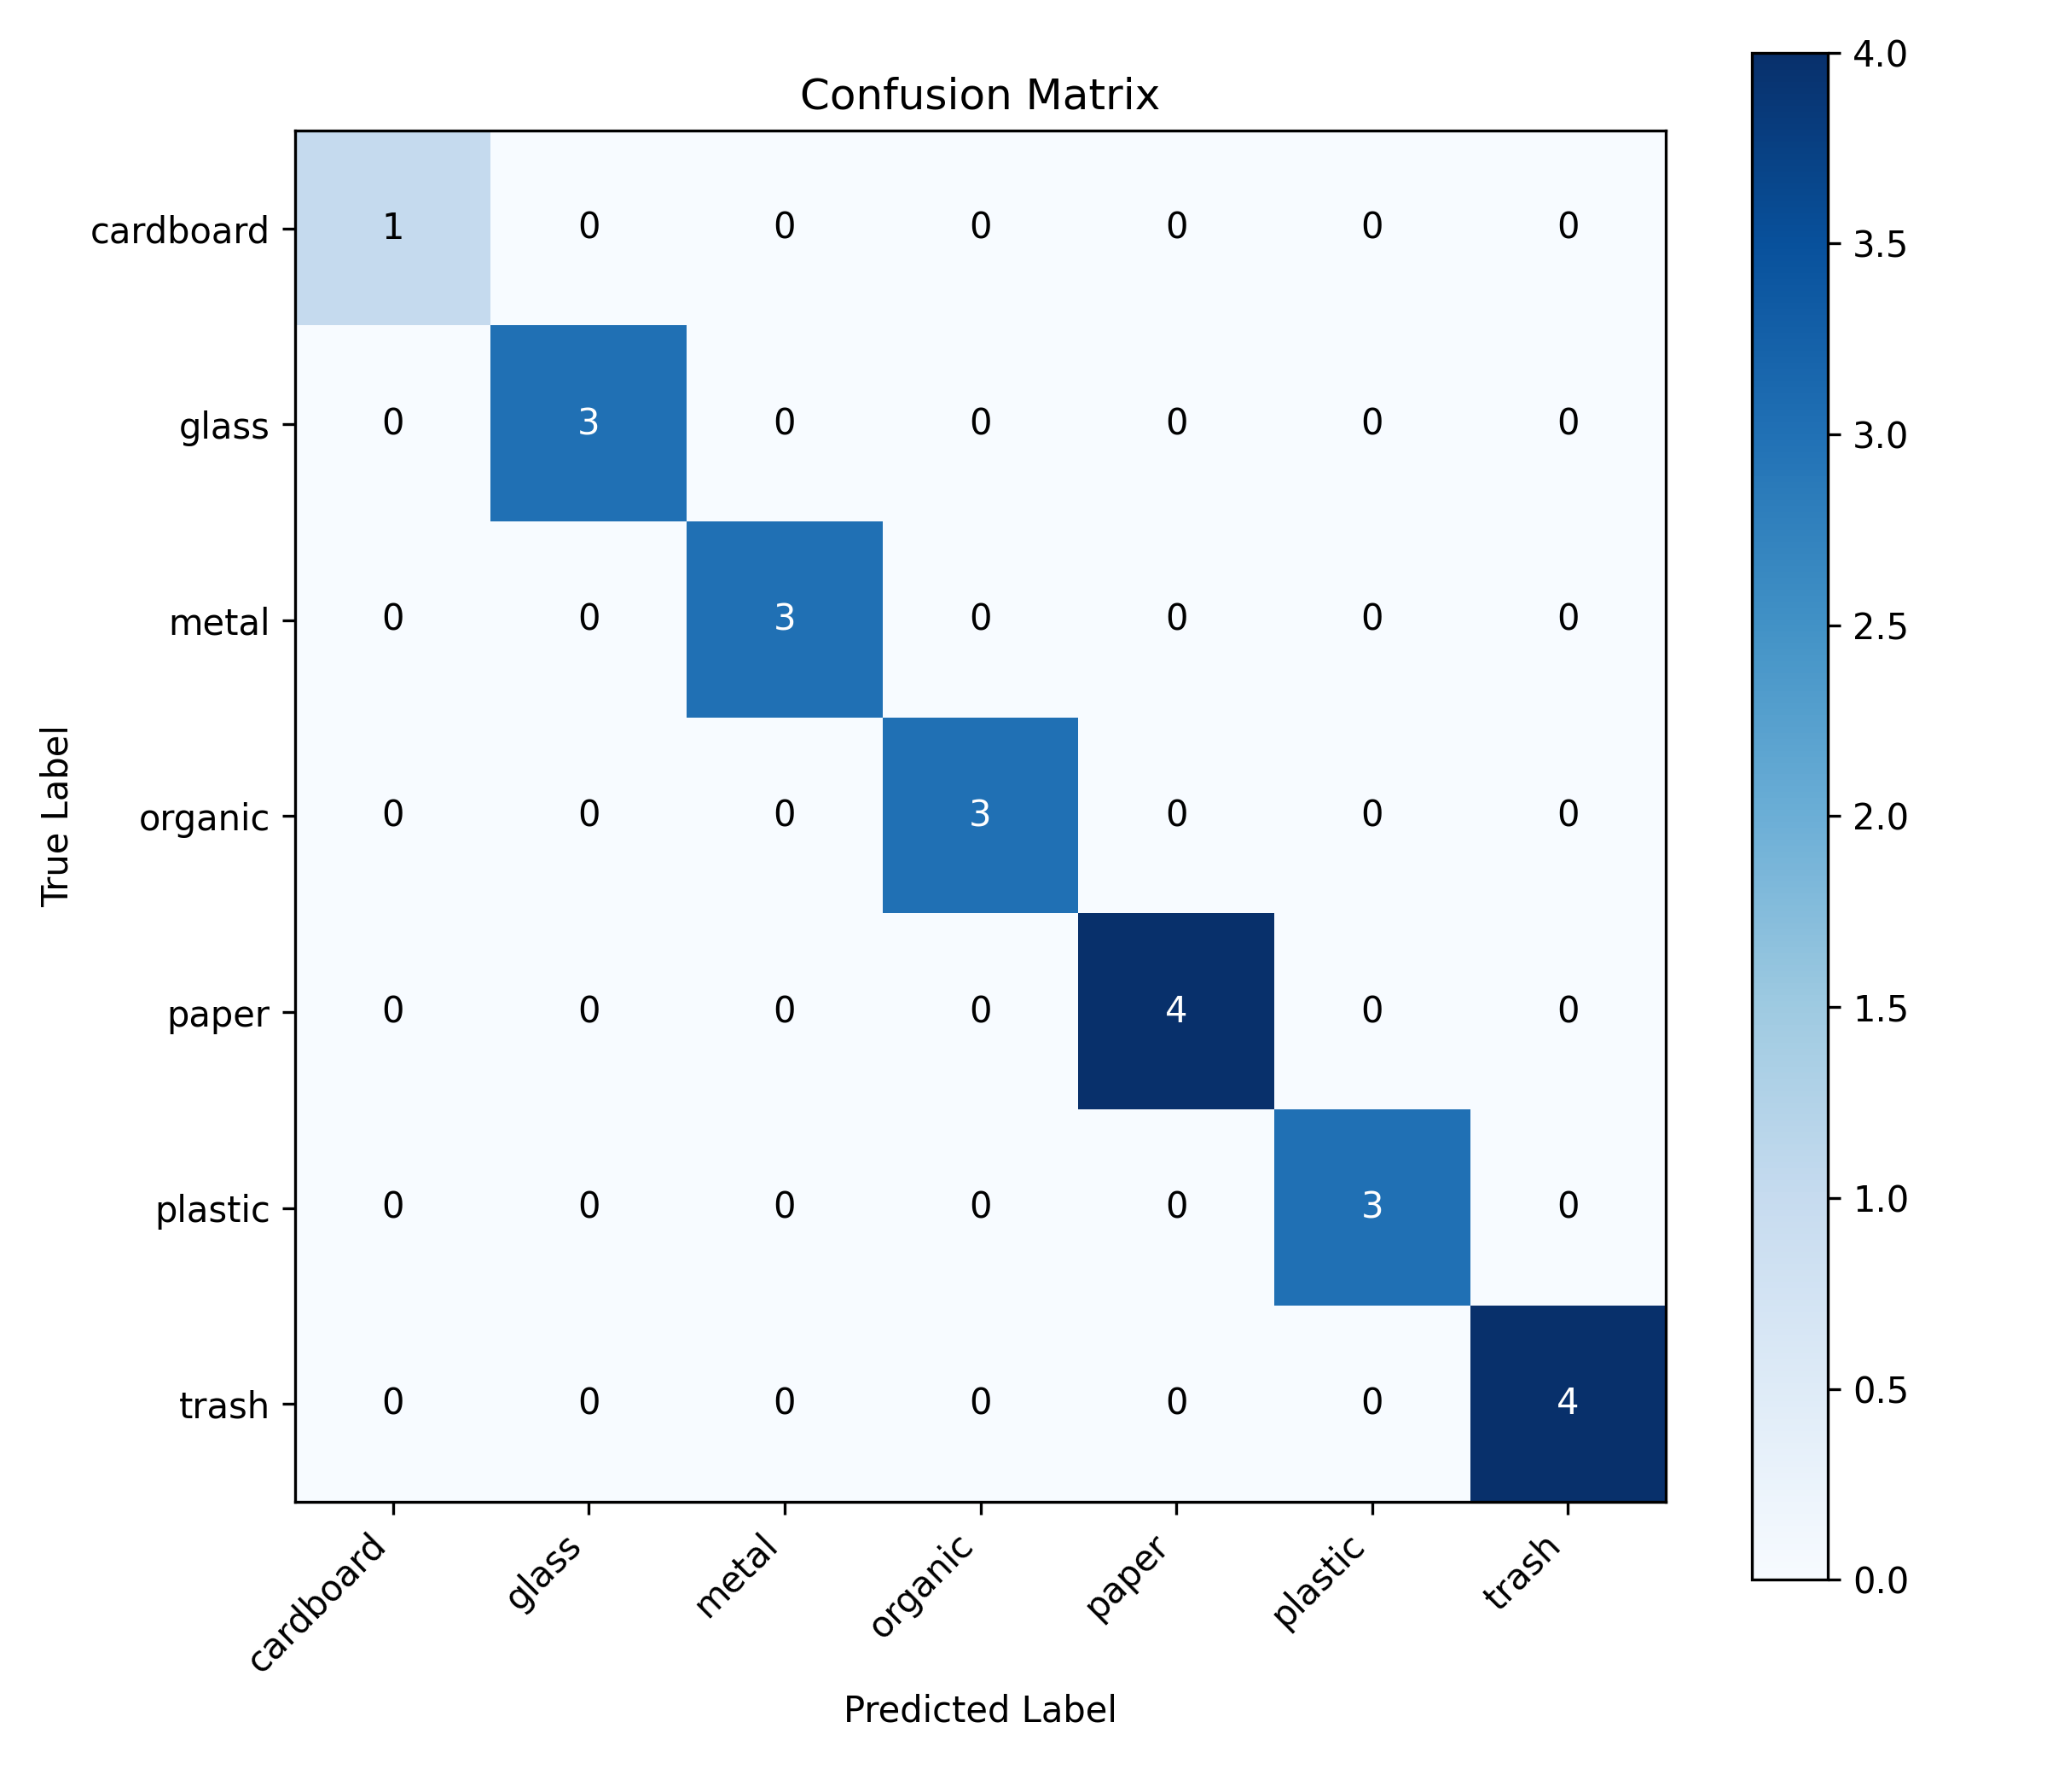
Figure 2: Confusion matrix demonstrating distinct inter-class separability.
6. Software Quality & Automated Verification
To ensure production-grade reliability, the repository was equipped with automated unit test suites using pytest. Tests rigorously validate the three core functional modules:
- Image Preprocessing (test_preprocessing.py): Verifies that arbitrary input dimensions (e.g., 640x480, 1024x768, 50x300) and color spaces (RGBA, Grayscale) are correctly transformed to (1, 224, 224, 3) float32 tensors without shape mismatches.
- Recovery Recommendation Engine (test_recovery_engine.py): Validates all seven category lookups, default rule fallback for unrecognized inputs, input sanitization, and graceful handling of non-numeric or negative weights.
- Data Persistence (test_history.py): Verifies thread-safe CSV logging, multi-item metrics calculation, and automatic recovery from corrupted or empty CSV files.
All 9 unit tests pass with zero regressions, confirming architectural stability across operating systems.
7. Real-World Use Cases & Applications
- Smart Municipal Infrastructure: Can be embedded into public smart bins fitted with internal webcams to dynamically display instructions or unlock designated recycling compartments upon item detection.
- Material Recovery Facilities (MRFs): Automates conveyor-belt sorting triage, allowing automated optical sorters to prioritize high-value scrap materials such as non-ferrous metals and clean PET.
- Corporate & Campus Zero-Waste Initiatives: Guides students and cafeteria visitors to deposit food waste in compost bins and rinse plastic cups before recycling, generating verifiable ESG sustainability audit logs.
- Citizen Engagement Mobile Applications: Empowers consumers to scan packaging labels before throwing them away, displaying neighborhood drop-off scrap value rebates.
8. Conclusion & Future Scope
The AI-Based Waste to Recovery System demonstrates that modern computer vision can be directly coupled with circular economy principles to produce actionable, quantifiable environmental dividends. By combining lightweight transfer learning with an automated decision engine, the platform enables accessible, reliable waste sorting for educational, municipal, and commercial deployment.
Future enhancements include:
1. Multi-Object Detection: Upgrading from single-item classification to YOLOv8/v10 object detection to localize multiple items simultaneously.
2. Edge Hardware Integration: Compiling the model to TensorFlow Lite / ONNX for deployment on Raspberry Pi 5 and NVIDIA Jetson platforms.
3. Barcode & Resin Identification: Integrating optical barcode scanning to cross-reference product databases for precise resin types (e.g., PETE 1 vs PP 5).

