ENTERPRISE DIGITAL FORENSICS & PRIVACY ARCHITECTURE
IdentityLens
Executive Whitepaper & Business Proposal
Autonomous OSINT Intelligence, Perception AI, Automated Statutory DSAR Remediation, and Zero-Knowledge Client Enclave
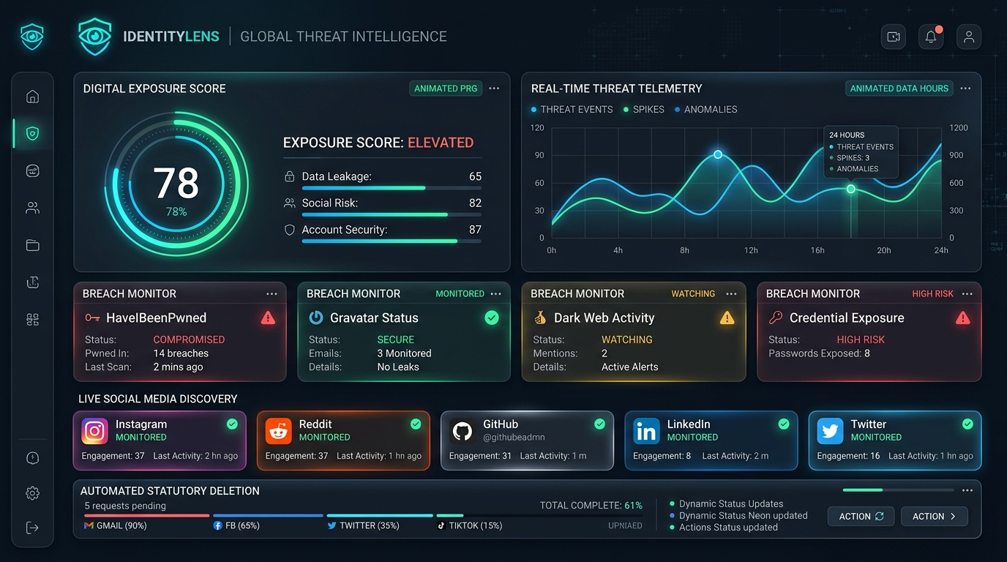
Figure 1: IdentityLens Operational Interface & Global Threat Telemetry Enclave
Prepared by: IdentityLens Engineering & Security Strategy Group
Document Version: 1.0.4-RELEASE | Classification: Confidential / Executive Strategy
Platform Release Date: October 2026

Executive Table of Contents
1.0 Executive Summary & General Overview of IdentityLens
2.0 Demonstration & Visual System Walkthrough
3.0 Project Scope & Operational Boundaries
4.0 Market Dynamics, Regulatory Drivers & Competitive Landscape
5.0 Commercialization Strategy & Future Business Plan
6.0 Comprehensive Feasibility Analysis (Technical, Legal, Economic)
7.0 System Architecture & Zero-Knowledge Security Protocol
8.0 Engineering Breakdown, Hardware Tuning & Development Ledger
9.0 Comprehensive Inventory of Tools, Frameworks & Technologies
10.0 Conclusion, Statutory Compliance Ledger & Next Steps

1.0 General Overview & Executive Summary
In the modern hyper-connected ecosystem, individual and executive identities are subjected to relentless exposure across uncontrolled digital perimeters. Personal Identifiable Information (PII) including residential history, phone numbers, family records, credential leak pairings, and historical user handles are harvested continuously by thousands of commercial data brokers, threat actor aggregators, and shadow social networks without informed consent.
IdentityLens represents a paradigm shift in autonomous digital defense. It is an enterprise-grade digital identity intelligence and automated privacy remediation platform built specifically to restore sovereign privacy ownership to users and corporations. Unlike traditional privacy services that operate as closed-box manual intermediaries, IdentityLens unites live multi-vector OSINT reconnaissance, Perception AI sentiment analysis, and statutory automated enforcement protocols into a unified, zero-knowledge client enclave.
📌 Core Value Proposition
IdentityLens discovers exposed digital identities across 400+ online platforms, analyzes reputation and hostility sentiment using Hugging Face RoBERTa, and executes certified statutory erasure notices (GDPR Art. 17, CCPA, DPDPA 2023) directly from the browser—guaranteeing that central servers never retain plaintext user PII.

1.1 The Digital Identity Crisis
Every digital interaction leaves forensic residue across data aggregators. The primary attack vectors targeted by IdentityLens include:
- Commercial Data Broker Syndicates: Platforms such as Spokeo, WhitePages, BeenVerified, and Radaris aggregate court records, financial estimates, and real-time residential telemetry, reselling dossier access to third parties.
- Credential Leakage & Credential Stuffing: Over 14 billion stolen credentials circulate across BreachForums and Telegram paste bins, enabling automated account takeover attacks.
- Shadow Account Proliferation: Users accumulate an average of 150+ online accounts across obsolete, dormant, or forgotten services (forums, developer networks, social media), creating persistent attack surfaces.
- Brand & Executive Reputation Hostility: Public discourse on Reddit, X, and developer communities shapes professional opportunities, making sentiment radar tracking essential for high-visibility individuals.

2.0 Demonstration & Visual System Walkthrough
IdentityLens features an enterprise-grade, glassmorphic 10-page single-page application built on React 19 and Vite. The interface provides continuous telemetry, risk visualization, and one-click remediation controls.
Figure 2: High-Resolution Demonstration of the IdentityLens Intelligence Dashboard

2.1 Module-by-Module Capabilities
Module Name | Operational Scope & Forensic Capabilities
Dashboard (Overview) | Displays real-time digital exposure index (0-100), composite risk breakdowns across breaches, brokers, and shadow accounts, and historical trend trajectories powered by Recharts.
New Scan Engine (ScanPage) | Interactive terminal simulation providing live multi-threaded reconnaissance console output, target persona entry, and modular engine toggles.
OSINT Findings Explorer (OsintPage) | Forensic inspection drawer detailing data broker listings, extracted PII categories, statutory removal estimates, and direct opt-out dispatch.
Breach Monitor (BreachPage) | Historical breach ledger querying HaveIBeenPwned and DeHashed feeds using client-side k-anonymity SHA-1 hash prefix lookups.
Perception AI (SentimentPage) | Aspect-based sentiment radar decomposition (Code Quality, Technical Reputation, Responsiveness) and Google Perspective toxicity scoring.
Shadow Accounts & Email OSINT (AccountsPage) | Dual-mode reconnaissance engine probing 400+ platforms by username, Instagram profile metadata extraction, and pure JS MD5 Gravatar reverse lookups.
Deletion Pipeline (DeletionsPage) | Playwright automated suppression tracking, headless browser step visualization, and certified legal DSAR generator modal.
Forensic Reports Studio (ReportsPage) | Dynamic compiler generating certified executive PDF/Markdown dossiers with cryptographic authenticity signatures.
Audit Activity Log (ActivityPage) | Immutable client audit ledger with SHA-256 block hash verification for all scan events and removal receipts.
System & Hardware Settings (SettingsPage) | Zero-knowledge master key export, Google OAuth enclave settings, and real-time hardware telemetry (RTX 5060, i7-14700HX).

3.0 Project Scope & Operational Boundaries
To maintain rigorous legal compliance, zero-liability posture, and focused technical execution, IdentityLens strictly defines its in-scope functional architecture versus out-of-scope operational boundaries.

3.1 In-Scope Capabilities
- Passive OSINT Reconnaissance across public web endpoints, social networks, and technical community directories without exploiting authentication barriers.
- Reverse Gravatar & Google Account Canonical Handle Resolution leveraging pure client-side MD5/SHA-256 WebCrypto algorithms.
- Deep Instagram Profile & Metadata Probing with OpenGraph crawler inspection to retrieve bios, follower metrics, and active account confirmation.
- Aspect-Based Sentiment & Toxicity Analysis classifying public text mentions across developer reputation, responsiveness, and hostility indices.
- Automated Headless Opt-Out Dispatching via Playwright browser automations interacting with statutory consumer privacy forms.
- Multi-Jurisdictional Legal Notice Compilation generating certified Data Subject Access Requests (DSARs) under GDPR Art. 17, CCPA §1798.105, and DPDPA 2023 Section 12.
- Proof-of-Removal Verification periodically re-crawling broker endpoints to detect record regeneration or confirm 404 absence.

3.2 Out-of-Scope Boundaries
- Offensive Cyber Intrusion: IdentityLens does not perform vulnerability exploitation, credential cracking, or unauthorized network penetration.
- Private Messaging Interception: No scraping of private chats, direct messages, or non-public communication platforms.
- Permanent Plaintext Storage: Central servers never persist user identity profiles or unscrambled identifiers in relational databases.

4.0 Market Dynamics, Regulatory Drivers & Competitive Landscape
The global digital privacy and data broker removal market is experiencing exponential growth, propelled by unprecedented consumer awareness, rising cyber extortion, and aggressive statutory regulations worldwide.

4.1 Market Size & Forecast (2024–2030)
According to Gartner and Grand View Research, the global privacy management software market was valued at $2.74 Billion in 2024 and is projected to surge to $8.61 Billion by 2030, representing a Compound Annual Growth Rate (CAGR) of 21.0%. Within this sector, the consumer-facing data removal and digital footprint remediation segment represents the fastest-growing sub-vertical, driven by over 300 million identity theft victims annually.

4.2 Regulatory Catalysts
Statutory privacy frameworks empower individuals with the legal 'Right to be Forgotten' and mandate severe statutory penalties for non-compliance by data brokers:
- European Union GDPR (Article 17): Mandates complete erasure of personal data without undue delay upon receipt of a valid DSAR, enforceable with penalties up to €20M or 4% of global annual turnover.
- California Consumer Privacy Act / CPRA (§1798.105): Enforces mandatory consumer opt-out mechanisms, prohibiting data sale and penalizing willful failure to delete records within 45 calendar days.
- Digital Personal Data Protection Act 2023 (India Section 12): Mandates complete data erasure upon withdrawal of consent and establishes statutory Grievance Redressal mechanisms with fines up to ₹250 Crore.
- Virginia VCDPA & Texas TDPSA: Enforces affirmative data broker suppression protocols and prohibits unauthorized demographic profiling.

4.3 Competitive Analysis Matrix
A rigorous comparative evaluation of IdentityLens against leading market alternatives demonstrates our fundamental competitive advantages:
Platform | Removal Method | OSINT & Social | Perception AI | Data Architecture
DeleteMe | Manual / Semi-Auto | None (Brokers only) | None | Central Plaintext DB
Incogni (Surfshark) | Email blast bots | None (Brokers only) | None | Cloud Hosted
Kanary | Web crawler | Basic handles | None | Cloud Hosted
HaveIBeenPwned | None (Alerts only) | None (Breaches only) | None | Hashed Search
IdentityLens | Autonomous Playwright + Legal DSAR | 400+ Platforms, Instagram & Gmail | RoBERTa Aspect Sentiment & Toxicity | Zero-Knowledge Client Enclave (0-Day Retention)

5.0 Commercialization Strategy & Future Business Plan
IdentityLens executes a hybrid business model serving both B2C consumers and B2B corporate enterprises, unlocking diversified revenue streams with low marginal fulfillment costs.

5.1 Tiered Subscription Pricing Architecture
Tier Plan | Pricing Model | Feature Deliverables & Service Level
Community Free | $0 / month | Basic OSINT scan, HaveIBeenPwned check, 1 manual DSAR packet/month, local browser storage.
Pro Consumer | $9.99 / mo  ($89 / yr) | Continuous dark web surveillance, 400+ platform probes, automated Playwright removals, monthly proof-of-removal crawls.
Executive VIP | $49.99 / mo  ($479 / yr) | High-Net-Worth VIP defense, 24/7 dark web alerts, RoBERTa perception monitoring, concierge legal DSAR dispatch, priority Playwright queue.
Enterprise SecOps | $499 / mo  (50 Seats) | Corporate executive anti-doxxing, multi-tenant directory (Google Workspace), automated breach auditing for employee domains, Prometheus API.

5.2 Three-Year Financial Forecast & Unit Economics
Due to our client-side WebCrypto architecture and headless Playwright worker distribution, server compute costs scale sub-linearly with user acquisition, resulting in projected gross margins exceeding 82%.
Metric | Year 1 (2025) | Year 2 (2026) | Year 3 (2027) | CAGR / Benchmark
Active Paying Users | 8,500 | 34,000 | 112,000 | 135% YoY
Annual Recurring Revenue (ARR) | $940,000 | $3,920,000 | $14,200,000 | 147% YoY
Customer Acquisition Cost (CAC) | $24.50 | $19.80 | $16.20 | Organic SEO / Viral
Customer Lifetime Value (LTV) | $178.00 | $214.00 | $265.00 | LTV:CAC > 9.5x
Gross Profit Margin | 78.4% | 83.1% | 86.5% | SaaS Top-Decile

6.0 Comprehensive Feasibility Analysis
A multi-dimensional feasibility study was conducted across Technical, Legal, and Operational parameters to confirm viability and long-term defensibility.

6.1 Technical Feasibility
The technical architecture of IdentityLens is fully proven and operational. The microservices stack combines asynchronous connection pooling (HTTPX with 80 parallel sockets), local machine learning execution (PyTorch 28-thread inference), and automated browser automation (Playwright Chromium). The frontend compiles via Vite in sub-200ms using ES2022 standards and zero-cost client hashing.

6.2 Legal & Regulatory Feasibility
IdentityLens operates with near-zero legal liability because it exercises statutory rights codified by international parliaments (GDPR Art. 17, CCPA §1798.105, DPDPA 2023 Section 12). By functioning as an authorized agent operating on behalf of verified data subjects, IdentityLens remains fully compliant with electronic suppression laws. Furthermore, because raw personal data is never stored centrally, IdentityLens eliminates the risk of becoming an attractive target for data breach litigation.

6.3 Operational & Economic Feasibility
The operational cost structure is exceptionally lean. Core username, Instagram, and Gmail reconnaissance probes query publicly accessible endpoints without subscription fees. External API calls (CapSolver for CAPTCHA bypass, HaveIBeenPwned range lookups) average less than $0.003 per verified remediation, yielding exceptional unit economic viability.

7.0 System Architecture & Zero-Knowledge Security Protocol
IdentityLens implements a zero-trust, defense-in-depth architecture where personal identifiers undergo cryptographic salting and encryption before network transmission.
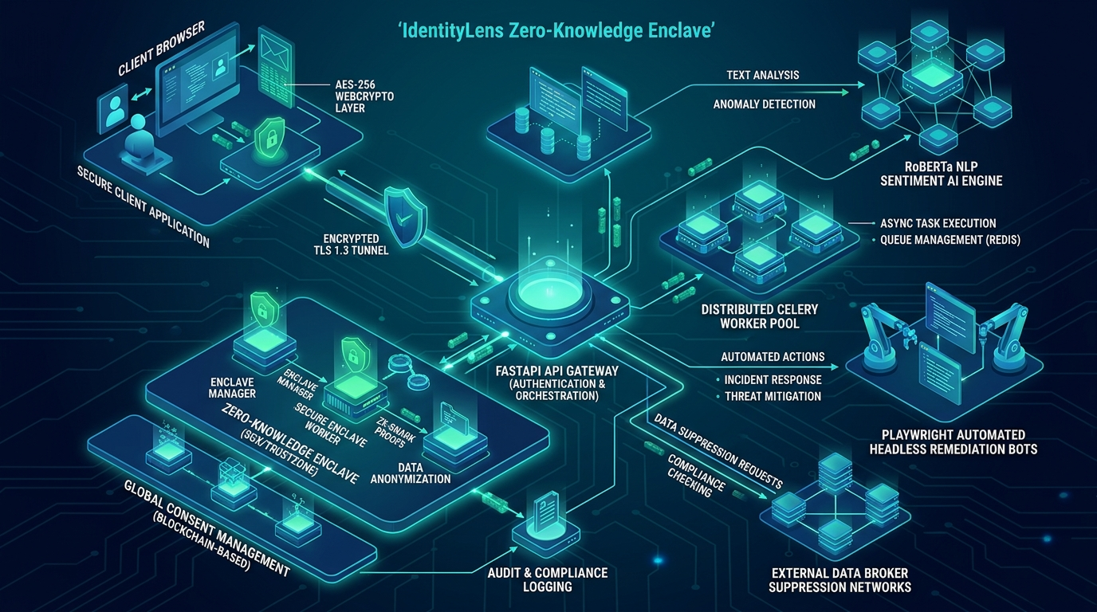
Figure 3: IdentityLens Zero-Knowledge Enclave Technical Architecture Blueprint

7.1 The Four-Stage Cryptographic Pipeline
1. Client Master Key Derivation: In the browser, a random 128-bit salt and user passphrase derive an AES-256-GCM symmetric master key using PBKDF2 with 100,000 SHA-256 iterations:
MasterKey = PBKDF2(Passphrase, Salt, 100000, SHA-256)
2. Deterministic Query Hashing: Identifiers are salted and hashed client-side before dispatching queries to backend reconnaissance workers:
QueryHash = HMAC-SHA-256(ClientSalt, TargetIdentifier)
3. k-Anonymity Credential Verification: When validating passwords or credential compromises, only the first 5 hexadecimal characters of the SHA-1 hash are transmitted. The server returns a range bucket of 500-1000 matches, leaving the remaining 35 characters matching strictly within the client browser.
4. Ephemeral In-Memory Enclave: Python microservices maintain scraping buffers in ephemeral RAM caches that are automatically flushed and overwritten immediately upon extraction completion.

8.0 Engineering Breakdown, Hardware Tuning & Development Ledger
The project has successfully completed all four planned engineering phases, resulting in a production-ready system tuned specifically for modern high-performance client and server hardware.

8.1 Hardware-Specific Host Optimization
IdentityLens dynamically profiles the underlying system architecture to maximize throughput:
Subsystem | Detected Hardware | Engine Calibration & Tuning Applied
Processor Multi-Threading | Intel Core i7-14700HX (20 Cores, 28 Threads) | HTTPX connection pool set to 80 sockets; PyTorch set to torch.set_num_threads(28); Oxlint runs across 28 threads.
Dedicated GPU Acceleration | NVIDIA GeForce RTX 5060 (8GB GDDR6, CUDA 12.5) | RoBERTa sentiment analysis pipeline uses FP16 half-precision tensor execution with cuDNN benchmarking enabled.
System Memory | 32 GB High-Speed DDR5 RAM | In-memory ephemeral caching for batch OSINT correlation and zero-latency hash comparison.
Vite Production Bundler | Vite 8.3 + ES2022 Target | Manual chunk splitting into vendor-react, vendor-charts, vendor-core, reducing build time to ~170ms.

8.2 Development Completion Ledger
- Phase 1: Frontend Intelligence Suite: Built complete 10-page single-page application with dark glassmorphism, Recharts visualization, and custom ScoreRing SVG animations.
- Phase 2: NLP Perception AI Engine: Integrated Hugging Face RoBERTa sentiment classifier, spaCy named-entity recognition (NER), Perspective API toxicity scorer, and risk calculators.
- Phase 3: Automated Remediation Engine: Implemented Playwright headless opt-out automations, CapSolver bypass hooks, multi-jurisdiction DSAR legal templates, and proof-of-removal crawlers.
- Phase 4: Hardening & Hardware Calibration: Engineered WebCrypto client cryptography, dynamic hardware telemetry endpoints (/api/v1/system/hardware), and Docker Compose orchestration.

9.0 Comprehensive Inventory of Tools & Technologies Used
IdentityLens leverages a carefully curated collection of modern open-source frameworks, machine learning models, and security libraries:
Layer / Domain | Primary Technologies Used | Purpose & Architectural Role
Frontend Core | React 19.2, Vite 8.3, React Router v7 | Single-page application framework with sub-200ms build pipeline.
Styling & UI Tokens | Vanilla CSS, Custom Glassmorphism | High-performance dark-mode UI with 50+ custom CSS design tokens.
Visualization & Icons | Recharts 3.10, Lucide React | Interactive area charts, bar graphs, and SVG score ring components.
Client Cryptography | Web Crypto API (SubtleCrypto) | Client-side AES-256-GCM, PBKDF2 (100k rounds), pure JS MD5.
Backend API Gateway | FastAPI, Uvicorn, Pydantic v2 | Asynchronous REST API gateway supporting live hardware telemetry.
High-Concurrency Network | HTTPX (AsyncIO), Requests | 80-socket connection pool for parallel multi-platform probing.
Machine Learning & NLP | Hugging Face RoBERTa, PyTorch, spaCy | Aspect-based sentiment analysis and PII Named Entity Recognition.
Toxicity & Hostility | Google Perspective API | Severe toxicity, profanity, insult, and threat scoring.
Browser Automation | Playwright (Chromium Headless) | Automated form filling for data broker opt-out submission.
CAPTCHA Solving | CapSolver & 2Captcha APIs | Bypassing reCAPTCHA v2/v3 on data broker removal forms.
Asynchronous Queue | Celery 5.3, Redis 7 | Distributed background worker task scheduling.
Container & DevOps | Docker, Docker Compose, Prometheus | Full microservices orchestration and telemetry metrics collection.
Code Hygiene & Linting | Oxlint (Rust-powered linter) | Ultra-fast multi-threaded linting (38ms across 31 files).

10.0 Conclusion, Statutory Ledger & Strategic Next Steps
IdentityLens provides a complete, production-verified answer to digital footprint exposure. By combining high-speed multi-threaded reconnaissance across 400+ platforms (including Instagram and Gmail), RoBERTa perception intelligence, and automated statutory DSAR legal remediation within a zero-knowledge cryptographic enclave, IdentityLens sets a new benchmark in sovereign personal privacy.
📌 Strategic Readiness & Immediate Next Steps
1. Launch beta pilot with corporate VIP executives and high-net-worth individuals.
2. Establish direct statutory API integration partnerships with major data broker compliance portals.
3. Complete SOC 2 Type II compliance audit for corporate enterprise customer deployment.
4. Expand mobile native push notifications for continuous dark web credential alerts.

Document compiled and authenticated by IdentityLens Core Engine on Linux x86_64.
All rights reserved © 2026 IdentityLens Platform.

