Install ollama
https://ollama.com/download/windows
Execute below command in powershell
irm https://ollama.com/install.ps1 | iex
After installing below is the screenshot how it looks like
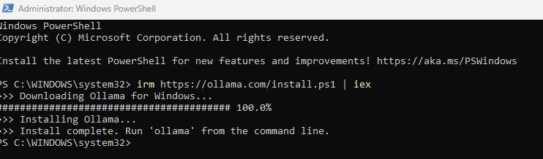

Connect to GIT HUB
-TO-DO-

Installing PlayWright MCP’s to the repository
Here is the documentation on installing playwright agents https://playwright.dev/docs/test-agents
In the command prompt where the repository is there go to that folder and type below command in the terminal or command prompt
npm init playwright@latest
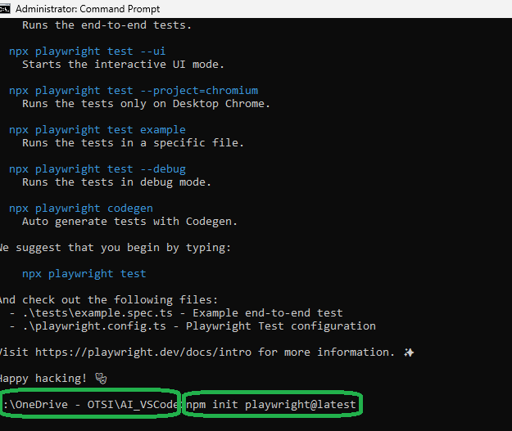
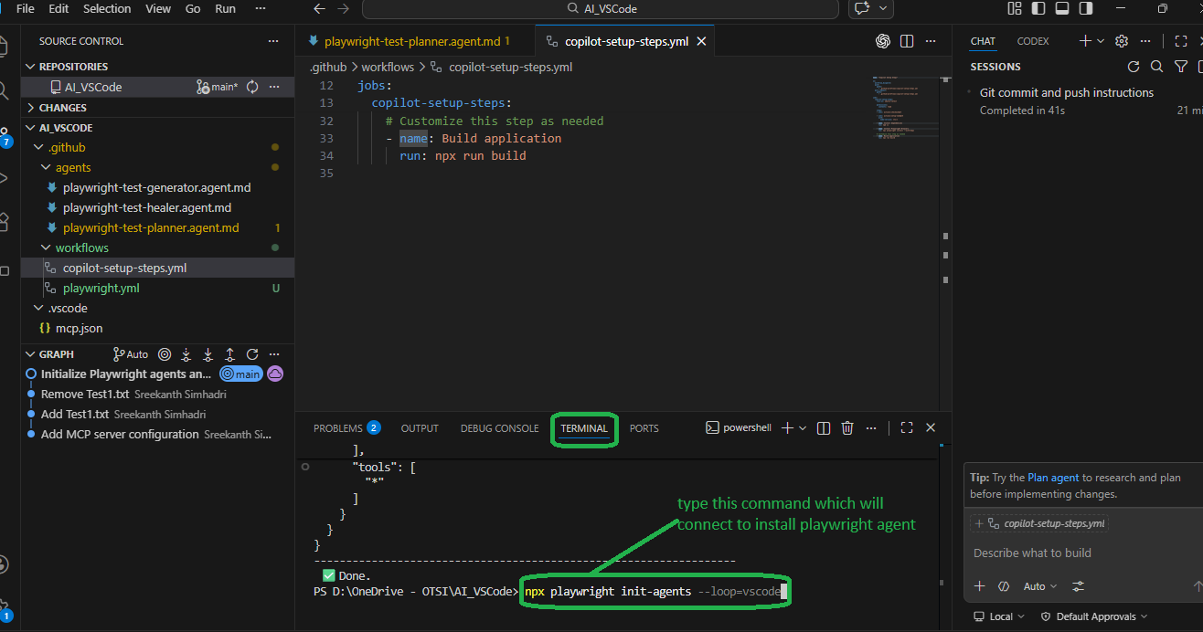

Create a Seed test
go to ChatGPT and enter below command
create a seed test for playwright for https://playwright.dev/docs/test-
agents , Playwright AI planner agent
create a file “speed.spec.js” file as in below screenshot with below content
// tests/seed.spec.ts
import { test, expect } from '@playwright/test';

test('seed', async ({ page }) => {
// Navigate to base application
await page.goto('https://playwright.dev/');

// Basic assertion to confirm page loaded
await expect(page).toHaveURL(/playwright\.dev/);

// Simple interaction (helps AI planner understand navigation pattern)
await page.getByRole('link', { name: 'Docs' }).click();

// Validate navigation
await expect(page).toHaveURL(/docs/);
});

Select the “speed.spec.js” as in below screen and type the prompt as below:
