Test Plan 1
Objective 2
Scope 2
Inclusions 4
Test Environments 6
Defect Reporting Procedure 7
Test Strategy 8
Test Schedule 9
Test Deliverables. 10
Entry and Exit Criteria 10
Entry Criteria: 10
Exit Criteria: 11
Test Execution 11
Entry Criteria: 11
Exit Criteria: 11
Test Closure 11
Entry Criteria: 11
Exit Criteria: 11
Tools 11
Risks and Mitigations 11
Approvals 12

Objective
The goal of this test plan is to ensure the quality, functionality, and reliability of the Restful Booker API hosted at https://restful-booker.herokuapp.com.

The API is designed to handle booking requests for a fictional hotel booking system.

Track both leading and lagging indicators for your experiment's impact
Keep an eye on guardrail metrics to stop bad experiments early on

- Sprint boot
- My SQL
- Documentation via flagger

Scope
Scope of Test Plan for Restful Booker API:

1. Functional Testing:
- Verify the correctness and functionality of all API endpoints as per the API documentation.
- Test various scenarios for booking creation, modification, and cancellation.
- Validate user authentication and authorization mechanisms for protected endpoints.

2. Data Validation Testing:
- Ensure that the API correctly validates input data, rejecting invalid requests.
- Test boundary values for input fields to check for any unexpected behavior.
- Validate the accuracy of data returned in responses.

3. Error Handling Testing:
- Verify that appropriate error codes and messages are returned for invalid requests.
- Check error responses for sensitive information disclosure.
- Validate the API's ability to handle unexpected errors gracefully.

4. Performance Testing:
- Assess the API's response time under normal and peak loads to identify potential bottlenecks.
- Measure the API's throughput and scalability to handle concurrent requests.

5. Security Testing:
- Conduct security assessments to identify vulnerabilities such as SQL injection, XSS, etc.
- Validate the API's compliance with secure data transmission practices (e.g., HTTPS).
- Check for proper access controls to prevent unauthorized access to sensitive resources.

6. Integration Testing:
- Verify interactions between different API endpoints and services.
- Test data consistency across related endpoints.

7. Compatibility Testing:
- Test the API on different platforms, browsers, and devices to ensure cross-compatibility.

8. Documentation Review:
- Assess the clarity, completeness, and accuracy of the API documentation.
- Verify that the API documentation is in sync with the actual API behavior.

9. Load Testing:
- Evaluate the API's behavior under high concurrent user loads to ensure stability.

10. Regression Testing:
- Conduct regression testing after bug fixes or updates to ensure existing functionality remains intact.

11. Edge Case Testing:
- Test extreme and boundary scenarios to identify potential issues.

12. Concurrency Testing:
- Assess the API's behavior when multiple users attempt to access and modify bookings simultaneously.

13. Ad Hoc Testing:
- Perform exploratory testing to identify any hidden defects or usability issues.

14. Usability Testing:
- Evaluate the API's user-friendliness and ease of use from a developer's perspective.

15. Continuous Integration and Deployment (CI/CD) Testing:
- Validate the API's behavior within the CI/CD pipeline to ensure smooth deployments.

16. Performance Monitoring:
- Implement monitoring to track API performance in real-time.

17. Backup and Recovery Testing:
- Validate data backup and recovery procedures to ensure data integrity.

18. Internationalization Testing:
- Test the API's behavior with different language settings.

19. Rate Limiting Testing:
- Check the API's adherence to rate-limiting rules to prevent abuse.

20. Third-Party Integration Testing:
- Validate any third-party integrations for smooth functioning.

It's important to note that the scope of the test plan may evolve during the testing process based on feedback, changing requirements, or discoveries during testing. The scope should be reviewed and adjusted accordingly throughout the testing phase to ensure comprehensive coverage of the Restful Booker API.

Inclusions

Create (POST) Operations:

Test the API's ability to create new bookings using valid input data.
Verify that appropriate error responses are returned for invalid or missing data.
Validate that newly created bookings are stored correctly in the system.

Read (GET) Operations:

Test the API's ability to retrieve booking information by various criteria (e.g., booking ID, date range, guest name).
Verify that the API returns the correct data in response to read requests.
Test for correct handling of non-existent or invalid booking IDs.

Update (PUT) Operations:

Test the API's ability to update existing bookings with valid data.
Verify that the API rejects invalid update requests with appropriate error responses.
Validate that the booking data is correctly modified in the system after updates.

Delete (DELETE) Operations:

Test the API's ability to delete bookings by providing valid booking IDs.
Verify that the API returns appropriate responses after successful deletion.
Validate that the deleted bookings are removed from the system.

Boundary Testing:

Test the API with minimum and maximum allowed values for input fields.
Validate the behavior of the API with values close to the boundaries.

Concurrency Testing:

Test the API's behavior when multiple users try to perform CRUD operations simultaneously.
Verify data consistency and handling of concurrent modifications.

Data Validation:

Test the API's response to various data validation scenarios (e.g., invalid characters, data types, mandatory fields).
Verify that the API handles validation errors appropriately.

Authentication and Authorization:

Test CRUD operations for both authenticated and unauthenticated users.
Verify that only authorized users can perform certain CRUD operations.

Error Handling:

Test the API's response when invalid or malformed requests are made for CRUD operations.
Validate that appropriate error codes and messages are returned.

Security Testing:

Test for security vulnerabilities during CRUD operations (e.g., SQL injection, XSS).
Verify that sensitive data is not exposed in responses.

Performance Testing:

Evaluate the API's response time for CRUD operations under normal and peak loads.
Measure the throughput and scalability of the API.

Integration Testing:

Verify the interaction and data consistency between CRUD operations and other API components.

Regression Testing:

Perform regression tests after bug fixes or updates to ensure existing CRUD functionalities remain intact.

Documentation Review:

Assess the accuracy of API documentation related to CRUD operations.

Load Testing:

Evaluate the API's behavior and performance during CRUD operations under high concurrent user loads.

Compatibility Testing:

Test the API's CRUD operations on different platforms, browsers, and devices.

Usability Testing:

Evaluate the ease of using CRUD functionalities from a developer's perspective.

Continuous Integration and Deployment (CI/CD) Testing:

Validate the CRUD operations within the CI/CD pipeline to ensure smooth deployments.

Rate Limiting Testing:

Check the API's adherence to rate-limiting rules for CRUD operations to prevent abuse.
Backup and Recovery Testing:

Validate data backup and recovery procedures for CRUD-related data.

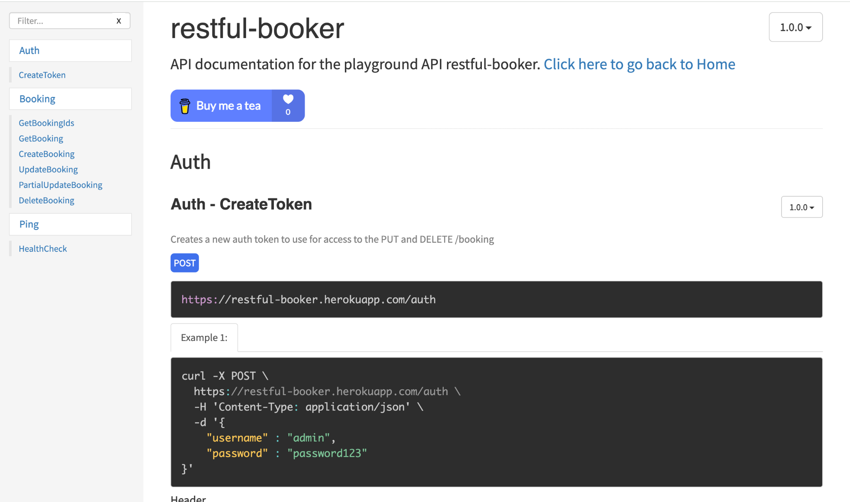

Test Environments

The operating systems and versions that will be used for testing, such as Windows 10, macOS, or Linux.

The browsers and versions that will be tested, such as Google Chrome, Mozilla Firefox, or Microsoft Edge.
The device types and screen sizes that will be used for testing, such as desktop computers, laptops, tablets, and smartphones.

The network connectivity and bandwidth that will be available for testing, such as Wi-Fi, cellular, or wired connections.

The hardware and software requirements for running the test cases, such as a specific processor, memory, or storage capacity.

The security protocols and authentication methods that will be used to access the test environment, such as passwords, tokens, or certificates.

The access permissions and roles of the team members who will be using the test environment, such as testers, developers, or stakeholders.

Name | Env url
QA | https://restful-booker.herokuapp.com/apidoc/index.html
Pre Prod | https://restful-booker.herokuapp.com/apidoc/index.html

Windows 10 – Chrome, Firefox and Edge
• Mac OS – Safari Browser
• Android Mobile OS – Chrome
• iPhone Mobile OS - Safari

Defect Reporting Procedure

The criteria for identifying a defect, such as deviation from the requirements, user experience issues, or technical errors.

The steps for reporting a defect, such as using a designated template, providing detailed reproduction steps, and attaching screenshots or logs.

The process for triaging and prioritizing defects, such as assigning severity and priority levels, and assigning them to the appropriate team members for investigation and resolution.

The tools and systems that will be used for tracking and managing defects, such as a defect tracking software or a project management tool.

The roles and responsibilities of the team members involved in the defect reporting process, such as testers, developers, and the test lead.

The communication channels and frequencies for updating stakeholders on the progress and status of defects.

The metrics and metrics that will be used to measure the effectiveness of the defect reporting process, such as the number of defects found, the time taken to resolve them, and the percentage of defects that were successfully fixed.

Defect Process | POC
New Frontend | Devesh
Backend | Sonal
Dev Ops | Prajeeth

Tools - JIRA

Test Strategy

The first step is to create test scenarios and test cases for the various features in
Scope.

While developing test cases, we'll use a number of test design techniques.
o Equivalence Class Partition
o Boundary Value Analysis
o Decision Table Testing
o State Transition Testing
o Use Case Testing

We also use our expertise in creating Test Cases by applying the below:
o Error Guessing
o Exploratory Testing
• We prioritize the Test Cases

Step 2: Our testing procedure when we receive a request for testing:

• First, we'll conduct smoke testing to see if the various and
important functionalities of the application are working.

• We reject the build, if the Smoke Testing fails and will wait for the stable
build before performing in depth testing of the application functionalities.

• Once we receive a stable build, which passes Smoke Testing, we perform
in depth testing using the Test Cases created.

• Multiple Test Resources will be testing the same Application on Multiple
Supported Environments simultaneously.

We then report the bugs in bug tracking tool and send dev. management
the defect found on that day in a status end of the day email.

As part of the Testing, we will perform the below types of Testing:
o Smoke Testing and Sanity Testing
o Regression Testing and Retesting
o Usability Testing, Functionality & UI Testing
• We repeat Test Cycles until we get the quality product.

Step3 – We will follow the below best practices to make our Testing better:

• Context Driven Testing – We will be performing Testing as per the context
of the given application.

• Shift Left Testing – We will start testing from the beginning stages of the
development itself, instead of waiting for the stable build.

• Exploratory Testing – Using our expertise we will perform Exploratory
Testing, apart from the normal execution of the Test cases.

• End to End Flow Testing – We will test the end-to-end scenario which
involve multiple functionalities to simulate the end user flows.

Test Schedule

Following is the test schedule planned for the project –
Task Time Duration

Task | Dates
▪ Creating Test Plan
▪ Test Case Creation
▪ Test Case Execution
▪ Summary Reports Submission Date

2 Sprints to Test the Application

Test Deliverables.

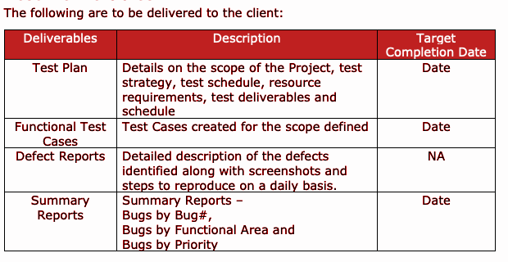

Entry and Exit Criteria
The below are the entry and exit criteria for every phase of Software Testing Life
Cycle:
Requirement Analysis

Entry Criteria:
• Once the testing team receives the Requirements Documents or details
about the Project

Exit Criteria:
• List of Requirements are explored and understood by the Testing team
• Doubts are cleared

Test Execution

Entry Criteria:
• Test Scenarios and Test Cases Documents are signed-off by the Client
• Application is ready for Testing

Exit Criteria:
• Test Case Reports, Defect Reports are ready

Test Closure

Entry Criteria:
• Test Case Reports, Defect Reports are ready

Exit Criteria:
• Test Summary Reports

Tools
The following are the list of Tools we will be using in this Project:
• JIRA Bug Tracking Tool
• Mind map Tool
• Snipping Screenshot Tool
• Word and Excel documents

Risks and Mitigations
The following are the list of risks possible and the ways to mitigate them:
Risk: Non-Availability of a Resource
Mitigation: Backup Resource Planning
Risk: Build URL is not working
Mitigation: Resources will work on other tasks
Risk: Less time for Testing
Mitigation: Ramp up the resources based on the Client needs dynamically

Approvals
Team will send different types of documents for Client Approval like below:
• Test Plan
• Test Scenarios
• Test Cases
• Reports
Testing will only continue to the next steps once these approvals are done

MFA TOTP Implementation Test Plan
Generated by AntiGravity Test Planner using GROQ with Zero-Hallucination Extraction Protocol.
Source: Jira — Ticket: KAN-5

Requirements Extraction Profile

Feature Scope
Implement Multi-Factor Authentication (MFA) using Time-based One-Time Passwords (TOTP)

Acceptance Criteria (AC)
QR code must be scannable by major authenticator apps
• QR code must be scannable by major authenticator apps
MFA setup requires valid 6-digit code verification
• MFA setup requires valid 6-digit code verification
Login fails if MFA code is incorrect
• Login fails if MFA code is incorrect
MFA disable requires valid code or recovery code
• MFA disable requires valid code or recovery code
Recovery codes invalid after single use
• Recovery codes invalid after single use

Test Cases Execution Table
Total Test Cases: 5 | Tool: Jira
Test Case ID | Jira ID | Module / Feature | Test Case Title | Preconditions | Test Steps | Test Data | Expected Result | Priority | Test Type
TC-001 | KAN-5 | MFA | Validate QR code is scannable by major authenticator apps | User is authenticated and has not enabled MFA. | 1. Send GET request to /api/v1/auth/mfa/setup.  2. Capture the returned QR code URL.  3. Scan the QR code with Google Authenticator (or equivalent). | QR URL: otpauth://totp/Example:alice@example.com?secret=JBSWY3DPEHPK3PXP&issuer=Example | Authenticator app successfully adds the account and displays a 6‑digit TOTP. | High | Functional
TC-002 | KAN-5 | MFA | Ensure MFA setup succeeds with a valid 6‑digit code | User has obtained a QR code and secret key from the setup endpoint. | 1. Generate TOTP using secret JBSWY3DPEHPK3PXP (e.g., code 282760).  2. POST the code to /api/v1/auth/mfa/verify.  3. Verify response indicates success. | Secret: JBSWY3DPEHPK3PXP; TOTP code: 282760 | API returns success, mfa_enabled flag set to true, and secret stored encrypted. | High | Functional
TC-003 | KAN-5 | MFA | Login must fail when an incorrect MFA code is supplied | User has MFA enabled and is at the second‑factor prompt. | 1. Submit username "alice" and password "Password123!" to /api/v1/auth/login.  2. When prompted, send incorrect 6‑digit code "000000" to /api/v1/auth/login/second-factor.  3. Observe the response. | Username: alice; Password: Password123!; MFA code: 000000 | Login is denied with an error indicating invalid MFA code; account remains locked out after 5 attempts. | High | Functional
TC-004 | KAN-5 | MFA | MFA disable succeeds with a valid current TOTP code | User has MFA enabled. | 1. Generate current TOTP using secret JBSWY3DPEHPK3PXP (e.g., code 282760).  2. Send request to disable MFA with the code.  3. Verify MFA is disabled in the system. | Secret: JBSWY3DPEHPK3PXP; TOTP code: 282760 | API confirms MFA disabled, mfa_enabled flag set to false, and secret removed. | High | Functional
TC-005 | KAN-5 | MFA | Recovery codes become invalid after a single use | User has a set of 10 recovery codes; one code "RCODE-1" is unused. | 1. Use recovery code "RCODE-1" at the second‑factor prompt.  2. Attempt to use the same recovery code "RCODE-1" again.  3. Observe the response. | Recovery code: RCODE-1 | First use succeeds and logs the user in; second use fails with an error indicating the code is invalid or already used. | High | Functional

