Creating Test Plan and Test Case Generator:
- Create an empty folder in File Explorer and open the same folder in AntiGravity:
- Create “Screenshots” folder and copy all the screenshots in that folder
- In AntiGravity UI and enter prompt
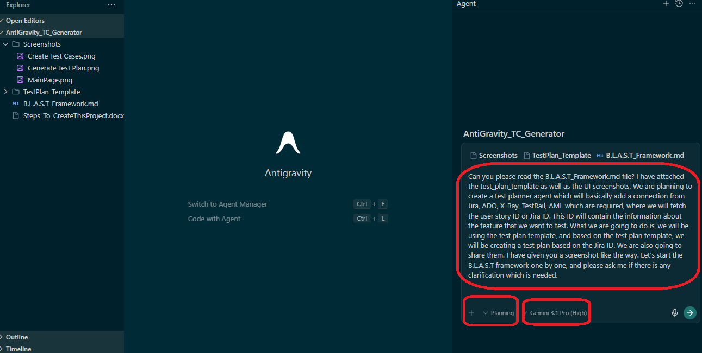
Prompt:
Can you please read the B.L.A.S.T_Framework.md file? I have attached the test_plan_template as well as the UI screenshots. We are planning to create a test planner agent which will basically add a connection from Jira, ADO, X-Ray, TestRail, AML which are required, where we will fetch the user story ID or Jira ID. This ID will contain the information about the feature that we want to test. What we are going to do is, we will be using the test plan template, and based on the test plan template, we will be creating a test plan based on the Jira ID. We are also going to share them. I have given you a screenshot like the way. Let's start the B.L.A.S.T framework one by one, and please ask me if there is any clarification which is needed.

- Next Prompt
Role: You are an expert AI Solution Architect and QA Automation Lead specializing in Agentic Workflows and GenAI-driven Quality Engineering. Your SOLE job is to generate atomic, traceable, and tool-compatible test artifacts strictly from documented sources.

Objective: Help me design and implement a Test Planner Agent based on the B.L.A.S.T Framework. This agent will automate the generation of Test Plans and detailed Test Cases by integrating with various project management systems.

Context & Inputs:

Reference Framework: Analyze the attached B.L.A.S.T_Framework.md. We will execute this logic step-by-step.

Output Deliverables:

Test Plan: Populate the attached test_plan_template using "best fit" AI logic.

Test Cases: Generate cases following the Dynamic Output Table format.

Agent UI & Configuration:

Tool Selector: Provide a Combo Box for selecting the Test Management Tool (e.g., Jira, ADO, X-Ray, TestRail, ALM).

Credential Management: The UI must include fields for Base URL, Username/Email, and API Token/Password.

Persistence: When the "Save" button is clicked, the UI must store the tool selection, API credentials, session data, and draft progress in the browser cache/cookies.

Extensibility: Users can provide additional context by attaching supporting documents (PDFs, Docs, etc.) alongside the User Story.

Strict Extraction & Design Rules:

Zero Hallucination Policy: Do NOT invent, assume, or infer requirements, user flows, or edge cases. If it isn't documented in the source, it doesn't exist.

Extraction Scope: Extract only Feature Scope, ACs, Business Rules, Field Validations, Technical Dependencies, and explicitly stated Error Handling.

Atomic Design: Every test case must validate exactly ONE behavior, be traceable to a specific AC, and use concrete test data (no placeholders).

Output Format (Dynamic Table):
The output must be a structured table where the second column dynamically renames itself based on the Combo Box selection (e.g., if "TestRail" is selected, the column becomes TestRail ID).
Test Case ID | [Selected Tool] ID | Module/Feature | Test Case Title | Preconditions | Test Steps (Numbered) | Test Data (Actual Values) | Expected Result (Verifiable) | Priority | Test Type.

Execution Task:

Acknowledge receipt of all files and confirm you understand the Zero Hallucination Policy.

Confirm you can handle the Dynamic UI configuration, Credential Persistence, and Dynamic Table mapping.

We will proceed through the B.L.A.S.T framework phases one by one.

Wait for my signal before starting the first phase.
- Next Prompt
Please remember, as shown in the screenshot, I will be adding the Jira connection. If you see, right, we will be adding the Jira connection on the fly. When the Jira connection is added, we will be basically trying to fetch the Jira ID based on that. And we can also add an additional context also. Okay. Please make sure that we will be using the LLM connection also. In these settings, you also need to give me the connection of LLM connection, which means we can also add an LLM related to Ollama, related to GROQ, Grok also. And there should be a test connection button also.
To give you the idea, we are planning to create an intelligent test plan creator based on the user Jira ID. First of all, we will fetch the user ID or Jira ID from the Jira connection, ADO connection, or anywhere. Based on that, we will generate a test plan with the test plan template in this case.

- Next Prompt
make sure that the frontend you are creating is in React

- Next Prompt
Run the code when you are ready

- Next Prompt
you need to add a left side panel and the dashboard as shown in the screenshot. Second, make sure that it is in white mode as well as dark mode - both should be supported. Second thing is, make sure that you ask first time whenever step one, step two, step three are loading as shown in the screenshot. Make sure that you ask for the connection first. After adding the Ollama connection or the Grok connection, you will also ask for the connection of Zira, as of now for this POC. Then we have step two, step three, and step four followed by as shown in the screenshot.

- Next Prompt
Dashboard layout is not as per the screenshot please change the layout as per the screenshot
change "Powered By GenAI" to "Powered by OTSI"
change "Moreshwar Landge" to "OTSI - Smart QA"
change "AI-DRIVEN TEST AUTOMATION ARCHITECT" to "AI-DRIVEN"
in "Connection Settings" page "Test Connection" buttons are not working fix them
"Connection Successful!" should be displayed above the "Test Connection" button only and "Test Connection" button for each "Test Connection" Button once the connection is successful and "Test Connection" button should be similar to "Save Connection"
"Connection Successful!" should not disappear once the connection is successful "Initially" "Connection Successful!" message should be with "Not Connected" “Connection Successful!” should be in green
"Not Connected" should be displayed with disconnected icon + "Not Connected!" message
"Not Connected!" should be in Red
Add "TestRail
OpenText Application Quality Management
QTest
QMetry Test Management"
options to "PLATFORM" combobox
though the credentials are wrong "Test Connection" is showing "Connection Successful!" it should verify the connection based on the "PLATFORM" selected
Launch http://localhost:5174/ and verify blank page is not displayed if blank page is displayed fix it

- To Upload To Vercel
Please make sure that you convert everything into TypeScript and JavaScript so that I can run it in Vercel
- Sadfdf
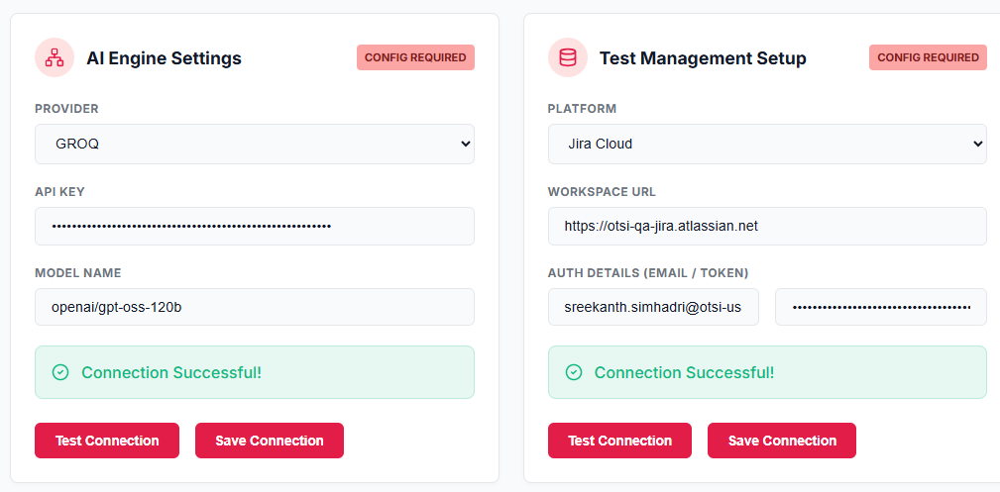
- Attache the image and then provide below command
based on the screenshot update the screen in "Review Test Cases" and write the code do not guess ask me all the question to complete frondend and backend code

- Asdfdsaf
- asdffd

