Disaster Recovery with IBM Cloud Virtual Servers

|  |  |
| --- | --- |
| **Date** | **10-10-2023** |
| **Team ID** | **680** |
| **Project Name** | **Disaster Recovery with IBM Cloud Virtual Servers** |

**Table of Contents**

|  |  |
| --- | --- |
| 1 | Introduction |
| 2 | Problem Statement |
| 3 | Design and Innovation Strategies |
| 3.1 | Data Collection and Feature Engineering |
| 3.2 | Backup and Replication |
| 3.3 | Failover and Redundancy |
| 3.4 | Serverless Database Solution |
| 3.5 | Assessment and Planning |
| 3.6 | Documentation |
| 3.7 | Replication and Redundancy |
| 4 | Conclusion |

# Introduction

Disaster recovery is a critical component of modern business continuity planning, ensuring that organizations can maintain essential operations and data accessibility in the face of unforeseen disruptions. IBM Cloud Virtual Servers offer a robust platform for hosting applications and workloads, and when combined with a well-designed disaster recovery strategy, they can help businesses minimize downtime and data loss.

# Problem Statement

In today's highly competitive and digitally-driven business landscape, organizations rely heavily on their IT infrastructure to deliver services, support operations, and manage critical data. However, they also face a growing array of potential risks, including natural disasters, hardware failures, cyberattacks, and human errors, which can lead to costly downtime, data loss, and reputation damage.

# Design and Innovation Strategies

### Data Collection and Feature Engineering

In Disaster Recovery using IBM Cloud Virtual Servers, data collection involves gathering server configurations and performance metrics. IBM Cloud provides tools for real-time and historical data extraction. Feature engineering transforms this data into meaningful indicators for predictive modelling. Aggregating metrics and creating new variables enhances system health insights.

IBM Cloud's analytics capabilities enable nuanced feature derivation. These features contribute to sophisticated disaster recovery models. Integrated into DR plans, these models facilitate automated responses to potential failures.

Effective data collection and feature engineering bolster resilience in the face of disasters. The process ensures swift and intelligent responses for maintaining business continuity. Ultimately, IBM Cloud Virtual Servers empower organizations with proactive disaster recovery strategies..

## Backup and Replication:

Using IBM Cloud Virtual Servers, backup involves periodic data copies to a secure repository, creating restore points. Concurrently, replication ensures real-time data duplication between primary and secondary locations, minimizing downtime. Continuous data replication technologies maintain an up-to-date copy on a remote server for enhanced resilience.

These processes collectively form a robust disaster recovery strategy. IBM Cloud Virtual Servers often provide automated tools for seamless backup and replication management. Backups act as a fall back for restoring to a known state, while replication minimizes data loss by maintaining synchronized copies. This combination ensures data integrity and system availability during unforeseen events. Automated tools in IBM Cloud Virtual Servers simplify the implementation and monitoring of these critical processes. The strategy prioritizes swift recovery and business continuity in the face of disasters.

## Failover and Redundancy:

IBM Cloud Virtual Servers for Disaster Recovery, failover ensures seamless transition from a primary to a secondary server during system failures. Redundancy is integral, with duplicated components minimizing risks. Automated failover mechanisms swiftly detect faults, redirecting traffic to healthy servers and reducing downtime. Network, storage, and critical resources are redundantly configured, enhancing system resilience. In a disaster, failover relies on redundant counterparts to maintain business continuity. IBM Cloud's approach ensures robust Disaster Recovery, prioritizing reliability and data integrity.

## Serverless Database Solutions:

Server less database solutions play a crucial role in disaster recovery strategies, especially when integrated with IBM Cloud Virtual Servers. In the event of a disaster, traditional databases may face challenges in terms of scalability and rapid deployment. However, serverless databases dynamically allocate resources based on demand, ensuring efficient utilization and cost-effectiveness. IBM Cloud Virtual Servers enhance this process by providing a flexible infrastructure that scales seamlessly.

In a disaster scenario, server less databases can swiftly and automatically shift data processing to available resources, minimizing downtime. This dynamic allocation of resources ensures high availability and fault tolerance, key aspects in disaster recovery. Additionally, serverless databases often offer automated backups and point-in-time recovery, further strengthening the disaster recovery capabilities. IBM Cloud Virtual Servers, coupled with serverless database solutions, create a resilient and responsive architecture that can adapt to unforeseen circumstances, providing a robust foundation for disaster recovery efforts.

## Assessment and Planning:

Assessment and planning in Disaster Recovery with IBM Cloud Virtual Servers involve evaluating existing virtual server setups, identifying vulnerabilities, and understanding dependencies. This phase defines recovery objectives, like RTO and RPO, tailoring strategies with IBM Cloud's flexibility. Backup, replication, and recovery tools are selected, and communication protocols established. Automation is often used to streamline recovery processes. Documentation and runbooks are created for guidance, and regular testing ensures plan effectiveness. The process aligns technology solutions with business continuity goals, mitigating the impact of disasters on IT infrastructure.

### Documentation:

Documentation in Disaster Recovery for IBM Cloud Virtual Servers involves creating an inventory of servers and assets, detailing configurations and network topologies. Backup and restore procedures should be clearly outlined, along with a comprehensive disaster recovery plan. Roles, responsibilities, and testing procedures must be documented for effective execution.

A communication plan with contact details ensures efficient coordination during a disaster. Accessible storage of documentation in secure repositories aids quick retrieval. Regular updates to documentation, reflecting changes in the IBM Cloud environment, enhance its relevance and reliability. This systematic approach ensures a swift and accurate recovery process, minimizing downtime and data loss in the face of unforeseen disasters

## Replication and Redundancy:

Replication involves creating identical data copies across dispersed servers using technologies like IBM Cloud Object Storage. Redundancy, through duplicated components and resources, enhances fault tolerance within a single system or across multiple data centres.

This ensures swift activation of replicated resources during a disaster, minimizing downtime. IBM Cloud's approach combines real-time data mirroring with hardware redundancy, creating a robust disaster recovery strategy. This dual strategy ensures data integrity, operational continuity, and rapid recovery, forming a resilient foundation for critical workloads in the cloud.

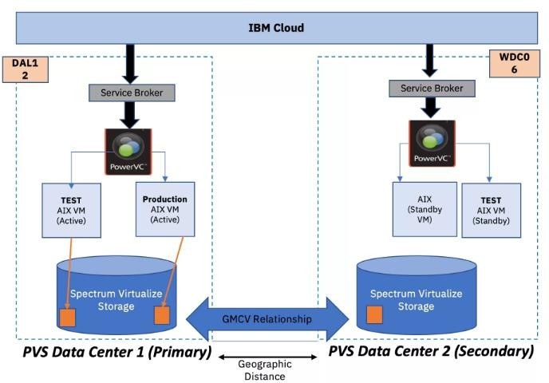.

### Conclusion

IBM Cloud Virtual Servers offer high availability and reliability, making them a suitable choice for hosting critical applications and data. You can easily scale your virtual server resources up or down based on your disaster recovery needs, ensuring that you have the right resources available when required. data centres in multiple geographic regions, allowing you to replicate your virtual server environments across different locations for added redundancy. Implement robust backup and recovery processes to ensure that your data is protected and can be quickly restored in the event of a disaster. IBM Cloud provides various backup and snapshot options to facilitate this.