Programming Assignment 1
XHTML
60 Points

Overview:

This assignment requires he implementation of numerous XHTML documents used by an online-store that sells items for the Balanced-Living Online E-Book store. The online-store will sell primarily Health, Financial and some Scientific E-Books. This assignment will implement the first part of the Balanced-Living website - only the pages consisting of the products offered by the online store. You will implement several HTML pages described in the subsequent sections. These pages will be integrated with a Home Page (index.html) which will be implemented in Programming Assignment 2.

HTML Pages

store_index.html

This is the top-level page for the online store. The purpose of this page is to illustrate all the categories of products offered by the Balanced-Living Store. An example of this page is shown below in Fig.1:
h1
h2 (with italics)

h3 (with bold and italics)

body bgColor is #b9ffff

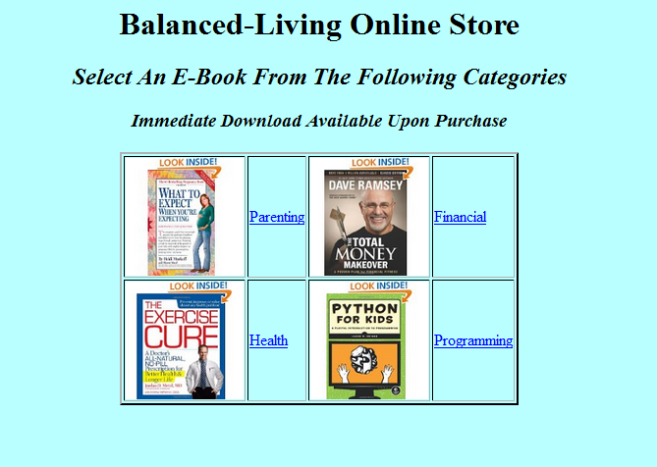
Suggested cell width is 120 Suggested cell width is 35 Suggested image width is 120
Fig. 1

There are 4 E-Book categories as indicated by the hyperlinks in Fig. 1. The 4 categories (and their corresponding images) are:

Categories Images
Parenting expect.jpg
Financial TotalMoney.jpg
Health NoExercise.jpg
Programming python.jpg

The corresponding images can be extracted from web-content.zip which can be downloaded from Blackboard.
Because of redundancy, only the links on the left side of the table –Parenting and Health - need be implemented for this assingment.

Parenting.htm1

Pressing the hyperlink Parenting found in store_index.html (See Fig. 1 above) results in the following page, containing products offered at the Bedroom online-store, being displayed:


There are 4 different Parenting E-Books offered. Their name with corresponding image are shown below:

Items Images
What To Expect expect.jpg
The First Year expect1.jpg
Hands Free Mama Mama.jpg
Talk To Kids talk.jpg

The user is returned to store_index.htm1 upon pressing the Continue Shopping hyperlink. Other links pertaining to the specific books need not be implemented for this assignment – we’ll implement those in Assignment 2 .

Health.html

Pressing the hyperlink Health found in store_index.htm (See Fig. 1 above) results in the following page, containing items offered at the Health’s online-store, being displayed:

There are 4 different products offered on the Health’s Online-Shop. . Their name with corresponding image are shown below:

Items Images
Daniel Plan healthPlan.jpg
Exercise Cure NoExercise.jpg
Soul Healing Soul.jpg
Wheat Belly WheatBelly.jpg

Pressing the Continue Shopping hyperlink returns the user to store_index.htm. Other links need not be implemented in this Assignment.

Product Pages Note

Individual html pages will be created for each product in Programming Assignment 2. The links for individual products need not be implemented in Programming Assignment 1. We’ll be using CSS to control the positioning, the background colors, and the fonts on these individual product pages in Programming Assignment 2.

checkout.html

Implement the following HTML form that contains the user information once they are ready to check out:

mc.jpg
visa.jpg
amex.jpg
discover.jpg

Submit

Reset
Modify the following <form> tag on checkout.html as shown below:
<form action=”http://localhost:8090/” method=”POST” >
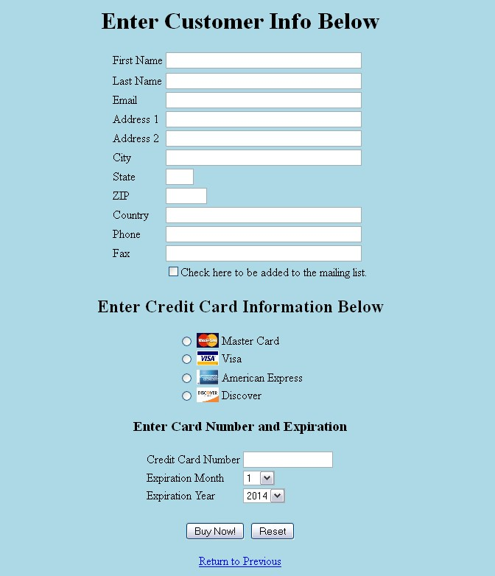
The example webserver demonstrated in example 2 can also be used for testing checkout.html as well. The validation rules will be implemented using two HTML 5 attributes - requried and pattern. A correctly completed form means that all fields have passed the validation rules. The validation rules are explained below in the next section If the form is not correctly completed, pressing the Submit button will display a message for a field that does not contain valid data. An example for an incorrectly entered First Name is shown below:
2019
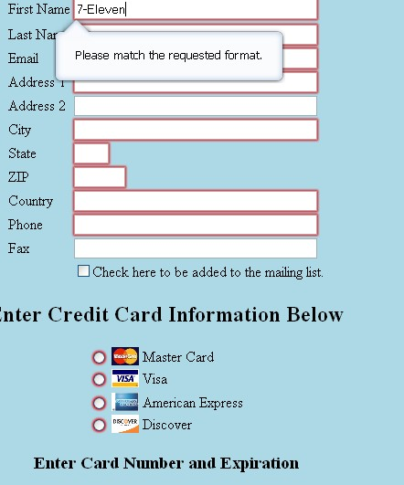
Note that the error message is automatically displayed by the Web Browser upon the user pressing the Submit (e.g., Buy Now) button.

Validation Rules
The suggested parameter names (enclosed in parenthesis) as specified in checkout.html are given below followed by the rules for each field:

First Name (name_first)
This field is required. The first name can only contain alphas (uppercase or lowercase), or a space (ascii – 32. The web browser should display the appropriate error message if this field contains anything besides these characters, (or left blank)

Last Name (name_last)
This field is required. The last name can only contain alphas (uppercase or lowercase), a space (ascii – 32), or tick mark (‘).The web browser should display the appropriate error message if this field contains anything besides these characters, (or left blank)

Email (email)
This field is required. The email field must contain any number of characters followed by the “at sign” - @ . Any number of characters can then follow the “@” symbol. The web browser should display the appropriate error message if this field contains anything besides these characters, (or left blank)

Address1 (address1)
This field is required. Any data in this field is acceptable. The web browser should display the appropriate error message if this field is left blank.

Address2 (address2)
This field is optional. Can be left blank. Any data in this field is acceptable or it can be left blank.

City (city)
This field is required. The city can only contain alphas (uppercase or lowercase), or a space (ascii – 32). The web browser should display the appropriate error message if this field contains anything besides these characters, (or left blank).

State (state)
This field is required. The state field must consist of 2 capital alpha letters. The web browser should display the appropriate error message if this field contains anything besides these characters, (or left blank).

Zip (zip)
This field is required. The zip code must consist of exactly 5 digits. The web browser should display the appropriate error message if this field contains anything besides these characters, (or left blank).

Phone (phone)
This field is required. Examples of valid phones are shown below:

5555555555
(555)555-5555
555-555-5555

The ()’s and dashes are optional, no whitespace, 10 digits are required. . The web browser should display the appropriate error message if this field contains anything besides these characters, (or left blank).

Fax (fax)
This field is not required. Use the same rule described above for the phone field if it does contain data. The web browser should display the appropriate error message if this field contains anything besides these characters.

Credit Cart Type (radio)
This field is required. Only one credit card type can be selected. The web browser should display the appropriate error message if this field is left blank - no radio button selected.

Credit Card Number (cc_no)
This field is required. Each credit card should consist of exactly 16 digits. The web browser should display the appropriate error message if this field contains anything besides these characters or is left blank.
Note: A more sophisticated algorithm will be implemented in a later assignment that will more correctly validate the credit card number. For this assignement, any 16 digit number will be acceptable.

Input Files

Download web-content.zip and unzip this in a folder of your choice (i.e. Assignment1). The following directory structure is created:

web-content
|
images
/ \
\
checkout e-books---
|
financial
programming
health
parenting

The images needed in our projects should be stored in an organized way. The checkout directory contains the credit card images. The products directory contains images illustrating the different products the store has for sale. More directories (and files) will be added to this same tree in future assignments. You will need to create these folders and add the images to the folders.

The contents of each folder are listed below:

Folder Name Contents
health healthPlan.jpg, NoExercise.jpg, Soul.jpg, WheatBelly.jpg
parenting expect.jpg, expect1.jpg, Mama.jpg, talk.jpg

financial getRich.jpg, GiveTake.jpg, TaxIncome.jpg, TotalMoney.jpg

checkout mc.jpg, visa.jpg, amex.jpg, discover.jpg

programming python.jpg, java.jpg, web.jpg, cpp.jpg

Other Considerations

The main objective of this project is to implement all links, images and the order form. I will not deduct points if your pages do not look exactly like the one in this document. Feel free to experiment with various spacing and alignment along with different background colors if you choose. However, all required functionality must be implemented and the pages should be neat and readable. There are so many ways to implement this project – use your own creativity and choose any approach you like as long as the HTML pages have all the required functionality and all images are displayed. Feel free to utilize comments within your HTML – it will help you when examining this project in the future. Also try to space your HTML appropriately (i.e., indent nested elements and utilize white space) so it is more readable. Be sure to display all images and all links.

Testing Your Project

Please test your Programming Assignment 1 project on a machine other than the one you developed on. Please use Mozilla when testing your project (this is what I’ll be using too). This will assure that you have no hard-coded paths and your project has no special requirements. Testing on one of UCA’s computer (Room 329/339/Library). Remember, if it doesn’t run on the UCA computers, it won’t run on my lap top when grading your work either!

I have to grade whatever you submit through Blackboard so please make sure that you submit all required files!

What you Submit

Please zip up the VS folder (e.g., progAssign1) where you implement the complete project Submit the compressed file via Blackboard before the due date. I will be using Mozilla Firefox to test your project. It is important to zip up your complete folder so I can run your work on my computer the same way that you run it.

Points will be deducted if you do not submit all required work.

git config --global user.email "you@example.com"
git config --global user.name "Your Name"
git config --global user.password "password"

