Programming Assignment 2
Cascading Style Sheets

Overview

ProgrammingAssignment2 utilizes Cascading Style Sheets (CSS) for implementing the home page (index.html) for the Balance-Living website. A suggested implementation for the homepage, index.html is illustrated in Fig. 1 below:
healthHeader2.png
div 1
Logo.png
bg_head2.png

div 2
div 3
Health
Header3.
png
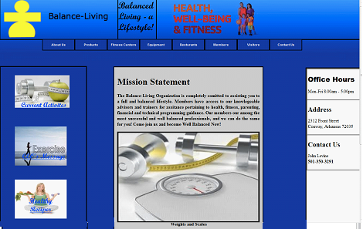
div 4
div 5
Health
Header4a.
jpg
recipes.
jpg
weights.jpg

The div sections shown above are examples and are referenced in the sections that follow.

The background color for most of the HTML’s body is #2224A2
. The background image for the whole document is bg_head2.bmp.

A close-up view of the example homepage is shown below:

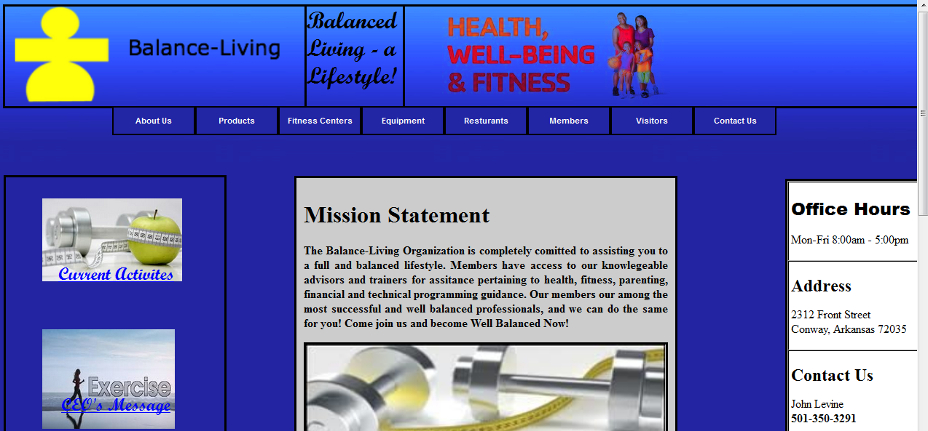
The details for this homepage are described as follows:

div 1

div 1 (banner section) has the following properties:

The font of the .heading text is script mt bold

The three images – logo.png, healthHeader2.png, and bg_header2.png- must be included in this section and this section should include the heading “Balanced Living – A Lifestyle ” in the text using Script MT Bold. A solid border should surround this div. The images will have to be resized appropriately in order to be displayed properly in this div.
\

div 2

div 2 contains the following menu items that stretch across the top of this section

:

The example illustrates a menu having a font of Arial and a font size of 11px. These top level menus should contain the text labels as shown. Each of these menus will display a submenu when the mouse hovers over them. A given submenu is then highlighted in light blue when the mouse hovers over it. A description of each submenu is given as follows:

About Us

When the mouse hovers over the About Us menu, the following submenu is displayed:

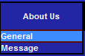

Each submenu item must be implemented as a link. The example above displays the links with a same blue color as the top-level menu.
When the mouse hovers over a submenu item, the submenu should be highlighted as shown above. The background for the submenu is (60,139,255). General, and Message are the two submenus displayed above.

Each submenu item must be implemented as a link. For this assignment, these links do not have to be associated with an existing HTML page.

Products

When the mouse hovers over the Products menu, the following submenu is displayed:

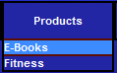

Each submenu item must be implemented as a link.
The link associated for E-Books should be connected to the store_index.htm page implemented in ProgrammingAssignment1 Upon pressing Our Store will direct the user to store_index.htm and display the following page (implemented in ProgrammingAssignment1).
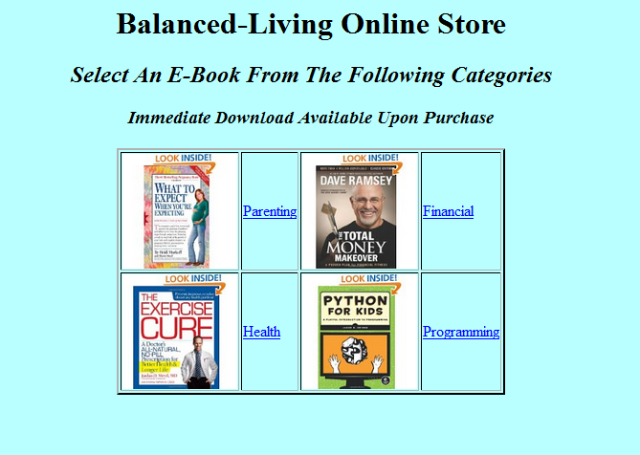
store_index.htm

The Our Store link is the only sub-menu to be implemented in ProgrammingAssignment2. There will also be 8 product links implemented in this Assignment for the Parenting and Health links. See the “Products” section on page 7.

Fitness Centers

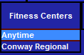
Each submenu item must be implemented as a link. For this assignment, these links do not have to be associated with an existing HTML page.

Equipment

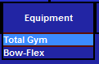
Each submenu item must be implemented as a link. For this assignment, these links do not have to be associated with an existing HTML page.
Restaurants

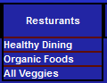
Each submenu item must be implemented as a link For this assignment, these links do not have to be associated with an existing HTML page.

Members

When the mouse hovers over the Members menu, the following submenu is displayed:

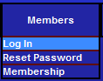

Each submenu item must be implemented as a link For this assignment, these links do not have to be associated with an existing HTML page.

Visitors

When the mouse hovers over the Visitors menu, the following submenu is displayed:



Each submenu item must be implemented as a link. For this assignment, these links do not have to be associated with an existing HTML page.

Contact Us

When the mouse hovers over the Contact Us menu, the following submenu is displayed:

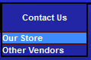

Each submenu item must be implemented as a link. For this assignment, these links do not have to be associated with an existing HTML page.

div 3

div 3 is located on the right side of the home page and pertains to current information/events. div 3 has the following properties:

Contains 3 images - healthHeader3.jpg, healthHeader4a.jpg, recipes.jpg. - implemented as hyperlinks. Text for each hyperlink is “Current Events”, “CEO’s Message” and “Healthy Recipes” also shown on page 1 and displayed over the image. For this assignment, the links do not have to be associated with an existing HTML page. A border should be drawn around this div. The images will have to be resized appropriately in order for this div to look properly.

div 4

div 4 is located near the center of the page and contains general information about the website. This div contains the following:

A brief description of the organization - as an example - The Balance-Living Organization is completely committed to assisting you to a full and balanced lifestyle. Members have access to our knowledgeable advisors and trainers for assistance pertaining to health, fitness, parenting, financial and technical programming guidance. Our members our among the most successful and well balanced professionals, and we can do the same for you! Come join us and become Well Balanced Now! The font should be bolder.

An image that represents the basic concept/interest for the website. The one images (weights.jpg) must be included in this section with a caption under the image. A border around the images should be used. The weights.jpg image must be resized appropriately in order for this image to be displayed properly in this div.

3. Set the background color for this div to #CCCCCC.

div 5
The contact information should be displayed in div 5. Use the following data content as shown displayed in a vertical fashion:

Tour Times

Product Pages
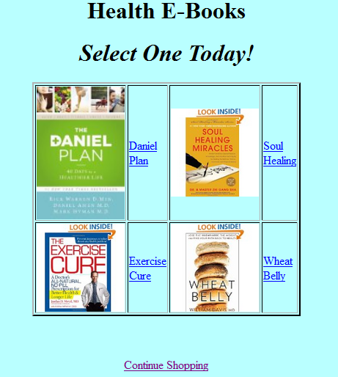
The following product page was implemented in Assignment1 (This page will not be re-graded in this assignment) for Health:

You will now need to create an individual page for each product. These pages will correspond to the hyperlinks shown above. The names of these pages should be:
Pages Hyperlink
daniel.html Daniel Plan
exercise.html Exercise Cure
soul.html Soul Healing
wheat.html Wheat Belly

An example product page for exercise.html is shown below:
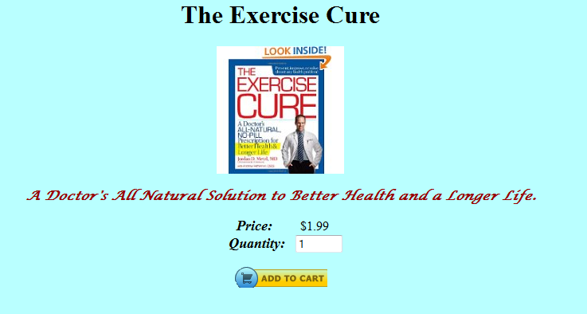
The product page must have a title (<h1>, the image of the product (displayed as actual size), with a description of the product (Lucida Calligraphy font). The price along with a textfield for the Quantity is displayed as shown. A maximum of 2 digits can be entered for the quantiy. The Command Button is displayed with atc.png displayed as its background image.
Note: You may need to set the background color and border color for the image in order for it to blend in with the background color of the html page.
Use <div> when creating the product pages. The suggested prices and descriptions for the other 3 health products are shown below:

Table 1 - Health
HealthPlan.jpg  Daniel Plan | The Tried and Tested Dietary Plan to Change Your Life. | $2.99
Soul.jpg  Soul Healing | A Guide to a Happy and Healthy Life by Basic Lifestyle Changes. | $1.99
WheatBelly.jpg  Wheat Belly | Wheat – The Real Wonder Food for the 21st Century. | $0.99
The same pattern can be used for all product pages. The links from health.html must be implemented to each product page. See me if you were not able to fully implement exercise .html for Programming Assignment 1.

The following page was implemented for Parenting (parenting.html) in ProgrammingAssignment1:


Implement the following 4 product pages the correspond to each hyperlink on the page:
Pages Link
expect.html What To Expect
expect1.html The First Year
mama.html Hands Free Mama
kids.html Talk to Kids

The description for each product is given below:
Table 2 - Parenting
expect.jpg  What To Expect | A Health and Exercise Guide for Expecting Mothers | $3.99
expect1.jpg  The First Year | A Health and Exercise Guide for Mothers in their First Year . | $1.99
Mama.jpg Hands Free Mama | Become a Multi-Tasking Mama with Less Stress | $0.99
talk.jpg  Talk to Kids | A Guide to Communicating with Your Children | $2.99
The same pattern can be used for all product pages. The links from parenting.html must be implemented to each product page. See me if you were not able to fully implement parenting.html for ProgrammingAssignment1.

Input Files

Unzip home.zip and you’ll see a folder named home. Insert this folder in the previously created hierarchy (from ProgrammingAssignment1) under the images folder.
All needed images for this project are found in the home folder.

Other Considerations

The main objective of this project is to implement a home page (index.html) with multiple sections consisting of a banner (section 1), main body/navigation menus (section 2), and special links (section 5). I will not deduct points if your home page does not look exactly like the one in this document, but your home page should be neat and readable (i.e., symmetrical, centered, balanced). You can choose your own fonts – I primarily used Arial and Times New Roman. Feel free to experiment with various spacing and alignment along with different background colors if you choose. You are required to use at least 5 divs. Feel free to utilize comments within your HTML – it will help you when examining this project in the future. Also try to space your HTML appropriately (i.e., indent nested elements and utilize white space) so it is readable.

Testing Your Project

Please test your ProgrammingAssignment 2 project on a machine other than the one you developed on. Please use Mozilla when testing your project (this is what I’ll be using too). This will assure that you have no hard-coded paths and your project has no special requirements. Testing on one of the computers in lab 329 is preferred. All files/pages must be included in your project. Remember, if it doesn’t run on the computers in lab 329, it most likely won’t run on my lap top when grading your work either!

What you Submit

Please zip up the VS project folder (e.g., ProgramAssign2) where you implement the complete project. Use WinZip (i.e., default compression for Windows). Submit the compressed file via Blackboard before the due date. I will be using Mozilla Firefox to test your project. It is important to zip up your complete folder so I can run your work on my computer the same way that you run it. Points will be deducted if you do not submit all required work.

