Tutorial-3 Extra Questions

- A sequence detector is designed to detect precisely 3 digital inputs, with overlapping sequences detectable. For the sequence (1, 0, 1) and input data (1, 1, 0,1,0,0,1,1,0,1,0,1,1,0) . What is the output of the detector.

- Draw the state Diagram for standard flip flops
( SR , JK , D and T )

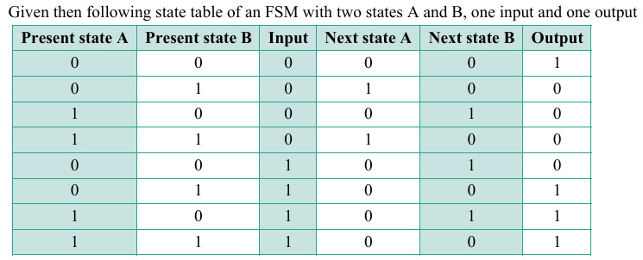
3. a)

Draw the state diagram
b) 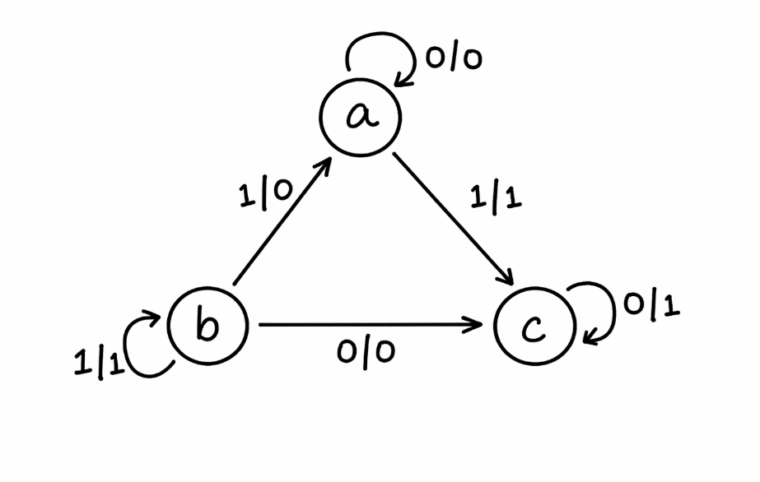
Design FSM for the given State diagram.
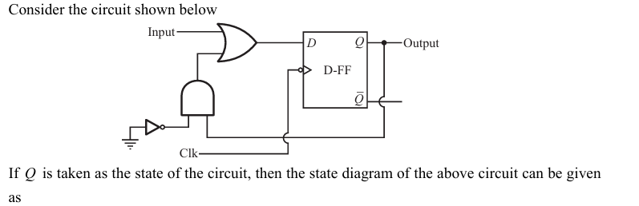
4.
Draw state table as well

