Image to gray
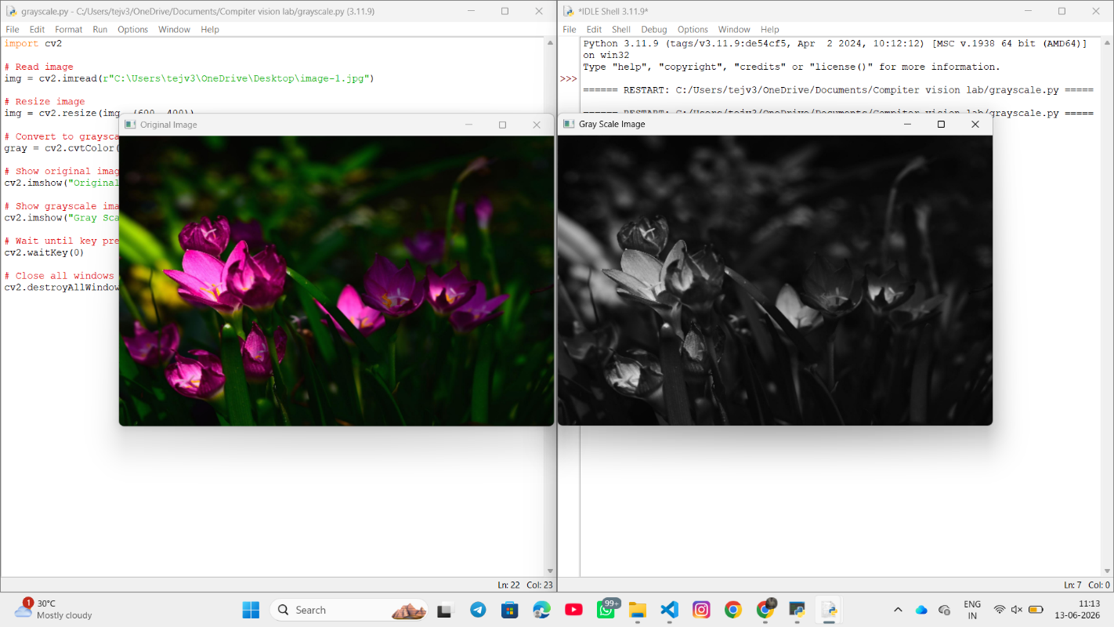
Code:
import cv2
img = cv2.imread(r"C:\Users\tejv3\OneDrive\Desktop\image-1.jpg")
img = cv2.resize(img, (600, 400))
gray = cv2.cvtColor(img, cv2.COLOR_BGR2GRAY)
cv2.imshow("Original Image", img)
cv2.imshow("Gray Scale Image", gray)
cv2.waitKey(0)
cv2.destroyAllWindows()

