DAY-3

expecting us to know bootstrap.

testing we are not including in this training

import and export from modules in typescript need to do exercises on that.

Angular 2:

check for the version

livereloadserver: whenever we are making any changes in codebase, automatically my server should reload. similarly we have this server option similar to springboot.in

angular2 cli.

observable design pattern is also avialable for typescript. typescript watchers can be enabled with npm commands. here we can know who modified and if the modification

is susccess or failure. this flag variable helps to trace.

anyfront end application will not have jar files. in angular 2 kind of applications, packing the application is taken care by webpack.it is a module bundler.this will

bundle the final output to .js

why angular 2:

main reason is mobility(mobile applications).

in angular we are dependent on ionic/konymobile/synchamobile/jquerymobile/springmobile are used.
angular 1 do not follow modular approach, angular 2 uses.
numberof services(middleware) support got increased from angular 1 to 2.
promise concept and observable are supported in angular2.
angular2 have transpiler as its part.it can use any transpiler. for angular 1 we need to do workaround.
benefits of typescript(access specifiers) are used more in angular2
packaging feature is not there in angular1 but in angular2 straight forward we have scaffolding and archiving is there.
cloud related services interaction

Architecture of angular2:

application = base component(template+class(properties+methods)+metadata)+child component(template+class(properties+methods)+metadata)+.... on top of services
it follows decorator design patterns. we are not goind to use all decorators. we use frequently @component @class etc

2 way binding: model and view binding.(Event and property binding)

angular follows MVC. this being frontend we have MVC support.

ngSwitch is used to perform switch operation between components.
ngContent is used in tiles view. read about tiles in presentation layer
ngif(*ngif) - for conditions
ngfor(*ngfor) - for loop
@decoratorname (decorator may be anything like class component etc.)
@injectable - used for IOC
ngmodel
for mobile appl we go with base64 convertions.
Angular 2 application creation.

Goto github angular2 quickstart and copy from git and follow below steps:
Goto quickstart project which we have cloned from git and issue: npm start
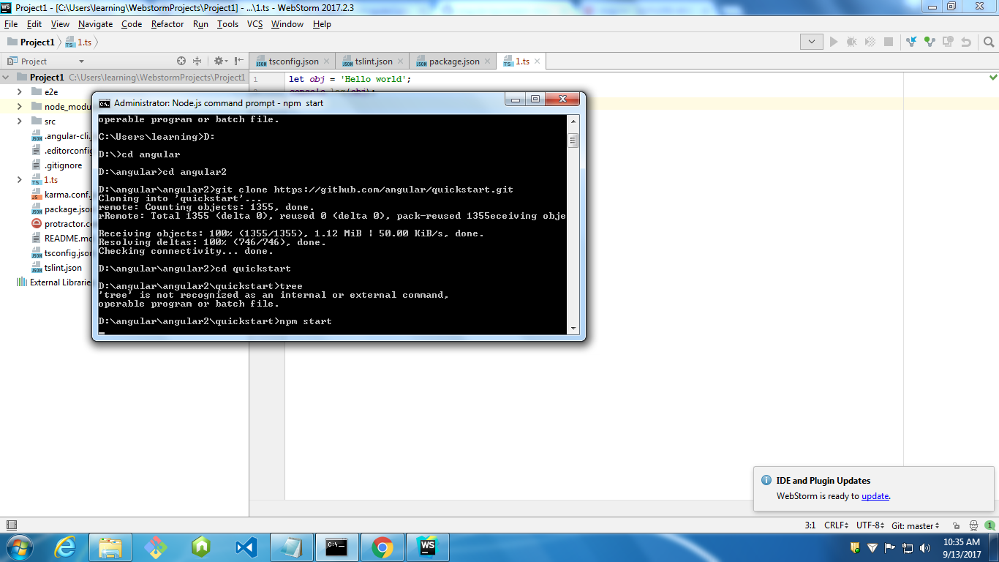

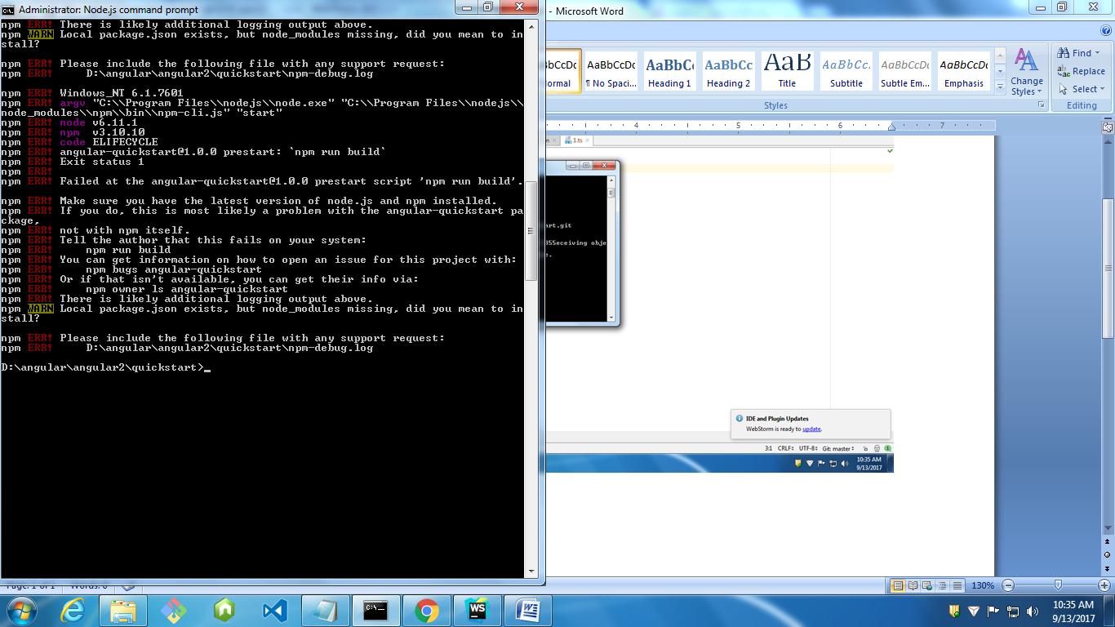

Now give npm install
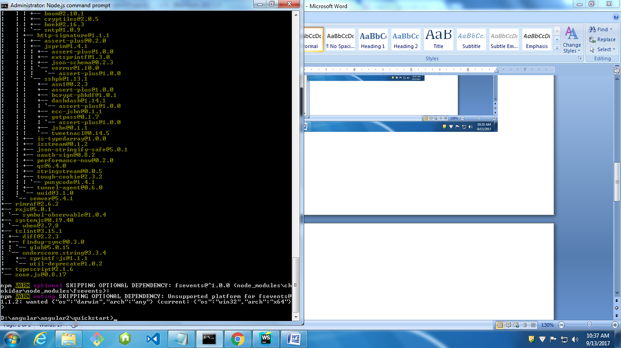

Install is completed
Now issue npm start again:
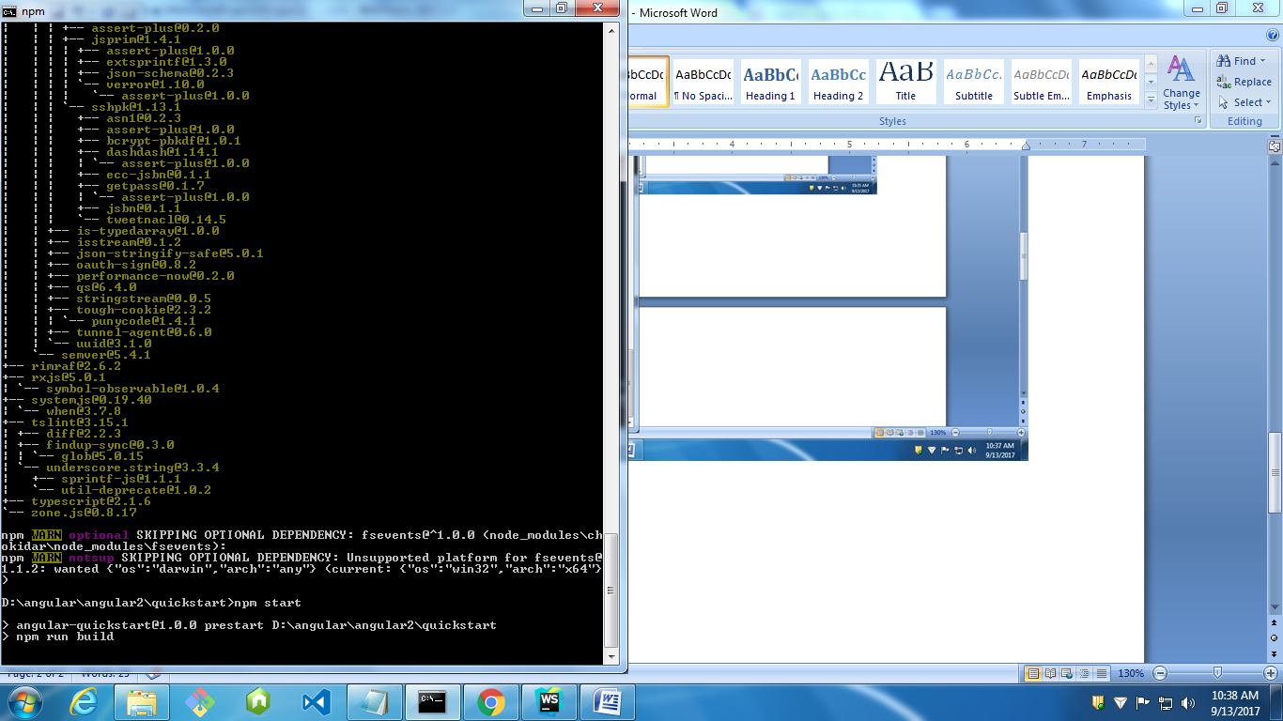
Instead create new project:
Create project in angular cli and issue npm start:
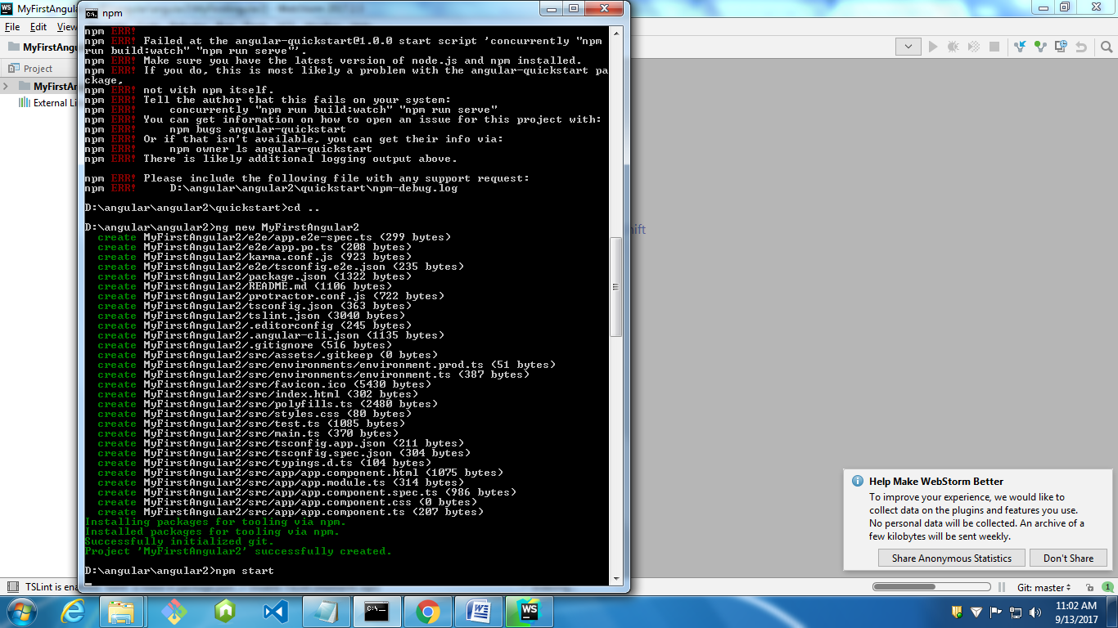
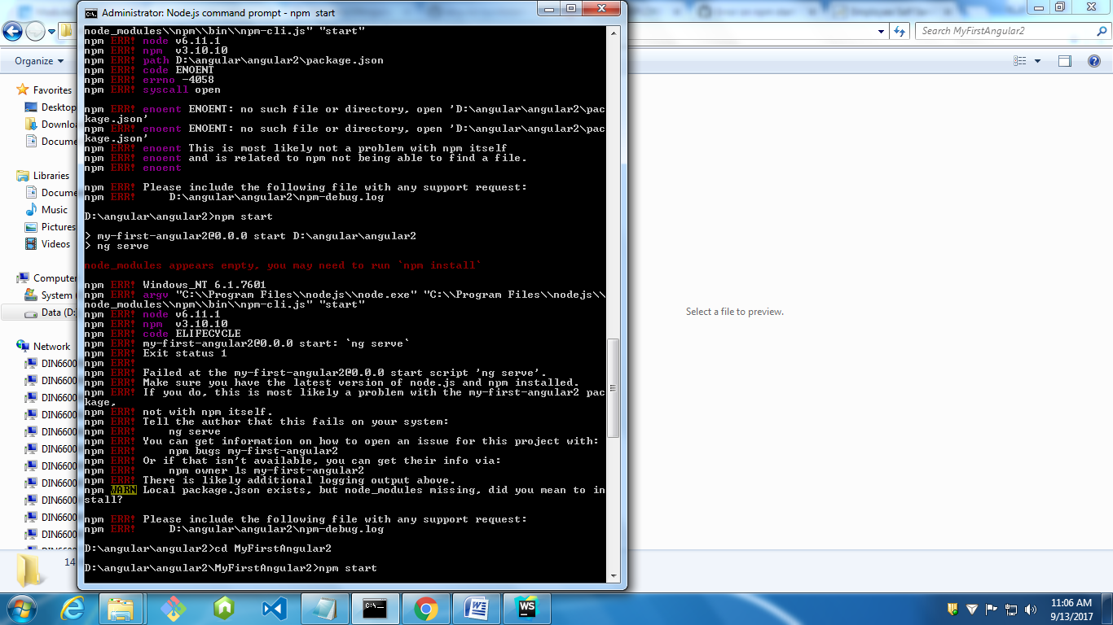
Compilation succesfull will be displayed. We can also give portnumber while starting: npm start –port 4201
Then when we go and open localhost:

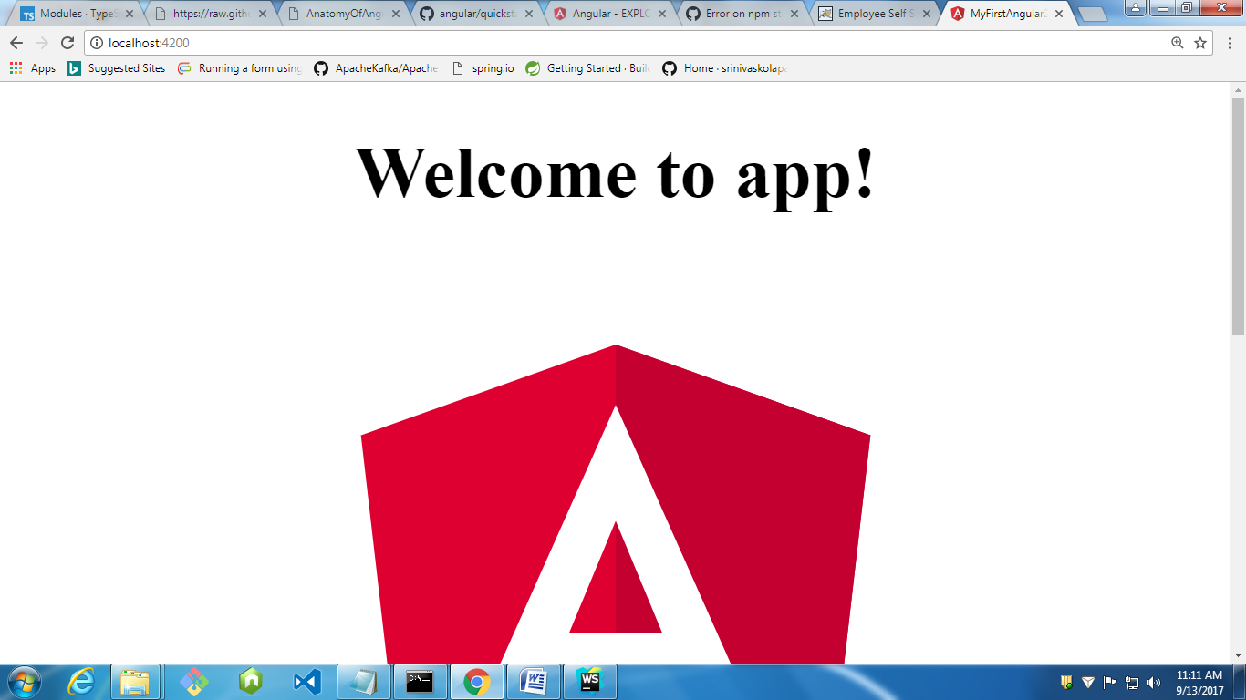

Whatever changes we make they will be 2way binding automatically. Don’t need to refresh the page also.auto compilation takes place.

Generate service:
Ng generate service abc and the service need to updated in providers:
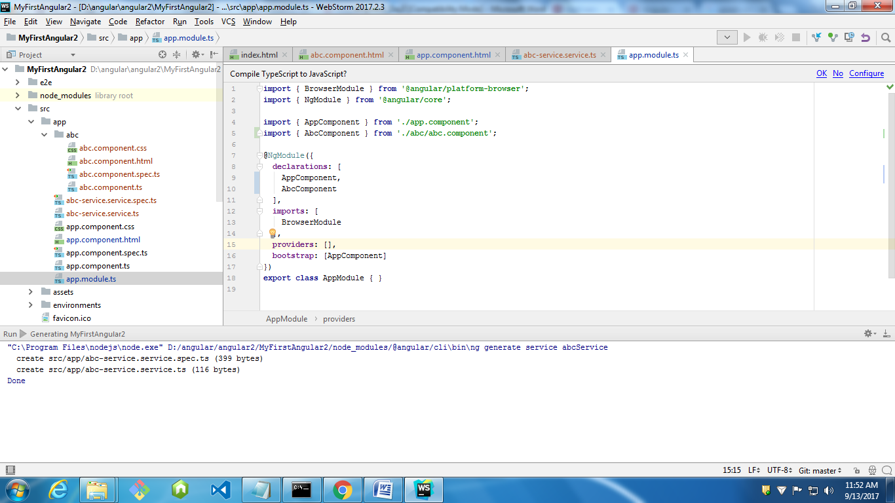
In angular 2 expression language is specified in {{ }} for the dynamic content

Create components:
Ng generate component componentname
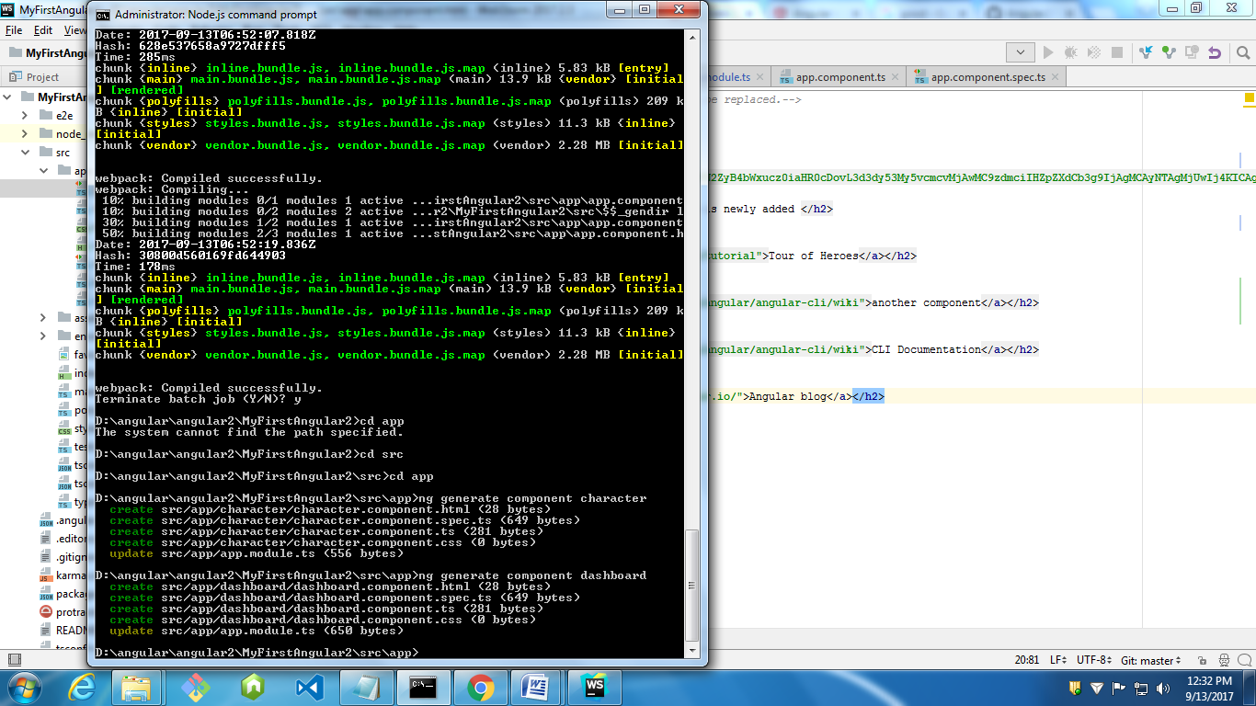

Day4:
To convert one language to another language i.e. I89 support we need to get node-redis and install. In reddis server they will place alphabets and conversions.
Every reddis server will have metadata, that data we need to retrieve and need to use in node-redis.
To retrieve get, to set set method are used.
Goto npm site and type node-redis and install the library and try this out. For this there is also an application in github location of https://github.com/vasu34k123.
https://unicode-table.com/en/ is the site where we can see all the conversion table.
Augury tool is used for debugging.
Plunker is an virtual place where we can run angular2 applications.
http://plnkr.co/edit/kBHV6AximaHAC26kYEOA?p=preview

Lifecycle Events Log
onChanges (0): name set to "Alice", onInit, doCheck, afterContentInit, afterContentChecked, afterViewInit, afterViewChecked, doCheck, afterContentChecked, afterViewChecked, onChanges (1): name changed to "Bob", doCheck, afterContentChecked, afterViewChecked, onDestroy, onDestroy
- onChanges (0): name set to "Alice"
- onInit
- doCheck
- afterContentInit
- afterContentChecked
- afterViewInit
- afterViewChecked
- doCheck
- afterContentChecked
- afterViewChecked
- onChanges (1): name changed to "Bob"
- doCheck
- afterContentChecked
- afterViewChecked
- onDestroy

